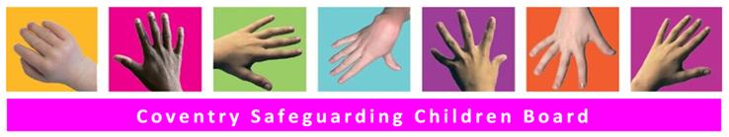

Early Help Module (EHM)
Family Matters Meetings
Step by Step User Guide
May 2021

Contents
1. Logging In
2. Tiles
3. The Homepage
4. Another way to check if you have access to a family hubs family matters tray
5. The family hub work tray
6. The Family Matters Episode

1 - Logging in
The system is internet based therefore you will need access to the internet and a web address to access the system
Enter website here Enter login ID here and click OK to continue
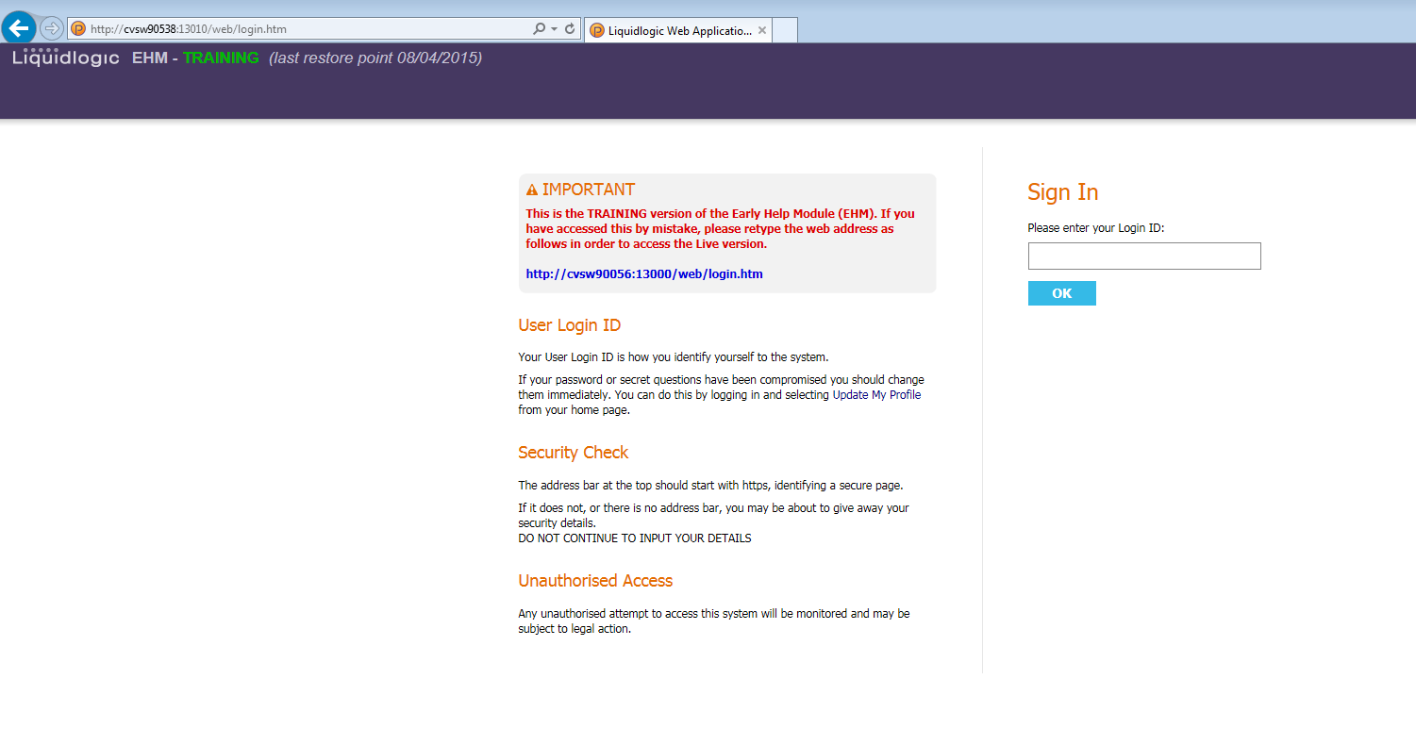

You will then be prompted to enter random characters from your password
Please Note – If you have forgotten your password do not use the Forgotten Password link, instead send an email to: steven.turner@coventry.gov.uk or ehmhelp@coventry.gov.uk they will send you a new password.
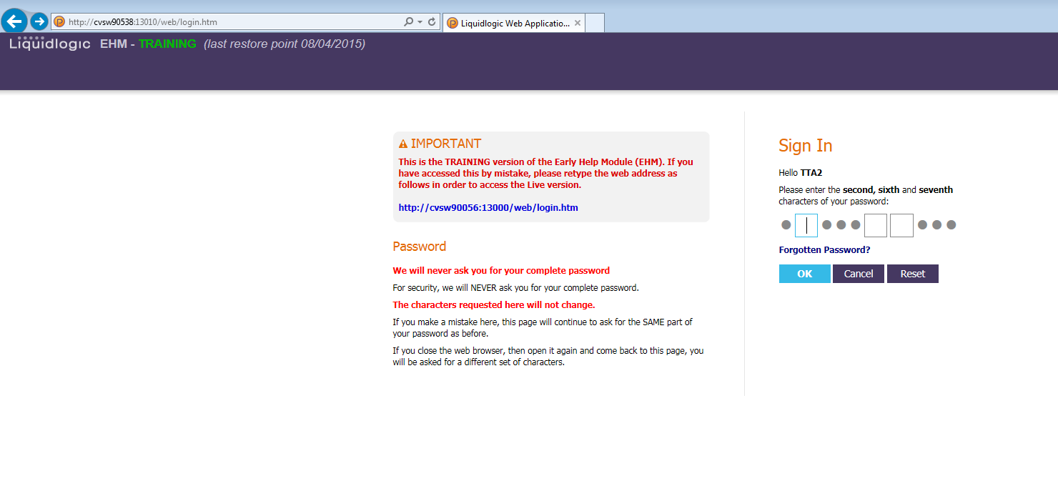

If you enter your password incorrectly, a message will be displayed requiring you to input the password again.
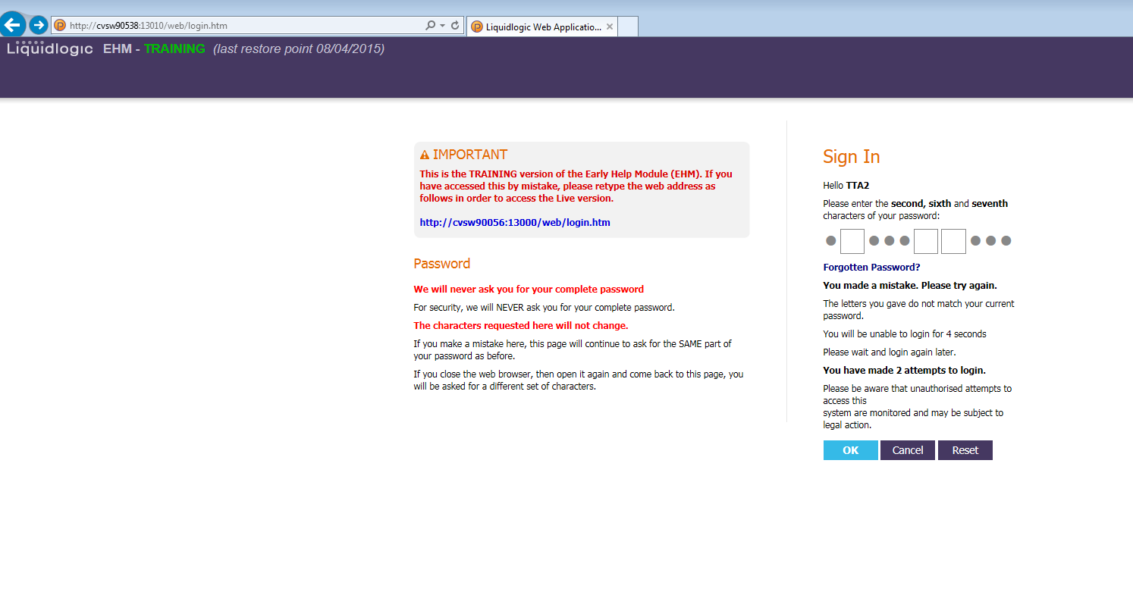
You will have 3 attempts to login, however with each incorrect attempt your account will be locked for a longer period. If you are unsuccessful after 3 attempts, your account will be locked and you will need to contact EHM Help to get your account unlocked – ehmhelp@coventry.gov.uk
Once the password has been entered correctly you will be asked at random one of your security questions. Enter security question answer and click OK to continue.
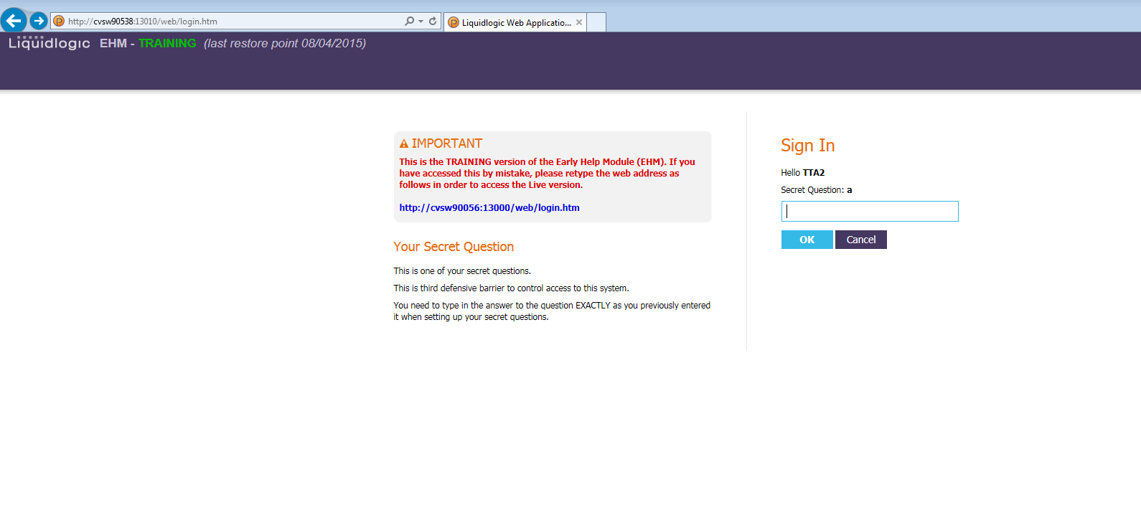

2 - Tiles
When you log into EHM, the Tiles screen is the first screen you will see.
It provides you with easy links to tasks, records and forms and shows you up to date information about your work. The Welcome Tile will provide you with further information on how the Tiles work.
At this stage we are not too concerned with the Tiles so what you need to click Home to get to your homepage.
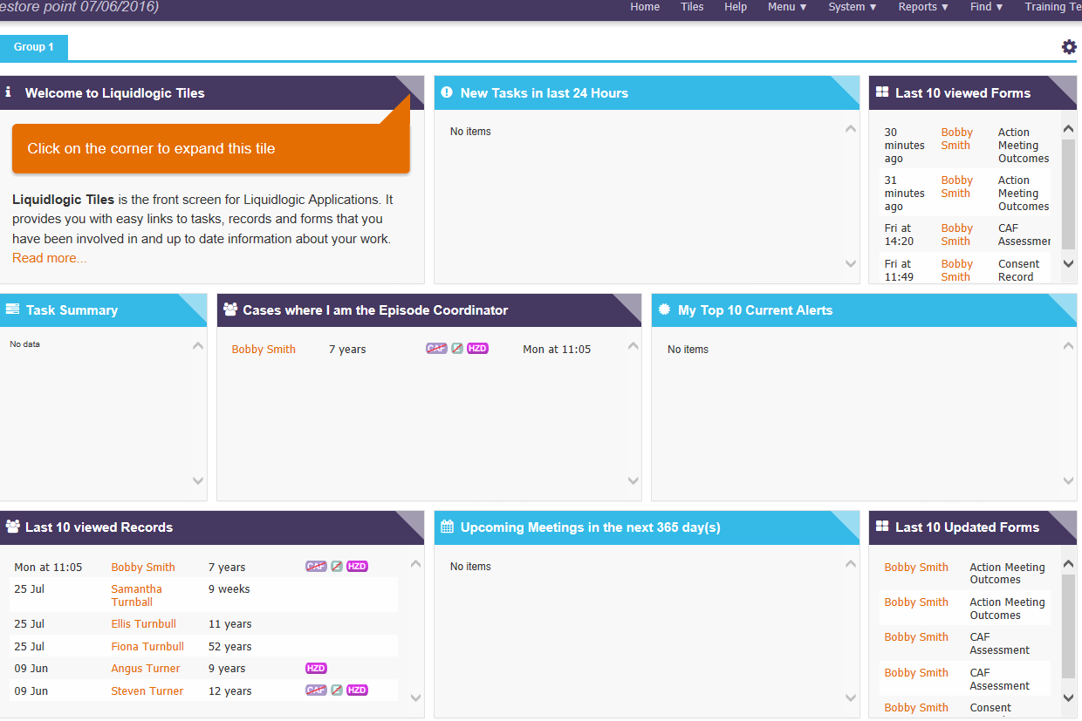

3 - The Homepage
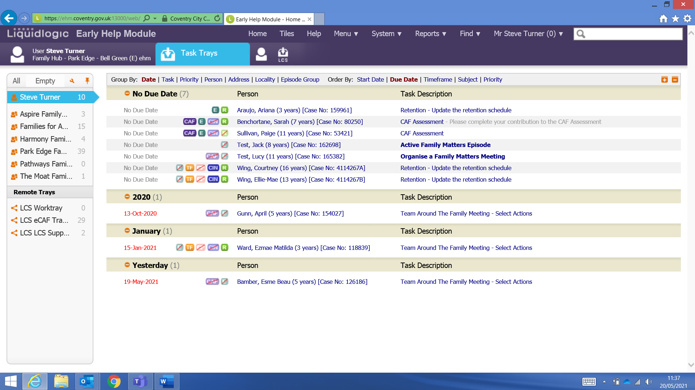
Task trays
The home page is accessed by clicking on ‘Home’ in the tool bar at the top of the screen. The majority of the home page screen is taken up with your task tray or work tray as it’s commonly known. The task tray contains the children you are the Episode Coordinator for.
For the purposes of this guide we are only interested in the family hubs family matters work trays. You will be able to see on the left-hand side of the home page the hubs you have access to. The hubs will be there if: 1) you have access to them, 2) if they have something in them.
To check a tray that is empty click on the word Empty.

4 - Another way to check if you have access to a family hubs family matters tray
From you home page click on the orange spanner
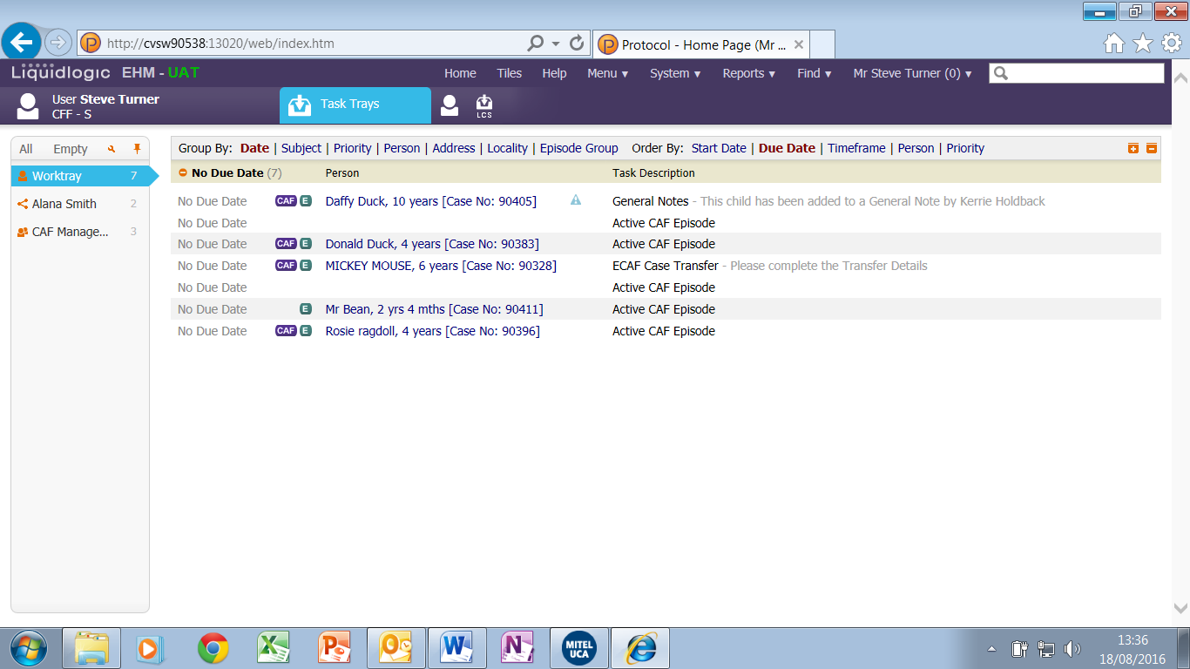

This will take you to this screen where you can select the family hub from the list under ‘Favourite Tray’.
Once you have selected click Done.
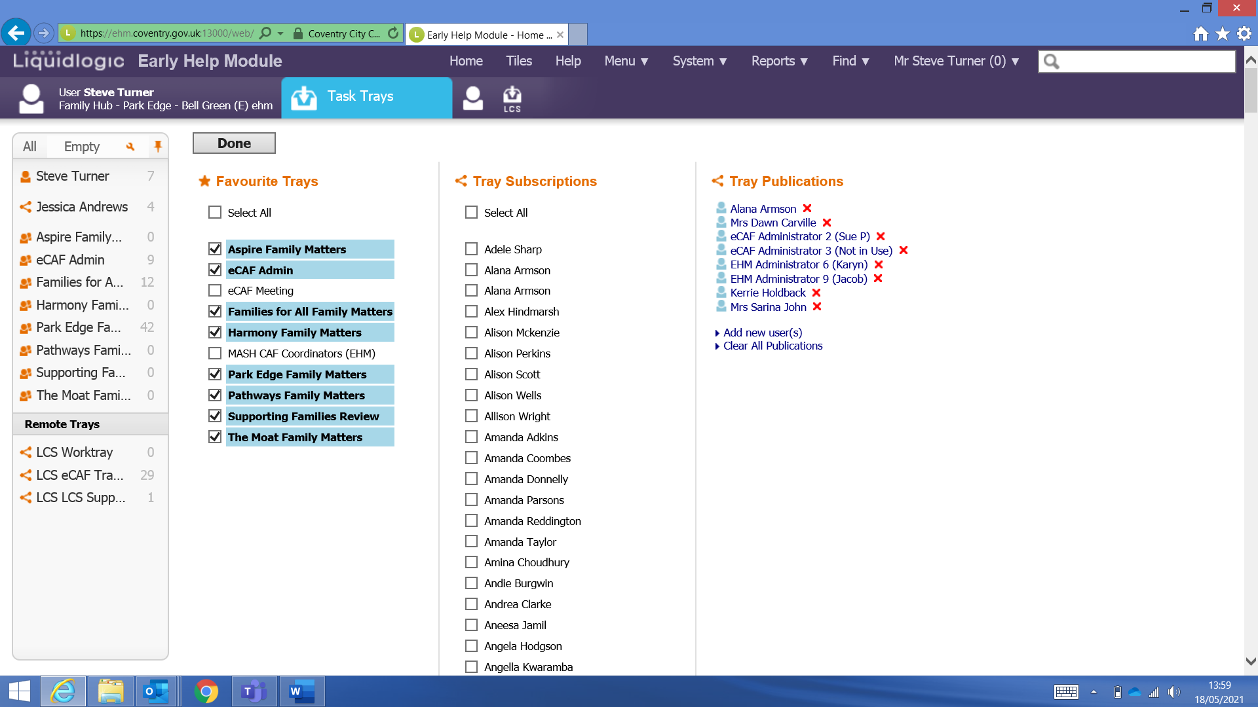

Clicking ‘done’ will take you back to your home page where you will now see the Hub tray.
Click on the name to view the work tray.
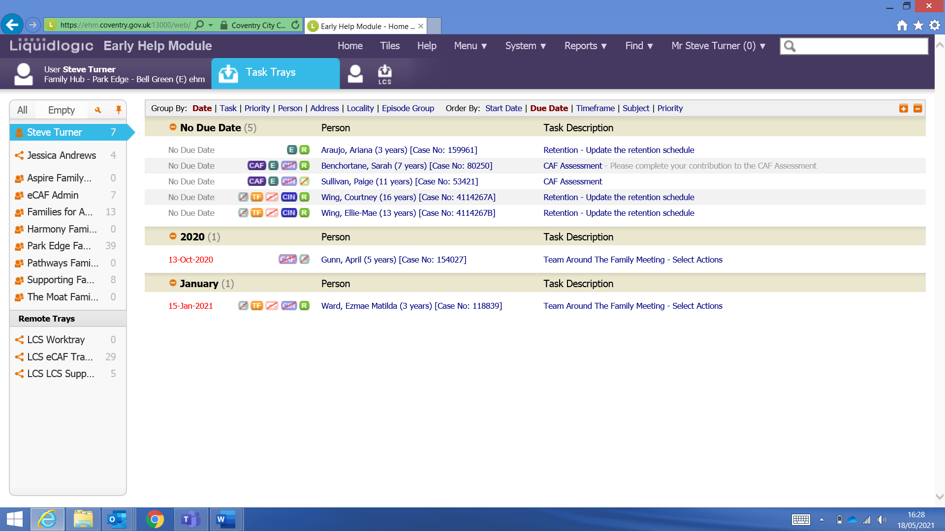
5 – The family hub work tray
By clicking on the relevant work tray you will then see all of the children that are going to be discussed at the forthcoming family matters meeting. You can then click on the child’s name and this will take you to the child’s record.
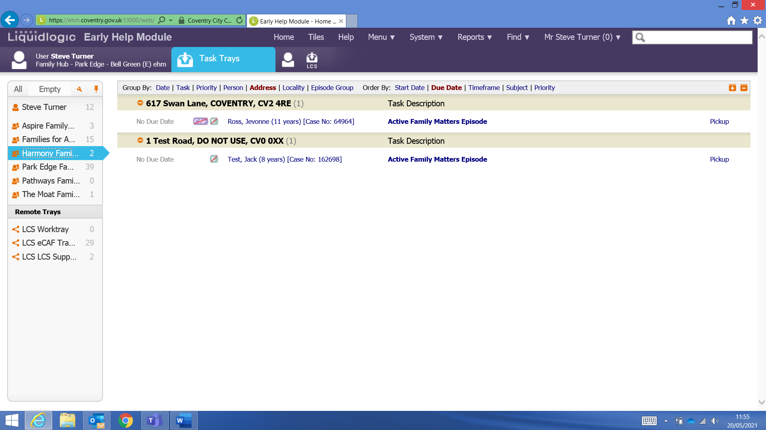

On the child’s record we can check:
- If they are any Key Agencies that are or have worked with the child
- If they are any General notes about the child
- The documents section to read the request for help form
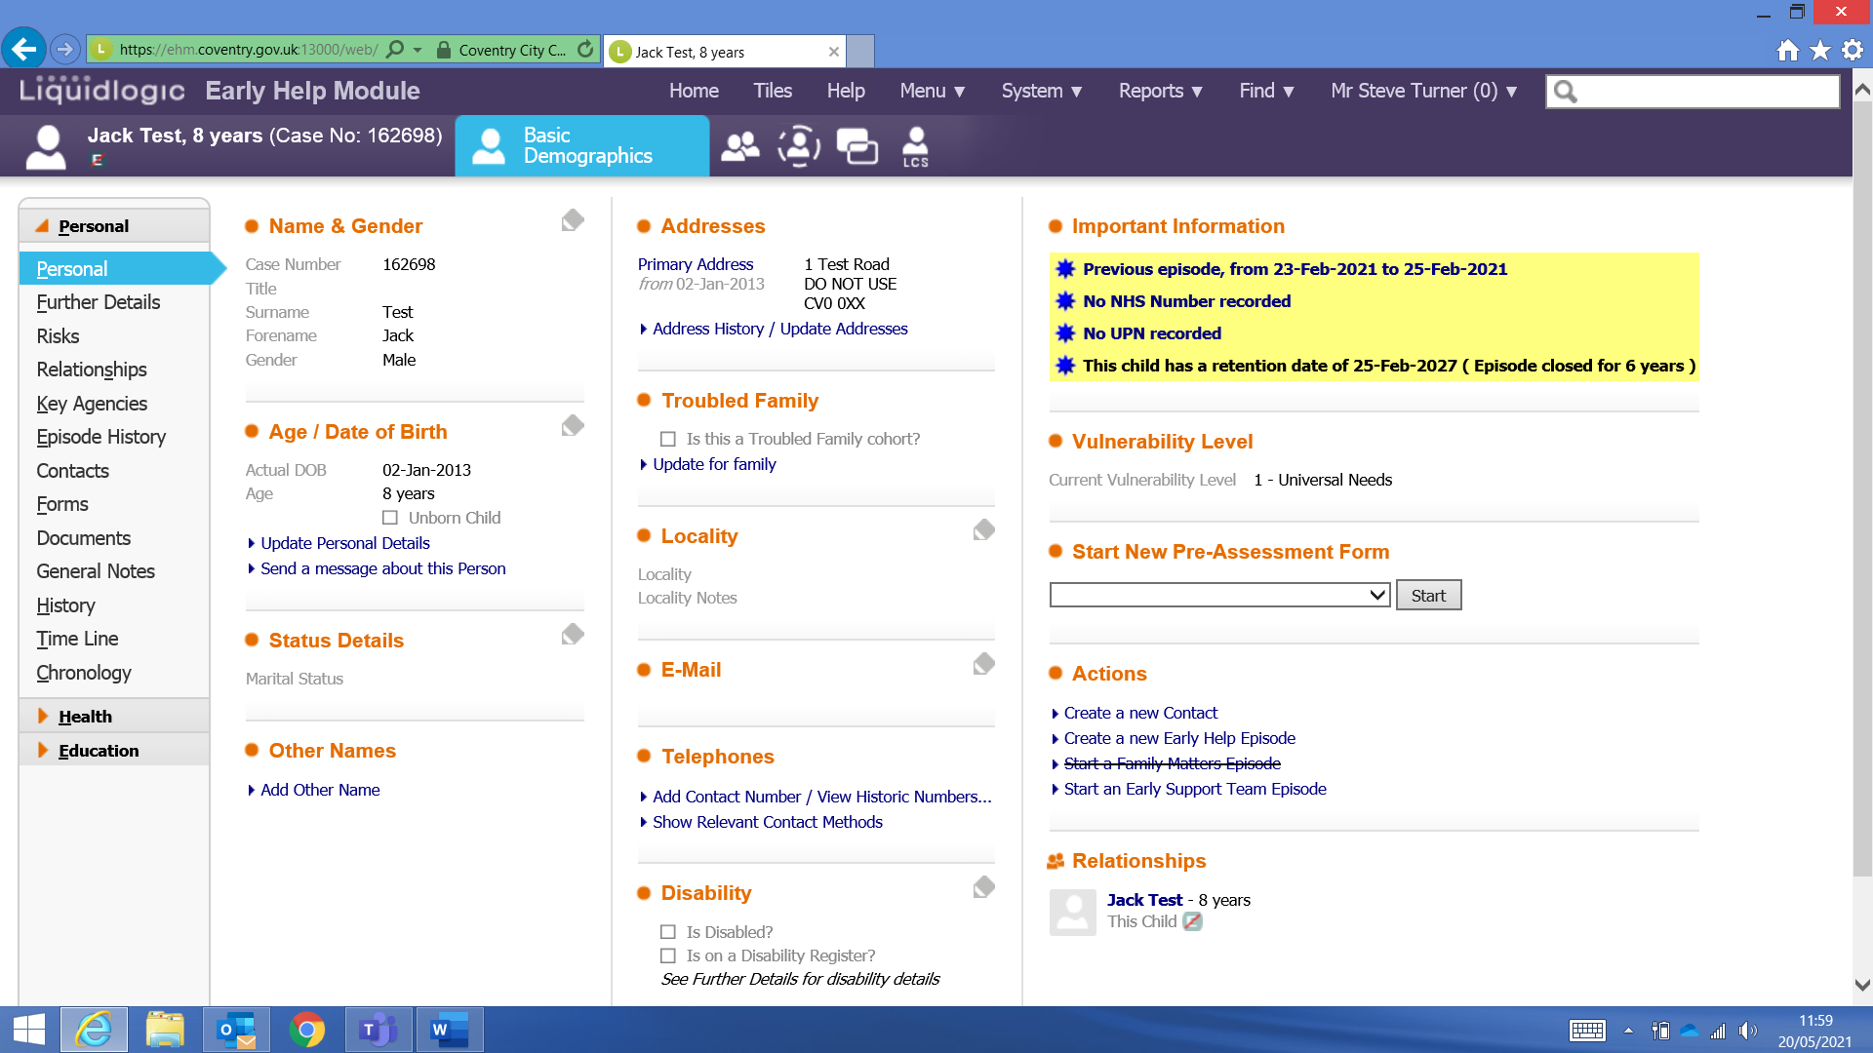
When we click on Documents we will see the request for help form. To open the document, click on the blue link.
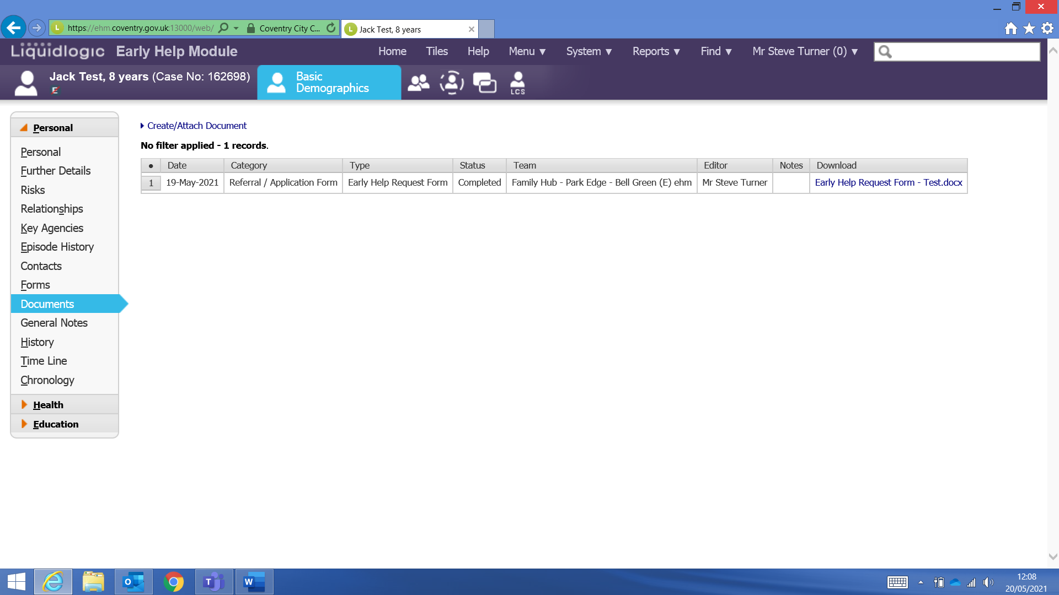

Once you have opened the document you will be able to view the request for help form.
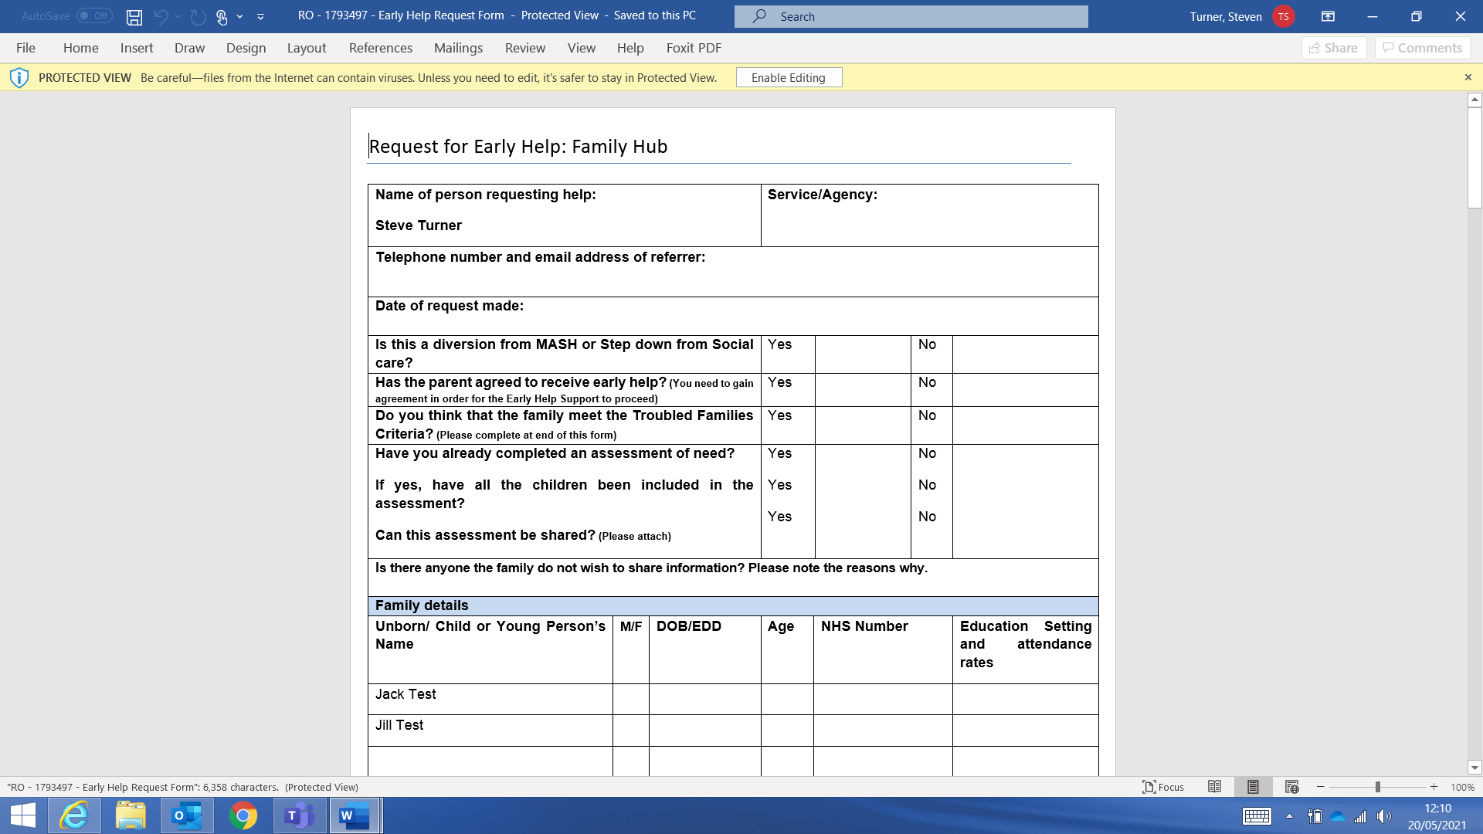
6 – The Family Matters Episode
Once you have checked the child’s record and viewed the request for help form you may want to open the family matters episode to check if a family matters meeting has been recorded.
To open the family matters episode click on the ‘Active Family Matters Episode’ link in the work tray.

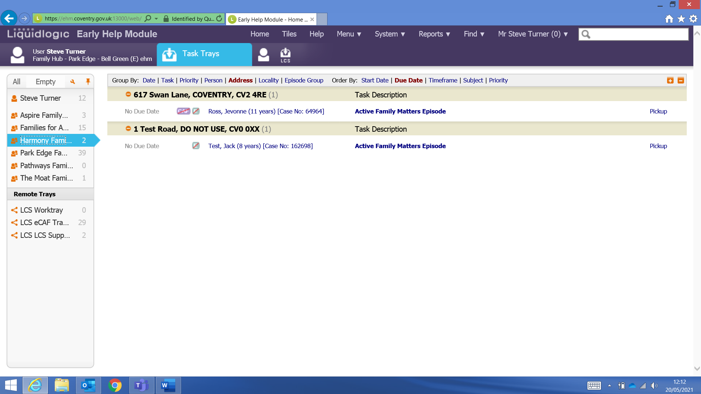
We can now see the case pathway on the left-hand side for the family matters episode. If a stage of the pathway is highlighted in blue it tells us this is an open stage, if the stage is grey it indicates the stage is closed.
We can click on the grey stage to show us the details of the family matters meeting.
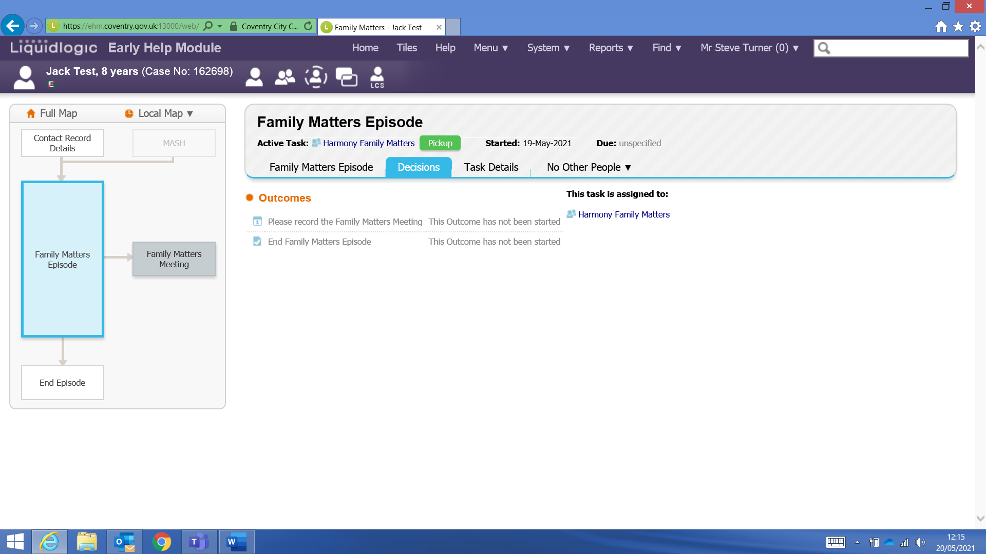

By clicking on the grey Family Matters Meeting stage we can now see the blue link to the Family Matters Meeting Decision.
By clicking on this we will be able to view the details of the meeting for the particular child.
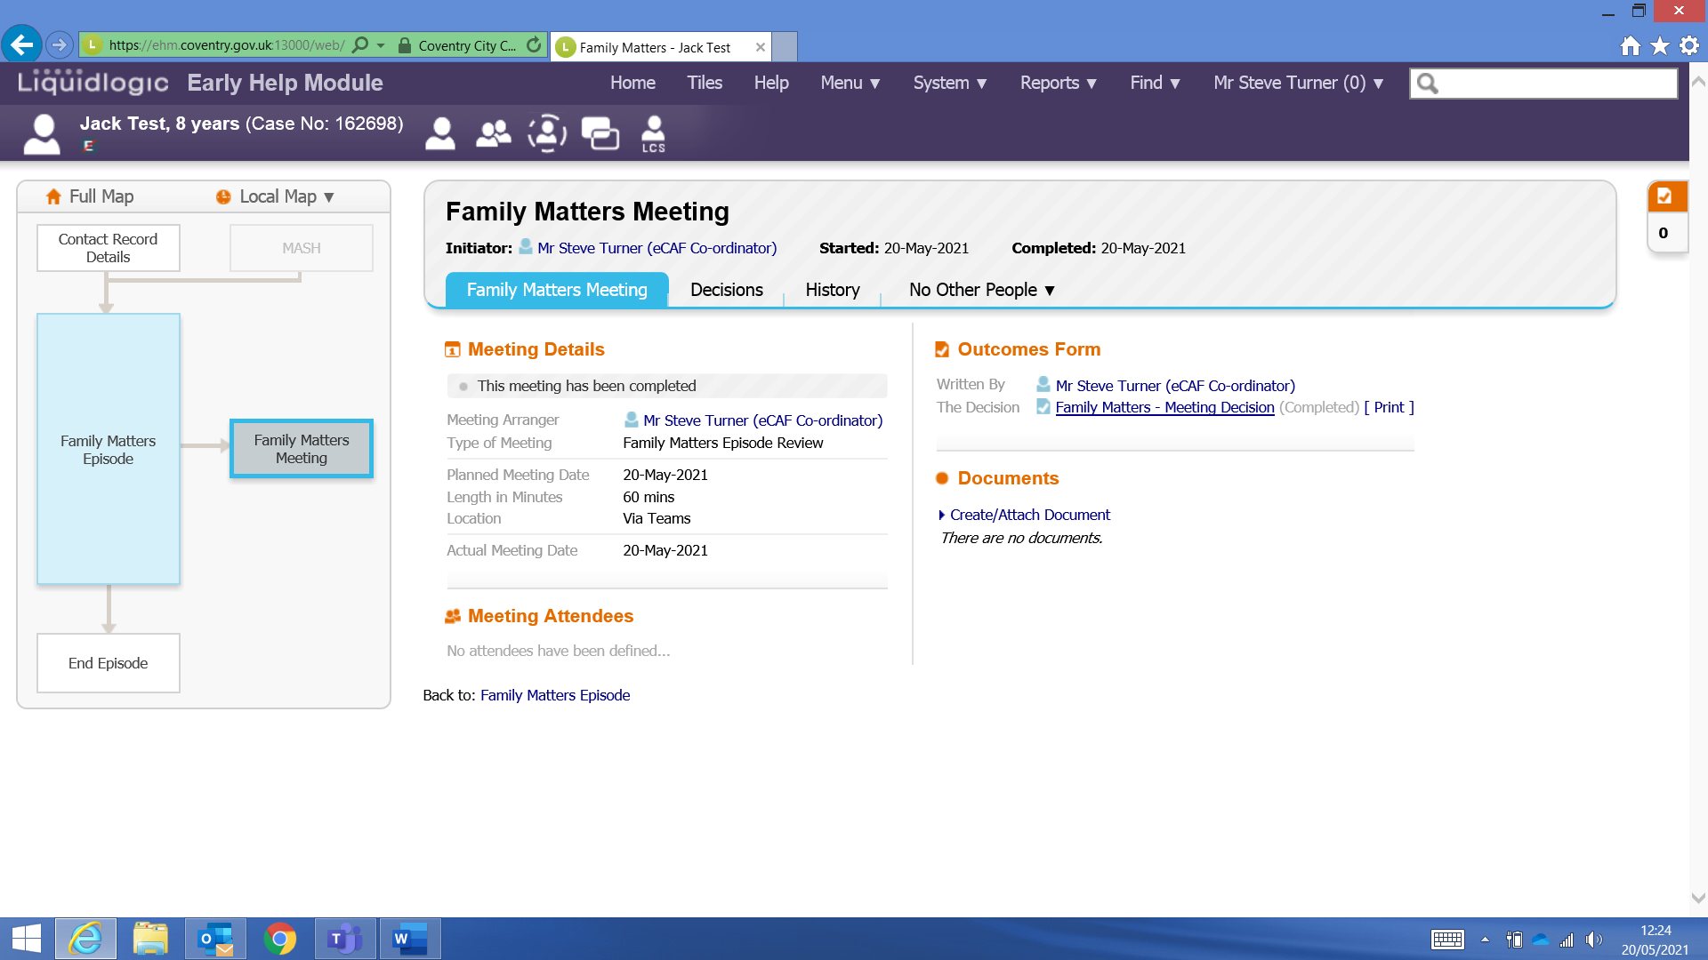

We can use the sections on the left-hand side to view the:
- Meeting Details
- Meeting Attendees
- Further Information

Once you have finished you can click on Close
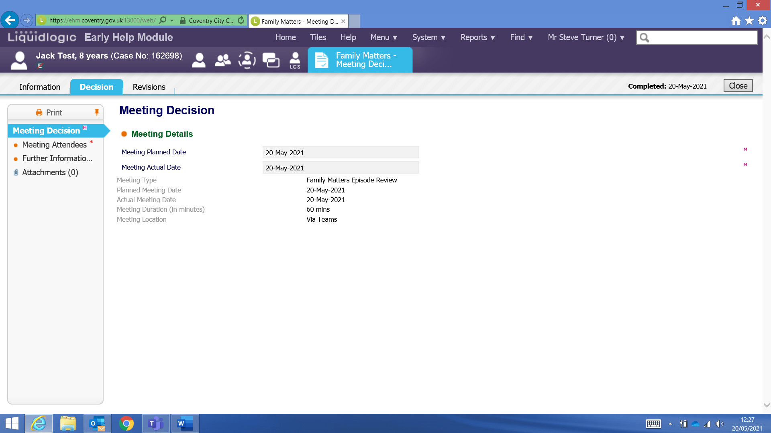
And then from here you can click on Home to take you back to your home page
