 |  | Coventry Schools Forum 7th March 2024  Agenda Item 4
 | Education and Skills

Title: Special Educational Needs & Disabilities (SEND) and High Needs Block
This item is to provide an update for Schools Forum on the local and national challenges in relation to SEND, from a financial and non-financial perspective. This is in response to a discussion at Schools Forum in January 2024.
_____________________________________________________________________________
- Information / Background
  - Local authorities (LA’s) receive funding for delivery of most SEND-related services from the Department for Education (DfE), through the High Needs Block of the Dedicated Schools Grant (DSG). Amounts distributed to LA’s via the DSG are calculated through the National Funding Formula administered by the DfE. LA’s in consultation with local education providers, determine individual allocations of this funding.

  - Demand for SEND services has increased significantly following the passing of the Children and Families Act 2014. Nationally the number of individuals with EHCP’s has risen from 240,183 in 2015 to 517,049 in 2023, an increase of 115% over eight years. In Coventry the number has increased from 1,432 in 2015 to 2,705 in 2023, an increase of 89%. Currently the number in Coventry is 3,115.

  - Whilst Coventry has consistently maintained the lowest % of EHCPs in the West Midlands, supported by the highest % of children receiving SEN Support (early intervention), demand has increased significantly since the introduction of the reforms. Activity in relation to new EHCP’s issued increased by 53% between 2022/23 and 2023/24 because of a significant increase in need, which may be partially attributed to the ongoing impact of the pandemic and increase in population.

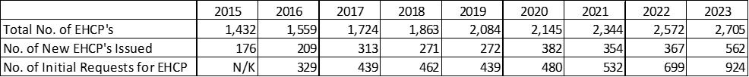

- High Needs Block
  - There are multiple elements and factors that combine to produce the formula. Firstly each LA is allocated their basic entitlement factor. This provides a per pupil funding amount, adjusted for geographical variation in costs. This is based on the number of pupils who attend special schools in each LA, and the number of high needs pupils placed in independent schools by the LA. It should be noted that the actual cost of a placement is significantly higher than the per pupil amount given via this factor.

  - Secondly, the historic spend factor is calculated for each LA as 50% of their actual High Needs spending in financial year 2017/18. For Coventry this forms ca. 20% of our overall allocation.

  - The funding for all other proxy factors is distributed to LA’s based on the following indicators: 2-18 year old general population, deprivation, health and disability, and low attainment. Some of the data used to calculate these proxy factors is significantly lagged. Please refer to Appendix 1 for further detail.

  - The formula then applies the protection of a funding floor to the sum of the proxy factors, and a gains cap such that no LA may receive a greater than a 5% increase per head on their 2023/24 baseline amount.

  - There is an Alternative Provision (AP) factor which also includes Hospital Education, and an Import / Export adjustment to reflect pupils that attend provision in a different LA from that in which they are resident.

  - The number of EHCP’s does not feature in the formula, instead the above proxy factors are used to estimate SEND demand.

  - National allocations rose to £10.1 billion for 2023/24 which is an increase of over 50% compared to 2019/20. For 2024/25 this is increasing to £10.54 billion. Coventry’s allocation for 2024/25 is £70.4 million compared to £67.1M for 2023/24. Please see Appendix 2 for full detail of the 2024/25 allocation, including a breakdown across the different formula elements.

  - Despite this level of funding, and the best efforts of local authorities, there continues to be a significant proportion of local authorities with accumulated DSG deficits. The total deficit had increased to over £1 billion by the end of 2020/21. A recent report published by the DLUHC Committee states that the estimated deficit is now approximately £2.3 billion rising to £3.6 billion by March 2025.

  - Coventry does not have a deficit currently and instead has a positive DSG reserve balance of £10.2M as at March 2023. However it is important to note this does not mean Coventry has been immune from the increased demand and cost increases seen nationally. A more detailed analysis of Coventry’s position can be found in section 5.

- DSG Statutory Override
  - In 2020 the government introduced a statutory override allowing LA’s to exclude any deficits on their DSG spending from their main revenue budgets. This originally covered three financial years 2020/21 to 2022/23.

  - Prior to the introduction of the override Local Authorities (LA’s) had choice in how they managed a DSG deficit. They could either carry it forward as an overspend against the schools budget in future years or fund it from general revenue funding. Because LA’s were allowed at that point to cover the deficit from the general fund, it led some S151 officers to conclude that if their DSG account was in deficit they needed to be able to cover that from general reserves. Local government auditors also began thinking the same. Given the size of some authorities DSG deficits and other pressures on LA’s reserves the DfE recognised that this could cause LA’s to make spending reductions in other services that they would not otherwise make.

  - Therefore they changed the rules (originally for 3 financial years – now extended until March 2026) to make it clear that a DSG deficit must not be charged against the general fund and instead charged to a separate fund used solely for the purpose of recognising deficits in respect of the schools budget. LA’s now need permission from the Secretary of State to override this and apply general funds against a DSG deficit. The DfE’s intention is that LA’s eliminate their deficits using future years DSG income.

  - It is unclear at this point what will happen in practice when the statutory override ends, with any government decisions not expected prior to the next Parliament. One LA (Bournemouth, Christchurch and Poole) has publicly stated there is a risk they will have to issue a S114 notice in December 2024 as it would not be possible to set a balanced budget for 2025/26 if their DSG deficit becomes part of the general fund. Bristol City Council has also said there is a risk of a S114 notice needing to be issued due to their DSG deficit.

- DSG Deficit Management
  - The DSG conditions of grant requires that any LA with an overall deficit on its DSG account at the end of a financial year, or whose DSG surplus has substantially reduced during the year must be able to present a plan to the DfE for managing their future DSG spend.

  - The plan must be updated and presented at Schools Forum meetings at least on a termly basis. The LA should aim to present their plan to the Schools Forum in time for budget planning discussions and before the deadline for block movement requests if it is submitting one. The plan must be approved by relevant leads in SEN and Finance (with sign off to be at least at Assistant Director level).

  - A block transfer is the movement of funds between different blocks of the DSG. LA’s have the option to transfer money out of Schools Block (which funds mainstream schools budget shares) into the High Needs Block. This effectively reduces the money available for mainstream schools to top-up the High Needs Block and help to eliminate deficits. Given the financial challenges facing schools more generally this is not a preferable solution for LA’s. To highlight this point Coventry has had to set its Minimum Funding Guarantee (MFG) at 0.42% for 2024/25 in order that the mainstream National Funding Formula was affordable. This means some mainstream schools across Coventry will only see their per pupil funding increase by 0.42% compared to 2023/24. Without Schools Forum agreement, or where an LA wishes to transfer more than 0.5% of their Schools Block funding into one or more other Blocks, LA’s must submit a disapplication request to the Secretary of State.

  - In response to the pressures faced by LA’s the DfE has created two intervention programmes. Those LA’s with the highest DSG deficits have been invited to the Safety Valve programme, those with less severe but substantial deficits have been invited to the Delivering Better Value (DBV) programme. More than half of LA’s have been invited to join one of these programmes. Coventry is not part of either of these programmes.

  - LA’s who are part of the intervention programmes are expected to reach an in-year balance on their DSG as quickly as possible and over time eliminate their deficits using future years DSG. However the DfE has recognised that some authorities will not be able to resolve their DSG deficits without additional intervention and / or funding. As part of the intervention programmes some LA’s have received additional DSG funding over and above their formula allocation, however in order to receive this they have to enter into a contractual arrangement with the DfE committing to carry out the required reforms in return for the additional money.

- Financial Position in Coventry
  - In recent years Coventry has gained via the National Funding Formula and seen significant increases in High Needs funding. In 2018/19 Coventry’s allocation was £37.4M, this has increased to £70.4M for 2024/25. Therefore although Coventry has seen a significant increase in demand and subsequently expenditure, funding increases have so far kept pace with rising costs.

  - The table below shows Coventry’s High Needs allocation, outturn and variance since 2021/22. For 2023/24 outturn is estimated as per Q3 budgetary control (additional detail is provided in Appendix 3). The 2024/25 budget plan will be presented in full at Schools Forum on 7th March 2024. As you can see although Coventry has under spent against its allocations, expenditure has increased significantly between years. The DfE has stated that increases in funding over the last few years have been exceptional, and LA’s should expect more modest funding increases moving forward (ca. 3% annually).

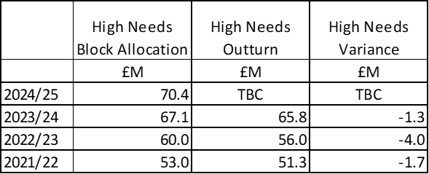

- Challenges in Coventry
  - Like many LA’s, Coventry is facing challenges which are impacting the LA from a sufficiency and financial perspective. Some of these are listed below.

    - Increasing volume of early years / rising 5’s who are presenting with additional needs.

    - An increasing number of pupils are moving into the city and requiring a school place in-year, putting pressure on all schools across the city.

    - A significant level of expansion across Coventry’s special schools has already taken place meaning larger amounts of capital investment is required to expand further. A lack of capacity within the city will create an increased reliance on the independent sector which have much higher unit costs (see Appendix 4). The table below shows the growth in number of commissioned special school places from academic year 2017/18 to 2023/24.
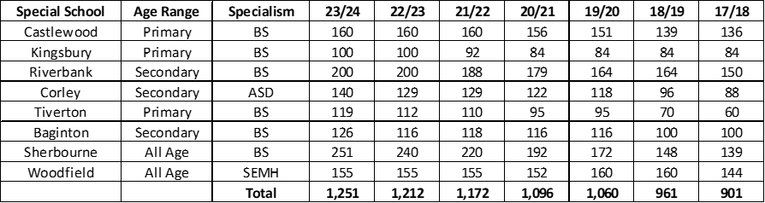

    - An increasing number of children with EHCP’s means that schools need to recruit additional specialist staff to support children in their settings.

    - The LA is currently operating in a high inflationary environment, particularly staffing costs. This impacts costs across the High Needs system including where the LA has top-up rates that are designed to cover the cost of a teaching assistant.

    - Increasing demand for services to support those children who either refuse or cannot attend mainstream school due to anxiety and social, emotional and mental health (SEMH) needs.

  - Due to the way the High Needs block funding formula works, growth in overall EHCP’s and a changing profile of need is not immediately reflected in the allocation that Coventry receives.

- SEND Strategy – National Policy
  - In March 2023 the DfE published the Special Educational Needs and Disabilities (SEND) and Alternative Provision (AP) Improvement Plan. This set out the government’s proposals to improve outcomes for children and young people; improve experience for families, reducing the current adversity and frustration they face; and deliver financial sustainability. SEND & AP Improvement Plan

  - The plan says new evidence based national standards will be introduced. These standards will improve early identification of needs and intervention, and set out clear expectations for the types of support that should be ordinarily available in mainstream settings. With these expectations, and improved mainstream provision, more children and young people will receive the support they need through ordinarily available provision in their local setting. Fewer will therefore need to access support through an EHCP. The national standards will set clear and ambitious expectations for what good looks like in identifying and meeting needs, and clarify who is responsible for delivering provision and from which budgets, across the 0-25 system.

  - The DfE’s intention is to develop a system of funding bands and tariffs so that consistent national standards are backed by more consistent funding across the country. This would apply across the whole range of special education provision, including the independent specialist sector. They will also develop new approaches to funding alternative provision aligned to their focus on preventative work, and reintegration of pupils into mainstream schools. Through their £70M change programme the DfE will establish up to nine Regional Expert Partnerships who will help them co-produce, test and refine key reforms.

  - Another key area of focus in the improvement plan is what actions can be taken to create a system that makes sure children and young people with SEND have successful transitions and are prepared for adulthood. It is also recognised that if more support is going to be provided in mainstream settings this will require an action plan to upskill the teaching and teaching assistant workforce.

  - These reforms will be a significant change to the High Needs system and will require reforms to funding arrangements to support their delivery. These reforms will take place over a number of years and the DfE’s published roadmap confirms that the target date for many of the actions is by the end of 2025. SEND & AP Roadmap

  - Therefore, it is not anticipated that this plan will resolve the financial challenges facing LA’s in the short to medium term.

- SEND Strategy – Coventry
  - Within Coventry work is ongoing to develop options to resolve both our sufficiency and financial challenges. Some of the key workstreams that are underway are listed below.

    - Woodfield Special School is in the process of relocation and expansion at the former Woodlands site. This could create up to an additional 104 SEMH places across both primary and secondary phases. These additional places will begin to be available from September 2025.

    - Exploring where possible and advantageous, further opportunities to create additional places in special schools and enhanced resource provisions.

    - Working with colleges (including the Adult Education Service) to diversify and expand the Post-16 SEND offer including increasing the number of supported internships.

    - Appointed a Workforce Strategy Lead in collaboration with schools.

    - The development of a High Needs Medium Term Financial Strategy.

  - It is important to note that for any expansion of places in Coventry to be affordable, there will need to be a reduction in the number of places commissioned via the independent sector.

  - It is therefore key that the Council monitors the position closely and manages resources effectively to ensure that it remains within funding allocations as far as is possible.

Report author(s):
Name and job title: Sarah Kinsell, Finance Manager (Children’s & Education Services)
Service: Financial Management
Tel and email contact: 024 7697 6885 Sarah.Kinsell@coventry.gov.uk
Enquiries should be directed to the above person.
Contributor/Approver | Title | Directorate or organisation | Date doc circulated | Date doc approved
Ewan Dewar | Head of Finance | Financial Management | 23/02/2024 | 29/02/2024
Jeannette Essex | Head of SEND & Specialist Services | Children’s & Education Services | 23/02/2024 | 29/02/2024
Rachael Sugars | Head of Education Improvement & Standards | Children’s & Education Services | 23/02/2024 | 04/03/2024
This report is published on the Schools Forum Section of the council's website:
https://www.coventry.gov.uk/meetings?status=&committee=28&filterList=Go

Appendix 1 – 2024/25 High Needs NFF
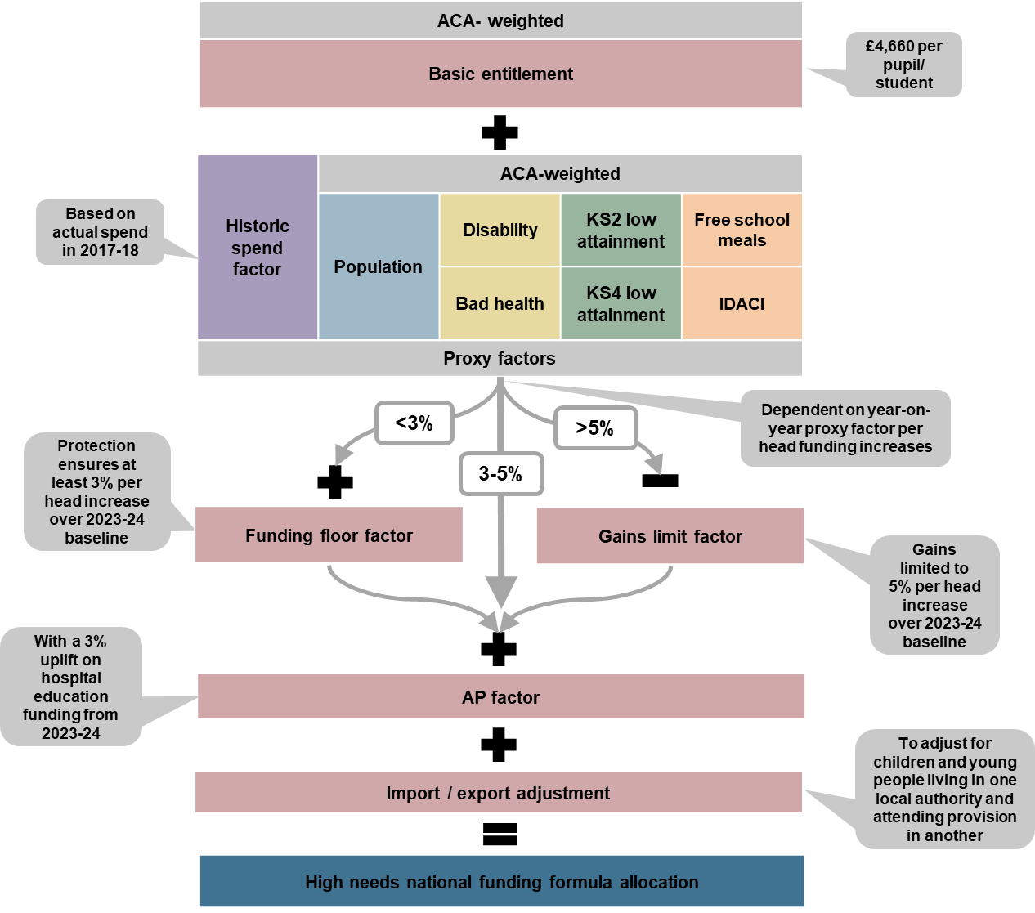

Factor | Data used for 2024/25 Allocations | Sourced from
Basic Entitlement | The number of pupils on roll at maintained special schools and special academies is summed with the number of pupils with SEND in independent schools. | Oct 2023 School Census and Jan 2023 AP Census
Historic Spend Factor | The historic spend factor for each LA is based on 50% of their actual spend in 2017/18. | Outturn Data
Population | The projected number of people aged 2-18 resident in each LA in mid-2024, based on mid-2018 population estimates. | ONS
Free School Meals (FSM) | The number of pupils resident in each LA and registered as eligible for FSM, as recorded in the January 2023 school census.  The number of pupils in each LA eligible for the 2-year-old offer or Early Years Pupil Premium for economic reasons, as recorded in the 2023 early years census. | Department for Education
Deprivation Index (IDACI) | The IDACI rank of each LSOA as specified in the IoD IDACI dataset.  The number of 2-18 year-olds in each LSOA based on mid-2020 population estimates. | MHCLG  ONS
Bad Health | The number of children aged 0-15 in bad or very bad health and resident in each LA, as reported by parents in the 2021 general population census. | ONS
Disability | The number of children aged 0-15 with parents entitled to disability living allowance and residing in each LA, as of November 2022 (published in May 2023) | Stat-Xplore
KS2 Low Attainment | The number of pupils resident in each LA who did not attain a specified scaled score in the KS2  reading test or who were not entered into the test due to being below the required standard or who were unable to access the test, for years 2018, 2019 and 2022  The numbers are taken from the test results across all mainstream and special maintained schools and academies.  2019 test data is used as a proxy for 2020 and 2022 test data as a proxy for 2021 due to a lack of appropriate data from those years. | Department for Education
KS4 Low Attainment | 2019 Attainment 8 results are used as a proxy for 2020 and 2022 Attainment 8 results for 2021 results due to a lack of appropriate data. | Department for Education
Funding Floor | The projected number of people aged 2-18 resident in each LA in mid-2023 and mid-2024, based on mid-2018 population projections. | ONS

Appendix 2 – Coventry 2024/25 High Needs Allocation
Select LA name | Coventry | %
Region | WEST MIDLANDS
LA code | 331
(A) Basic entitlement factor | £6,298,473 | 9%
(B) Historic spend factor | £15,058,162 | 21%
(C) Population factor | £21,711,984 | 31%
(D) FSM factor | £4,989,726 | 7%
(E) IDACI factor | £6,239,751 | 9%
(F) Bad health factor | £3,742,793 | 5%
(G) Disability factor | £3,364,990 | 5%
(H) KS2 low attainment factor | £3,677,185 | 5%
(I) KS4 low attainment factor | £3,794,239 | 5%
(J) Funding floor factor | £0 | 0%
(K) Gains limit factor | £0 | 0%
(L) AP factor | £794,311 | 1%
Provisional HN NFF 2024-25 allocations excluding additional funding for new and growing special free schools and import/export adjustments | £69,671,614 | 99%
(M) Import/export adjustment | £720,000 | 1%
Provisional HN NFF 2024-25 allocations including additional funding for new and growing special free schools and import/export adjustments | £70,391,614 | 100%

Appendix 3 – Coventry 2023/24 High Needs Allocation and Q3 Budgetary Control Forecast

 | 2023/24  High Needs Budget | 2023/24 Forecast Variance
 | £M | £M
Coventry Special & Alternative Provision Schools | 31.2 | 1.3
Specialist Support Services (e.g., SEN Early Years, Sensory Support, KEYS) & Central Costs | 9.0 | -0.9
Independent Specialist / Mainstream Providers (ISP / IMP) | 6.8 | 0.5
Top Up - Mainstream Schools | 6.8 | 0.2
Post 16 - Colleges, Adult Education, Independent Sector | 5.9 | -0.1
Holding Pot | 2.4 | -2.4
Top Up - Other Local Authority Schools | 1.6 | 0.3
Hospital Education & Outreach Service | 0.9 | 0.0
Enhanced Resource Provisions | 0.9 | -0.2
Personal Budgets / Alternative Provision / Home Tuition | 0.7 | 0.0
Disproportionate SEN | 0.7 | 0.0
Top Up - Early Years | 0.2 | 0.0
Total | 67.1 | -1.3

Appendix 4 – Unit Cost of Provision Types (High Needs Block Only)

2023/24
Avg. Unit Cost
 | £000
Independent Specialist Providers | 55
Coventry Special & Alternative Provision Schools | 23
*Enhanced Resource Provisions | 12
*Top Up - Mainstream Schools | 8

*Pupils on roll at a mainstream school also attract pupil led funding via the Schools Block element of the Dedicated Schools Grant

