 |  | Coventry Schools Forum 3rd October 2024  Agenda Item 7 and 8
 | Education and Skills

Title: Financial Outturn 2023-24 including School Balances
This item is for Schools Forum for information
This paper looks at the 2023-24 Financial Outturn, including school balances (reported at the financial close 31st March 2024).

Executive Summary

Central Dedicated Schools Grant (DSG) underspend in 2023-24 was £4.3m which includes a High Needs (HN) underspend of £3.3m, an Early Years (EY) underspend of £0.9m, a £0.2m underspend on de-delegated services offset by an overspend on the growth fund of £0.1m.

The opening 2023-24 unallocated reserve position (excluding school balances) was £9.5m. Factoring in the £4.3m 2023-24 underspend the current total unallocated DSG reserve is £13.8m in 2024-25.

In addition to the central DSG reserve, there is also an earmarked element within the DSG reserve which covers the NNDR implications of academisations. This had an opening 2023-24 balance of £0.5m. Conversions to academy in 2023-24 meant that £0.1m of this reserve was used meaning the closing NNDR DSG reserve was £0.4m.

Therefore, the total closing DSG reserve for 2023-24 is £14.2m.

Total school & academy balances were £56.2m at the end of the 2023-24 financial year which is a £3.3m increase from the level in 2022-23.

DSG Outturn

The central underspend against DSG expenditure at the end of the 2023-24 financial year is £4.3m. This excludes the school balances position. The largest area of underspend was £3.3m against the High Needs block which can be broken down as follows.

The main contributing factor to the £3.3m underspend on the High Needs block is the £3.9m High Needs holding pot. This is budget that has been earmarked to support the Council’s overall SEND strategy and fund known provision cost pressures that will arise in future years.

The Early Years Block had an underspend position of £0.7m which can be broken down as follows.

The July 2023 provision adjustment line is included because the Early Years Block DSG allocation is adjusted in July each year to account for pupil number movements between the previous two January censuses; part of this allocation change relates to the previous year. As the January 2023 census saw an increase in numbers, the July 2023 adjustment was a £0.1m increase to DSG in 2023-24 which shows as an effective £0.1m underspend. There has been a similar adjustment to the 2024-25 allocation which relates to 2023-24 provision. This adjustment will reduce the DSG allocation by £0.2m.

The de-delegated services underspend of £0.2m was due to an underspend on teachers’ maternity costs and an underspend on the New Arrivals fund.

The remainder of the DSG position related to an overspend on the growth fund of £0.1m. This was due to there being a requirement to fund bulge classes in-year, despite the growth fund already being used in full. Schools Forum approved this in the meeting held in September 2023.

Central DSG Reserves

The opening 2023-24 unallocated reserve position excluding school balances was £9.5m for the central reserve and £0.5m for the NNDR DSG reserves.

Adding in the outturn position set out in section 2.1 results in a closing reserve value, excluding school balances, of £13.8m for the central reserve, and £0.4m for the NNDR DSG reserve.

We have already had notification of the adjustment we will see in our 2024-25 DSG allocation which relates to the Early Years provision levels in 2023-24. This will be £0.2m meaning the opening 2024-25 balance is £13.6m for the central reserve and £0.4m for the NNDR DSG reserve.

Background to school balances

The DSG is a ring-fenced grant, and any unspent school balances are carried forward for use against eligible expenditure. Use of reserves must be considered as part of the school budget setting process.

Many schools and academies will have specific plans for their reported balances, including supporting an in-year funding shortfall, revenue contributions to projects, earmarked grants, network or cluster fund or funding other specific projects. Any balance remaining after these schemes have been built into the schools’ plans for the new year will be deemed the ‘uncommitted’ balance.

Reported balances

The overall level of reported balances for all schools and academies was £56.2m, an increase of £3.3m from 2022-23. This represents 15.8% of total school and academy budget shares, with 65% of institutions declaring a reported balance over 10% of budget share, a decrease from 74% of institutions in 2022-23.

Breaking these figures down by phase showed that primary phase balances increased by £1.6m compared to 2022-23, special phase balances increased by £1m and secondary phase increased by £0.6m. Primary total balances are the largest as a % of budget share, this currently stands at 17.8%.

Breaking the figures down by institution type showed that the level of balances in the maintained sector was ca. 19% and academy sector ca. 14%.

Looking at the profile of balances as a percentage of budget shares again reveals a broadly similar position for both institution types, with the majority of balances in excess of 10% of budget share. It should be noted that the <5% profile includes a number of academies reporting deficit (<0%) balance positions. Refer to table 1 and table 2 in appendix 1 for further information.

3 Year balances position

Comparing on a like for like basis, total reported balances for maintained and academy schools have increased by £4m between 2021-22 and 2023-24.

When broken down by phase, Primary schools’ and Secondary schools’ balances show a £1.9m and a £2.4m increase respectively, with Special school balances decreasing by £0.3m. See further detail in table 1 of appendix 1.

Who does the report affect?

The financial outturn affects all schools and other education providers. The Local Authority must strike a balance between delegating resource to providers alongside retaining enough resource to manage funding pressures in the high needs block.

Report author(s)
Names and job titles: Paul Hammond; Lead Accountant
Janice Chan; Accountant
Service: Financial Management
Tel and email contact: 024 7697 2635; Paul.Hammond@coventry.gov.uk
Tel and email contact: 024 7538 1240; Janice.Chan@coventry.gov.uk

Enquiries should be directed to the above person.

Contributor/approver name | Title | Division or organisation | Date doc sent out | Date response received or approved
Sarah Kinsell | Finance Manager (Children’s & Education Services) | Financial Management | 24/09/2023 | 24/09/2023
Rachael Sugars | Strategic Lead – Education | Children’s & Education Services | 25/09/2023 | 26/09/2024

This report is published on the Schools Forum Section of the council's website:
http://www.coventry.gov.uk/schoolsforum

Appendix 1
Table 1
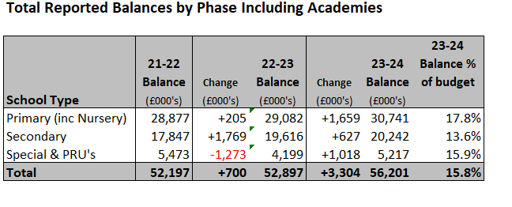

Table 2
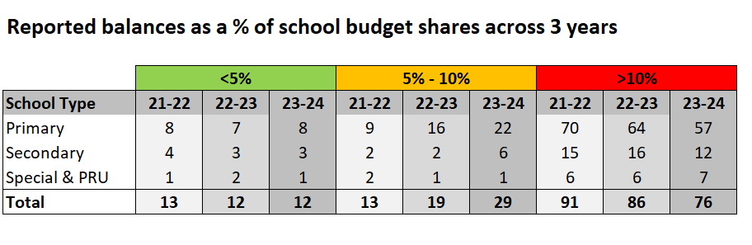
Please note some academy trusts report year end balances on a trust wide basis not at a school by school level. Where this is the case we have used pupil numbers to split that trust balance down to a school level to ensure school level comparisons can be made.

? Reported School balances include the end of year position of maintained schools consolidated into the Local Authority accounts as at the 31st March and academy balances as reported in their financial statements as at the 31st August. The reported balances are before taking account of any balances committed for future purposes.
Schools that converted to academy status during 2023-24 have been included as locally maintained schools in the three years of analysis with predecessor school balances included where appropriate to ensure that the analysis is carried out on a like for like basis.

