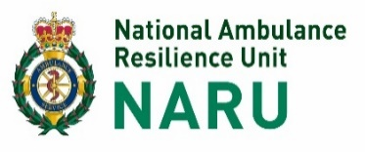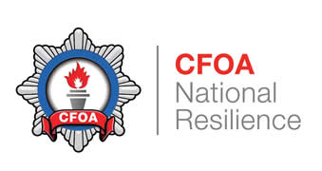

National CBRN Centre Bulletin – 2,4 DNP.

Bulletin issued by National CBRN Centre – 26 October 2016 – 2,4 DNP

Dear Colleagues.

The following relates to a UK wide operational issue and is for your attention/action.

In the last two weeks there have been approximately 15 incidents at educational establishments throughout the UK that relate to a powdered substance called 2,4 DNP (Dinitrophenyl hydrazine).

This substance is kept in laboratories in many educational establishments and is used in experiments as part of students A level studies. The substance is a yellow/orange coloured powder and is normally held within a 25g container, this container should then be stored within another vessel that contains water in order to keep the substance ‘damp’ and, if stored correctly, presents little risk. However, if the substance is not stored correctly and is allowed to ‘dry out’ then it may present an explosive hazard.

A governmental organisation called CLEAPSS (Consortium of Local Education Authorities for the Provision of Science Equipment) have recently received reports from several schools/colleges that 2,4 DNP has not been stored correctly at their premises, has been allowed to ‘dry out’ and the substance therefore may be presenting an explosive hazard. The Explosive Ordnance Division (EOD) have attended these incidents and carried out controlled explosives to make the scene safe.

CLEAPSS is in the process of sending out a bulletin to all educational establishments across the England, Wales and Northern Ireland requesting that they conduct checks on their stocks of 2,4 DNP and to ascertain that the substance has been stored correctly. These checks may lead to stocks of 2,4DNP being found to have ‘dried out’ and educational establishment reporting that they require EOD assistance at the school etc. This may result in a surge of calls requesting EOD support.

In the event of a Police Force receiving a report of an incident involving 2,4 DNP then they should
- Confirm the establishment has been in contact with the CLEAPPS helpline
- The Force should then notify and seek advice & assistance from EOD as soon as possible in accordance with existing force processes.

If the chemical is confirmed to be in a hazardous state there may be a requirement for EOD to conduct a controlled explosion to remove the hazard at the scene (usually on the school field or similar).

JSEODOC (Joint Services EOD Operational Centre) or the Metropolitan Police SO15 unit if the incident occurs in the London region, will advise and link in with the school/college and emergency services appropriately to minimise risk and minimise disruption.

They may also request local emergency services attendance to support EOD assets.

There is no automatic requirement for whole premise evacuation or large scale emergency service attendance, with associated disruption, however each incident must be assessed on merit (quantities stored, physical state, other materials in the store, store location etc.) and in accordance with EOD advice.

EOD are aware of the current incidents with 2,4 DNP at educational establishments and are aware that there may be an ongoing requirement for assistance at these incidents. Plans are in hand to enhance EOD capacity accordingly. In addition, a co-ordinated proportionate response plan is being implemented with specialists and the Department of Education and the Home Office.

A PNC broadcast has been circulated to all forces to alert them of the possibility that incidents involving 2,4 DNP may be reported to Force Control Rooms.

There are no proactive media lines planned for central release at this stage, in recognition of the fact that the lead agency in this issue is the Dept. for Education, however a brief communique to Police Corporate Communication leads is being prepared and will be circulated in due course.

