Display Screen Equipment (DSE) – Frequently Asked Questions

- What is a DSE assessment?
A DSE assessment considers the hazards associated with DSE workstations and identifies any necessary control measures to ensure that the User is adequately equipped and comfortable to undertake the tasks required.

The assessment covers:
- The workstation including equipment, furniture, and the work environment,
- The work undertaken,
- Any special needs of individual staff and
- Where risks are identified, steps are taken to reduce them.

- What is a Workstation?
This is the immediate working environment associated with a computer and includes the desk, chair, display screen, computer processor, keyboard, mouse and other desk-based equipment such as telephone and copy holder. Some of these items are specifically mentioned in the DSE Regulations, but anything else in the immediate work environment is also part of the workstation.

- Who is a DSE 'user'?
A ‘user’ is an employee who uses DSE more or less continually each day or satisfies most of the following:

- Is dependent on DSE to carry out their work,
- Specific skills/training on DSE is required to carry out duties,
- Continuous periods of one-hour’s use or more are regularly undertaken.
- The equipment is used in the above ways more or less daily.
- A fast transfer of information between the user and the DSE is required.
- High levels of concentration and accuracy are required to avoid critical errors.

(Note - even if a DSE operator does not fall within the HSE’s definition of a user then the Council’s guidance on DSE must still be followed).

- Can I carry out my own DSE assessment?
Yes – but before completing the self-assessment, you MUST complete the DSE E-learning Course or have attended the corporate DSE Assessors training course in the last three years. To access the E–learning course you will need complete the on line Workforce Development registration form; Registration Form . The course explains the risks from using DSE, the reasons why you need to carry out an assessment and how to set up your workstation for comfort. You should also familiarise yourself with the Council’s guidance, and the 2 appendices in this document.

- What happens once I have completed my own DSE assessment?
Your self-assessment will be reviewed by your Line Manager and if necessary a trained DSE Assessor. Where required, the assessor and line manager, will assist you with simple adjustments, such as changes to work pattern or ordering new equipment. If there are potential health issues, eg if you indicated possible musculoskeletal symptoms, your manager will refer you to Occupational Health through the Health and Wellbeing Team.

- Who are DSE Assessors?
DSE Assessors are trained in the practical skills that will enable them to assess a display screen configuration and make recommendations, where appropriate, to improve the workstation lay out.
DSE Assessors are competent to:

- Identify hazards and assess risks from the workstation and the kind of DSE work being done; for example by completing a DSE assessment or reviewing one completed by the worker (self-assessment);
- Where necessary, identify steps to reduce risks;
- Make a clear record of the review of the assessment and communicate the findings to those who need to take appropriate action, and to the employee concerned;
- Recognise their own limitations as to assessment so that further expertise can be called on if necessary.

N.B. -The inclusion of the views of the DSE users about their workstations is an essential part of the assessment.

DSE Assessors must undertake the council's DSE Assessors course; to ensure they remain competent the course must be undertaken every three years.

- How often should DSE risk assessments be undertaken?
The assessment must be completed or revised:

- When a new workstation is set up
- When a new user starts work
- When there are significant changes to your work or workstation.
- If the User starts to experience regular aches and pains or eyesight problems whilst using the equipment.
- At least every three years.

- How long and how often should breaks be for DSE users?
There is no legal guidance but it is advisable to break up long spells of DSE work.

Short frequent breaks are better than longer ones but less frequent ones such as 5–10 minute breaks every hour are better than 20 minutes every 2 hours.

Most jobs provide opportunities to pause from DSE work to do other tasks, such as filing or copying. If there are no such natural changes of activity in your job, your manager should plan for you to have rest breaks. It is best if breaks or changes of activity allow the user to get up from their workstation and move around, or at least stretch and change posture.

- My wrist aches when I use my mouse. How to can this be prevented or reduced?
Make sure you take adequate breaks and do not sit for long periods in a fixed posture.

Put your mouse within easy reach, so you can use it with your wrist straight. Do not work with your mouse arm stretched. Support your forearm on the desk. Do not grip the mouse tightly, rest your fingers lightly on the buttons and do not press them hard.

If this still remains an issue, discuss this with your DSE assessor or Line Manager.

- What should I do about DSE if I am pregnant?
You must inform your line manager as soon as your pregnancy has been confirmed. A pregnant worker risk assessment should be undertaken to ensure any risks arising out of work activities are identified and controlled. It may also be appropriate for your DSE self-assessment to be reviewed during your pregnancy.

- Am I entitled to an eyesight test if I work on a VDU?

Yes. If you are declared as a DSE ‘user’ you are entitled to an eye screening or full ophthalmic examination at no personal cost. If corrective appliances (spectacles, lenses) are required then the council is required to bear the cost of the appliances, or part of the appliances, which are solely required for use with DSE.
Before applying for eye screening, or an examination, your supervisor / line manager must confirm that you fall within the definition of a user.

An appointment will be made for you attend the Occupational Health Unit for a vision screen and to be issued with payment vouchers where a referral is to be made to the Council’s appointed optician.

- What do I need to do if I work with laptops or other portable DSE?
Portable DSE such as laptops and handheld devices are subject to the Regulations if used similarly to PC’s such as prolonged and/or frequent use for work purposes.

If you habitually use portable DSE you should be trained in how to minimise risks, for example, by sitting comfortably, angling the screen so it is easy to read and taking frequent breaks. Where lap tops and the like, are in prolonged use, additional steps should be taken to reduce risks, e g by using a separate mouse, a docking station, detachable key board etc.

. Wherever possible, portable DSE should be placed on a firm surface and at a comfortable height.

Contact
For further information contact:

Occupational Health, Safety and Wellbeing Services on 024 7683 3285 or email healthandsafetyservicesadmin@coventry.gov.uk

Workstation Set Up Diagram
Appendix 1

Screen height adjusted to prevent poor head and neck posture
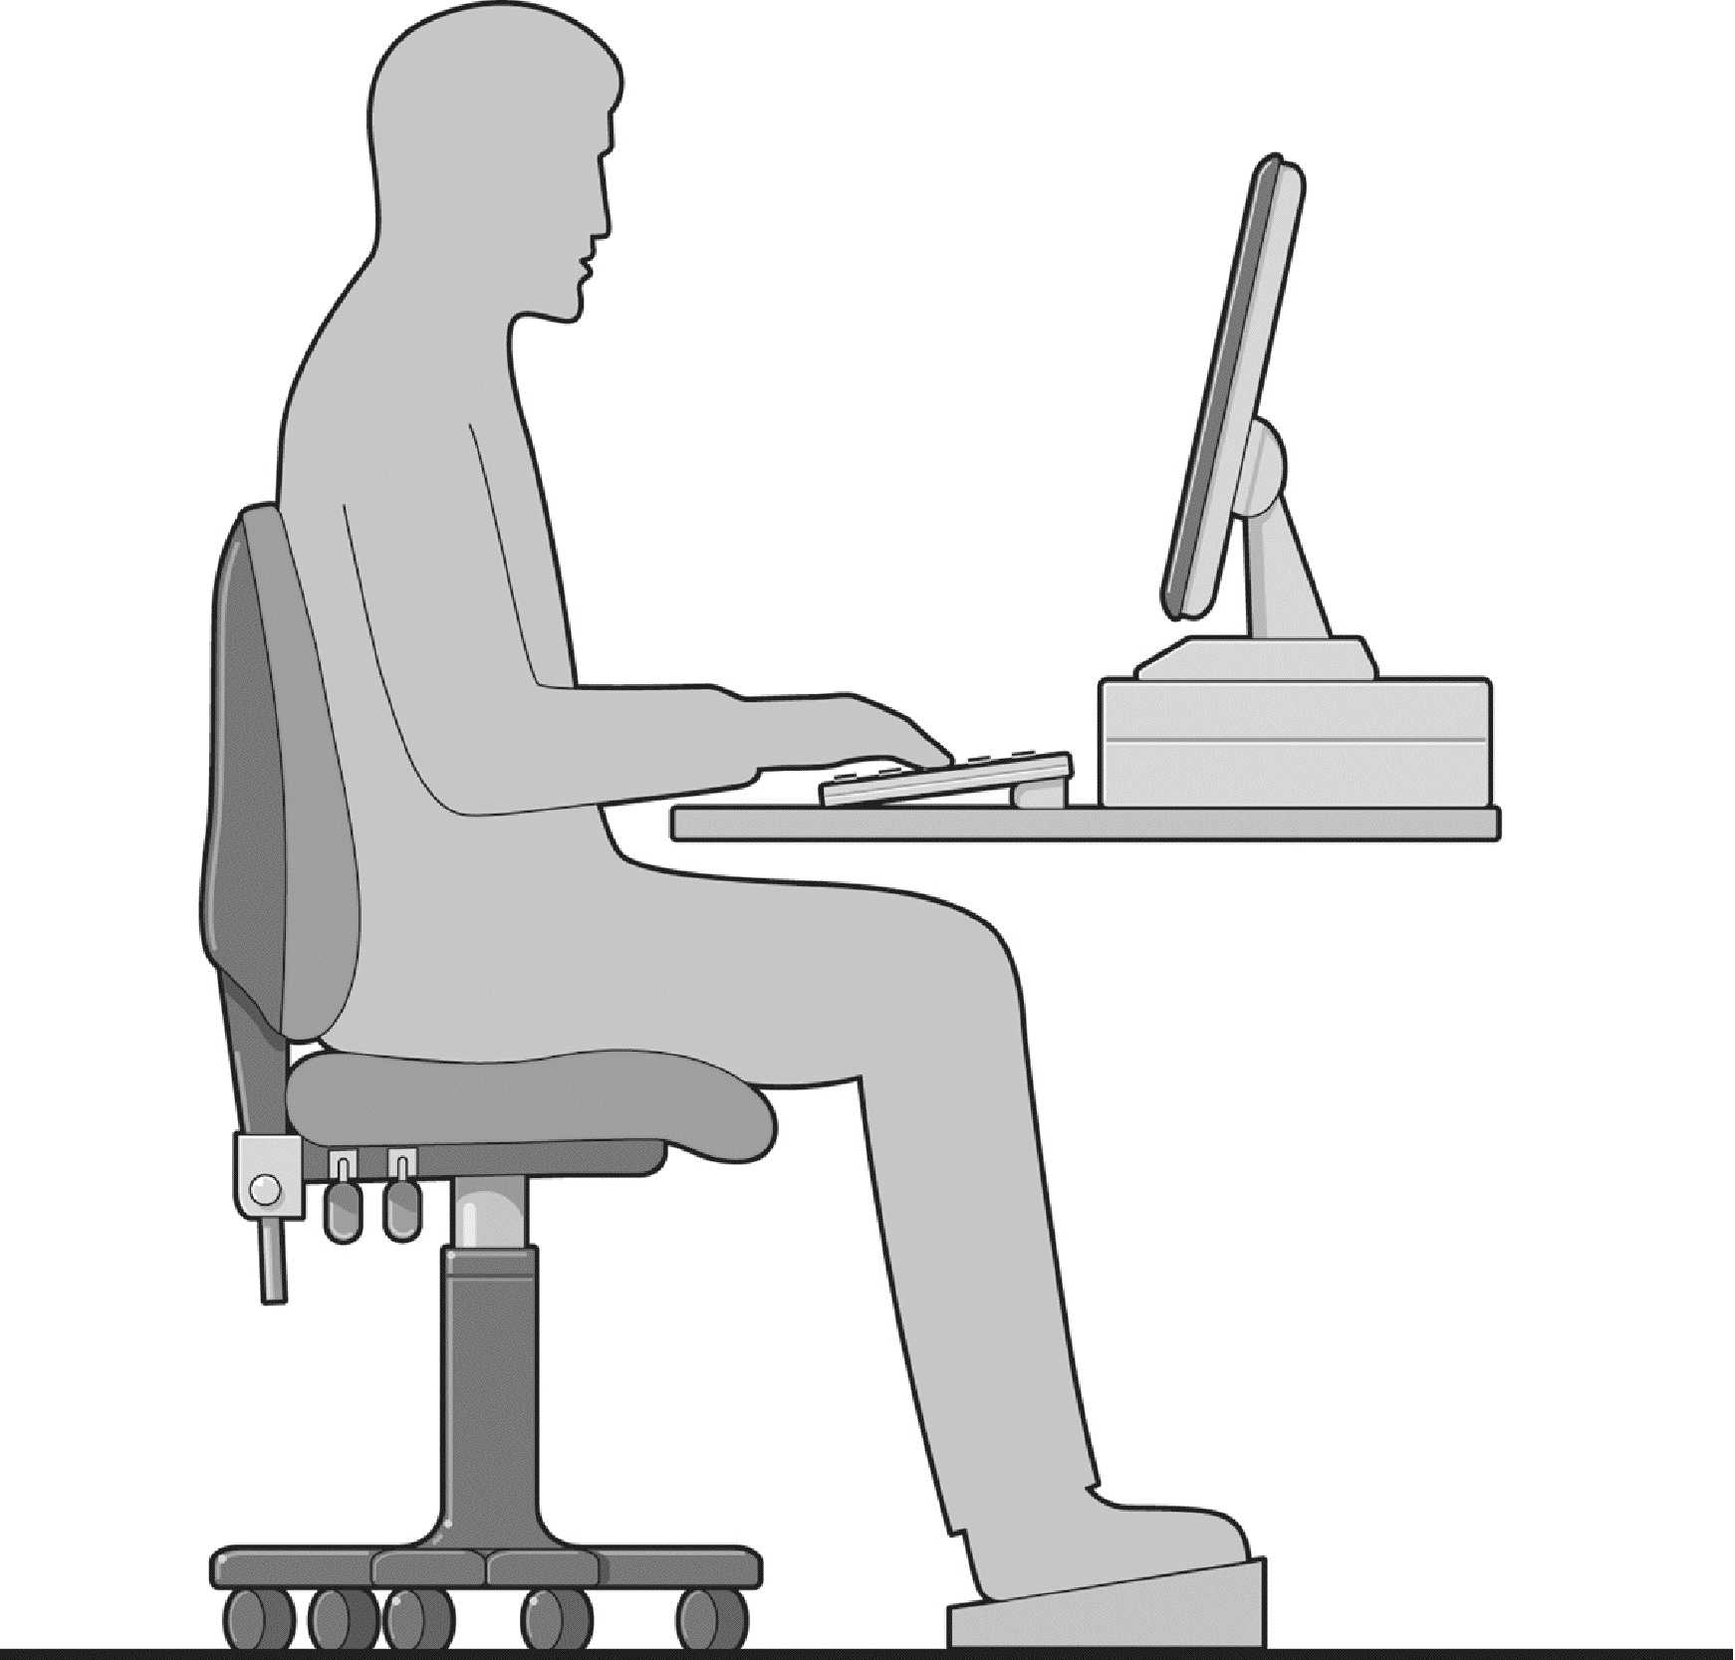
Neutral wrist posture
Screen height dependent on typing style, tasks performed, software used and glasses worn
Feet supported by floor or footrest
Space beneath your desk to allow you to move your legs
Chair adjusted to support back at a comfortable angle and to allow for appropriate upper body posture
Even pressure across thighs
Shoulders relaxed
Elbows at approximately 90° degrees
12 Point Display Screen Equipment Set Up Plan
Appendix 2

1  Backrest | - Adjust the chair back angle for comfort and support; this should be fairly upright when typing.  - Adjust the chair back height to give support to the small of your back.
2  Seat height | - Adjust the seat height so that your elbows are just above the desk (relaxed shoulders, upper arms vertical, elbows bent at right angles).  - Your wrists should be in a relaxed, neutral position over the keyboard.  - Ensure armrests do not prevent you getting close enough to the desk or obstruct your elbows whilst typing. If necessary, request that armrests are removed.
3  Footrest | - Your thighs should be approximately horizontal.  - Ensure that there is no undue pressure on the underside of your thighs.  - If thighs are not horizontal or your feet are not flat on the floor, use a footrest.
4  Keyboard | - The keyboard should be directly in front of you and at a distance to allow you to maintain relaxed shoulders, upper arms vertical, elbows at right angles and a level (neutral) wrist posture (8-10 cm from desk edge).
5  Mouse | - Position your mouse close to the side of the keyboard and within easy reach.  - Take your hand away from the mouse when not in use.  - Use keyboard shortcuts as an alternative to the mouse.
6 Screen, lighting & blinds | - The screen viewing distance should be at approximately arm’s length.  - Screen height should prevent excessive movement of the head and neck. Top of casing at or just below eye level. This will depend on typing style, software used, glasses worn and tasks performed.  - Glare and reflections should be avoided by adjusting lights and closing blinds.
7  Desk & drawers | - Your body position should be ‘squared-up’ to the desk.  - Avoid sitting twisted. Shoulders should be in line with your hips.  - Drawers, computers, waste bins, etc. should not obstruct your legs.
8  Document position | - Use a document holder or position documents to reduce head and neck movement, e.g. between the screen and keyboard.
9  Equipment position & work area | - Place frequently used items within easy reach.  - As far as possible do not locate printers on your desk or within reaching distance.  - Don’t cradle the phone between your shoulder and chin. Use your other hand to hold it or consider a headset if you use the phone and PC together a lot.  - Make sure the area around your desk is free from obstructions, trip hazards, etc.
10  Work routine | - Organise your work so that you that you have reason to get up out of your chair and away from your workstation, e.g. collecting documents, filing, making drinks, at least once an hour.  - Adopt a variety of postures throughout the day.
11  Vision | - Ensure you are aware of your entitlement to eye and eyesight testing (even if you already wear glasses). If in doubt, ask your line manager for details of local arrangements.  - Have regular eye tests. Follow your optician’s guidance on repeat eye testing - usually every 2 years.
12  Reporting problems  (and other issues) | - If you experience any problems whilst using your workstation or have any health and safety related concerns you should inform your line manager in the first instance. Always seek medical advice about health concerns.

