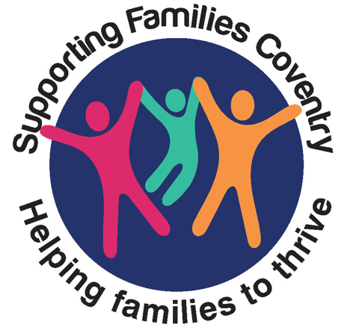
EARLY HELP ASSESSMENT
Your Family
Name of agency completing this form with you:
Name of Practitioner:
Practitioners job title:
Telephone number of the agency completing this form:
Email address of Agency completing this form:

What led to you asking for help for your Family?

Is there anyone in the Family you do not wish to share the information in this Early Help Assessment with?

Names of Everyone who lives in the household
Name | Gender | DOB/EDB | Age | Family Status (e.g. Mother, Father, Child)

Family Tree and Community Network
Who else is important to you and your Children, how do they help?
Prompts: Neighbours, Faith Group, Best friend, Financial Support, Regular Visits, Telephone/Video Calls, Childcare

Current Key Agencies
Professional | Agency | Agency Role | Started On | End Date | Address | Telephone
Prompts: Local Community Centre/Groups, Religious Agencies, School, Health, Credit Union

Child’s Voice
What is the Young Person or Child(ren)’s understanding of why Early Help are involved with you?
Was each Child/Young Person seen during this assessment?

How has the voice of the child/ren been gathered? What evidenced based programmes and resources have been used?

What observations have you gathered to support your understanding of the Child’s life (bedroom seen, home environment visited, Parent/Carer Child attachment, other observations)?

What are the best things about your life? | What are you worried about? | What do you want to happen to make things better?

Analysis and Scaling
What is working well?
Existing Strengths- Supporting Families Criteria | Evidence of the strength
Education
Attendance above 90%, no exclusions or other education concerns, child accessing mainstream education on a regular basis, no NEET risk
Development - Pre-birth to 5 Years
Children have good overall development, age and stage appropriate learning, immunisations up to date, good social interactions/ skills, pregnancy progressing well.
Mental and Physical Health
All the members of the family have good levels of mental & physical health.
Substance Misuse
No substance misuse concerns; family understand safety related to alcohol and drug use
Family Relationships
There are good family relationships, boundaries and rules are appropriately in place, the family get on well, clear attachment, no unsupported young carer in the home.
Abuse and Exploitation
The family home is free from abuse and or neglect, no exploitation identified, and any young people understand exploitation risk, no reported bullying, no missing episodes.
Crime
There are no crime related risks or risk-taking behaviours. There have been no reported crime incidents in the last 12 months, there is a reduction in criminal activity, diversionary activities are in place, engagement with specialist services
Domestic Abuse
There are no current domestic abuse risks identified. The Family Home is safe, safety plans in place. Victims (including Children) and perpetrators are or have accessed specialists’ services.
Housing
The family live in accommodation that is suitable and meets their current needs. Family is actively seeking alternative accommodation. No risk of homelessness.
Finance
Adult/s in the house are working, training, in education. There are no debts or rent arrears and the family can manage their money appropriately. No Young Person NEET.
Other (Please Specify)

What are we worried about?

Current Worries- Supporting Families Criteria | Evidence of the worries
Education
Attendance below 90%, any exclusions, issue with being late, not on school role, not in mainstream school, on a part time timetable, risk of NEET
Development - Pre-birth to 5 Years
Pregnancy related concerns, Child or Young Person with SEN, development delay, immunisations outstanding, Speech and Language concerns
Mental and Physical Health
Child or Adult who has low mood, anxiety, depression, long term health conditions, long term illness, disability requiring ongoing support.
Substance Misuse
Adult or Child where a risk is identified regarding misuse of drugs or alcohol
Family Relationships
Parent/Carer require parenting support. Parental conflict, Child or Young Person abusive in the home, young carers.
Abuse and Exploitation
Any abuse, neglect, missing episodes, sexual exploitation, criminal exploitation, county line, radicalisation, bullying.
Crime
Adult, Young Person or Child who has committed an offence. Offences, arrests, antisocial behaviour, gang activity, weapons, risk taking behaviours.
Domestic Abuse
Historical and current events whereby the impact is still present, safety concerns due to DA, victim and perpetrator- impact on children
Housing
Homeless or at risk of homelessness, unsuitable housing, overcrowding, Young Person at risk of or has been excluded from the Family home.
Finance
Parents/ carers on out of work benefits, poor money management, unmanaged debt, rent arrears, Young Person NEET.
Other (Please Specify)
https://www.coventry.gov.uk/common-assessment-framework-caf/supporting-families-programme

 | Current Worry | Supporting Families Desired Outcome | Scale | Rationale
Education
Development – Pre-birth to 5 years
Mental and Physical Health
Substance Misuse
Family Relationships
Abuse and Exploitation
Crime
Domestic Abuse
Housing
Finance
Other

Sharing Information
Is there any information on this form that you do not want to share with other people? If so, please provide details and what you do not want to share and why?

How will your information be shared?
You will be asked for your agreement for Early Help services to support you and your family.
Coventry City Council complies with the Data Protection Act and the GDPR and is registered with the Information Commissioners Office (ICO) as a Data Controller.
We use your personal information so that we can provide advice and guidance, assessments, services, support and safeguarding for children and their families as well as to provide the help that you require as early as possible. We process personal data because it is necessary to comply with our legal obligations and perform our public duty.
This Privacy Notice explains how personal information is going to be used, what for, who it will be shared with and why.
http://www.coventry.gov.uk/info/31/children_and_families/3245/childrens_services_privacy_notice/1

Outcome
What is happening at the end of this Assessment? ___________________________________________
Is this a whole family assessment? Yes No
Is this generating a plan that takes into account all relevant family members? Yes No

