Geographical Skills: Paper 3

A: Cartographic Skills

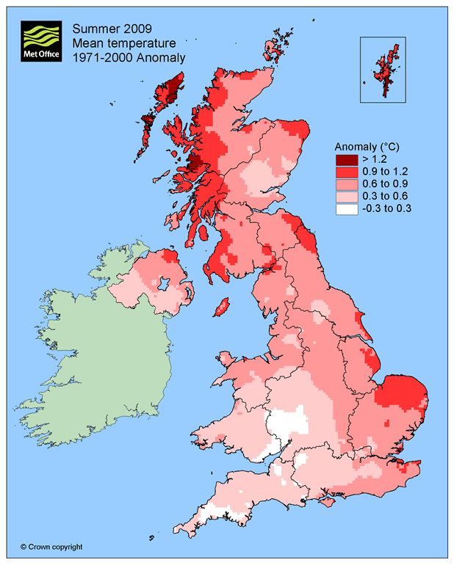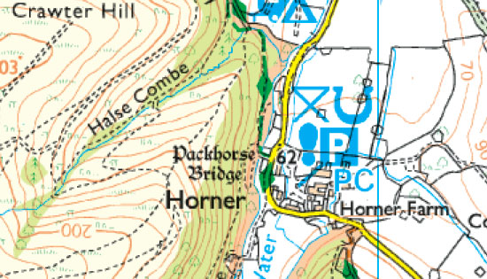

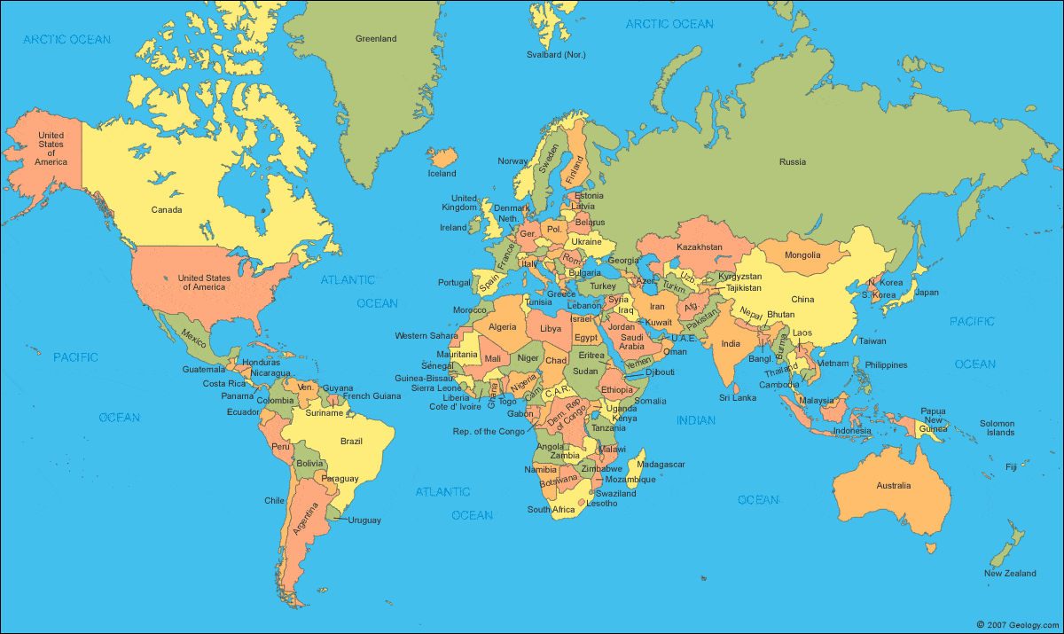

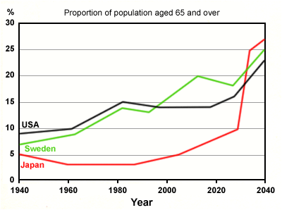

**STUDENT NAME: _______________________________**

**TEACHER NAME: _______________________________**

**5 lesson skills practice.**

**Did you know?**

10% of the marks across **all three papers** is allocated to the assessment of maths and statistical skills.

15% of the **total marks** is allocated to assessment of fieldwork (including interpretation of results).

A: Cartographic Skills

**Lesson 1: Types of Maps**

A map is

|  |  |  |
| --- | --- | --- |
| **Type of map** | **What does it show?** | **Examples of key features** |
| **Political map** | A political map shows the boundaries……………………… | * Labelled seas and oceans |
| **Physical map** |  |  |
| **Thematic Map** |  |  |
| **Choropleth Map** |  |  |
| **Climate map** |  |  |
| **Topographic Map** |  |  |

Lesson 2: Atlas Scavenger hunt

1. What 4 places make up the United Kingdom? ………………………………………………………
2. How many countries in the European Union? …………………………………………………………
3. What 4 countries make up Scandinavia? ………………………………………………………………
4. What is the capital city of the following countries? :

USA: …………………………. ……………….. Australia: …………………………………………

India: ………………………………………….. Papua New Guinea……………………………………

Iceland: ……………………………………… Mongolia: …………………………………………….

Canada: ……………………………………… Brazil: ………………………………………………..

Ecuador: ……………………………………….. Greenland: ………………………………………..

Libya: …………………………………………. Ukraine: …………………………………………….

1. What continents are under the Equator?

………………………………………………………………………………………………………………

1. What continents are under the Tropic of Cancer? ………………………………………………………..

………………………………………………………………………………………………………………

1. Where are the Galapagos Islands ? ……………………………………………………………
2. Which continent is Brazil part of?
3. Nigeria is in ________________.
4. Where are the Atlas mountains? …………………………………………………………………
5. Who owns Antarctica? …………………………………………………………………………..
6. What do the Ural Mountains separate? …………………………………………………………
7. Where are the following rivers (continents will do) ? Chang Jiang …………………….

Congo? …………………….. Rio de la Plata-Parana ? ………………………………………..

1. Where is the hottest region in the world? …………………………………..
2. Where has the most rainy days? ……………………………………………………
3. Which continent doesn’t have any countries on it?

**Lesson 3: Latitude and longitude**

*Latitude and longitude are measured in degrees (°). Each degree is subdivided into 60 minutes (‘). So the location of Spalding is expressed as:*

**52°47' N 0°9'W**

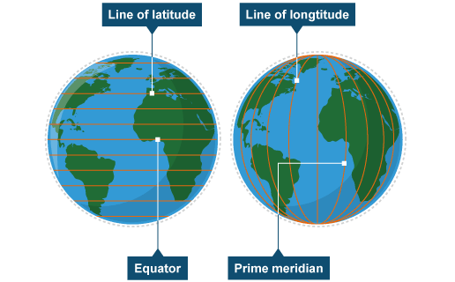

Lines of [*latitude*](http://www.bbc.co.uk/bitesize/ks3/geography/geographical_enquiry/geographical_skills/revision/6/) and [*longitude*](http://www.bbc.co.uk/bitesize/ks3/geography/geographical_enquiry/geographical_skills/revision/6/) are used to locate places accurately on the Earth's surface.

**Lines of latitude**

These imaginary lines run parallel to the equator, from e___ to w____**.** They divide the world into the n___________ and s___________ hemisphere. They are parallelbut they are not the same length and get s_______ as they move away from the equator, reaching 90° at the poles.

How many important lines of latitude can you name?

**Lines of longitude**

Lines of longitude run from the top of the Earth to the bottom – n_____ to s______. They are not parallel as lines of latitude are – they meet at a point at the north and south poles and are called meridians. The lines start at the Prime or G____________ Meridian (0°) and move east and west to the International D______ L_____ (180°).

TASK: Which CONTINENTS do these lines of latitude pass through?

1. 0o (Equator) ________, _______, _______
2. 20oS ________, _______, _______
3. 40oN ________, _______, _______
4. 40oS ________, _______
5. 60oN ________, _______, _______
6. 80oS ________
7. 20oN ________, _______, _______

**GCSE Exam question**

**Question 1 Issue evaluation**

Study **Figure 1**, a map showing the location of ten of the world’s top ten megacities (2014).



1. On **Figure 1**, add the names of the **two** megacities to the correct boxes.

Use the information in the table below. **[1 mark]**

|  |  |  |
| --- | --- | --- |
| **Megacity** | **Latitude** | **Longitude** |
| Lagos | 6 °N | 3 °E |
| São Paulo | 24 °S | 46 °W |

1. Which **one** of the following is the correct latitude and longitude for Jakarta?

Shade **one** circle only.

**A** 21 °N 52 °E

**B** 30 °S 157 °E

**C** 6 °S 106 °E

**D** 33 °N 75 °E

**[1 mark]**

**Identify patterns or distributions on maps**

When asked to describe patterns or distributions on maps, think about **PEA!**

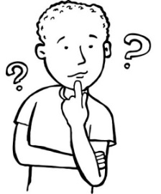**P**attern

*This is a very important skill. Use this acronym to help you write a quality description.*

**E**xample

**A**nomaly

1. **Pattern** -Give an overview. Is the pattern even or uneven? Consider the spread.
2. **Examples** - State where things are that support your pattern are – be specific.
3. **Anomalies** -Are there any oddities or gaps? These are anomalies and you need to identify where they are.

**GCSE Exam Question**

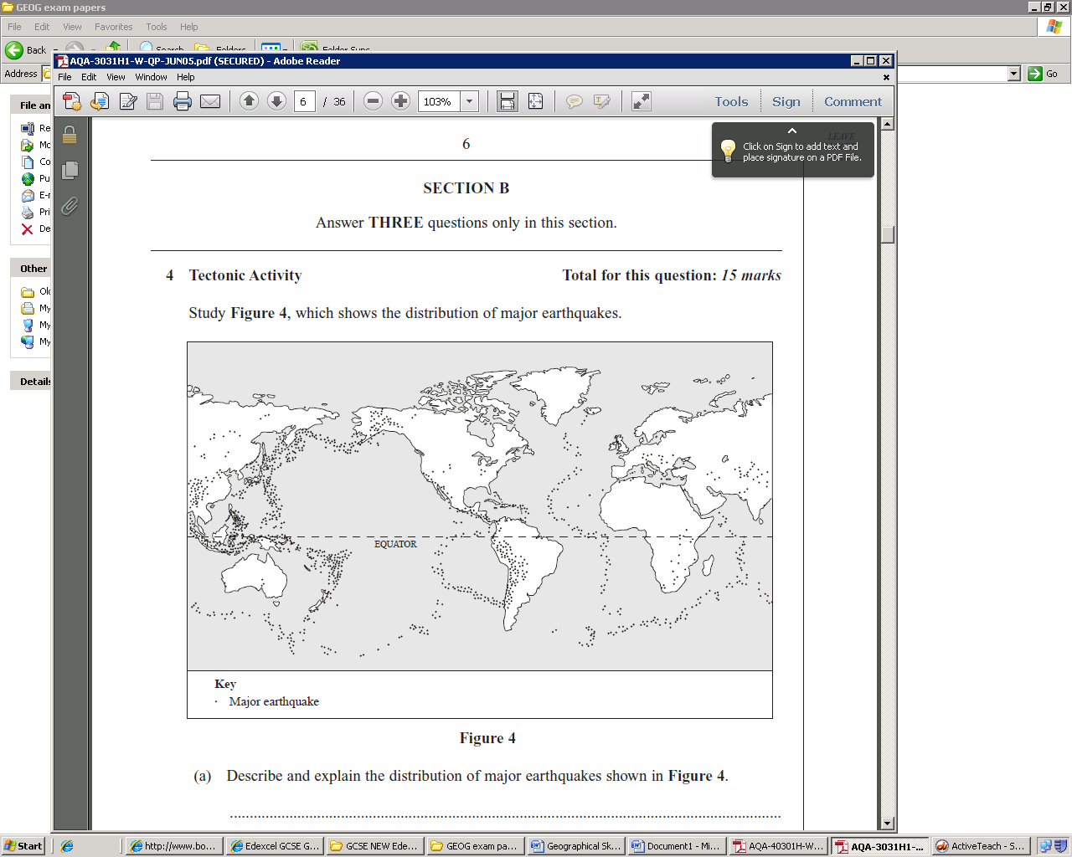

Describe the distribution of earthquakes shown in figure 4

................................................................................................................................................................................................................................................................................................................................................................................................................................................................................................................................................................................................................................................................................................................................................................................................................................................................................................................................................................................................................................................................................................................

**Lesson 4 & 5 : Ordnance Survey Maps**

Maps are produced at different scales. The scale of the map is how much smaller the map is than the area it represents.

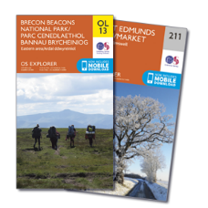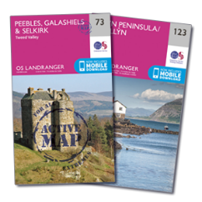

***Explorer Maps***

***1:25 000 scale means 4cm on the map means 1km on the ground.***

***It covers a smaller area, but shows more detail e.g. footpaths.***

***Landranger Maps***

***1:50 000 scale means 2cm on the map means 1km on the ground.***

***It covers a larger area, but shows less detail.***

**Grid references**

Ordnance Survey maps are covered in a series of blue gridlines. These gridlines can be used to pinpoint locations through a unique number known as a grid r_________.

A **four-figure grid reference** is a handy way of identifying any s________ on a map. Four figure references are useful if you’re trying to describe the position of a large feature such as a forest or settlement.

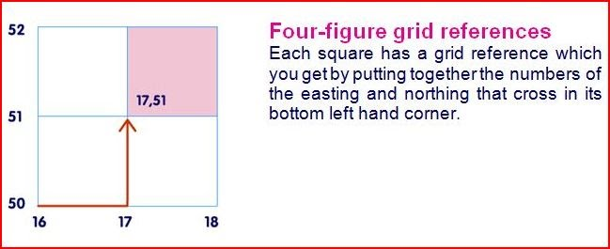Grid references are easy, as long as you remember that you always **go along the corridor** before you **go up the stairs**.

*No need to add brackets, commas or dashes.*

* Write down the **four figure** grid references for the following:

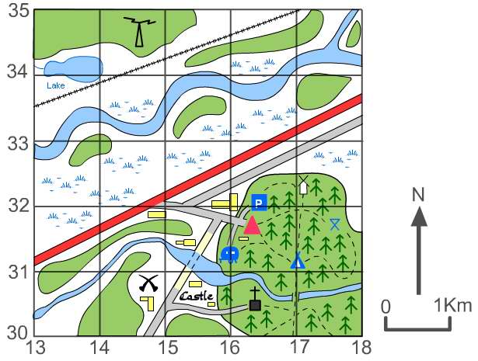

1. Picnic site _________________
2. Church with a tower _________
3. Youth hostel ______________
4. Campsite _________________
5. Castle ___________________
6. Car Park _________________

**Grid references continued…..**

A **four-figure reference** on an Ordnance Survey map equals an area on the ground of one square k____________. One kilometre is quite a large area. To be more accurate we need to use a **six-figure grid reference**. This pinpoints a place exactly to within 100 metres.

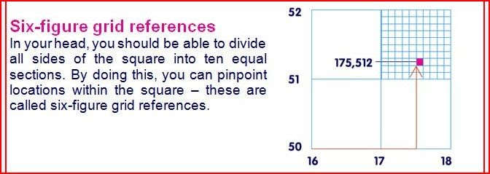

* Write down the **six figure** grid references for the following:



1. Picnic site __________________
2. Church with a tower __________
3. Youth hostel _______________
4. Campsite __________________
5. Castle ____________________
6. Car Park __________________

**Symbols**

When drawing a map, it is important to include as much information as possible. However, adding a lot of detail can make a map confusing, so symbols (images, abbreviations and letters) are used to represent the main items.

The exam board is expecting you to know the main symbols used by the Ordnance Survey. However, **there is no need to learn the meaning of every symbol**, as a map extract will always be accompanied by a key. However, it is important to at least **learn some of the basic symbols** so that map reading becomes easier.

* **Green bits** mean woodland (various types).
* **Blue areas** are either water, tourist information or motorways.
* **Roads** are colour coded. Blue= motorways, red= ‘A’ roads, orange/ brown = ‘B’ roads, yellow= local roads and white=tracks.
* **Contours** are thin brown lines that join areas of equal height at 10 metre intervals e.g. 10m, 20 m and 30 m above sea level.
* To help with height black dots with figures next to them are written on maps.

Draw the correct symbol in the box below.

|  |  |  |
| --- | --- | --- |
| Church with tower | Cemetery | Quarry |
| Main Road | Marsh | Rivers |
| Motorway | Coniferous Wood | Windmill |
| Footpath | Camp Site | Mixed Woodland |
| Parking | Radio/ TV Mast | Non-coniferous woodland |
| Information Centre | Post Office | Public convenience |

**Directional Practice questions**

From the black star draw:

1. A green circle 3 squares north.
2. A blue square 1 squares south.
3. A yellow triangle 3 squares south east.
4. A pink heart 1 square north west.
5. A brown circle 3 squares east.
6. An orange square 5 squares west.
7. A purple heart 3 squares south west.
8. A blue triangle 2 squares north.

|  |  |  |  |  |  |  |  |  |  |
| --- | --- | --- | --- | --- | --- | --- | --- | --- | --- |
|  |  |  |  |  |  |  |  |  |  |
|  |  |  |  |  |  |  |  |  |  |
|  |  |  |  |  |  |  |  |  |  |
|  |  |  |  |  | 🟊 |  |  |  |  |
|  |  |  |  |  |  |  |  |  |  |
|  |  |  |  |  |  |  |  |  |  |
|  |  |  |  |  |  |  |  |  |  |
|  |  |  |  |  |  |  |  |  |  |
|  |  |  |  |  |  |  |  |  |  |
|  |  |  |  |  |  |  |  |  |  |

**Scale**

The scale of a map allows a reader to calculate the size, height and dimensions of the features shown on the map, as well as d_____________ between different points.

The scale on a map is the ratio between real life distances and how many times it has been shrunk to fit it on the map.

**The maps in your exam will have a scale of 1:50 000** *(where 1cm = 50,000cm on the ground or 500m or 0.5 km)* **or a scale of 1:25 000** *(where 1cm = 25,000cm on the ground, or 250m or 0.25km)***.**

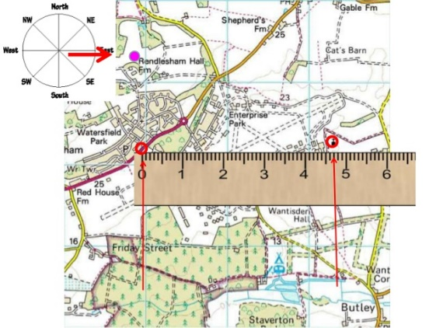

***Remember!***

*1:25 000 map 1 km = 4 cm on the map.*

*1:50 000 map 1 km = 2 cm on the map.*

**Straight line distances**

**Straight line distances between locations can be calculated as follows:**

* 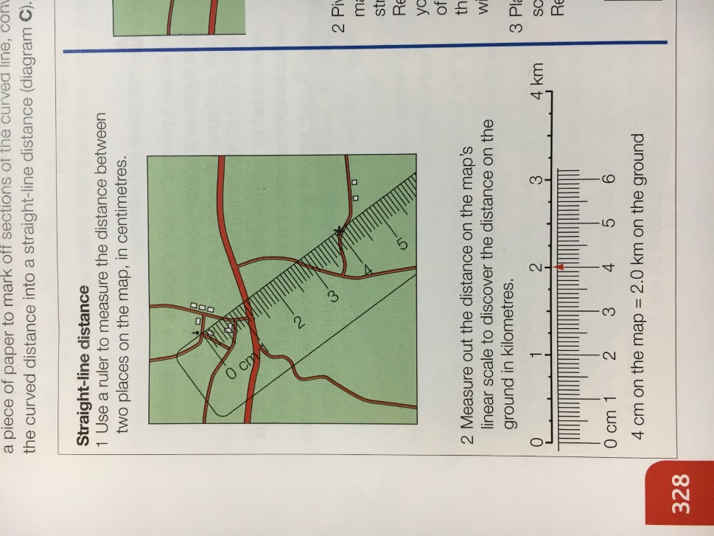Simply place your ruler over both points and measure the distance in-between in cm.
* Convert into kilometres using the scale line.
* Or by multiply your answer by 0.5 (1:50 000 map) or by 0.25 (1: 25 000 map).

**Practice question:**

If the distance between a church and a campsite is 16cm, what would the real-life distance be on a:

1. 1:50 000 scale map _________
2. 1:25 000 scale map _________

**Curved line distances**

Measuring the distance along a curved or winding route such as a road or river is more complicated. This can be done by either using a piece of string or by splitting the road or river into straight sections. The easiest way to measure the distance along a winding route is by using a piece of paper or string.

* 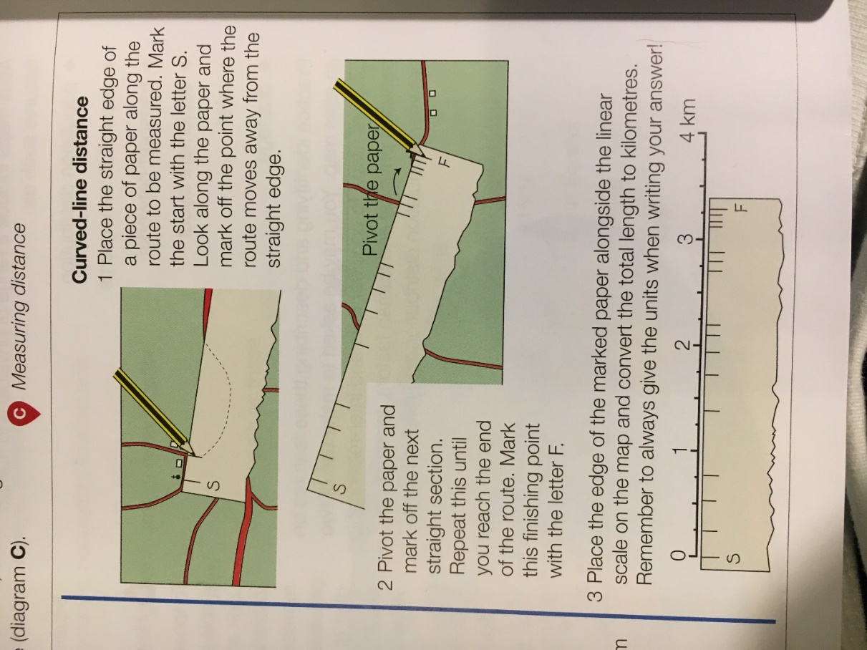Another method is to take a piece of string and place one end at the starting point.
* Carefully lay the string along the road or path, following the curves as closely as you can.
* When you reach the end mark it on your string with a pen.
* Now straighten the string along the scale line to work out the real-life distance.

**Remember!**

**Take a ruler and a piece of paper / string into the exam to help you use the scale!**

**Compass direction**

In the exam you will be expected to know the 8-point compass, shown below:

* 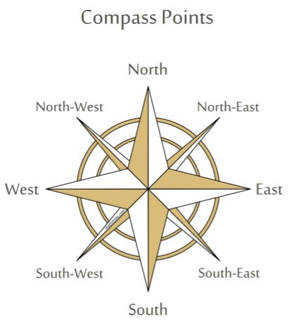The **top** of an OS map is always **north.**
* Remember to give the direction **from** one point **to another**.

***Can you think of a rhyme to help you remember the points of the compass?***

**Contours, spot heights and gradients**

Relief is a term geographers use to describe the shape and height of the land. OS maps use two systems to illustrate relief, spot heights and contour lines.

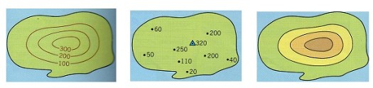

G___________

S_____ heights

C__________ lines

**Contour lines**

A contour is a line drawn on a map that joins points of equal height above sea level in 10 metre intervals. Therefore, every point on a 50 metre contour line is 50 metres above sea level. Contours on OS maps are coloured light brown. The diagram below shows the link between the shape of a hill and the contours representing it on a map.

* ***Lines that are close together show a s_______ slope.***
* ***Lines that are far apart show slopes that are g_________.***

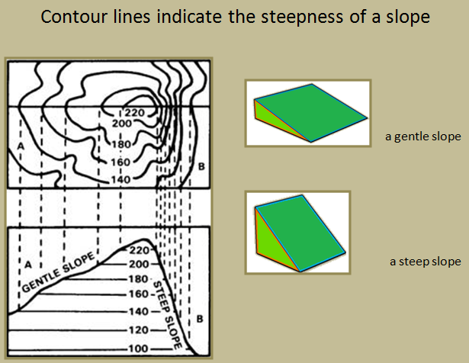

**Interpreting the physical and human landscape** – Colour code which features are human and which are physical on the spider diagram.

**Land Use**

**Relief**

**Settlement**

**Drainage**

**Communication**

1. Relief – the height and shape of the land. To describe the land accurately you need to use **actual figures** taken from **spot heights** or **contour lines** and include the **units e.g. metres.**
2. Drainage – the presence of **water** and where it **flows**. To describe the drainage, you need to comment on the **direction they are flowing** (highland to lowland), the **drainage density** (the total length of the rivers), the **pattern** of the rivers (see below) and any evidence of **human activity** (straightening the channel/building embankments).

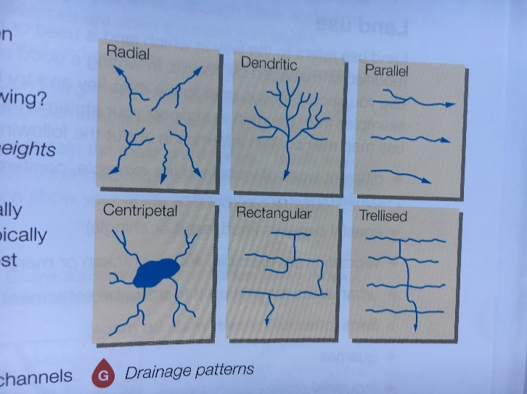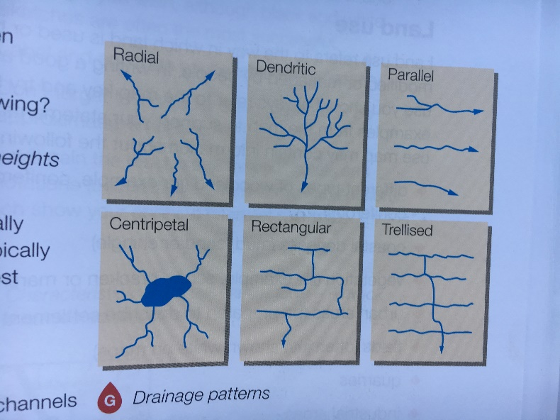

1. Settlement – where and how people live. To describe settlement patterns, you need to know the difference between **dispersed, nucleated** and **linear**.

**A linear settlement pattern** is where the buildings are built in lines and is often found on steep hillsides.

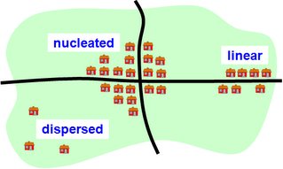

**A dispersed settlement pattern** is where the buildings are spread out and is often found in upland areas.

**A nucleated settlement pattern** is where a lot of buildings are grouped together and is often found in lowland areas.

1. Communication – these can include many different types of transport, such as **roads, railways, footpaths, ferries, airports, cycleways.** To describe communication networks, you need to give such as length of feature, orientation (compass direction), patterns and density e.g. **ring road**. Roads, canals and railways often follow **flat land**, footpaths often follow **river valleys.**

Ring road around a city centre on OS map.

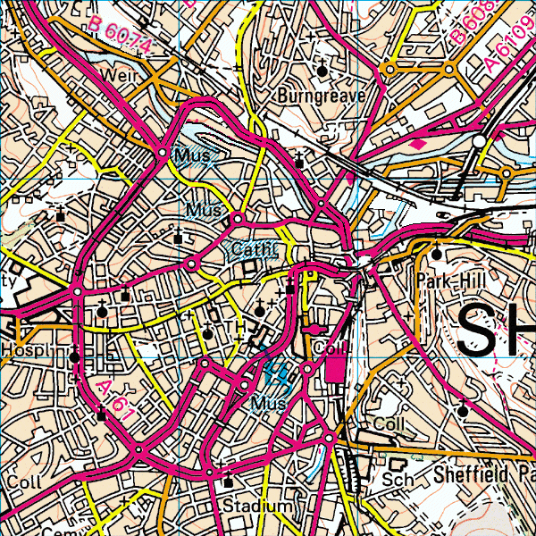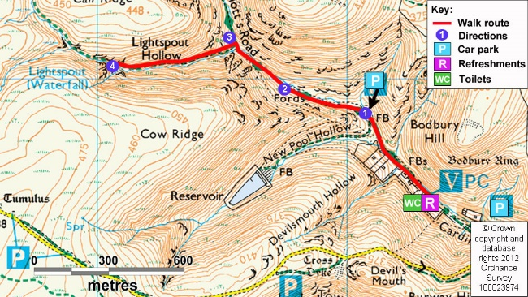

Footpath at the bottom of a valley.

1. Land Use – this is the way land is used or has been changed by people. To describe land use you need to use the **map key** and give **specific examples** to support your statements. Examples of land use which can be seen on OS map include: -

* Woodland (coniferous or non-coniferous)
* Coastal deposits (marsh)
* Urban areas (housing, settlement)
* Fields (white on OS maps)
* 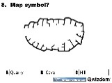Quarries
* Industrial areas (Wks)
* Tourist sites (blue symbols)
* Recreation