Student task:
Annotate the diagram below with the different features of a headland and explain what is happening in terms of erosion and weathering.
Joint: | Small cave: | Large cave: | Arch: | Stack: | Stump:
Erosion: what is happening? | Erosion: what is happening? | Erosion: what is happening? | Erosion: what is happening? | Erosion: what is happening? | Erosion: what is happening?
Weathering: what is happening? | Weathering: what is happening? | Weathering: what is happening? | Weathering: what is happening? | Weathering: what is happening? | Weathering: what is happening?
Keywords: | Keywords: | Keywords: | Keywords: | Keywords: | Keywords:
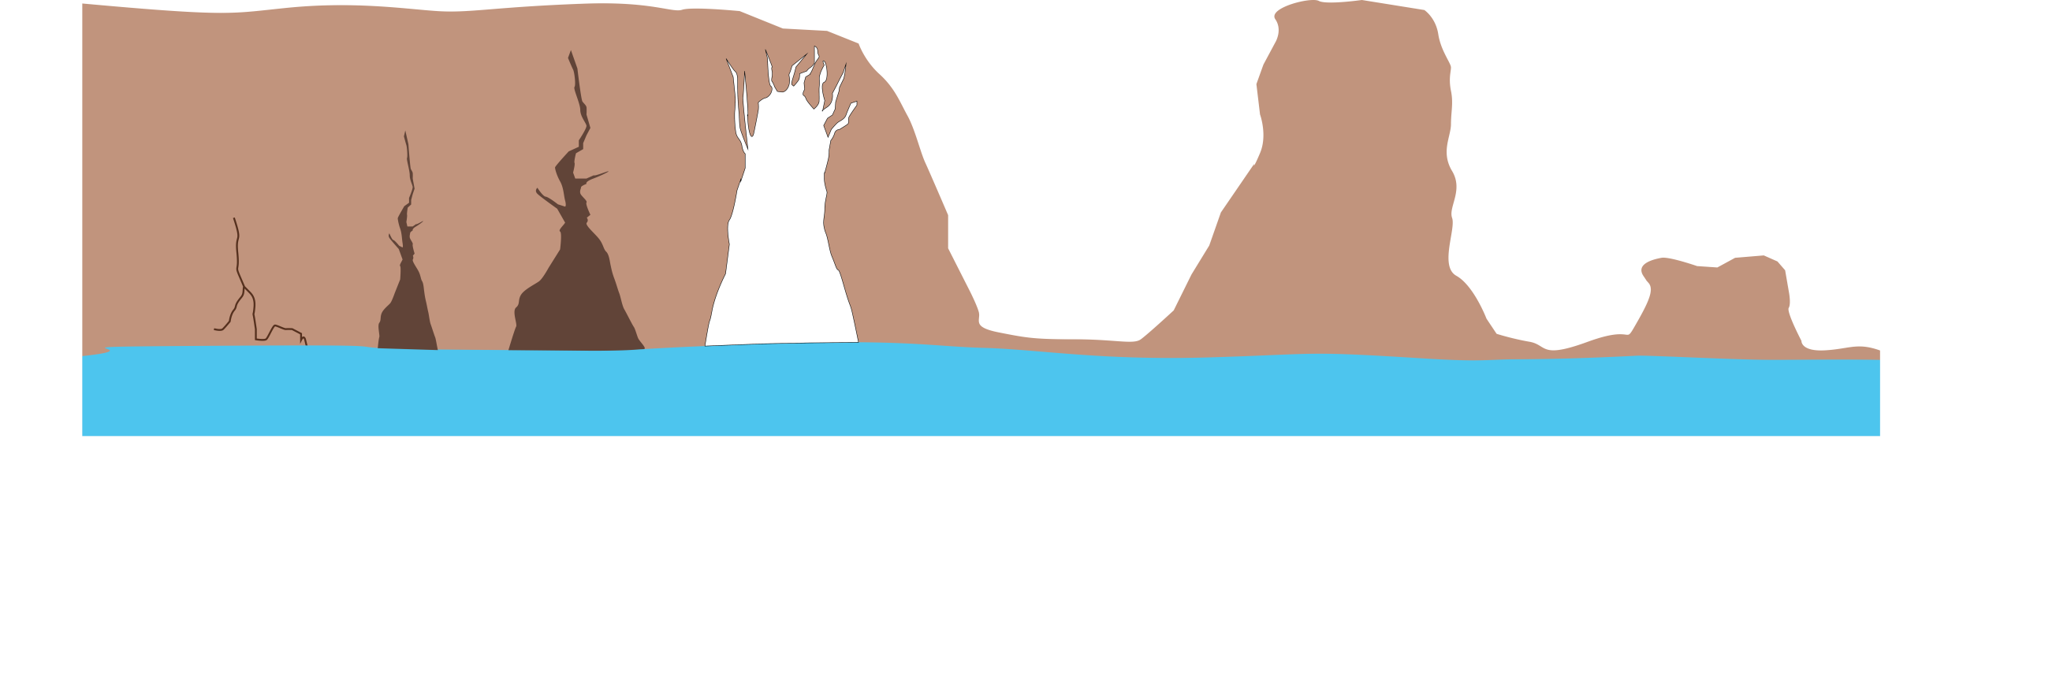
Large cave
Arch
Joint
Stack
Stump
Small cave

Student task:
Annotate the diagram below with the different features of a headland and explain what is happening in terms of erosion and weathering.
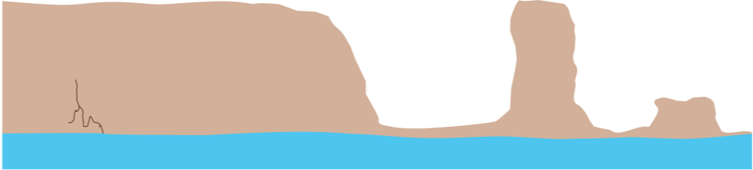
Joint

Information gathering - formation of a joint

• Cracks and joints in the rock between the high and low tide mark (the wave attack zone) form and become enlarged due to hydraulic action, abrasion and solution. | 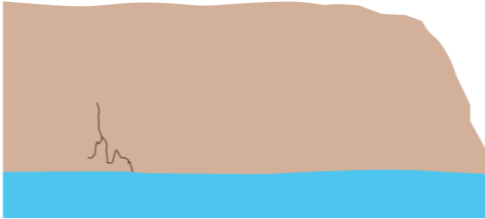  Joint
• Weathering processes such as chemical weathering can also speed up this widening.

Information gathering - formation of a small cave

• These cracks and joints eventually widen into smaller caves through continued hydraulic action and abrasion. The larger surface area exposed to weathering and erosion processes leads to an increase in the rate of rock removal. | 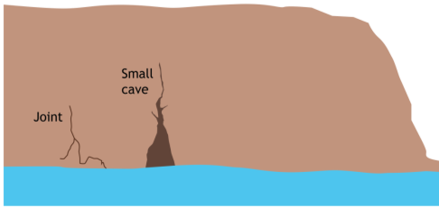
• Weathering processes continue as before.

Information gathering - formation of a large cave

• Wave refraction (where waves bend in around the sides of a headland) leads to increased erosion along the side of the headland, forming a very large cave. | 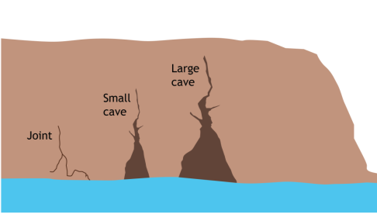
• The large area exposed within the cave means more hydraulic action and abrasion can table place.

Information gathering - formation of an arch

• Caves developing on opposite sides of a headland may erode deeper as a result of these erosional processes. | 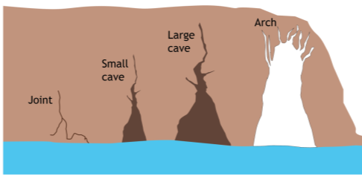
• Eventually they meet, combine, and form an arch.
• Biological and chemical weathering on the top or roof of the arch begin to weaken it.

Information gathering - formation of stack

• The arch roof becomes narrower as it is weathered from above by biological and chemical weathering. It becomes thinner until it eventually collapses, leaving an isolated pillar of rock known as a stack. | 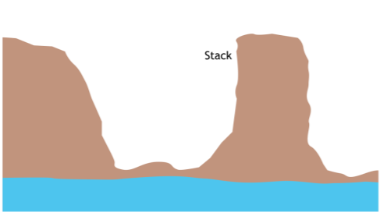
• Material that falls into the sea is eroded away by attrition.

Information gathering - formation of stump

• The resultant stack is weathered from above by chemical and mechanical processes, as well as eroded by the sea at it base. It will reduce in both height and width until it collapses and leaves behind a stump. | 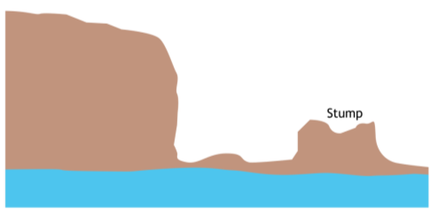
• The collapsed material is eroded by attrition and transported away.

