Student tasks

- Find each of these 24 words connected with rivers in the word search below.

S | E | S | F | L | O | O | D | P | L | A | I | N | D | E
L | R | U | O | M | U | I | V | U | L | L | A | R | G | X
I | O | S | Y | R | A | T | U | B | I | R | T | C | O | S
P | G | P | A | B | R | A | S | I | O | N | L | E | R | O
O | F | E | R | O | S | I | O | N | L | L | E | E | G | D
F | F | N | V | E | L | O | C | I | T | Y | D | P | E | N
F | I | S | A | L | T | A | T | I | O | N | E | E | D | O
S | L | I | J | P | R | F | O | W | A | W | E | A | I | I
L | C | O | S | O | A | L | Y | E | U | R | O | N | O | T
O | R | N | S | S | C | E | M | R | S | L | W | B | N | I
P | E | O | P | D | T | V | T | A | A | E | C | R | X | S
E | V | O | U | I | I | E | E | S | O | U | R | C | E | O
A | I | D | R | P | O | E | R | I | D | S | T | T | A | P
I | R | P | W | A | N | O | I | T | U | L | O | S | L | E
W | A | T | E | R | F | A | L | L | A | R | Y | T | E | D

ABRASION | RAPIDS
ALLUVIUM | RIVER CLIFF
DELTA | SALTATION
DEPOSITION | SLIP OFF SLOPE
EROSION | SOLUTION
ESTUARY | SOURCE
FLOOD PLAIN | SPUR
GORGE | SUSPENSION
LEVEE | TRACTION
LOAD | TRIBUTARY
MEANDERS | VELOCITY
OX BOW | WATERFALL

- Work with a partner to write a definition for each word.
- Copy and complete the table below to match the terms associated with the three stages of a river. One example for each stage has been given as an example. Remember that words can be used more than once, as they may be relevant to more than one stage.

UPPER | MIDDLE | LOWER
EROSION | MEANDERS | DELTA

- Compile a list of other words or phrases associated with rivers not included in the word search.
- Write a definition for each of the new words you have added.
- Click on the link below and answer the River landscapes test.
http://www.bbc.co.uk/bitesize/standard/geography/rivers
- Draw a labelled diagram to show the features of a river valley from its source to mouth. Review your diagram with a partner and add any additional labels.
Make a labelled sketch of the river, near Seydisfjordur, Iceland below.
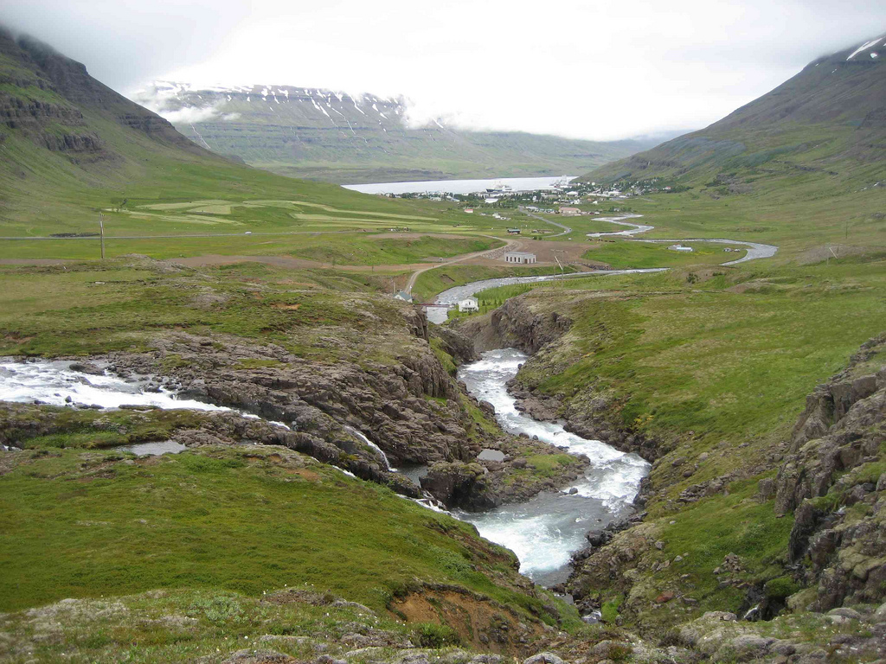
© 2010 D-Stanley http://www.flickriver.com/photos/davidstanleytravel/4899034803

Teaching notes

S | E | S | F | L | O | O | D | P | L | A | I | N | D | E
L | R | U | O | M | U | I | V | U | L | L | A | R | G | X
I | O | S | Y | R | A | T | U | B | I | R | T | C | O | S
P | G | P | A | B | R | A | S | I | O | N | L | E | R | O
O | F | E | R | O | S | I | O | N | L | L | E | E | G | D
F | F | N | V | E | L | O | C | I | T | Y | D | P | E | N
F | I | S | A | L | T | A | T | I | O | N | E | E | D | O
S | L | I | J | P | R | F | O | W | A | W | E | A | I | I
L | C | O | S | O | A | L | Y | E | U | R | O | N | O | T
O | R | N | S | S | C | E | M | R | S | L | W | B | N | I
P | E | O | P | D | T | V | T | A | A | E | C | R | X | S
E | V | O | U | I | I | E | E | S | O | U | R | C | E | O
A | I | D | R | P | O | E | R | I | D | S | T | T | A | P
I | R | P | W | A | N | O | I | T | U | L | O | S | L | E
W | A | T | E | R | F | A | L | L | A | R | Y | T | E | D

- This word search could be used as a starter or a plenary for work on rivers and their valleys. It could also be used as a revision activity.

- Allow students time to complete the table and to then discuss their responses. This is a very good way to deepen their understanding of the changes along the course of a river. An interactive version is available to subscribers for this task.

- This activity can be answered as a class. Students could add terms on the whiteboard or the teacher could ask questions to individual students and collate their answers.

- This activity could be used either as a class or as an individual activity.

- The interactive online quiz will give students an instant mark and feedback with 'Try again' options.

- Students draw a diagram and then assess each other adding any missing features.

- This could be an alternative exercise for task 7. Students draw a field sketch. There is an opportunity to label features linked to glaciation, settlement and transport etc.

