

Introduction

This workbook is designed to be used alongside your lessons on geographical applications and skills.

The workbook can be completed at different times during your GCSE course to support or consolidate your learning in class or could be completed as a revision exercise.

**Remember that there are four assessment objectives:**

|  |  |
| --- | --- |
| **AO1:** | Demonstrate knowledge of locations, places, processes, environments and different scales. |
| **AO2:** | Demonstrate geographical understanding of: concepts and how they are used in relation to places, environments and processes; the interrelationships between places, environments and processes. |
| **AO3:** | Apply knowledge and understanding to interpret, analyse and evaluate geographical information and issues to make judgements. |
| **AO4:** | Select, adapt and use a variety of skills and techniques to investigate questions and issues and communicate findings. |

Most of the activities in this workbook will assess AO3 and AO4 which is why it is **very** important you know and understand how to interpret and analyse different forms of data presentation and are able to use a variety of geographical skills and techniques.

Contents

|  |  |  |
| --- | --- | --- |
| **Page number** | **Content** | **Completed** |
| **5-7** | Mean, median, mode and interquartile range |  |
| **8-9** | Calculating area |  |
| **10** | Atlas skills – describing patterns |  |
| **11** | OS map symbols |  |
| **12-16** | Four- and six-figure grid references |  |
| **17** | Compass directions |  |
| **18-20** | Scale and measuring distance |  |
| **21-22** | Latitude and longitude |  |
| **23** | Synoptic charts |  |
| **24.26** | Cross sections |  |
| **27-29** | Ground, satellite and aerial photographs |  |
| **30-31** | Drawing sketches from photographs |  |
| **32-33** | Labelling and annotating photographs |  |
| **34** | Using maps and photographs together |  |
| **35** | Labelling and annotating diagrams |  |
| **36-37** | Data key terms – sampling and data types |  |
| **38-39** | Bar charts and histograms |  |
| **40-41** | Divided/compound bar charts |  |
| **42-43** | Line graphs |  |
| **44-48** | Calculating percentages and creating a pie chart |  |
| **49-50** | Pie charts |  |
| **51-52** | Scatter graphs |  |
| **53-54** | Dispersion graphs |  |
| **55** | Pictograms |  |

|  |  |  |
| --- | --- | --- |
| **56-57** | Proportional circles |  |
| **58** | Triangular graphs |  |
| **59-60** | Star and radial diagrams |  |
| **61-62** | Kite diagrams |  |
| **63** | Desire lines |  |
| **64** | Flow lines |  |
| **65-66** | Choropleth maps |  |
| **67-70** | Population pyramids |  |
| **71-73** | Interpreting graphs |  |
| **74-75** | Fieldwork enquiry questions |  |
| **76-78** | Fieldwork data collection |  |
| **79-81** | Sampling |  |
| **82-85** | Methodology |  |
| **85-86** | Evaluating methods |  |
| **87-90** | Dictionary/glossary |  |

Mean, mode, median and range

|  |  |
| --- | --- |
| **Remember:**  **Mean:** the average  **Mode:** the most common  **Median:** the middle number  **Range:** the difference between the lowest and highest values | **Hint:**  Put the numbers in order from smallest to largest first! |

Practice

1. From these lists of numbers find the mean, mode, median and range.

|  |  |
| --- | --- |
| 1. 3, 5, 7, 11, 11, 2, 4, 17, 13, 1, 9   **Mean**: **Mode**:  **Median**: **Range**: | **Remember:**  When there is an even set of values you will need to find the mean of the middle two values to find the median. |
| 1. 27, 24, 22, 19, 34, 7, 16, 23, 39, 4, 5, 5, 22, 17, 5   **Mean**: **Mode**:  **Median**: **Range:** |
| 1. 9, 7, 13, 36, 43, 7, 15, 1, 15, 7, 54, 63, 6, 5   **Mean**: **Mode**:  **Median**: **Range**: |
| 1. 11.5, 7.5, 8.5, 36.5, 17.5, 11.5, 12.5, 24.5, 11.5   **Mean**: **Mode**:  **Median**: **Range**: |

Using this skill in a geographical context

1. This table shows rainfall in mm for each month of the year.

|  |  |  |  |  |  |  |  |  |  |  |  |
| --- | --- | --- | --- | --- | --- | --- | --- | --- | --- | --- | --- |
| **JAN** | **FEB** | **MAR** | **APR** | **MAY** | **JUN** | **JUL** | **AUG** | **SEP** | **OCT** | **NOV** | **DEC** |
| 56 | 39 | 46 | 45 | 49 | 50 | 48 | 53 | 56 | 60 | 61 | 58 |

What is the mean amount of rainfall?

What is the median amount of rainfall?

What is the modal amount of rainfall?

What is the range for the data set?

|  |  |  |  |  |  |  |  |  |
| --- | --- | --- | --- | --- | --- | --- | --- | --- |
| **Location** | **A** | **B** | **C** | **D** | **E** | **F** | **G** | **H** |
| **Number of pedestrians** | 42 | 17 | 93 | 42 | 12 | 51 | 66 | 20 |

1. Calculate the mean, median, mode and range of this pedestrian count data.

Mean:

Median:

Mode:

Range:

1. Students collected data about bedload size in the river.

|  |  |  |  |  |  |  |  |  |  |  |  |
| --- | --- | --- | --- | --- | --- | --- | --- | --- | --- | --- | --- |
|  | **Pebble size (mm)** | | | | | | | | | | |
| **Site A** | 40 | 32 | 45 | 18 | 55 | 15 | 28 | 43 | 16 | 42 | 38 |
| **Site B** | 13 | 12 | 15 | 13 | 15 | 12 | 14 | 13 | 16 | 14 | 10 |

Calculate the median sediment size for each site. Show your working.

1. Calculate the modal sediment size for site B. Show your working.

Interquartile range

In your exam you could be asked to find the interquartile range (IQR) of a set of data. For each set of data find the IQR.

|  |  |
| --- | --- |
| 1. 17, 13, 14, 17, 23, 25, 17, 11, 9, 19, 23   Lower quartile:  Upper quartile:  IQR: | **Remember:**  The IQR is the difference between the 25th (lower) and 75th (upper) quartiles.  You will need to put the data in numerical order first. |
| 1. 4, 8, 16, 25, 23, 4, 4, 29, 31, 33, 4   Lower quartile:  Upper quartile:  IQR: |
| 1. 267, 345, 132, 78, 98, 74, 345, 34, 111, 98, 33   Lower quartile:  Upper quartile:  IQR: |

Using this skill in a geographical context

Students collected data about bedload size in the river.

|  |  |  |  |  |  |  |  |  |  |  |  |
| --- | --- | --- | --- | --- | --- | --- | --- | --- | --- | --- | --- |
|  | **Pebble size (mm)** | | | | | | | | | | |
| **Site A** | 40 | 32 | 45 | 18 | 55 | 15 | 28 | 43 | 16 | 42 | 38 |
| **Site B** | 13 | 12 | 15 | 13 | 15 | 12 | 14 | 13 | 15 | 14 | 10 |

1. Calculate the IQR for each site

**Site A IQR:**

**Site B IQR:**

Calculating area

|  |  |
| --- | --- |
| In your exam you could be asked to calculate the area of a part of the map, for example a forest or a lake.  It can be difficult to measure the area of location on a map, as they are often an irregular shape. One method is to divide the area into a series of squares that can be measured. | **Remember:**  A grid square on an OS map is 1km by 1km. If a feature covers one grid square it will be at least 1km². |

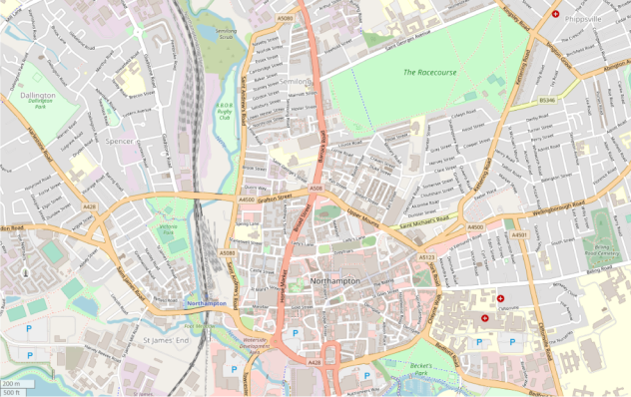

© OpenStreetMap contributors

Use the scale on the map to help you to measure the area, and always remember to convert it to km instead of cm.

**Using the scale in the bottom left corner of the map, estimate the area of:**

1. The racecourse:

1. The park in Dallington (under the word Dallington):

1. The Billing Road Cemetery::

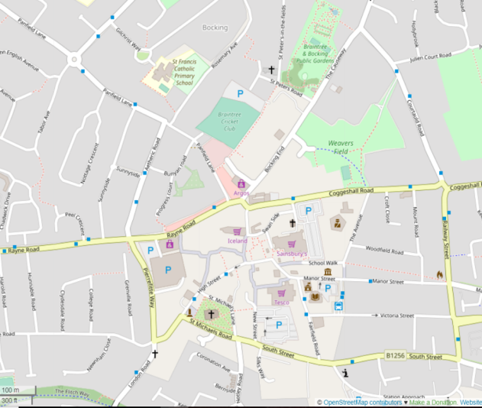

**Using the scale in the bottom left corner of the map, estimate the area of:**

1. Braintree cricket club:

1. St Michaels church and churchyard:

1. The parking area south of Tesco:

1. The public gardens:

Atlas skills – describing patterns

In your exam you could be asked to describe patterns of distribution on a map. This is a choropleth map, and shows the population density in India.

|  |  |  |  |
| --- | --- | --- | --- |
|  | Describe the pattern of population distribution in India: | | |
| **Remember:**  When you are describing, you are saying what you can see; you do not need to give reasons for the pattern as well. | | **Hint:**  You can give general statements to begin with but then you must go into more detail, for example naming specific areas where there is high/low density. | |
|  | Describe the pattern of upland areas in the UK: | | **Hint:**  You may need to look at the key to help you pick out particular areas. |
| **Hint:**  Look at the number of marks available. If there are four marks available try to pick out four pieces of information. |

OS map symbols

Test your knowledge of map symbols. Look at each symbol below and write down what it means in the box below it. Look carefully at each symbol as some symbols are very similar!

|  |  |  |  |
| --- | --- | --- | --- |
|  |  |  |  |
|  |  |  |  |
|  |  |  |  |
|  |  |  |  |
|  |  |  |  |
|  |  |  |  |
|  |  |  |  |
|  |  |  |  |

Four- and six-figure grid references

It is important to be able to locate places using four- and six-figure grid references. A four-figure grid reference will locate a particular square on the map. A six-figure grid reference will pinpoint a location such as a school, bridge or hospital.

00

01

02

03

04

00

01

02

03

04

**Easting**

Northing

|  |
| --- |
| **Hint:**  Remember to give the Easting first and then the Northing. Always go from the bottom left corner of the square.  For example, the four-figure grid reference for the heart is 00 03. |

Give the four-figure grid reference of the following symbols.

1. **Square:**
2. **Cloud:**
3. **Circle:**
4. **Cross:**
5. **Moon:**

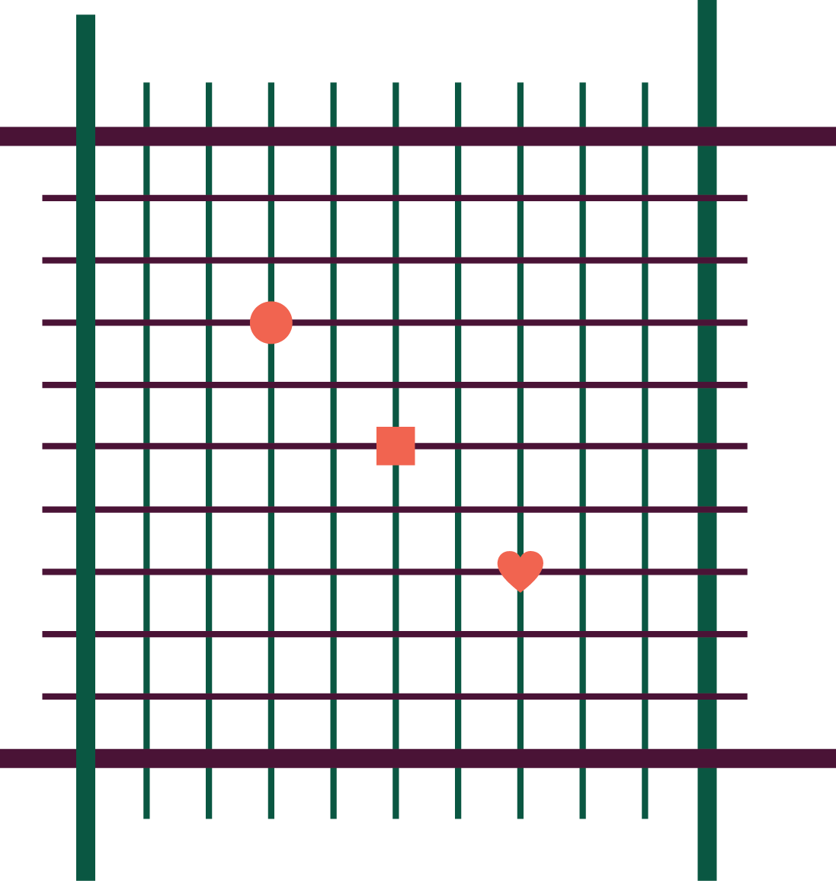

1

2

3

4

5

6

7

8

9

9

8

7

6

5

4

3

2

1

01

02

02

03

Remember to always go from the bottom left-hand corner of the square when giving a grid reference. Use the middle of the symbol as your starting point.

|  |  |  |
| --- | --- | --- |
| **Remember:**  For a six-figure grid reference you are pinpointing a particular spot within the square. The square has been divided into 100 smaller squares.  In the exam the square won’t be divided up, you will have to mentally divide it. It helps to find the centre of the square first!  The first two numbers and the fourth and fifth numbers will be the number from the four-figure grid reference.  The third and sixth numbers will pinpoint the location within the square.  **Examples:** | | |
| **Circle:** 02**3** 01**7** | **Square:** 02**5** 01**5** | **Heart:** 02**7** 01**3** |

Task:

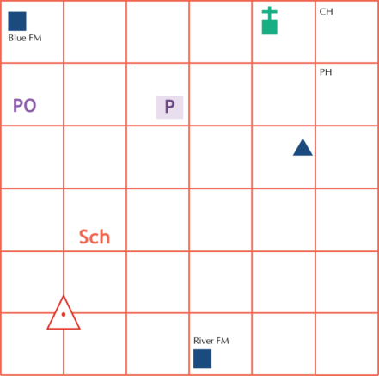

15

16

17

18

19

20

21

34

39

38

37

36

35

40

Give the six-figure grid reference for the symbols below:

|  |  |  |  |
| --- | --- | --- | --- |
| **Feature** | **Six-figure reference** | **Feature** | **Six-figure reference** |
| Blue farm |  | Church with tower |  |
| Youth hostel |  | River farm |  |
| Car park |  | Triangulation point |  |
| School |  | Pub |  |
| Post office |  | Clubhouse |  |

Task:

Draw these symbols onto the grid in the correct locations:

|  |  |  |  |  |  |
| --- | --- | --- | --- | --- | --- |
| **Windmill:** | 171 345 | **Information centre:** | 202 378 | **Bus station:** | 158 362 |
| **Nature reserve:** | 185 385 | **Viewpoint:** | 180 350 | **Campsite:** | 152 372 |

Use the OS map for Newport Pagnell and Northampton South (OS Explorer 207). You can also access this map using:

1. [www.bing.com/maps/](https://www.bing.com/maps/) − type in *Great Houghton, Northampton* and then hover over the symbol in the top right-hand corner of the map which says ‘Road’ and change to ‘Ordnance Survey’. Zoom in or out to show grid references. You may need to move the centre point of the screen for the different questions.
2. [osmaps.ordnancesurvey.co.uk/52.24148,-0.87990,14](https://osmaps.ordnancesurvey.co.uk/52.24148,-0.87990,14) − you will need a login for the OS website and will then get a free trial to view the maps online.
3. **1. Find the following locations using six-figure grid references:**

|  |  |  |  |  |
| --- | --- | --- | --- | --- |
| 1. 776 598 | 1. 807 606 | 1. 809 614 | 1. 758 591 | 1. 804 596 |
| 1. 818 624 | 1. 769 599 | 1. 774 616 | 1. 747 605 | 1. 761 587 |

|  |  |
| --- | --- |
| 1. **What is the six-figure grid reference of?** 2. The school in Briar Hill 3. The cathedral in Northampton 4. The bus station in Northampton 5. The museum in Hunsbury Hill 6. Kingsthorpe golf club 7. The rugby ground in St James End 8. The cemetery in Far Cotton 9. The church in Queens Park 10. The information centre in the town centre 11. The car park south of the Shelfleys | **Hint:**  The edge of a paper map has divisions within each square to help you measure how far along and up a square your location is. This is called a roamer and will enable you to be more accurate. |

1. **What is the straight-line distance between?**
2. Delapre golf club and the cathedral
3. Kingsthorpe golf club and the campsite in Billing Aquadrome
4. Storton’s Pits nature reserve and the bus station in Northampton
5. The museum in Abington Park and the Museum in Hunsbury Hill country park
6. Delapre Abbey and Northampton train station
7. The post office in Little Houghton and Delapre Abbey
8. The church in St James End and the cathedral
9. The cemetery in Far Cotton and Storton’s Pits nature reserve
10. The bus station and the cathedral
11. The campsite in Billing Aquadrome and the museum in Abington Park

Compass directions

Complete the 16-point compass below:



|  |  |  |  |  |  |
| --- | --- | --- | --- | --- | --- |
|  | | | | **What is the compass direction from:**   1. The theatre on Southgate to Magdalen Road car park? 2. The Maynard School to Triangle car park? 3. The library to the court? 4. The church on Heavitree Road to the court? 5. The church on Dixs Field to the theatre on Southgate? 6. Magdalen Road car park to Triangle car park? 7. The car park on Eastgate to the war memorial? | |
| **Key** |  | | | | |
| Theatre | | Library | Memorial | | Court |

Scale and measuring distance

|  |  |
| --- | --- |
| Scale 2 cm = 1 km | **Remember:**  You must convert the measurement you take into the units used on the map, for example cm into km. |

Measure each of these lines and convert the measurement into kilometres:

1 cm on a 1:25000 map = 1 cm on a 1:50000 map =

On an OS map one grid square =

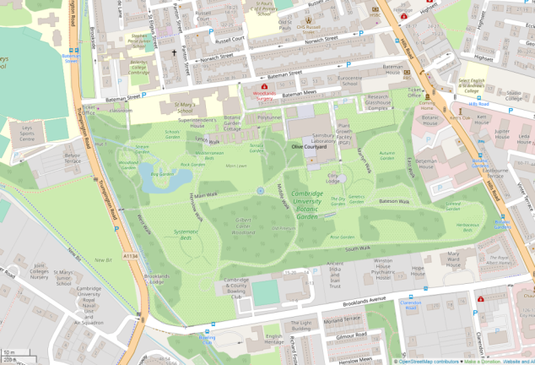

Using the scale on the map measure the distance of:

1. Brooklands Avenue
2. The width of the botanic garden at its widest
3. Norwich Street
4. The width of The Leys Sports Centre
5. Bateman Mews

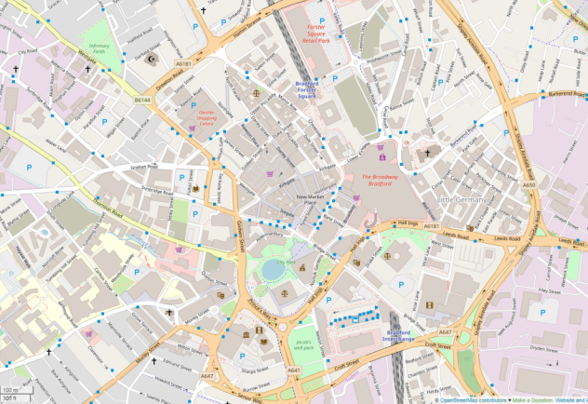

Measure the distance as the crow flies from:

1. The centre of City Park to the centre of Forster Square retail park
2. Bradford Interchange to Bradford Forster Square
3. A650 symbol to A6181 symbol on Drewton Road
4. The parking on Paradise Street to New Market Place
5. Centre of The Broadway Bradford to A650 symbol

Measuring curved-line distances

|  |  |
| --- | --- |
| Often when you need to measure distance on a map the route won’t be a straight line. One of the easiest ways to measure distance when the route isn’t straight is with a piece of string. You can manipulate the string to fit the route and then measure it with a ruler. Remember to always convert the measurements to the units used on the map. | **Hint:**  Carry a piece of string in your pencil case so that you can easily measure curved distances. Mark the string in 1 cm intervals. |

Using this method, measure the distances below, using the scale on the map.

1. The distance from the north to the south of James Street.
2. York St John University to Sainsbury car park.
3. The castle symbol on Gillygate to the castle symbol south of Castlegate via Davygate.
4. The car park on James Street to the B1227 symbol via Walmgate.
5. Layerthorpe Bridge to the castle on Gillygate via Lord Mayors Walk.
6. The bridge on Piccadilly to York St John University via Gillygate.
7. Sainsbury car park to the bridge on Fossgate.
8. The castle south of Castlegate to Layerthorpe Bridge.
9. The junction of Heworth Green and Mill Lane to the junction of Lord Mayors Walk and Gillygate.
10. The junction of Walmgate and Foss Island Road to the car park on James Street via A1079.

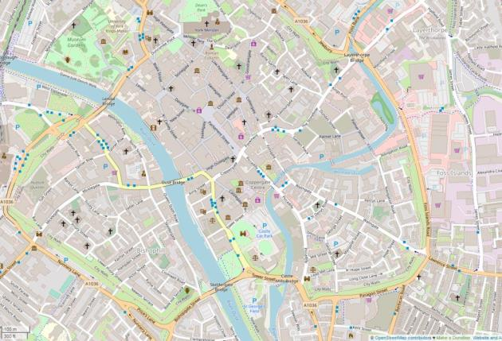

Latitude and longitude

You may be asked to locate a country or feature by latitude and longitude. Remember to always give latitude first (north or south) and longitude second (east or west).

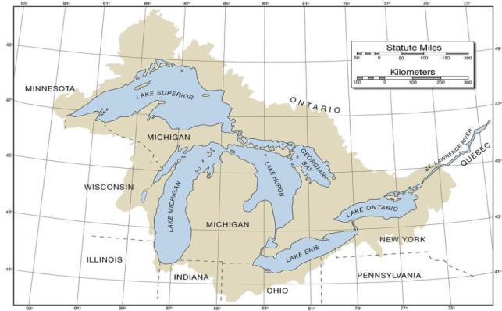

**1.**

**2.**

**3.**

**4.**

**5.**

**X.**

|  |  |
| --- | --- |
| You could be given a world map or a map of an individual country or state.  Give the latitude and longitude for the numbers on the map:  X. 50°N 88°W | Latitude and longitude quiz  What is the name of the line at 0° latitude?    What is the name of the line at 0° longitude?    How many degrees away from the equator are the Tropics of Cancer and Capricorn?    How many degrees away from the equator are the poles? |
| **Hint:**  Consider where the location is on the globe. For example the above map shows a location **north** of the equator and **west** of the Greenwich meridian. | |

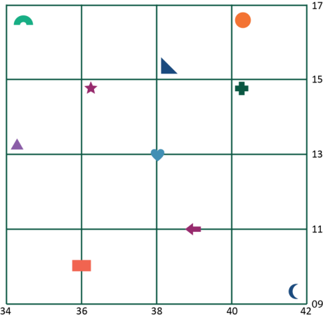

Sometimes you may need to be more precise when giving latitude and longitude references (like when giving six-figure grid references). You will need to include a further figure to note how far along or up the square the location is.

E.g. the latitude and longitude of the cross symbol  is: 13°5’N 40°9’E

Give the latitude and longitude of the following symbols:

|  |  |  |  |
| --- | --- | --- | --- |
|  |  |  |  |
|  |  |  |  |
|  |  |  |  |
|  |  |  |  |
|  |  |  | 13°5’N 40°9’E |

Synoptic charts

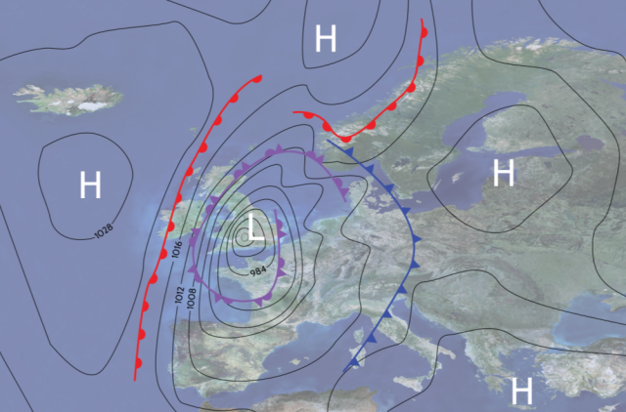

A synoptic chart is a map which shows the weather conditions for a particular area. It will show precipitation, wind speeds, atmospheric pressure, cloud cover and wind direction. The charts are ever-changing as weather fronts move and the atmospheric conditions change.

In your exam you won’t need to draw a synoptic chart but you will be expected to have a good understanding of what they show.

The lines on the map are isobars; these join together lines of equal atmospheric pressure. The higher the number, the higher the pressure. The closer the lines are together the higher the wind speed.

**Questions:**

1. What do the red lines with semicircles indicate?
2. What do the blue lines with triangles indicate?
3. What do the purple lines with semicircles and triangles indicate?
4. What would you expect the weather to be over the Irish Sea?
5. What type of atmospheric pressure is found over the UK?

Constructing a cross section

A cross section shows how relief (height) changes along a chosen route. They are shown on a graph.

For this task you will need some graph paper.

1. Using the diagrams below, construct two cross sections.

**Diagram A**

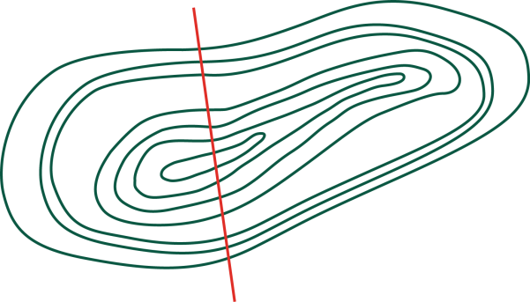

0

100

200

300

**Diagram B**

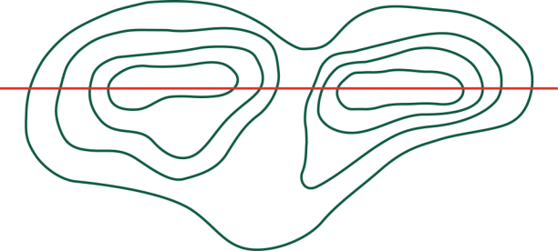

100

200

|  |
| --- |
| 1. Describe the relief of the land of the two diagrams.   Diagram A: |
| Diagram B: |

Use the OS map for Gloucester, Cheltenham and Stroud (OS map 179). You can also access this map using:

* [www.bing.com/maps/](https://www.bing.com/maps/) − type in *Elkstone, Cotswolds* and then hover over the symbol in the top right-hand corner of the map which says ‘Road’ and change to ‘Ordnance Survey’. Zoom in or out to show grid references. You may need to move the centre point of the screen for the different questions.
* [osmaps.ordnancesurvey.co.uk/51.79650,-2.07456,15/pin](https://osmaps.ordnancesurvey.co.uk/51.79650,-2.07456,15/pin) − you will need a login for the OS website and will then get a free trial to view the maps online.

1. Draw a cross section of the area from Harcombe Farm 957 111 to Elkstone Church 966 123. Use the same technique you used before to construct your cross sections. Include any spot heights on your graph.

|  |
| --- |
|  |

**Using the same map/website, now answer the following:**

1. If you started at Winstone radio station 967 103 and walked to Manor Farm, Winstone 966 095 are you gaining or losing height?

1. Describe the relief around Quarry Farm House 938 108.

1. Describe the relief of Shewel Wood 987 106 (grid reference takes you to the centre of the wood).

Ground, aerial and satellite photographs

In your exam you may have to annotate photographs or describe human and physical landscapes from photographs.

Match the correct definition with the type of photograph:

|  |  |  |
| --- | --- | --- |
| Ground photograph |  | A photo taken by an aircraft of the ground below. |
| Aerial photograph |  | A photo taken from space. |
| Satellite photograph |  | A photo taken at ground level. |

Look at the photographs below. Describe the human and physical features that you can see. State what type of photograph it is.

|  |  |
| --- | --- |
| Photo 1 | **Remember:**  Always describe in detail and use geographical vocabulary in your descriptions. |

|  |
| --- |
| Description of photo 1: |

|  |
| --- |
| Photo 2 |
| Description of photo 2: |

|  |
| --- |
| Photo 3 |
| Description of photo 3: |

|  |
| --- |
| Photo 4 |
| Description of photo 4: |

|  |
| --- |
| Photo 5 |
| Description of photo 5: |

Drawing sketches from photographs

|  |  |
| --- | --- |
| Using the photographs below, draw sketches. Remember you do not have to be a good artist to draw a sketch; you are also not drawing every single detail from the photograph. | **Hint:**  Ensure you know the difference between a label and an annotation! A label is a simple point and an annotation is a more detailed description or explanation. |

**Follow these key steps to draw your sketch:**

1. Draw a box to put your sketch into and then divide this box into four. Ensure you draw the division lines lightly so that they can be rubbed out. These four boxes will help you to focus on each area of the photograph.
2. Draw in the important details such as coastal features, rivers and hills – this is anything that shapes the land.
3. Draw in the other details such as buildings and forests.
4. Annotate and label your sketch. Consider both the physical and human features. These should be labelled with geographical reasoning. Then rub out the guidelines that you put in.

|  |  |
| --- | --- |
| Photo 1: Carding Mill Valley |  |

Space for extra annotations:

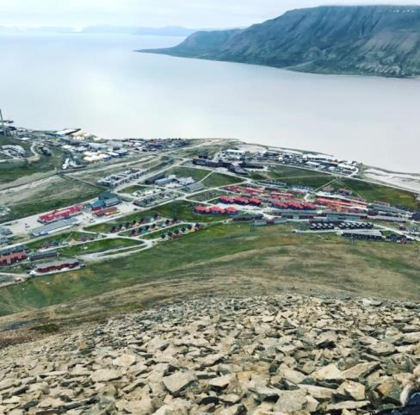

Photo 2: Longyearbyen, Svalbard

|  |
| --- |
|  |

Labelling and annotating photographs

Use the space below to practise labelling and annotating photographs. Look at the example to see the level of detail that you could pick out.

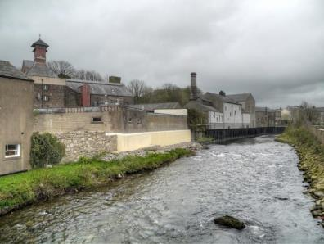

Cockermouth

Evidence of industry; this could have been built here to have easy access to water, as it is close to the banks of the river.

River flood defences have been built here to protect homes and industry from flooding. The height could indicate previous flood levels.

Middle/lower course of the river as it is becoming wider.

Deposition occurring on river banks as this is the approach to a meander.

Buildings follow the course of the river – this is a flood risk; the land here is impermeable so surface runoff will occur more quickly.

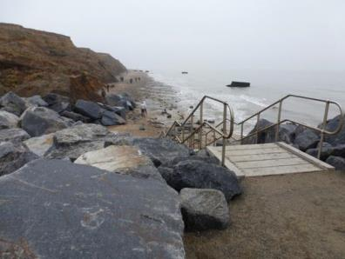

Walton-on-the-Naze

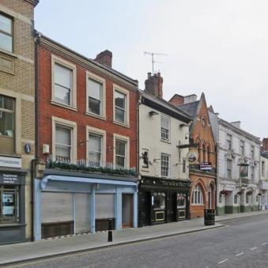

St Giles Street, Northampton

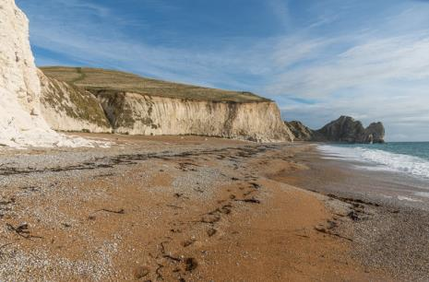

Jurassic Coast, near Durdle Door

Using maps and photographs together

It is likely that you will have an OS map extract and a photograph on the same page in the resource booklet in your exam. You will be expected to use the two together. You could be asked what direction a photograph was taken in, to compare with what you can see in the photo but can’t see on the map, or to give the location of the photograph on the map.

Use the photo below and OS map 162 Greenwich and Gravesend (Grid reference TQ 390 799) or [osmaps.ordnancesurvey.co.uk/51.50114,0.00239,7/pin](https://osmaps.ordnancesurvey.co.uk/51.50114,0.00239,7/pin) (zoom in close).

|  |  |
| --- | --- |
| London Helicopter Lanes | In which compass direction was the camera pointing? |
|  |
| Name two features that can be seen on the photograph, but not on the map. |
|  |
| Name two features that can be seen on the map, but not on the photograph. |
|  |

**Hint:**

Look closely at the map. North will always be at the top. Look closely at the features this will help you to orientate in the photo.



**Annotate the photograph below. What human and physical features are visible?**

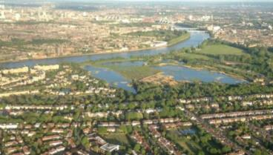

Labelling and annotating diagrams

There are a variety of different diagrams that you could be asked to annotate or label. When answering questions about how landforms are created you could also draw a series of diagrams to help you explain the processes taking place.

|  |  |
| --- | --- |
| **Choose one of the following:**   1. Formation of a waterfall 2. Formation of a stack 3. Formation of a wave-cut platform | **Hint:**  When answering a question such as ‘explain the formation of a waterfall’, draw a series of diagrams to help you to answer the question. |

In the space below draw a series of diagrams or a single diagram to show how one of those landforms is formed.

Remember to annotate your diagram. Each annotation should have an arrow pointing to the exact feature you are describing/explaining.

**Hint:**

The arrow should be touching the exact feature, not just pointing vaguely to it!



Data key terms

1. Add the letter to each box to determine the correct definition.
2. Add the number of each example to complete your table.

|  |  |  |
| --- | --- | --- |
| **Key term** | **Definition letter** | **Example number** |
| Qualitative data |  |  |
| Quantitative data |  |  |
| Discrete data |  |  |
| Continuous data |  |  |
| Primary data |  |  |
| Secondary data |  |  |
| Sample size |  |  |
| Random sampling |  |  |
| Systematic sampling |  |  |
| Stratified sampling |  |  |

Definitions:

|  |  |
| --- | --- |
| **A** | Data that is measured in numbers and not an opinion. Answers are in numbers. |
| **B** | The amount of data in your sample. |
| **C** | Getting data by sampling in a random way, no order. |
| **D** | Data collected by other people, e.g. internet data. |
| **E** | Getting data by sampling equal amounts in each category, e.g. five male, five female. |
| **F** | Data that is subjective or based on opinions. Answers use words. |
| **G** | Getting data by sampling at specific intervals, e.g. every 20 m or every 10th person who walks by. |
| **H** | Numerical data that cannot be shown in decimals, e.g. the number of children in a classroom. |
| **I** | Numerical data that can be shown in decimals, e.g. the weights of 10 babies. |
| **J** | Selecting a sample that is representative of different groups. If the groups are of different sizes, the number of items selected from each group will be proportional to the number of items in that group. |
| **K** | Data you collected. |

**Examples:**

|  |  |
| --- | --- |
| **1** | The number of people we counted in our pedestrian count. |
| **2** | The method we used for choosing the people to answer questionnaires. |
| **3** | Questionnaire answers which use viewpoints, e.g. ‘Do you think Birmingham is a safe city?’ |
| **4** | Newspaper reports and internet searches on Carding Mill Valley/Birmingham. |
| **5** | Any of the methods we used on site at either Carding Mill Valley or Birmingham. |
| **6** | You were asked to find five people to ask questions of. |
| **7** | The measurements on depth/width of the stream at Carding Mill Valley. |
| **8** | Measuring the width every 20 cm along the river. |
| **9** | If we had ensured we had given someone from each age bracket the questionnaires, it would be classed as this type of sampling. |
| **10** | If we had ensured we had given every 10th person a questionnaire, it would be classed as this type of sampling. |

Bar charts and histograms

For these tasks you will need graph paper, a ruler and a pencil. It is also important to have a ruler and a pencil in your pencil case for your exam in case need to complete a graph.

Look at the data below. Think about which would need to be shown on a bar chart and which would need to be shown as a histogram.

|  |  |
| --- | --- |
| **Remember:**  Bar charts show discrete data; there should be a gap between the bars.  Histograms show continuous data and the bars should be touching. | **Hint:**  Bar charts should have bars of different colours and histograms should have bars of the same colour. |

|  |  |  |  |  |
| --- | --- | --- | --- | --- |
| **Data set 1:**  Data from a questionnaire given to shoppers at Northampton Grosvenor Centre. One question asked how they arrived in Northampton that day. | |  | **Data set 2:**  Data from a pedestrian count carried out during a field trip to Colchester**.** | |
| **Mode of transport** | **Number** | **Time** | **Number of people** |
| Foot | 17 | 11.00−11.10 | 37 |
| Bicycle | 4 | 11.10−11.20 | 45 |
| Public transport | 23 | 11.20−11.30 | 47 |
| Motorbike | 2 | 11.30−11.40 | 28 |
|  |  | 11.40−11.50 | 57 |

1. Which type of graph would be most appropriate for each of these sets of data? Why?

2. Why would a pie chart **not** be appropriate for the second data set?

3. What are the issues with the graph below?

Divided/compound bar charts

You could be asked to complete a divided bar chart; however, it is unlikely that you would need to draw an entire divided bar chart.

Remember that each bar has been subdivided by the information in the table. Each bar will add up to 100%.

For this task you will need graph paper, a ruler and a pencil.

Look at the data below and create a divided bar chart. For this data set you will need to convert the numbers to percentages first. In an exam you may not need to do this.

**Data set 1:** Vehicle count in Braintree town centre carried out for 10 minutes at three different times of the day.

|  |  |  |  |
| --- | --- | --- | --- |
| **Vehicle type** | **07.00−07.10** | **12.00−12.10** | **18.00−18.10** |
| Bicycle | 4 | 12 | 3 |
| Public transport | 17 | 8 | 15 |
| Lorry | 3 | 6 | 5 |
| Car | 28 | 34 | 54 |

|  |
| --- |
| Space for working out percentages: |

**Data set 2:** Age categories of guests of differing nationalities at Hopping Hare Hotel, Northampton**.**

|  |  |  |  |
| --- | --- | --- | --- |
| **Nationality** | **Child 0−18** | **Adult 19−65** | **OAP 66−100** |
| British | 4 | 15 | 3 |
| Irish | 2 | 17 | 2 |
| Mainland Europe | 6 | 12 | 4 |
| Rest of the world | 1 | 4 | 0 |

|  |
| --- |
| Space for working out percentages: |

Line graphs

Line graphs show changes over time. On some graphs there is more than one line. For those graphs each line will be a different colour and the key will denote which line is which.

For this task you will need graph paper, a ruler and a pencil. Ensure that you always have a pencil and a ruler in your pencil case in an exam.

For each of the data sets below, draw a line graph. Ensure that the axes are correctly labelled and that your graph has a title. All units must be included on the axes.

**Data set 1:** Temperature data for Northampton across one year.

|  |  |  |  |  |  |  |  |  |  |  |  |  |
| --- | --- | --- | --- | --- | --- | --- | --- | --- | --- | --- | --- | --- |
| **Month** | **J** | **F** | **M** | **A** | **M** | **J** | **J** | **A** | **S** | **O** | **N** | **D** |
| **Temp (°C)** | 5 | 5 | 7 | 9 | 13 | 15 | 18 | 17 | 14 | 11 | 7 | 5 |

**Data set 2:** Traffic flows in and out of Abington Park, Northampton on 2−3 May 2019.

For this graph you will have four lines.

|  |  |  |  |  |
| --- | --- | --- | --- | --- |
|  | **Thursday 2 May 2019** | | **Friday 3 May 2019** | |
| **Time** | **Into Abington Park** | **Out of Abington Park** | **Into Abington Park** | **Out of Abington Park** |
| 10.00−10.30 | 12 | 4 | 18 | 17 |
| 10.30−11.00 | 7 | 14 | 23 | 5 |
| 11.00−11.30 | 15 | 3 | 4 | 13 |
| 11.30−12.00 | 9 | 12 | 15 | 13 |
| 12.00−12.30 | 23 | 5 | 31 | 8 |
| 12.30−13.00 | 17 | 24 | 25 | 12 |

**Data set 3:** Relationship between wetted perimeter and distance from the source at Carding Mill Valley.

|  |  |
| --- | --- |
| **Distance from the source (km)** | **Wetted perimeter (m)** |
| 0.5 | 0.7 |
| 1.0 | 1.3 |
| 1.5 | 1.5 |
| 2.0 | 1.6 |
| 2.5 | 2.2 |
| 3.0 | 2.4 |

**Data set 4:** Relationship between distance across river channel and depth of the river. This line graph will create a cross section of this part of the river.

|  |  |  |  |  |  |  |  |  |  |
| --- | --- | --- | --- | --- | --- | --- | --- | --- | --- |
|  | **Distance across the channel (cm)** | | | | | | | | |
|  | 0 | 10 | 20 | 30 | 40 | 50 | 60 | 70 | 80 |
| **Depth** | 0 | 5 | 12 | 14 | 21 | 19 | 17 | 8 | 0 |

How to calculate a percentage and create a pie chart

Shopping example:

In your exam you may be asked to calculate a percentage from a set of data; for example, what percentage of people stated that shopping was the main purpose of their visit?

|  |  |  |  |
| --- | --- | --- | --- |
| **Purpose** | **Tally** |  | **Hint:**  If the data set figure is divisible into 100 it can be easier to work out what percentage each person would be. |
| **Shopping** | 15 |
| **Visiting friends** | 13 |
| **Business** | 6 |
| **Visiting an attraction** | 16 |

The total number of people asked was **50**.

**Each person asked would be 2% of the total**

**15 x 2 = 30%**

Work out the percentages for the remaining purposes:

|  |  |  |  |
| --- | --- | --- | --- |
| **Purpose** | **Tally** | **Percentage** | **Hint:**  Work out the percentage by dividing the number by the total number and then multiplying by 100. |
| **Shopping** | 15 | 30 |
| **Visiting friends** | 13 |  |
| **Business** | 6 |  |
| **Visiting an attraction** | 16 |  |

A pie chart is a good way of presenting percentages. You may be asked to complete a pie chart in your exam.

|  |  |  |  |
| --- | --- | --- | --- |
|  | **Purpose** | **Degrees** | **Key** |
| Shopping |  |  |
| Visiting friends |  |  |
| Business |  |  |
| Visiting an attraction |  |  |
| **Hint:**  Divide the percentage figure by 100 and then multiply it by 360 to find the number of degrees needed for your pie chart. | | |

Traffic count example:

A group of students counted the different types of vehicles passing them during a one hour period. The results are in the table below.

|  |  |  |
| --- | --- | --- |
| **Vehicle type** | **Number passing in one hour** | **Percentage** |
| Car | 37 |  |
| Lorry | 4 |  |
| Emergency vehicle | 1 |  |
| Bicycle | 12 |  |
| Bus or Coach | 6 |  |
| Van | 4 |  |

Total number of vehicles in one hour: 64

Work out the percentage for each vehicle type, then complete the pie chart below.

|  |  |  |  |  |  |  |  |  |  |  |  |  |  |  |  |  |  |  |  |  |  |  |
| --- | --- | --- | --- | --- | --- | --- | --- | --- | --- | --- | --- | --- | --- | --- | --- | --- | --- | --- | --- | --- | --- | --- |
|  | |  |  |  | | --- | --- | --- | | **Vehicle** | **Degrees** | **Key** | | Car |  |  | | Lorry |  |  | | Emergency |  |  | | Bicycle |  |  | | Bus/Coach |  |  | | Van |  |  | |
| Working out space: | |

The students completed the same activity at the same time the next day. Calculate the percentage increase or decrease.

|  |  |  |
| --- | --- | --- |
| **Vehicle type** | **Number passing in one hour** | **Percentage increase/decrease** |
| Car | 43 |  |
| Lorry | 2 |  |
| Emergency vehicle | 2 |  |
| Bicycle | 8 |  |
| Bus or Coach | 6 |  |
| Van | 5 |  |

**Hint:**

To work out the percentage increase/decrease, work out the difference between the two numbers, divide the difference by the first number, then multiply this number by 100.

For example, the difference between 37 and 43 is 6. Then 6 / 37 x 100 = 16.21. The percentage increase is therefore 16.21%.



Country wealth example:

You could also be given a set of data that isn’t fieldwork data, but general statistics.

|  |  |  |
| --- | --- | --- |
| **Country** | **GDP in 2005 in billions of US $** | **GDP in 2015 in billions of US $** |
| Ethiopia | 12.4 | 64.46 |
| Tanzania | 16.9 | 45.62 |
| Uganda | 9.01 | 27.1 |
| Kenya | 18.74 | 64.01 |
| Ghana | 10.73 | 37.34 |

Data from [www.worldbank.org](http://www.worldbank.org)

Calculate the percentage increase for each country.

|  |  |
| --- | --- |
| **Country** | **Percentage increase** |
| Ethiopia |  |
| Tanzania |  |
| Uganda |  |
| Kenya |  |
| Ghana |  |

|  |
| --- |
| Space for working out |

Pie charts

|  |  |
| --- | --- |
| For the following tasks you will require a protractor, a pencil and some coloured pencils. In the boxes below you will be drawing the pie charts for the data sets. | **Hint:**  Work out what 1% of the total is by dividing by 100 and multiplying that figure by the number you need. |

|  |  |  |  |  |  |  |
| --- | --- | --- | --- | --- | --- | --- |
| 1. Students recorded the shape of bedload during a river survey. They used the Powers Scale of Roundness to classify the bedload. Construct a pie chart to show their results. | | | | | | |
| **Very angular** | **Angular** | **Sub-angular** | **Sub-rounded** | **Rounded** | **Very rounded** |
| 18 | 12 | 12 | 3 | 1 | 0 |
|  | | | | | |
|  | | | | | |

|  |  |  |  |  |  |  |
| --- | --- | --- | --- | --- | --- | --- |
| 1. During an urban study, students completed a questionnaire. One question asked was, ‘How do you travel to work?’. Construct a pie chart to show their results. | | | | | | |
| **Walk** | **Bus** | **Taxi** | **Car** | **Train** | **Other** |
| 13 | 27 | 2 | 34 | 8 | 1 |
|  | | | | | |
|  | | | | | |

|  |  |  |  |  |  |  |
| --- | --- | --- | --- | --- | --- | --- |
| 1. Students completed a transect across a town centre. They noted down what each building was that they walked past. Construct a pie chart to show the quantity of each building type. | | | | | | |
| **House** | **Shop** | **Estate agent** | **Office** | **Nursery** | **Derelict** |
| 42 | 37 | 7 | 18 | 5 | 17 |
|  | | | | | |
|  | | | | | |

Scatter graphs

|  |  |
| --- | --- |
| For this task you will need graph paper, a pencil and a ruler.  Using the data below, construct a series of scatter graphs and answer the questions. | **Hint:**  River depth and river width are examples of bivariate data. The data is related. |

|  |  |  |
| --- | --- | --- |
| **Site number** | **River width (m)** | **River depth (cm)** |
| Site 1 | 1.4 | 30 |
| Site 2 | 2.6 | 43 |
| Site 3 | 2.4 | 45 |
| Site 4 | 3.1 | 39 |
| Site 5 | 4.2 | 62 |
| Site 6 | 4.9 | 71 |
| Site 7 | 5.6 | 84 |

|  |
| --- |
| 1. Describe the correlation between the river width and the river depth. Are there any anomalies? |

|  |  |  |
| --- | --- | --- |
| **Country** | **GDP per capita (USD)** | **Adult literacy rate (%)** |
| **Somalia** | 499.82 | 37.8 |
| **Singapore** | 57 714.30 | 97.05 |
| **UK** | 39 720.44 | 99 |
| **India** | 1 939.61 | 74.04 |
| **Madagascar** | 449.72 | 64.7 |
| **Peru** | 6 571.93 | 94.17 |
| **Nigeria** | 1 968.56 | 59.6 |

|  |
| --- |
| 2. Describe the correlation between the GDP per capita and the adult literacy rates. Are there any anomalies? Suggest reasons for your answers. |

|  |  |  |  |
| --- | --- | --- | --- |
| **Distance from city centre (km)** | **Price of a can of Coke (£)** |  | 3. Describe the correlation between the distance from the city centre and the price of a can of Coke |
| 0.25 | 1.80 |
| 0.5 | 1.30 |
| 0.75 | 1.47 |
| 1 | 0.99 |
| 1.25 | 0.85 |
| 1.5 | 0.85 |
| 1.75 | 0.60 |
| 2 | 0.55 |

Dispersion graphs

|  |  |
| --- | --- |
| For this task you will need graph paper, a ruler and a pencil.  At Walton-on-the-Naze, a group of students collected 20 pebbles from the beach at three different sites. They measured the length of each pebble and recorded the data. | **Hint:**  You could be asked to complete a dispersion graph. Read the axis carefully to ensure that you are plotting the points correctly. |

**Site 1:**

|  |  |  |  |  |  |  |  |  |  |
| --- | --- | --- | --- | --- | --- | --- | --- | --- | --- |
| 5 cm | 7 cm | 11.2 cm | 15 cm | 13 cm | 14 cm | 8.5 cm | 8.5 cm | 9.1 cm | 10.2 cm |
| 7.6 cm | 4.3 cm | 13.1 cm | 13.9 cm | 14.2 cm | 8.6 cm | 9.2 cm | 5.4 cm | 6.3 cm | 4.6 cm |

**Site 2:**

|  |  |  |  |  |  |  |  |  |  |
| --- | --- | --- | --- | --- | --- | --- | --- | --- | --- |
| 5.1 cm | 6.2 cm | 5.8 cm | 4.8 cm | 7.1 cm | 8.4 cm | 4.6 cm | 8.1 cm | 5.1 cm | 10.6 cm |
| 6.1 cm | 4.2 cm | 7.3 cm | 6.9 cm | 8 cm | 4 cm | 5 cm | 9.5 cm | 5 cm | 5 cm |

**Site 3:**

|  |  |  |  |  |  |  |  |  |  |
| --- | --- | --- | --- | --- | --- | --- | --- | --- | --- |
| 2 cm | 4.8 cm | 2 cm | 3 cm | 3.4 cm | 2.4 cm | 1.9 cm | 2 cm | 2.8 cm | 2.8 cm |
| 3.1 cm | 1.9 cm | 2.2 cm | 4 cm | 5.1 cm | 3.1 cm | 3 cm | 3.4 cm | 2.6 cm | 3.5 cm |

|  |
| --- |
| 1. Suggest reasons for the differences in the samples. |

|  |
| --- |
| 1. Suggest another data presentation technique that could be used to display this data. Give reasons for your answer. |

|  |
| --- |
| 1. Calculate the mean, median, mode and interquartile range for each of the sites. |

Pictograms

|  |  |
| --- | --- |
| Complete the pictograms below. Use a pencil to complete each question.   1. During an urban study, students completed a questionnaire. One question was, ‘What sector do you work in?’. Complete the pictogram using the data below. | **Hint:**  Look carefully at the scale; if you draw incorrectly, you won’t score the marks! |

|  |  |  |  |  |
| --- | --- | --- | --- | --- |
| Primary (6) |  |  | = 2 people | |
| Secondary (18) |  |  | |
| Tertiary (20) |  |  | |
| Quaternary (4) |  |  | |

How else could this data be displayed?

|  |
| --- |
|  |

Suggest two advantages of using a pictogram.

|  |
| --- |
|  |

1. During an urban study, students completed a transect. They wrote down what each building was that they walked past. Complete the pictogram using the data below.

|  |  |  |  |
| --- | --- | --- | --- |
| Houses (55) |  |  | = 10 buildings |
| Shops (20) |  |  | |
| Offices (5) |  |  | |
| Estate agents (5) |  |  | |
| Derelict (10) |  |  | |

Proportional circles

|  |  |
| --- | --- |
| Using the data below, complete a proportional circles map. Use the instructions below to complete this.   1. Calculate the square root of each of the values in the data table; this will be used to calculate the radius of each circle. 2. Look at each square root value and find the range. 3. Create a scale which suits the range – the circles must be able to fit onto your map. A scale of 5 mm should be enough to fit your map. 4. Multiply each square root value by the scale size to determine the circle size; e.g., if the square root was 5, you would multiply this by 5 to give a radius of 25 mm. 5. Remember that radius is only the distance from the centre of the circle to the edge, so multiply the radius measurement by 2 to give the diameter. | **Hint:**  In an exam you would not be asked to complete an entire proportional circles map, but you may be asked to finish one. It is important to know how to do this. |
| 1. Locate where you are going to draw the circles on your map. Draw the radius/diameter in each location and then complete the circle. You could use a compass. 2. Ensure your map has a key, a north arrow and a title. | |

|  |  |  |  |
| --- | --- | --- | --- |
| **Country** | **Birth rate (per 1000)** | **Square root** | **Hint:**  Check the key carefully, it may give you a measurement for the circles and you would need to work out your measurement in comparison. |
| Austria | 9.5 |  |
| Iceland | 13.6 |  |
| Sweden | 12.1 |  |
| Russia | 10.7 |  |
| Germany | 8.6 |  | **Question:**  Describe the pattern of birth rates across Europe. Suggest reasons for this pattern. |
| Turkey | 15.4 |  |
| Portugal | 8.2 |  |

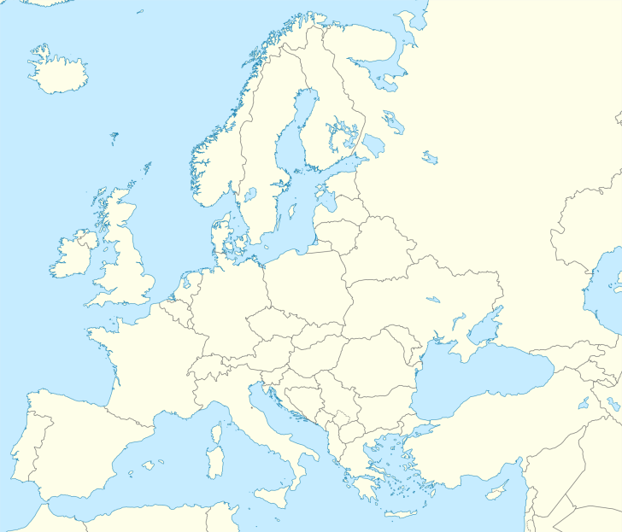

Triangular graphs

Triangular graphs are a sophisticated way of presenting data, as you are plotting three variables onto a graph.

The data below shows type of employment percentages for various countries. One example has been completed for you.

|  |  |  |  |  |
| --- | --- | --- | --- | --- |
| **Country** | **Primary %** | **Secondary %** | **Tertiary %** | **Hint:**  Read each side carefully so you are aware which direction the data should go in. Take your time plotting the dots; this isn’t something to be rushed. In your exam you are likely to have to add to a graph rather than complete one from scratch. |
| **Example:** Argentina | 5% | 28% | 67% |
| Ghana | 45% | 14% | 41% |
| Jamaica | 16% | 16% | 68% |
| Malaysia | 11% | 36% | 53% |
| Mexico | 14% | 24% | 62% |
| Pakistan | 42% | 23% | 35% |
| Singapore | 1% | 26% | 73% |
| Switzerland | 3% | 20% | 77% |

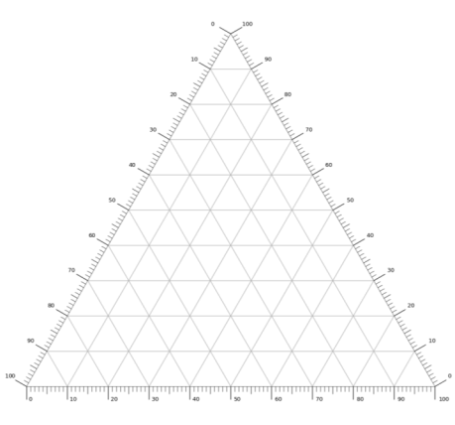

Tertiary Employment

Secondary Employment

Primary Employment

**Arg**

Star and radial diagrams

|  |  |
| --- | --- |
| For this task you will need a ruler, a pencil and some coloured pencils. You may also find a calculator useful.  Star/Radial diagrams show movements or connections between two places. Each ray will represent a different location. | **Remember:**  The rays on the diagram are in the right direction for the location of the place that they are originated from. |

Using the data below construct a star / radial diagram. Remember to include a key and a title. The data is based on where people who travel to work in Norwich originate from.

|  |  |
| --- | --- |
| Give an example of when you would use a star/radial diagram. Suggest an advantage of this type of data presentation. | **Hint:**  In your exam pencil case you should always have at least two pens, a pencil, a ruler, a protractor, a calculator and some coloured pencils. **Don’t just turn up to your exam with one pen!** |

|  |  |  |  |
| --- | --- | --- | --- |
| **Location** | **Number of people** | **Location** | **Number of people** |
| Lowestoft | 6 | Cromer | 4 |
| Dereham | 8 | Stalham | 11 |
| Great Yarmouth | 8 | Beccles | 9 |
| Hethersett | 10 | Diss | 9 |
| Mattishall | 5 | Poringland | 10 |

|  |
| --- |
|  |
| **0.5cm = 1 person** |

Kite diagrams

For this task you will need graph paper, a ruler, a pencil and some coloured pencils.

|  |  |
| --- | --- |
| **Instructions:**   1. On one axis of your graph, scale out the distance for the transect from the data in the table below. 2. On the other axis write the names of the types of vegetation found along the transect. 3. Use the central line for each vegetation type and draw a cross either side of the central line for where the vegetation is found. The crosses should be symmetrical. Any data which is 0 will be on the central line. 4. Remember that the percentages won’t necessarily add up to 100% as it is percentage coverage within the quadrat. Some of the quadrat could have just been sand or soil. |  |

|  |  |  |  |  |
| --- | --- | --- | --- | --- |
| **Distance from high-tide line** | **Marram grass % cover** | **Lichen % cover** | **Heather % cover** | **Hawthorne % cover** |
| 25 m | 44 | 0 | 0 | 0 |
| 50 m | 20 | 0 | 0 | 0 |
| 75 m | 6 | 2 | 0 | 0 |
| 100 m | 2 | 16 | 20 | 0 |
| 125 m | 0 | 54 | 34 | 2 |
| 150 m | 0 | 0 | 20 | 40 |

|  |
| --- |
| Describe the pattern shown by your kite diagram. |

|  |
| --- |
| State the advantages and disadvantages of using this type of data presentation technique. |

|  |
| --- |
| Suggest another way to show this data. Give reasons for your suggestion. |

Desire lines

Desire lines show the direction of movement on a map. The arrows will start from the origin location and extend to the destination. They could show movement such as traffic moving from the suburbs to the town centre. The width of the line is proportional to the density of the movement. They could also show data such as migration.

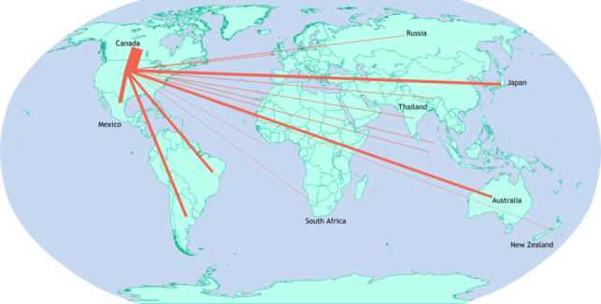

|  |  |
| --- | --- |
| **Key** |  |
| The wider the line the more US exports (in US$) | |

Using Figure 1, answer the following questions:

1. Which two countries received the highest amount of US exports in 2010?

1. Name two countries which received the lowest amount of US exports in 2010?

1. Suggest why the pattern of US exports looks like this.

Flow lines

Flow lines show movement between places on a map; the thickness of the arrows used is proportional. Some arrows will only have one head, as movement was counted in one direction only. If an arrow has two heads, the number within the arrow shows the combined movement in both directions. The arrows should be drawn along the length of the road that the numbers are based on. The key will show the proportion of the arrow to the number of people it represents.

Complete the flow line of Northampton town centre below. The pedestrian flow is a combination of both directions.

|  |  |  |
| --- | --- | --- |
|  | **Road name** | **Pedestrian flow** |
| Drapery | 120 |
| George Row | 75 |
| College Street | 50 |
| Abington Street | 45 |
| Gold Street | 150 |
|  |  |

**Arrow proportion: 1 cm wide = 100 people.**

Suggest two advantages and two disadvantages of using this data presentation technique.

Choropleth maps

For this task you will need an atlas and some coloured pencils. In your exam the countries would be labelled and you could be asked to complete a partially drawn choropleth map rather than constructing an entire choropleth map from scratch.

Using the data below, complete the choropleth map based on population. Use one colour or a pattern to complete the map. Ensure that you also complete a key.

Population figures:

|  |  |  |  |  |  |
| --- | --- | --- | --- | --- | --- |
| Albania  2 870 324 | Andorra  74 794 | Armenia  2 969 200 | Austria  8 857 960 | Azerbaijan  10 000 000 | Belarus  9 477 100 |
| Belgium  11 449 656 | Bosnia & Herzegovina  3 511 372 | Bulgaria  7 000 039 | Croatia  4 105 493 | Cyprus  864 200 | Czech Republic  10 627 794 |
| Denmark  5 806 015 | Estonia  1 319 133 | Finland  5 522 015 | France  67 372 000 | Greece  10 768 193 | Georgia  3 729 600 |
| Germany  82 887 000 | Hungary  9 771 000 | Iceland  355 620 | Ireland  4 857 000 | Italy  60 390 560 | Kazakhstan  18 356 900 |
| Kosovo  1 798 506 | Latvia  1 921 300 | Liechtenstein  38 201 | Lithuania  2 791 903 | Luxembourg  602 005 | Malta  475 701 |
| Moldova  2 681 735 | Monaco  38 300 | Montenegro  622 359 | Netherlands  17 305 660 | North Macedonia  2 075 301 | Norway  5 323 933 |
| Poland  38 433 600 | Portugal  10 291 027 | Romania  19 523 621 | Russia  146 877 088 | San Marino  33 407 | Serbia  6 963 764 |
| Slovakia  5 445 087 | Slovenia  2 070 050 | Spain  46 733 038 | Sweden  10 215 250 | Switzerland  8 526 932 | Turkey  82 003 882 |
| Ukraine  42 220 824 | UK  66 040 229 |  |  |  |  |

**Question:**

Describe the distribution shown on the map. Suggest reasons for this distribution.

|  |  |
| --- | --- |
| [File:Europe blank laea location map.svg](https://upload.wikimedia.org/wikipedia/commons/b/b4/Europe_blank_laea_location_map.svg) | |
|
|
|
|
|
|
| **Key** | |
|  |  |
|  |  |
|  |  |
|  |  |
|  |  |

Population pyramids

You may be asked to complete a population pyramid for which you will be given the data. Use the population pyramid sheet to help you to complete each of the population pyramids. Look carefully at the axis to ensure you have the correct data on each side.

|  |  |  |  |  |  |  |
| --- | --- | --- | --- | --- | --- | --- |
| **Germany** | | |  | **Kenya** | | |
| Age | Percentage male | Percentage female | Age | Percentage male | Percentage female |
| 100+ | 0 | 0.1 | 100+ | 0 | 0 |
| 95−99 | 0.1 | 0.2 | 95−99 | 0 | 0 |
| 90−94 | 0.4 | 1.1 | 90−94 | 0 | 0 |
| 85−89 | 1.1 | 2.3 | 85−89 | 0 | 0.1 |
| 80−84 | 2.3 | 3.3 | 80−84 | 0.1 | 0.2 |
| 75−79 | 4.1 | 5.1 | 75−79 | 0.2 | 0.2 |
| 70−74 | 5.6 | 6.2 | 70−74 | 0.3 | 0.4 |
| 65−69 | 4.9 | 5 | 65−69 | 0.6 | 0.7 |
| 60−64 | 6.3 | 6.3 | 60−64 | 0.8 | 0.9 |
| 55−59 | 7.1 | 6.9 | 55−59 | 1 | 1.1 |
| 50−54 | 8.5 | 8 | 50−54 | 1.2 | 1.3 |
| 45−49 | 9.1 | 8.4 | 45−49 | 1.6 | 1.6 |
| 40−44 | 7.4 | 6.9 | 40−44 | 2.2 | 2.1 |
| 35−39 | 5.9 | 5.6 | 35−39 | 3.0 | 2.9 |
| 30−34 | 6.2 | 5.9 | 30−34 | 3.8 | 3.8 |
| 25−29 | 6.3 | 5.9 | 25−29 | 4.3 | 4.3 |
| 20−24 | 6 | 5.6 | 20−24 | 4.5 | 4.5 |
| 15−19 | 5.2 | 4.8 | 15−19 | 5.2 | 5.2 |
| 10−14 | 4.8 | 4.4 | 10−14 | 6.2 | 6.1 |
| 5−9 | 4.4 | 4.1 | 5−9 | 7.1 | 7.9 |
| 0−4 | 4.4 | 4 | 0−4 | 7.7 | 7.6 |

|  |  |
| --- | --- |
| **Questions:**   1. What is the overall shape of each of the pyramids? 2. What does this suggest about each of the countries, e.g. is it an HIC or an LIC? Give reasons. 3. Annotate your population pyramids. What do they tell you about society? 4. Describe the differences between the pyramids, give reasons for the differences. 5. Explain why this is an appropriate way of showing this type of data. | Hint:  Ensure you start from the bottom of this table when you are putting the bars onto your population pyramid. |

A population pyramid for for the year

|  |  |  |  |  |  |  |  |  |  |  |  |  |  |  |  |  |  |  |  |  |  |
| --- | --- | --- | --- | --- | --- | --- | --- | --- | --- | --- | --- | --- | --- | --- | --- | --- | --- | --- | --- | --- | --- |
|  |  |  |  |  |  |  |  |  |  | **Age** |  |  |  |  |  |  |  |  |  |  |  |
|  |  |  |  |  |  |  |  |  |  | 100+ |  |  |  |  |  |  |  |  |  |  |  |
|  |  |  |  |  |  |  |  |  |  | 95−99 |  |  |  |  |  |  |  |  |  |  |  |
|  |  |  |  |  |  |  |  |  |  | 90−94 |  |  |  |  |  |  |  |  |  |  |  |
|  |  |  |  |  |  |  |  |  |  | 85−89 |  |  |  |  |  |  |  |  |  |  |  |
|  |  |  |  |  |  |  |  |  |  | 80−84 |  |  |  |  |  |  |  |  |  |  |  |
|  |  |  |  |  |  |  |  |  |  | 75−79 |  |  |  |  |  |  |  |  |  |  |  |
|  |  |  |  |  |  |  |  |  |  | 70−74 |  |  |  |  |  |  |  |  |  |  |  |
|  |  |  |  |  |  |  |  |  |  | 65−69 |  |  |  |  |  |  |  |  |  |  |  |
|  |  |  |  |  |  |  |  |  |  | 60−64 |  |  |  |  |  |  |  |  |  |  |  |
|  |  |  |  |  |  |  |  |  |  | 55−59 |  |  |  |  |  |  |  |  |  |  |  |
|  |  |  |  |  |  |  |  |  |  | 50−54 |  |  |  |  |  |  |  |  |  |  |  |
|  |  |  |  |  |  |  |  |  |  | 45−49 |  |  |  |  |  |  |  |  |  |  |  |
|  |  |  |  |  |  |  |  |  |  | 40−44 |  |  |  |  |  |  |  |  |  |  |  |
|  |  |  |  |  |  |  |  |  |  | 35−39 |  |  |  |  |  |  |  |  |  |  |  |
|  |  |  |  |  |  |  |  |  |  | 30−34 |  |  |  |  |  |  |  |  |  |  |  |
|  |  |  |  |  |  |  |  |  |  | 25−29 |  |  |  |  |  |  |  |  |  |  |  |
|  |  |  |  |  |  |  |  |  |  | 20−24 |  |  |  |  |  |  |  |  |  |  |  |
|  |  |  |  |  |  |  |  |  |  | 15−19 |  |  |  |  |  |  |  |  |  |  |  |
|  |  |  |  |  |  |  |  |  |  | 10−14 |  |  |  |  |  |  |  |  |  |  |  |
|  |  |  |  |  |  |  |  |  |  | 5−9 |  |  |  |  |  |  |  |  |  |  |  |
|  |  |  |  |  |  |  |  |  |  | 0−4 |  |  |  |  |  |  |  |  |  |  |  |
| 10 9 8 7 6 5 4 3 2 1 0 0 1 2 3 4 5 6 7 8 9 10 | | | | | | | | | | | | | | | | | | | | | | | |

**Percentage of the total population**

A population pyramid for for the year

|  |  |  |  |  |  |  |  |  |  |  |  |  |  |  |  |  |  |  |  |  |  |
| --- | --- | --- | --- | --- | --- | --- | --- | --- | --- | --- | --- | --- | --- | --- | --- | --- | --- | --- | --- | --- | --- |
|  |  |  |  |  |  |  |  |  |  | **Age** |  |  |  |  |  |  |  |  |  |  |  |
|  |  |  |  |  |  |  |  |  |  | 100+ |  |  |  |  |  |  |  |  |  |  |  |
|  |  |  |  |  |  |  |  |  |  | 95−99 |  |  |  |  |  |  |  |  |  |  |  |
|  |  |  |  |  |  |  |  |  |  | 90−94 |  |  |  |  |  |  |  |  |  |  |  |
|  |  |  |  |  |  |  |  |  |  | 85−89 |  |  |  |  |  |  |  |  |  |  |  |
|  |  |  |  |  |  |  |  |  |  | 80−84 |  |  |  |  |  |  |  |  |  |  |  |
|  |  |  |  |  |  |  |  |  |  | 75−79 |  |  |  |  |  |  |  |  |  |  |  |
|  |  |  |  |  |  |  |  |  |  | 70−74 |  |  |  |  |  |  |  |  |  |  |  |
|  |  |  |  |  |  |  |  |  |  | 65−69 |  |  |  |  |  |  |  |  |  |  |  |
|  |  |  |  |  |  |  |  |  |  | 60−64 |  |  |  |  |  |  |  |  |  |  |  |
|  |  |  |  |  |  |  |  |  |  | 55−59 |  |  |  |  |  |  |  |  |  |  |  |
|  |  |  |  |  |  |  |  |  |  | 50−54 |  |  |  |  |  |  |  |  |  |  |  |
|  |  |  |  |  |  |  |  |  |  | 45−49 |  |  |  |  |  |  |  |  |  |  |  |
|  |  |  |  |  |  |  |  |  |  | 40−44 |  |  |  |  |  |  |  |  |  |  |  |
|  |  |  |  |  |  |  |  |  |  | 35−39 |  |  |  |  |  |  |  |  |  |  |  |
|  |  |  |  |  |  |  |  |  |  | 30−34 |  |  |  |  |  |  |  |  |  |  |  |
|  |  |  |  |  |  |  |  |  |  | 25−29 |  |  |  |  |  |  |  |  |  |  |  |
|  |  |  |  |  |  |  |  |  |  | 20−24 |  |  |  |  |  |  |  |  |  |  |  |
|  |  |  |  |  |  |  |  |  |  | 15−19 |  |  |  |  |  |  |  |  |  |  |  |
|  |  |  |  |  |  |  |  |  |  | 10−14 |  |  |  |  |  |  |  |  |  |  |  |
|  |  |  |  |  |  |  |  |  |  | 5−9 |  |  |  |  |  |  |  |  |  |  |  |
|  |  |  |  |  |  |  |  |  |  | 0−4 |  |  |  |  |  |  |  |  |  |  |  |
| 10 9 8 7 6 5 4 3 2 1 0 0 1 2 3 4 5 6 7 8 9 10 | | | | | | | | | | | | | | | | | | | | | | | |

**Percentage of the total population**

Drawing and interpreting graphs

**Flow line maps**

Using the pedestrian count from Birmingham, you are going to create a flow line map.

**Instructions**

Draw four arrows on the map, making sure you follow the key to make them *proportional.* Remember, the thickness of the arrow represents the number of people.

|  |  |  |  |
| --- | --- | --- | --- |
| **Data**: |  |  | **Key:**  Each 5 people = 1 mm.  E.g. 20 people would mean an arrow 4 mm wide*.* |
| **Location** | **Pedestrian count** |  |
| **1** | **57** |  |
| **2** | **42** |  |
| **3** | **23** |  |
| **4**  1.  2.  3.  4. | **21** |  |

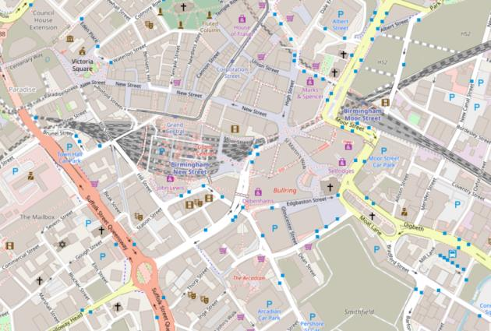

**Questions**

Based on this map, respond to the following enquiry question, using evidence:

1. ‘Do more people visit the Bullring (location 1) than other parts of Central Birmingham?’

1. How could you improve this data?

1. What limitations are there with this data?

**Pie chart**

Using the Likert Survey from Carding Mill Valley, you are going to create a pie chart.

**Instructions:** A pie chart is a circular chart. It shows the *proportion* of each group at a glance. Remember that there are 360° in a circle so each group in the pie chart will be a proportion of 360°. You are working out the percentage first then the proportion of 360. Don’t forget to add a key!

**Calculation**: Degrees of the circle = (Number of people / total number of people) x 360

e.g. (2/30) x 360 = 24 degrees

|  |  |  |  |  |  |
| --- | --- | --- | --- | --- | --- |
| **Data**: | | | |  | **Important**  Each statement should be a different pie chart. Choose **one** of these questions.  If you are confident with pie charts, create all three (two on graph paper). |
| Statement: | Flood risk to property caused by river is significant | Management of flood risk is good | More can be done to manage flood risk |  |
| Strongly agree | 2 | 3 | 1 |  |
| Agree | 5 | 7 | 5 |  |
| Neutral | 7 | 13 | 14 |  |
| Disagree | 10 | 4 | 8 |  |
| Strongly disagree | 6 | 3 | 2 |  |

.

Questions

1. Based on this pie chart, respond to the following enquiry question, using evidence: ‘Is flooding a concern to the people visiting and living in and around Carding Mill Valley?’

1. How could you improve this data?

1. What limitations are there with this data?

Fieldwork: enquiry questions

It is important to know your fieldwork enquiry questions; however, you may also be asked to create an enquiry question based on a location.

In the spaces below, suggest a list of enquiry questions which you might ask; an example has been provided for each location.

|  |
| --- |
| **A river study:**  Does the width of the river change as you move from source to mouth? |

|  |
| --- |
| **A coastal study (sand dunes):**  How does the vegetation change with distance from the sea? |

|  |
| --- |
| **A coastal study (landforms):**  Does longshore drift affect the characteristics of the coastline? |

|  |
| --- |
| **Urban study:**  How does the land use change as you move from the CBD to the suburbs? |

|  |
| --- |
| **A rural study:**  What is the impact of tourism on the rural location? |

|  |
| --- |
| Notes section for other fieldwork enquiry questions studied: |

Fieldwork: data collection

|  |
| --- |
| 1. Why is it important to have a data collection sheet? |

|  |
| --- |
| 1. Study the data collection sheet below. How could the data collection be improved? |

|  |  |  |
| --- | --- | --- |
| **Measurement type** | **Measurement 1** | **Measurement 2** |
| River depth |  |  |
| River width |  |  |
| Wetted perimeter |  |  |
| Velocity |  |  |
| Bedload width |  |  |
| Bedload shape (Powers Scale) |  |  |
| Gradient |  |  |

In the space below, draw an improved data collection sheet for the river measurements.

You could have more than one sheet if you feel that this would be more practical. Please use a pencil and a ruler when drawing your data collection sheet.

|  |
| --- |
|  |

Complete the environmental quality survey below – give four more examples of criteria that could be included.

|  |  |  |  |  |  |  |  |
| --- | --- | --- | --- | --- | --- | --- | --- |
| **Criteria** | **+3** |  | **+1** |  | **-1** |  | **-3** |
| Amount of litter |  |  |  |  |  |  |  |
| Amount of graffiti |  |  |  |  |  |  |  |
| Amount of traffic |  |  |  |  |  |  |  |
|  |  |  |  |  |  |  |  |
|  |  |  |  |  |  |  |  |
|  |  |  |  |  |  |  |  |
|  |  |  |  |  |  |  |  |

What are the advantages and disadvantages of this type of survey?

|  |
| --- |
|  |

Sampling

1. Why do we use samples in Geography?

|  |
| --- |
|  |

1. Define stratified and systematic sampling:

|  |
| --- |
|  |

1. Explain one advantage of systematic sampling.

|  |
| --- |
|  |

1. Explain one advantage of stratified sampling.

|  |
| --- |
|  |

1. 5. Explain one advantage of random sampling.

|  |
| --- |
|  |

1. Use the space below to consider how you used sampling during your fieldwork enquiry. What sampling techniques did you use? How many sites did you visit / people did you ask?

|  |
| --- |
|  |

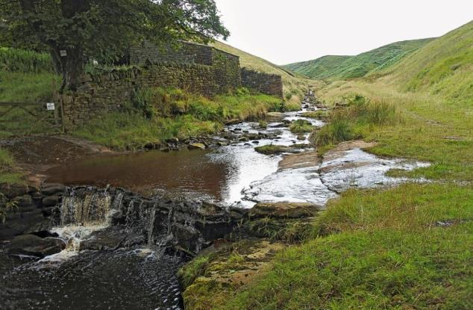

**Look at the image above:**

Describe the fieldwork enquiries that could be carried out here. Which sampling techniques would be used? What data collection techniques could be employed here?

|  |
| --- |
|  |

Methodology – quantitative data

How do we carry out fieldwork?

Complete the methodology tables below, describing the individual methods for each type of fieldwork and the equipment that could be used.

River study

|  |  |  |
| --- | --- | --- |
| **Data collected** | **Equipment required** | **How to carry it out** |
| **Gradient** |  |  |
| **Wetted perimeter** |  |  |
| **Channel width** |  |  |
| **Channel depth** |  |  |
| **Cross section** |  |  |
| **Bedload size and shape** |  |  |
| **Velocity** |  |  |

Coastal study

|  |  |  |
| --- | --- | --- |
| **Data collected** | **Equipment required** | **How to carry it out** |
| **Beach profile** |  |  |
| **Speed and direction of longshore drift** |  |  |
| **Sediment size** |  |  |
| **Sediment shape** |  |  |
| **Depth of sediment by groynes** |  |  |

Urban/rural study

|  |  |  |
| --- | --- | --- |
| **Data collected** | **Equipment required** | **How to carry it out** |
| Land use survey (transect) |  |  |
| Bipolar survey |  |  |
| Environmental quality survey |  |  |
| Questionnaire (qualitative data) |  |  |
| Traffic count |  |  |
| Pedestrian count |  |  |

Evaluating your methods

Choose four methods from the tables above.

1. Evaluate the methods – what was good / bad / could be improved?
2. Suggest how reliable the methods were.
3. Suggest how accurate your results obtained using those methods were.

|  |
| --- |
| Method 1: |

|  |
| --- |
| Method 2: |

|  |
| --- |
| Method 3: |

|  |
| --- |
| Method 4: |

Geographical skills and applications dictionary

|  |  |
| --- | --- |
| **Key word** | **Definition** |
| **Accuracy** | How close a measurement is to the true value. |
| **Aerial photograph** | A photograph taken from the air, i.e. from a plane or drone. There are two types: vertical photos which are taken straight down (birds eye view), and oblique ones, which are taken at an angle. Oblique photos tend to show more detail, e.g. the sides of buildings. |
| **Annotate** | Add notes to a diagram which comment on or explain it. |
| **Anomaly / anomalies** | Something which is different to what is expected. |
| **Bar chart** | A graph which shows the data in rectangles of equal width. There should be a gap between the bars. The data is discrete data. |
| **Biased** | When an opinion only supports one argument. Collecting data from interviews in one part of town is likely to be biased, as the opinions gathered might be found in that part of town only. |
| **Bivariate data** | Data for two variables which are related, e.g. river depth and river width. |
| **Cartographic** | Related to the practice of drawing maps. |
| **Central tendency** | The tendency for the values of a random variable to cluster around its mean, mode or median. |
| **Choropleth map** | A map which uses differences in shading, colouring or symbols to indicate a value, e.g. population density. |
| **Conclusion** | The end of a piece of fieldwork where you come to a judgment or decision. |
| **Continuous data** | Data that can be measured on a continuum or scale, e.g. something that happens over time. |
| **Contour** | Contour lines join points of equal elevation (height) on a map. On an OS map they are orange/brown. |
| **Control group** | The set of data that your results could be compared to. |
| **Correlation** | The relationship or connection between data. Data which has a strong relationship has a strong correlation. On a graph this data would be in a straight line and close together. |
| **Cumulative frequency** | The running total of frequencies. |
| **Cross section** | Showing the shape of a feature viewed from the side as if it was cut through with a knife, to show things like contours or the changing depth along a river. |
| **Depth** | How deep something is, e.g. a river. |

|  |  |
| --- | --- |
| **Desire line** | A line drawn to show the direction of movement. It is drawn from the starting point to the destination, e.g. traffic flow from the east of town to the town centre. |
| **Discrete data** | This is data that is counted and whose values cannot be subdivided, e.g. the number of students in a class, the number of different types of transport. |
| **Dispersion graph** | A graph to display the main pattern in the distribution of data. |
| **Distribution** | The way something is spread over an area. |
| **Dot map** | A map that uses a dot symbol to show data, e.g. housing distribution. |
| **Extrapolate** | When the value is found outside of the data set. This can be found by extending a set of data. |
| **Flow lines** | These show the movement between places. The thickness of the arrow indicates the amount of movement. |
| **Fluvial landscape** | Environments that surround, or have been created by, rivers. |
| **Frequency** | The rate at which something occurs over a period of time. |
| **Glacial landscape** | Environments that have been created by the movement of ice. |
| **Gradient** | The steepness of a slope. This can be an incline or a decline. |
| **Grid reference** | A particular point of a map found by using the eastings and northings that are along the bottom and the side of the map. |
| **Ground photograph** | A photograph taken at ground level. |
| **Histogram** | A diagram consisting of rectangles whose areas are proportional to the frequency of the variable. The bars are drawn touching and they portray continuous data, e.g. a pedestrian count over the course of two hours. |
| **Human landscape** | A landscape which has been modified by human activities, e.g. a settlement. |
| **Hypothesis / hypotheses** | An educated prediction which can be tested. These are statements, not questions, e.g. ‘The width of a river will increase from source to mouth’. They should be statements which can be investigated. |
| **Inference** | An idea or conclusion that is drawn from evidence or reasoning. You can make an inference about a place you have not visited by using existing data to reach a conclusion, e.g. that the mouth of a river is very wide, even though you might not visit the mouth. |
| **Interpolate** | When a value is inserted within a set of data. |
| **Interpret** | To make a judgement from a set of data or find a meaning. |
| **Interquartile range** | The middle 50% of a range of data, between the 25th and 75th percentiles or the lower and upper quartiles. |
| **Isoline map** | Maps which show areas of equal value, e.g. a weather map that shows isobars is an isoline map. |

|  |  |
| --- | --- |
| **Justification** | The reason why you think something is right or reasonable. Proving why it is right and reasonable. |
| **Latitude** | The angular distance north or south of the equator. The equator is 0˚, each line parallel to the equator is a new line of latitude. The degrees increase as you move away from the equator towards the poles. |
| **Limitation** | Something which restricts your investigation, e.g. time of day that you visited or a physical boundary which you could not pass. |
| **Line chart / line graph** | A graph which displays information as a series of points joined together by straight lines. These graphs usually show changes. Multiple pieces of data can be shown on a line graph. |
| **Longitude** | The angular distance of a place east or west of the Greenwich meridian. Greenwich is 0˚. As you move east or west, the degrees increase. |
| **Magnitude** | The size or extent of something. |
| **Mean** | The average number. |
| **Median** | The middle number when all numbers are put into numerical sequence. |
| **Mode** | The most common number. |
| **Ordnance Survey map** | A detailed map produced by the British government map-making organisation Ordnance Survey. |
| **Percentage** | A rate, number or amount in each hundred. |
| **Percentiles** | A value on a scale of 100 that indicates the percent of a distribution that is equal to or below it. |
| **Physical landscape** | A natural landscape, e.g. mountains, hills etc. |
| **Pictogram** | A way of demonstrating data by using symbols. This is for discrete data. |
| **Pie chart** | A circle which is divided into sections each representing a particular piece of data. Percentages are often shown in pie charts. |
| **Population distribution** | The pattern of where people live. |
| **Population pyramid** | This is a form of histogram showing age and gender data for a group of people. The male data is on one side and the female data on the other. The length of the bars is determined by the number of people in that age group of that gender. |
| **Primary evidence/data** | Evidence/data you have collected yourself through fieldwork or enquiry. |
| **Proportion** | A part, share or number considered in comparative relation to the whole. |
| **Proportional symbols** | Symbols that are drawn in proportion to the size of the piece of data or variable. The larger the number, the larger the symbol. |

|  |  |
| --- | --- |
| **Qualitative data** | Results that are not expressed as numbers or numerical data. This is usually opinion-based, e.g. an environmental quality survey. |
| **Quantitative data** | Results that can be expressed using numerical values. This is factual information that can be counted, e.g. river width and depth. |
| **Random sampling** | Selecting a person to interview, or site to measure, at random. This is an unbiased sampling method as you have not selected specific things. |
| **Range** | The difference between the lowest and highest values. |
| **Ratio** | The relative sizes of two or more values, e.g. 3:1 to show that for every three cars we saw, we saw one lorry. |
| **Reliability** | The degree to which results can be depended on to be accurate. |
| **Relief** | Refers to the highest and lowest elevation points in an area. |
| **Sample size** | The number of results that will be required. |
| **Sampling** | The selection of objects included in a study. |
| **Satellite photograph** | An image taken from space by a satellite. Many online maps take advantage of satellite imagery. |
| **Secondary evidence/data** | Evidence/data that you have collected from elsewhere, e.g. books, the internet or other groups. |
| **Scale** | The relationship between distance on a map and the corresponding distance on the ground. On a 1:50000 map, 1 cm represents 500 metres on the ground. |
| **Scatter graph** | A graph used to show the relationship between two sets of data. They are used to show the correlation. |
| **Sketch map** | A roughly drawn map that shows the basic details of an area. |
| **Spot height** | The altitude of a point. Shown by small numbers on the map. |
| **Stratified sampling** | Dividing samples into groups, e.g. asking 10 people in each range, or taking three specific sites on a river study. |
| **Synoptic** | A study which covers all the connections between different elements. |
| **Systematic sampling** | Collecting data in an ordered or regular way, e.g. measuring the depth of a river every 10 cm across at each site. |
| **Transect** | A line following a route along which a survey or observations are made. They help to study changes from one place to another. |
| **Trend lines** | A line indicating the general course or tendency of something. |

Image credits

© CC-by-sa PlaneMad/Wikimedia [commons.wikimedia.org/w/index.php?curid=1287596](https://commons.wikimedia.org/w/index.php?curid=1287596), (CC BY-SA 3.0)

©By Alexrk2 - own work, using SRTM Data,File:United Kingdom location map.svg by NordNordWest, CC BY-SA 3.0, [commons.wikimedia.org/w/index.php?curid=19934584](https://commons.wikimedia.org/w/index.php?curid=19934584)

©By Thamizhpparithi Maari - Own work, CC BY-SA 4.0, [commons.wikimedia.org/w/index.php?curid=76376759](https://commons.wikimedia.org/w/index.php?curid=76376759)

©Mappleton, a case study in coastal management: aerial 2018, [cc-by-sa/2.0](http://creativecommons.org/licenses/by-sa/2.0/) - © [Chris](https://www.geograph.org.uk/profile/79357) - [geograph.org.uk/p/5720146](https://www.geograph.org.uk/photo/5720146)

© CQ2, City Quays site, Belfast - January 2014(1), cc-by-sa/2.0 - © Albert Bridge - geograph.org.uk/p/3816439

Thank you to our Contirubtor, Fiona Old for permission to use her photographs throughout.

River Cocker, Cockermouth, [cc-by-sa/2.0](http://creativecommons.org/licenses/by-sa/2.0/) - © [David Dixon](https://www.geograph.org.uk/profile/43729) - [geograph.org.uk/p/3933082](https://www.geograph.org.uk/photo/3933082)

Northampton: St Giles Street, cc-by-sa/2.0 - © John Sutton - geograph.org.uk/p/5555939

© By power.corrupts, kwinkunks - Ternary_plot_1.png, CC BY-SA 4.0, [commons.wikimedia.org/w/index.php?curid=30518683](https://commons.wikimedia.org/w/index.php?curid=30518683)

©[It's No Game](https://www.flickr.com/photos/duncanh1/), 2017, flic.kr/p/Y6Gv6T