Geogrevise – AQA Coastal Environments
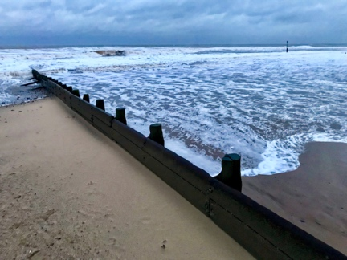
Improve learning by reducing forgetting using retrieval practice Retrieval practice involves retrieving and using knowledge. Through thinking about and using what we know we strengthen learning. Low stakes quizzes, flashcards and quick writing can be used to improve learning. We’ve put together this resource to help you support your child enhance their learning in geography. This GEOGREVISE focuses on the AQA GCSE Geography Coastal Environments units. Resources to support revision for this unit are available here: www.internetgeography.net/topics/coasts/
Homework Tips Checklist for Parents

Waves
- What is a wave?
- What causes waves?
- What 3 factors affect the size of waves?
- What is the fetch of a wave?
- What word describes the movement of a wave up a beach?
- What word describes the movement of a wave down a beach?
- Identify the two types of wave.
- Which type of wave builds beaches?
- Which type of wave has a strong swash and a weak backwash?
- Describe the swash and backwash of a destructive wave.

Coastal Processes – Weathering
- What is weathering?
- What is mechanical weathering?
- Describe the processes of freeze-thaw weathering.
- Describe the characteristics of rock that has recently gone through freeze-thaw.
- What is salt weathering?
- What is chemical weathering?
- Describe carbonation weathering

Coastal Processes – Mass Movement
- What is mass movement?
- Identify 4 types of mass movement.
- Describe the process of slumping
- Large blocks of rock sliding downhill is which type of mass movement?
- Which type of mass movement involves fragments of rock breaking away from the cliff face, often due to freeze-thaw weathering?
- Which type of mass movement involves saturated soil and weak rock flows down a slope, typically where cliffs are made up of boulder clay?

Coastal Processes – Erosion
- What is coastal erosion?
- Identify the main processes of coastal erosion.
- Give an outline of what corrasion involves.
- Give an outline of what abrasion involves.
- Give an outline of the steps involved in hydraulic action.
- What is attrition?
- What is corrosion/solution?

Coastal Processes – Transportation
- What is coastal transportation?
- Identify the 4 main processes of coastal transportation.
- What is traction?
- What is saltation?
- What is suspension?
- What is solution?
- What is the zig-zag movement of material along the shore by wave action called?
- What is longshore drift also known as?
- Describe how longshore drift transports material.

Coastal Processes – Deposition
- What is coastal deposition?
- Why does coastal deposition occur?
- Give three conditions that lead to coastal deposition happening.

Landforms of coastal Erosion
- What is a headland?
- What is a bay?
- Do headlands form along concordant or discordant coastlines?
- What is a discordant coastline?
- What is a concordant coastline?
- Explain the formation of bays and headlands.
- Why are sandy beaches likely to form in bays?
- What is a wave-cut platform?
- Explain the formation of a wave-cut platform.
- Produce an annotated diagram to show the formation of a stump.
- Identify your case study location for landforms of coastal erosion.
- Describe the landforms that have formed here.

Landforms of coastal deposition
- Identify 3 landforms of coastal deposition
- What is a beach?
- Where do sandy beaches typically form?
- Draw a beach profile.
- What are ridges and runnels?
- What is a spit?
- Produce an annotated diagram to show the main features of a spit.
- What is a bar?
- Explain the formation of a bar.
- What is an off-shore bar?
- How are off-shore bars formed?
- What is a sand dune?
- How are sand dunes formed?

Hard Engineering
- What is hard engineering?
- Give three examples of hard engineering techniques used to protect the coast.
- How does a groyne help reduce coastal erosion?
- What is the impact of groynes down drift?
- Give an advantage of using rock armour to protect the coast.
- What are gabions?

Soft Engineering
- What is soft engineering?
- Give three examples of soft engineering.
- Identify the soft engineering techniques being described below.

- This is when areas of the coast are allowed to erode. This is usually in areas where the land is of low value.
- Beaches are made higher and wider by importing sand and shingle to an area affected by longshore drift.
- This involves taking action to build up dunes and increase vegetation
- This technique involves redistributing sediment from the lower part of the beach to the upper part of the beach.

Case Study of Coastal management
- Identify your coastal management case study location.
- Why are coastal management strategies needed at your location?
- Identify the coastal management strategies used at your location.
- What have been the positive impacts of the coastal management strategy?
- What have been the negative impacts of the coastal management strategy?
- What conflicts have occurred as the result of the management strategy?

Answers

Waves
- A wave is a disturbance on the surface of the sea or ocean, in the form of a moving ridge or swell.
- Waves are caused by the transfer of energy from the wind to the sea due to the friction of wind on the water’s surface.
- Fetch, wind speed and wind duration
- The distance a wave has travelled
- Swash
- Backwash
- Destructive and constructive
- Constructive
- Constructive
- Weak swash, strong backwash

Coastal Processes – Weathering
- Weathering is the breakdown of rock in situ by the action of rainwater, extremes of temperature, and biological activity.
- Mechanical weathering is the breakdown of rock without changing its chemical structure (composition).
- Freeze-thaw weathering occurs when rocks are porous (contain holes) or permeable (allow water to pass through). Water enters the rock and freezes. The ice expands by around 9%. This causes pressure on the rock until it cracks. Repeated freeze-thaw can cause the rock to break up.
- Recently weathered rock can be seen at the foot of chalk and limestone cliffs and is easily identified because it is angular.
- Salt weathering is when salt spray from the sea gets into a crack in a rock. It may evaporate and crystallise, putting pressure on the surrounding rock and weakening the structure.
- Chemical weathering is the breakdown of rock through changing its chemical composition.
- When rainwater hits rock it decomposes it or eats it away. This is known as carbonation. This occurs when slightly acidic (carbonic) rain or sea water comes into contact with sedimentary rock, such as limestone or chalk, it causes it to dissolve. A chemical reaction occurs between the acidic water and the calcium carbonate and forms calcium bicarbonate. This is soluble and is carried away in solution. Carbonation weathering occurs in warm, wet conditions.

Coastal Processes – Mass Movement
- Mass Movement is the downhill movement of cliff material under the influence of gravity.
- Rock fall, landslide, mudslide and slumping
- The soft boulder clay holds rainwater and run-off. Waves erode the base of the cliff creating a wave-cut notch. The clay becomes saturated and forms a slip plane. The weight of the saturated cliff causes it to slump.
- Landslide
- Rockfall
- Mudslide / mudflow

Coastal Processes – Erosion
- Coastal erosion is the wearing away of the land by the sea.
- Corrasion, abrasion, hydraulic action, attrition and corrosion/solution.
- Corrasion is when destructive waves pick up beach material (e.g. pebbles) and hurl them at the base of a cliff. Over time this can loosen cliff material forming a wave-cut notch.
- Abrasion occurs as breaking waves, concentrated between the high and low watermarks, which contain sand and larger fragments wear away the base of a cliff or headland. It is commonly known as the sandpaper effect. This process is particularly common in high-energy storm conditions.
- Waves hitting the base of a cliff causes leads to air compression in cracks, joints and folds in bedding planes causing repeated changes in air pressure. As air rushes out of the crack when the wave retreats it leads to an explosive effect as pressure is released. This process is supported further by the weakening effect of weathering. Material breaks off cliffs, sometimes in huge chunks. This process is known as hydraulic action.
- Attrition is when waves cause rocks and pebbles to bump into each other and break up.
- Corrosion/solution is when certain types of cliff erode as a result of weak acids in the sea.

Coastal Processes – Transportation
- The movement of sediment and beach material through wave action.
- Solution, suspension, saltation and traction
- Traction – large pebbles and boulders are rolled along the seafloor.
- Saltation – beach material is bounced along the seafloor.
- Suspension – beach material is suspended and carried by the waves.
- Solution – material is dissolved and carried by the water.
- Longshore Drift
- Littoral drift
- Longshore drift happens when waves approach the beach at an angle. The swash (waves moving up the beach) carries material up and along the beach. The backwash (waves moving back down the beach) carries material back down the beach at right angles. This is the result of gravity. This process slowly moves material along the beach and provides a link between erosion and deposition. The material is transported through suspension, traction, solution and saltation. Longshore drift provides a link between erosion, transportation and deposition.

Coastal Processes – Deposition
- Coastal transportation involves material being transported by the sea being deposited or dropped.
- Wave energy reduces leading to material being deposited.
- Any three from: Waves enter an area of shallow water / waves enter a sheltered area, eg a cove or bay / there is little wind / a river or estuary flows into the sea reducing wave energy / there is a good supply of material and the amount of material being transported is greater than the wave energy can transport.

Landforms of coastal Erosion
- A headland is a cliff that sticks out into the sea and is surrounded by water on three sides.
- A bay is an inlet of the sea where the land curves inwards
- Headlands form along discordant coastlines
- A discordant coastline is where the geology alternates between strata (bands) of soft and hard rock.
- A concordant coastline is where the same rock runs along the length of the coast. Concordant coastlines tend to have fewer bays and headlands.
- The bands of soft rock, such as sand and clay, erode more quickly than those of more resistant rock, such as chalk. This leaves a section of land jutting out into the sea called a headland. The areas where the soft rock has eroded away, next to the headland, are called bays.
- Sandy beaches are often found the sheltered bays where waves lose energy, and their capacity to transport material decreases resulting in material being deposited.
- A wave-cut platform is a wide, gently sloping surface found at the base of the cliff and extends into the sea.
- A wave-cut platform is formed when:
- The sea attacks a weakness in the base of the cliff. For example, this could be a joint in chalk.
- A wave-cut notch is created by erosional processes such as hydraulic action and abrasion.
- As the notch becomes larger the cliff becomes unstable and collapses as the result of gravity.
- The cliff retreats inland.
- The material from the collapsed cliff face is eroded and transported away. This leaves a wave-cut platform.
- The process repeats over time.
- 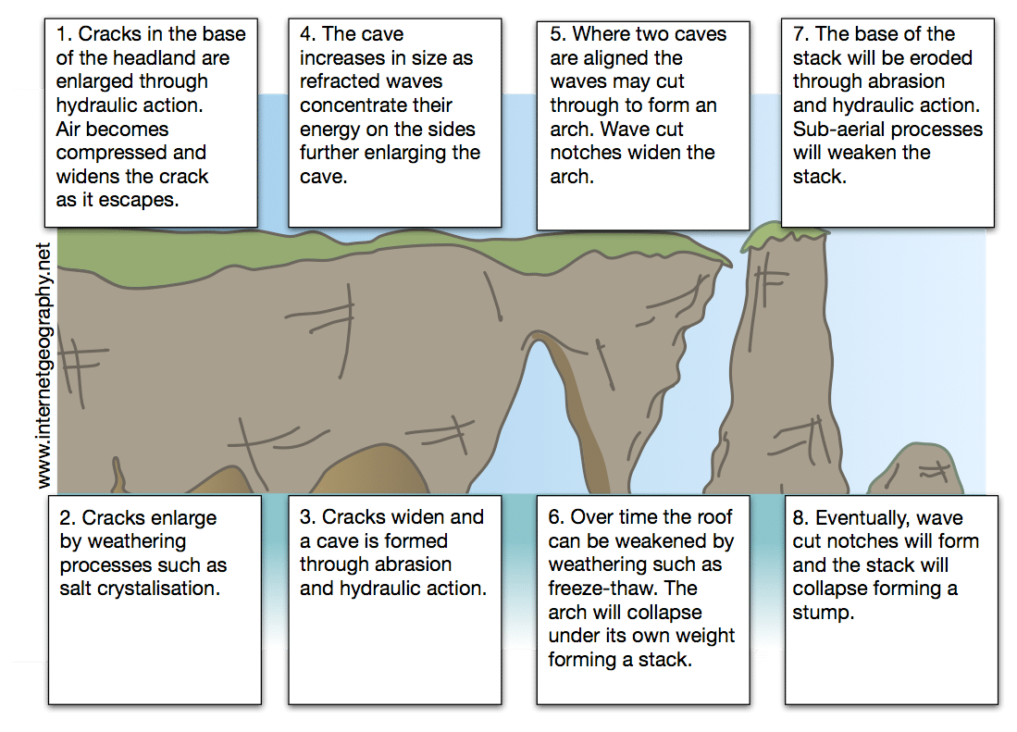
- The case study location will be identified e.g. Flamborough Head / Durdle Door / Old Harry Rocks
- Landforms will include wave cut platforms, headlands, bays, stacks, arches and stumps.

Landforms of coastal deposition
- Beaches, sand dunes, spits and bars.
- The beach is the area between the lowest spring tide level and the point reached by the storm waves in the highest tides.
- A sandy beach is usually formed in a sheltered bays, where low energy, constructive waves transport material onto the shore.
- 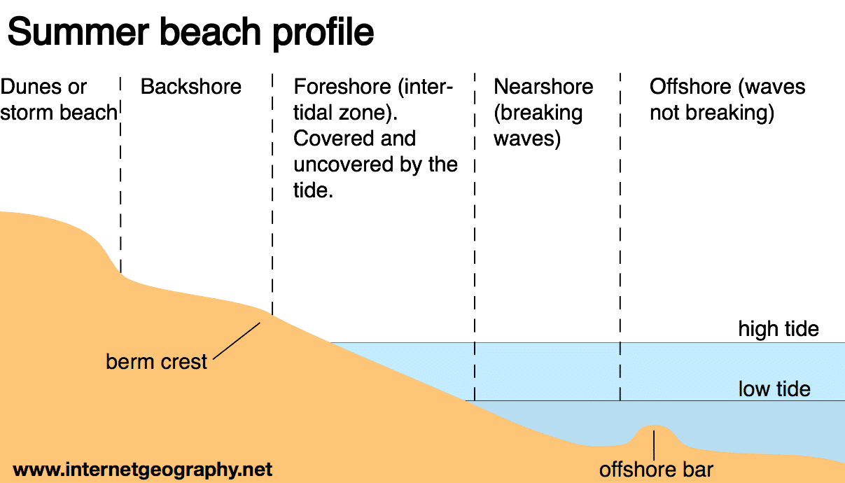
- Ridges are areas of the beach that are raised. The dips are water-filled troughs called runnels.
- A spit is an extended stretch of beach material that sticks out to sea and is joined to the mainland at one end.
- 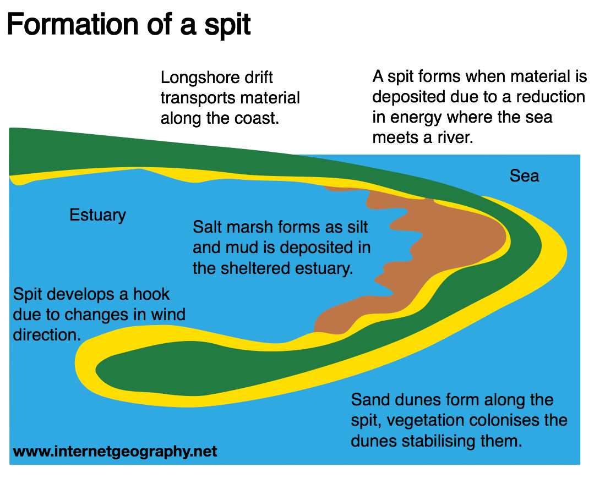
- A bar is a ridge of sand or single that joins two headlands either side of a bay.
- A bar is created when there is a gap in the coastland with water in it. This could be a bay or a natural hollow in the coastland. The process of longshore drift occurs and this carries material across the front of the bay.
Material is pushed up onto beaches at an 45 degree angle when the swash brings it onto the coastline. The backwash takes it back out towards the sea at a right angle to the coast. Through this process material is constantly moved along the coastline. The deposited material eventually joins up with the other side of the bay and a strip of deposited material blocks off the water in the bay. The area behind the newly formed bar is known as a lagoon.
- An offshore bar is a raised area of seabed that is found offshore.
- Offshore bars form when sediment is transported on and off a beach. Destructive waves remove sediment from the beach and form the offshore bar.
- A sand dune is a small ridge or hill of sand found at the top of a beach, above the reach of the waves.
- Onshore winds (winds blowing inland from the sea) cause the formation of sand dunes at the back of a beach. Sand is deposited by the wind around an object such as a rock, forming embryo dunes. Over time, vegetation such as marram grass stabilise the sand dunes forming foredunes. As the vegetation around the foredunes decomposes nutrients are released and soil begins to form. A wider range of plants are then able to colonise the dunes.

Hard Engineering
- Hard engineering involves building artificial structures which try to control natural processes.
- Groynes, rock armour, sea walls, revetments, gabions or breakwater.
- Groynes trap material being transported by longshore drift. This builds up a wide beach which helps absorb energy from waves, reducing the rate of cliff erosion.
- Beaches beyond the defences are starved of beach material due to their impact on longshore drift.
- Cheap and efficient at reducing energy in waves approaching the coast.
- Gabions are coastal defences that consist of rocks and boulders encased in a wired mesh. They absorb the energy from waves.

Soft Engineering
- Soft engineering does not involve building artificial structures but takes a more sustainable and natural approach to managing the coast.
- Beach nourishment, managed retreat, dune regeneration, brief reprofiling.
- Answers include:
- Managed retreat (coastal realignment)
- Beach nourishment
- Dune regeneration
- Beach reprofiling

Case Study of Coastal management
The answers to this section will depend on the case study used. Below is some guidance of the type of things that should be included.
- The name of the location where the coastal management scheme will be given.
- Social, economic and environmental reasons may be given here.
- The difference types of coastal management strategies will be given e.g. groynes, rock armour, sea wall etc.
- Positive social, economic and environmental impacts of the coastal management strategy will be given.
- Negative social, economic and environmental impacts of the coastal management strategy will be given.
- Conflicts between different groups will be given here.

