Geogrevise – AQA The Challenge of natural hazards
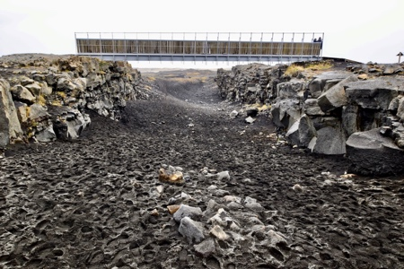
Improve learning by reducing forgetting using retrieval practice Retrieval practice involves retrieving and using knowledge. Through thinking about and using what we know we strengthen learning. Low stakes quizzes, flashcards and quick writing can be used to improve learning. We’ve put together this resource to help you support your child enhance their learning in geography. This GEOGREVISE focuses on the AQA GCSE Geography Challenge of Natural Hazards unit. Resources to support revision for this unit are available on this page: https://www.internetgeography.net/aqa-gcse-geography/the-challenge-of-natural-hazards/
Homework Tips Checklist for Parents

Retrieval Practice
Homework Tips Checklist for Parents
Retrieval Practice
Homework Tips Checklist for Parents

Natural hazards
- What is a natural hazard?
- How can natural hazards be classified?
- Give one reason why the incidence of natural hazards is increasing.
- What factors affect hazard risk?

Structure of the earth
- What is the structure of the Earth?
- What are the characteristics of the inner core?
- What are the characteristics of the outer core?
- What are the characteristics of the mantle?
- What is the name of the upper portion of the mantle?
- What is the lithosphere?
- What are the two types of crust called?
- Give 2 characteristics of continental crust
- Give 2 characteristics of oceanic crust.
- What is the area where two plates meet known as?
- What are the three types of plate margin?
- Give two possible reasons why plates move
- Explain ridge push and slab pull as a cause of plate movement.
- Do volcanoes and earthquakes occur at all plate margins?
- Where in the world are the majority of the Earth’s volcanoes and earthquakes found?
- Describe the global distribution of volcanoes and earthquakes.
- Some volcanoes occur in the middle of plates. What are these known as?
- Give an example of a location where volcanoes occur at a volcanic hot spot.

Constructive plate margins
- Draw a diagram to show the main features of a constructive plate margin.
- Describe the physical processes that happen at constructive plate margin.
- Give an example of two tectonic plates that form a constructive plate margin
- Identify the type of volcano that forms on constructive plate margins
- What is a rift valley?

Destructive plate margins
- Describe the physical processes that happen at a destructive plate margin.
- Give an example of two tectonic plates that form a destructive plate margin
- Identify the type of volcano that form on destructive plate margins

conservative plate margins
- Describe the physical processes that happen at a conservative plate margin.
- Give an example of two tectonic plates that form a conservative plate margin
- Why are volcanoes not found along conservative plate margins?

tectonic hazards – effects and responses
- What is the difference between a primary and secondary effect of natural hazard?
- Give three examples of primary effects of earthquakes.
- Give three examples of secondary effects of earthquakes.
- Give three examples of primary effects of volcanic eruptions.
- Give three examples of secondary effects of volcanic eruptions.
- Give three immediate responses to tectonic hazards.
- Give three long term effects of a tectonic hazard.

comparing tectonic hazards
- For a tectonic hazard you have studied in an HIC identify 3 primary effects
- For a tectonic you have studied in an HIC identify 3 secondary effects
- For a tectonic you have studied in an HIC identify 3 immediate responses
- For a tectonic you have studied in an HIC identify 3 long term responses
- For a tectonic hazard you have studied in an LIC identify 3 primary effects
- For a tectonic you have studied in an LIC identify 3 secondary effects
- For a tectonic you have studied in an LIC identify 3 immediate responses
- For a tectonic you have studied in an LIC identify 3 long term responses
- Give 3 reasons tectonic hazards tend to have a greater impact in LICs than HICs

Management of tectonic hazards
- Give 3 economic reasons why people live in areas at risk of tectonic hazards
- Give one social reason why people live in areas at risk of tectonic hazards
- Identify the 3 categories used to reduce the risks associated with tectonic hazards.
- Give definitions of each of the three categories identified above.

global atmospheric circulation
- What is global atmospheric circulation?
- What drives global atmospheric circulation?
- Describe the main characteristics of global atmospheric circulation.

tropical storms
- What is a tropical storm?
- Where do tropical storms occur?
- Why do tropical storms occur where they do?
- How do tropical storms form?
- Draw a simple diagram to show the structure and features of a tropical storm
- Why does a tropical storm spin?
- What direction do tropical storms travel in?
- Why do they travel in this direction?
- How might climate change affect tropical storms?
- Give three effects of a tropical storm
- How are tropical storms measured?
- Give three ways Governments respond to tropical storms

tropical storms case study
- Identify the tropical storm case study you have studied.
- What were the primary effects of the tropical storm?
- What were the secondary effects of the tropical storm?
- What were the immediate responses?
- What were the long-term responses?

reducing the effects of tropical storms
- How are tropical storms monitored?
- How can tropical storms be predicted?
- Give three ways people can protect themselves and their property from the impact of tropical storms
- Give three ways people can plan to reduce the risks associated with tropical storms

extreme weather hazards in the uk
- What extreme weather events affect the UK?
- Identify a case study of an extreme weather hazard in the UK
- What caused the hazard?
- What were the social impacts of the extreme weather?
- What were the economic impacts of the extreme weather?
- What were the environmental impacts of the extreme weather?
- Give an example of how management strategies have reduced the risk of extreme weather in the example you have studied.
- What does the rainfall record for the UK tell us about changes in storm frequency?
- What does the temperature record for the UK tell us about changes in drought frequency?
- What are the extreme weather predictions for the future in the UK?

Climate change
- What is the quaternary period?
- Give three pieces of evidence for climate change.
- What is the evidence for climate change being a natural phenomenon?
- Give three causes of natural climate change
- Select one cause and explain how it causes the climate to change.
- What is the greenhouse effect?
- Why is the greenhouse effect important to life on Earth?
- What is the enhanced greenhouse effect?
- Identify three ways humans cause climate change
- Explain how deforestation causes climate change
- Explain how burning fossil fuels causes climate change
- Explain how agriculture causes climate change.
- Give 4 social effects of climate change
- Give 4 environmental effects of climate change

managing climate change
- What is mitigation?
- Identify 5 ways the causes of climate change can be reduced.
- How does planting trees reduce CO2?
- How can international agreements reduce CO2?
- What is carbon capture and storage?
- What is adaptation?
- What is the difference between mitigation and adaptation?
- Identify three ways climate change can be managed through adaptation.
- How can adaptations in agricultural systems help manage the impact of climate change?

Answers

Natural hazards
- What is a natural hazard?
A natural hazard is a natural event such as an earthquake, volcanic eruption, tropical storm or flood that has the potential to cause death and damage.
- How can natural hazards be classified?
- Tectonic hazards
- Atmospheric hazards
- Geomorphological hazards
- Biological hazards
- Give one reason why the incidence of natural hazards is increasing.
- Global warming
- Deforestation
- Urbanisation
- Population increase
- What factors affect hazard risk?
- An increase in the number of people vulnerable to the natural hazard (e.g. population growth & increased population density close to hazard-prone areas)
- An increase in the frequency and magnitude of the natural hazard
- A decrease in the number of people capable of coping with the natural hazard

STructure of the earth

- What is the structure of the Earth?
- Inner core
- Outer core
- Mantle
- Crust
- What are the characteristics of the inner core?
Solid mass of iron and nickel. Hottest part of the Earth. Temperatures up to 5,550°C.
- What are the characteristics of the outer core?
Layer surrounding the inner core. Liquid layer of icon and nickel.
- What are the characteristics of the mantle?
Thickest section of the Earth. Approximately 2900km. Made up of semi-molten rock called magma.
- What is the name of the upper portion of the mantle?
Asthenosphere
- What is the lithosphere?
The rigid layer formed by the crust and upper mantle.
- What are the two types of crust called?
Oceanic and continental crust
- Give 2 characteristics of continental crust
- Less dense than oceanic crust
- Thicker than oceanic crust
- Lighter than oceanic crust
- Forms the Earth’s continents
- Older than oceanic crust
- Give 2 characteristics of oceanic crust.
- More dense than continental crust
- Heavier than continental crust
- Younger than continental crust
- Thinner than continental crust.
- What is the area where two plates meet known as?
A plate margin or boundary.
- What are the three types of plate margin?
Constructive, conservative and destructive.
- Give two possible reasons why plates move
Convection currents & Slab pull (+ ridge push).
- Explain ridge push and slab pull as a cause of plate movement.
Ridge push – magma rises as the plates move apart. The magma cools to form new plate material. As it cools It become denser and slides down away from the ridge. This causes other plates to move away from each other.
Slab pull – The denser plate sinks back in to the mantle under the influence of gravity. It pulls the rest of the plate along behind it.
- Do volcanoes and earthquakes occur at all plate margins?
Volcanoes and earthquakes occur at all plate boundaries except at a conservative margin where only earthquakes happen.
- Where in the world are the majority of the Earth’s volcanoes and earthquakes found?
The majority of the Earth’s volcanoes and earthquakes occur around the Pacific Ring of Fire.
- Describe the global distribution of volcanoes and earthquakes
Earthquakes are found along all types of plate margins. Volcanoes however, only occur at constructive and destructive plate margins. Volcanoes are also found away from plate margins at volcanic hot spots such as Hawaii in the Pacific Ocean.
- Some volcanoes occur in the middle of plates. What are these known as?
Volcanic hotspot
- Give an example of a location where volcanoes occur at a volcanic hot spot.
Hawaii, Yellowstone and The Deccan Traps.

Constructive plate margins
- Draw a diagram to show the main features of a constructive plate margin.
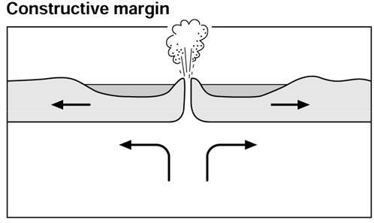

- Describe the physical processes that happen at constructive plate margin.
At a constructive plate margin magma rises between two tectonic plates. The plates move away from each other due to ridge push and slab pull. The magma cools to form new plate. On land rift valleys form such as the East African rift valley. Where two oceanic plates move apart new islands can be formed e.g. Iceland.
- Give an example of two tectonic plates that form a constructive plate margin
North American and Eurasian Plate, South American plate and African Plate, Pacific plate and Nazca plate and the Cocos plate and Pacific plate.
- Identify the type of volcano that forms on constructive plate margins
Shield volcanoes
- What is a rift valley?
A long, narrow valley lying between two normal geologic faults. Rift valleys usually form where the Earth's lithosphere has become thin through extension associated with plate-tectonic processes.

Destructive plate margins
- Draw a diagram to show the main features of a destructive plate margin
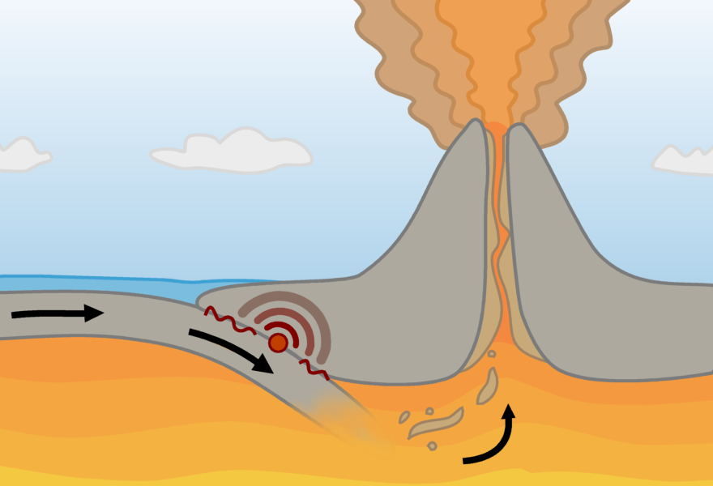
- Describe the physical processes that happen at a destructive plate margin.
When oceanic and continental plates collide the denser oceanic plate subducts the continental plate and enters the mantle where it melts. Magma can rise through the lithosphere and erupt as lava through volcanoes. As the oceanic plate subducts, it gets stuck due to friction. Pressure builds up until it is released as an earthquake.
- Give an example of two tectonic plates that form a destructive plate margin
Pacific and Eurasian plate, Nazca and South American plate, Philippines and Eurasian plate and the Indo-Australian and Pacific plate.
- Identify the type of volcano that form on destructive plate margins
Composite volcano

conservative plate margins
- Describe the physical processes that happen at a conservative plate margin.
At a conservative margin two plates move parallel to each other. They can be moving in the same or opposite directions. Pressure builds along the margin of tectonic plates. As friction is overcome the rock fractures releasing energy as an earthquake.
- Give an example of two tectonic plates that form a conservative plate margin.
North American and Pacific plates, Cocos and Nazca plates, Arabian and Indo-Australian plates and the African and Eurasian plates.
- Why are volcanoes not found along conservative plate margins?
The main reason for this is that no volcanic activity occurs at the margin, only earthquakes. This is because a conservative plate margin, sometimes known as a transform fault, is where two plates shear past each other without direct collision.

tectonic hazards – effects and responses
- What is the difference between a primary and secondary effect of natural hazard?
primary effects - things that happen immediately as a result of an earthquake
secondary effects - things that happen in the hours, days and weeks after the initial earthquake
- Give three examples of primary effects of earthquakes.
- Property, buildings and homes destroyed
- People injured and killed
- Ports, bridges, roads and railways damaged
- Pipes (water & gas) and electric cables broken
- Give three examples of secondary effects of earthquakes.
- Business reduced, and money spent repairing damage, so the economy slows
- Emergency services are hindered by blocked transport infrastructure leading to more casualties
- Broken gas pipes and fallen electricity cables cause fires leading to further injuries, death and damage
- Disease spreads due to the lack of clean water as water pipes are damaged and poor sanitation
- Give three examples of primary effects of volcanic eruptions.
- People and livestock injured and killed. Property and farmland destroyed. This is due to lava and pyroclastic flows and ash causing buildings to collapse
- Contaminated water supplies from ash fall and the release of gases such as Sulphur dioxide
- Airspace closed due to the risk of volcanic ash in the atmosphere affecting engines
- Give three examples of secondary effects of volcanic eruptions.
- Economy slows due to the impact of the volcanic eruption on infrastructure
- Snow and ice caused to melt causing widespread flooding. Ash mixes with flood water causing lahars (mudflows) destroying property and killing people
- Tourism increases as people want to visit places affected by volcanic eruptions
- Soil becomes more fertile as volcanic ash provides
- Give three immediate responses to tectonic hazards.
- Issue warnings to those at risk
- Rescue teams search for survivors
- Injured receive treatment
- Shelter, food and drink provided
- Recover bodies
- Fight fires
- Give three long term effects of a tectonic hazard.
- Buildings and transport infrastructure repaired and rebuilt
- Regulations and building codes improved
- Utilities such as gas, electricity and water restored
- Resettle local people affected by the tectonic hazard
- Develop strategies to recover the economy
- Install and/or upgrade monitoring technology

comparing tectonic hazards
Responses to these questions will vary depending on the case study studied in class. Below are some example answers based on the 2009 earthquake in L’Aquila, Italy (HIC) and the one in Nepal (LIC) in 2015.

- For a tectonic hazard you have studied in an HIC identify 3 primary effects
- 308 people killed, and 1,500 people injured
- 65000 people made homeless
- Between 3000 and 11000 buildings destroyed
- The European Union reported US$ 11,434 million damage to L’Aquila
- For a tectonic you have studied in an HIC identify 3 secondary effects
- Aftershocks triggering landslides and rockfalls, causing damage to housing and transport
- A landslide and mudflow were caused by a burst main water supply pipeline near the town of Paganio.
- The numbers of students at L’Aquila University has decreased since the earthquake.
- The lack of housing for all residents meant house prices and rents increased.
- Much of the city’s central business district was cordoned off due to unsafe buildings.
- Some ‘red zones’ still exist, which has reduced the amount of business, tourism and income.
- For a tectonic you have studied in an HIC identify 3 immediate responses
- For those made homeless, hotels provided shelter for 10,000 people and 40,000 tents were given out. Some train carriages were used as shelters.
- The prime minister of Italy, Silvio Berlusconi, reportedly offered some of his homes as temporary shelters.
- Within an hour, the Italian Red Cross was searching for survivors. They were helped by seven dog units, 36 ambulances and a temporary hospital. Water, hot meals, tents and blankets were distributed.
- The British Red Cross raised £ 171,000 in support.
- Mortgages and bills for Sky TV, gas and electric were suspended.
- The Italian Post Office offered free mobile calls, raised donations and gave free delivery for products sold by small businesses.
- L’Aquila was declared a state of emergency, which sped up international aid to the area from the EU and the USA. The EU granted US $ 552.9 million from its Solidarity Fund for major disasters to begin rebuilding L’Aquila. The Disasters Emergency Committee (DEC), a UK group, did not provide aid because it considered Italy a more developed country which had the resources to provide help, and had the help of the EU.
- For a tectonic you have studied in an HIC identify 3 long term responses
- A torch-lit procession, which took place with a Catholic mass on the anniversary of the earthquake, as an act of remembrance.
- Residents did not have to pay taxes during 2010.
- Students were given free public transport, discounts on educational equipment and were exempt from university fees for three years.
- Homes took several years to rebuild, and historic centres are expected to take approximately 15 years to rebuild.
- In October 2012, six scientists and one government official were found guilty of manslaughter as they had not predicted the earthquake. They were accused of giving residents a false sense of confidence and seriously underestimating the risks. They each received six years in prison and were ordered to pay several million euros in damages. However, in November 2014, the verdict was overturned for the six scientists.
- For a tectonic hazard you have studied in an LIC identify 3 primary effects
- 8,632 dead and 19,009 injured.
- US $5 billion damage
- 1 million people were made homeless
- 7000 schools and 26 hospitals destroyed
- For a tectonic you have studied in an LIC identify 3 secondary effects
- 19 people were killed on Mount Everest by landslides and avalanches
- Tourism declined leading to job losses in tourism
- Food shortage due to the loss of harvest
- Economic losses were estimated to be between nine per cent to 50 per cent of GDP by The United States Geological Survey (USGS)
- Many landslides occurred along steep valleys. 250 people were killed when the village of Ghodatabela was covered in material.
- For a tectonic you have studied in an LIC identify 3 immediate responses
- India and China provided over $1 billion of international aid
- Over 100 search and rescue responders, medics and disaster and rescue experts were provided by The UK along with three Chinook helicopters for use by the Nepali government.
- The GIS tool “Crisis mapping” was used to coordinate the response.
- Aid workers from charities such as the Red Cross came to help.
- Temporary housing was provided, including ‘Tent city’ in Kathmandu.
- For a tectonic you have studied in an LIC identify 3 long term responses
- A $3 million grant was provided by the The Asian Development Bank (ADB) for immediate relief efforts, and up to $200 million for the first phase of rehabilitation.
- Many countries donated aid. £73 million was donated by the UK (£23 million by the government and £50 million by the public). In addition to this the UK provided 30 tonnes of humanitarian aid and eight tonnes of equipment.
- Give 3 reasons tectonic hazards tend to have a greater impact in LICs than HICs
- Poor construction standards
- Corruption, particularly in planning and construction
- Monitoring and prediction systems are less developed
- Medical facilities cannot cope with the influx of injured people
- There is a lack of resources / finances to effectively respond following a natural disaster
- Poor transport infrastructure

Management of tectonic hazards
- Give 3 economic reasons why people live in areas at risk of tectonic hazards
- Geothermal energy provides employment opportunities and energy for the area
- Nutrient rich soil provide ideal conditions for agriculture
- Mining provides income and energy
- Jobs are created in tourism which provides income for locals
- Moving may be expensive
- Give one social reason why people live in areas at risk of tectonic hazards
- People want to be close to friends and family
- Local people may not understand the risk, or the threat may not be great enough
- People may feel confident that their properties will keep them safe
- Identify the 3 categories used to reduce the risks associated with tectonic hazards.
- Monitoring and prediction
- Protection
- Planning
- Give definitions of each of the three categories identified above.
- Monitoring and prediction = Monitoring involves using technology to observe earth tremors. Prediction involves experts using this data to calculate where earthquakes are likely to happen, however it's very difficult to predict when they will happen.
- Protection = Many areas prone to earthquake hazards now use building codes. Any new building or adjustment to existing buildings must be built to strict guidelines that would protect people from future earthquake hazards. Protection involves constructing buildings so that they are safe to live in and will not collapse.
- Planning/preparation = Hospitals, emergency services and residents practise for an earthquake in earthquake-prone countries. They have drills in all public buildings so that people know what to do in the event of an earthquake. This helps to reduce the impact and increases people's chance of survival.

global atmospheric circulation
- What is global atmospheric circulation?
The movement of air across the planet in a specific pattern.
- What drives global atmospheric circulation?
Heat at the equator.
- Describe the main characteristics of global atmospheric circulation.
Air rises at the equator, leading to low pressure and rainfall. When the air reaches the edge of the atmosphere, it cannot go any further and so it travels to the north and south. The air becomes cold and falls to create high pressure and dry conditions at around 30° north and south of the equator. Large cells of air are created in this way. Air rises again at around 60° north and south and descends again around 90° north and south.

tropical storms
- What is a tropical storm?
A tropical storm is a very powerful low-pressure weather system which results in strong winds (over 120 km/h) and heavy rainfall (up to 250 mm in one day).
- Where do tropical storms occur?
They occur between 5 and 30° north and south of the equator and form over oceans.
- Why do tropical storms occur where they do?
Tropical storms occur between 5 and 30° north and south of the equator because this area provides intense low pressure so that warm, moist air is able to rapidly rise through the atmosphere.
- How do tropical storms form?
Tropical Storms start within 5º and 30º north and south of the equator where surface sea temperatures reach at least 26.5ºC. The air above the warm sea is heated and rises. This causes low pressure. As the air rises it cools then condenses, forming clouds. The air around the weather system rushes in to fill the gap caused by the rising air. The air begins to spiral. This is caused by the spinning movement of the earth.
- Draw a simple diagram to show the structure and features of a tropical storm
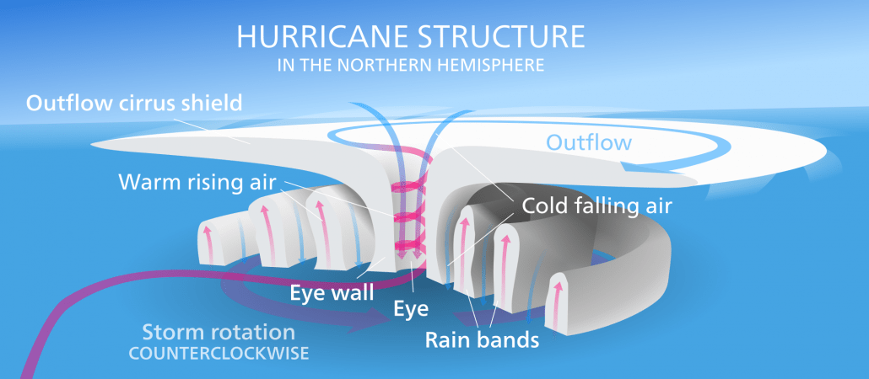
- Why does a tropical storm spin?
The air begins to spiral which is caused by the spinning of the Earth.
- What direction do tropical storms travel in?
East to west.
- Why do they travel in this direction?
The rotation of the Earth.
- How might climate change affect tropical storms?
It's unclear whether climate change will increase or decrease the number of hurricanes, but climate models predict that their intensity may increase. There may be more in the South Atlantic as sea level temperatures increase.
- Give three effects of a tropical storm
Answers could include (but not limited to):
- Damage to property
- People being made homeless
- Storm surge causing flooding
- How are tropical storms measured?
- The intensity of tropical storms is measured on the Saffir-Simpson scale, a wind scale with categories from 1-5.
- Give three ways Governments respond to tropical storms
- A wide range of answers can be given here. They may include immediate and long-term responses.

tropical storms case study
Responses to these questions will vary depending on the case study chosen. There are a number of cases studies available here: https://www.internetgeography.net/weather-and-climate/ which you can use to check answers.
- Identify the tropical storm case study you have studied.
- What were the primary effects of the tropical storm?
- What were the secondary effects of the tropical storm?
- What were the immediate responses?
- What were the long-term responses?

reducing the effects of tropical storms
- How are tropical storms monitored?
- Satellites are used to monitor cloud patterns associated with tropical storms
- Two unmanned aircraft monitor weather patterns across the Atlantic
- High altitude rainclouds are monitored by the Global Precipitation Measurement satellites which indicate whether a tropical storm will intensify within 24 hours
- How can tropical storms be predicted?
- 5 day’s warning is given by supercomputers that can predict a location within 400 kilometers
- Track forecast cones plot the predicted path of a tropical storm. Approximately 70 per cent occur within the cone
- Early warnings are issued by national hurricane centers around the world
- Give three ways people can protect themselves and their property from the impact of tropical storms
- Buildings are reinforced
- Coastal flood defenses are developed
- No build zones are created in low-lying areas
- Give three ways people can plan to reduce the risks associated with tropical storms
- Preparing disaster supply kits
- Ensure vehicles are fueled
- Know the location of evacuation shelters
- Have a plan in place for what their family will do

extreme weather hazards in the uk
- What extreme weather events affect the UK?
- Storm events
- Flooding
- Droughts and heatwaves
- Extremes of cold weather
- Identify a case study of an extreme weather hazard in the UK
- Case studies will vary and may include The Beast from the East, Boscastle Flooding and the Cumbrian floods (2009). In this case we will provide answers for the Beast from the East.
- What caused the hazard?
- Under normal circumstances, winters in the UK are mild compared to some places on the same latitude. This is because of the jet stream, a warm air mass that travels across the Atlantic Ocean from Mexico to the UK. However, a meteorological event called stratospheric warming disturbed the jet stream – allowing cold winds from Russia to travel as far as Great Britain. At this time of year, there is normally a polar vortex – a large mass of cold air – in the upper atmosphere, also known as the stratosphere. This vortex is what causes air to usually move from west to east. However, there was a huge rise in air temperature of around 50°C in an area 18 miles above the Earth in the North Pole. Sudden stratospheric warming caused a weakening of the jet stream. This led to a change in direction of the winds approaching the UK from west to east to east to west, allowing a cold air mass (polar continental air mass) from Russia to cover the UK. The air mass picked up water over the North Sea which resulted in heavy snowfall when it reached the UK.
- What were the social impacts of the extreme weather?
- 10 people died
- The National Grid issued a ‘gas deficit warning’ prompting fears of a shortage, but households were reassured domestic supplies would not be affected.
- There was a shortage of food in some supermarkets
- Thousands of schools were closed across the UK, including more than 125 in North Yorkshire and more than 330 across Kent, and hospital operations were cancelled.
- Drifting snow led to the isolation of a number of villages
- More than 200,000 customers were left without water for more than four hours and tens of thousands were cut off for days.
- Some NHS workers were unable to travel to work due to the poor weather which put services under pressure. Some NHS trusts set up ad hoc arrangements to transport staff into work using 4x4s
- What were the economic impacts of the extreme weather?
- Hundreds of motorists on the M80 near Glasgow reported being stuck for up to 13 hours, with some spending the night in their cars, and others abandoning their vehicles. Around 1,000 vehicles were at a standstill, tailing back eight miles in both directions.
- Nearly all train operators warned of cancellations and disruption and hundreds of flights were cancelled.
- British Airways cancelled hundreds of short-haul flights from Heathrow, and London City Airport also cancelled many services.
- What were the environmental impacts of the extreme weather?
- Flooding occurred in Devon following snow melt
- Give an example of how management strategies have reduced the risk of extreme weather in the example you have studied.
- Ofwat said all water companies in England and Wales needed to improve, but it asked Severn Trent, South East, Southern and Thames Water to publish action plans by 28 September setting out how they would do better next time.
- Some NHS trusts in Scotland have developed a transport plan to ensure staff, patients and supplies can get to hospitals during extreme weather after volunteers with 4x4s were drafted in ad hoc as the beast from the east struck in early March.
- What does the rainfall record for the UK tell us about changes in storm frequency?
- Precipitation is expected to become more seasonal.
- The incidence of rain-bearing storms will continue to increase
- What does the temperature record for the UK tell us about changes in drought frequency?
- Air temperature is expected to continue to increase, which could cause more drought
- What are the extreme weather predictions for the future in the UK?
- Warmer and wetter winters
- More rain-bearing depressions will affect all parts of the UK
- The risk of flooding and high wind speeds is likely to increase
- Colder water could pour into the Atlantic from the Arctic which could have unknown effects for the movement of air masses and ocean currents that regulate the UKs environment. It could lead to the UK facing more extremes of cold weather.

Climate change
- What is the quaternary period?
- The period of time that stretches from 250 million years ago to the present day.
- Give three pieces of evidence for climate change.
- Sea levels have risen (by 19cms since 1900)
- Ocean temperatures are their warmest for since 1850
- The world’s glaciers and ice sheets are decreasing in size
- The volume of ice lost in Greenland since 2002 is 287 billion tonnes per year and 134 billion in Antarctica per year.
- Ice cores
- Ocean sediments
- What is the evidence for climate change being a natural phenomenon?
- There is geological evidence that suggests climate change has been happening throughout the Quaternary period before humans were on the planet.
- Give three causes of natural climate change
- Solar output
- Orbital changes
- Volcanic activity
- Select one cause and explain how it causes the climate to change.
- Solar output: there can be fluctuations in the amount of radiation from the sun. If there is high amount emitted there will be an increase in Earth's temperatures.
- Orbital changes: the Earth has natural warming and cooling periods caused by Milankovitch cycles or variations in the tilt and/or orbit of the Earth around the Sun (Wobble, roll and stretch theory).
- Volcanic activity: during a volcanic eruption carbon dioxide is released into the atmosphere.
- What is the greenhouse effect?
- A natural function of the Earth's atmosphere is to keep in some of the heat that is lost from the Earth.
- Why is the greenhouse effect important to life on Earth?
- Without the greenhouse effects the Earth would be approximately 33°C colder and therefore life would not exist as we know it today.
- What is the enhanced greenhouse effect?
- Human activity has increased the layers of greenhouse gases which naturally exist. Less heat escapes from the Earth and more is trapped in by the thicker layer of the greenhouse gases, which means the earth warms up even more.
- Identify three ways humans cause climate change
- Burning fossil fuels
- Agriculture
- Deforestation
- Explain how deforestation causes climate change
- During the process of photosynthesis trees absorb carbon dioxide which reduces the amount in the atmosphere. By cutting down trees less carbon dioxide is absorbed. Therefore, the enhanced greenhouse gases contribute to climate change. Also, burning trees during practices such as slash and burn releases stored carbon dioxide.
- Explain how burning fossil fuels causes climate change
- Burning fossil fuels such as coal, oil and gas releases carbon dioxide in the atmosphere. The enhanced greenhouse gases contribute to climate change.
- Explain how agriculture causes climate change.
- A large amount of methane is produced by cattle during digestion. Also, microbes produce it as they decay organic matter under the water of flooded rice paddies. As world population continues to grow this will lead to a greater demand for food leading to an increase in greenhouse gases.
- Give 4 social effects of climate change
- Properties, particularly in low lying areas in the east of England are likely to be flooded
- Scottish ski resorts may have to close due to lack of snow
- Increased demand for water in hotter summers puts pressure on water supplies
- Crops such as oranges, grapes and peaches can be grown in the UK
- Winter heating costs will be reduced as winters will be milder
- Accidents on the roads in winter will be less likely to occur
- Heatwaves are likely to lead to more deaths
- Tropical storms are likely to increase in intensity
- Diseases such as malaria increase, an additional 280 million people may be affected
- Energy consumption may decrease due to a warmer climate
- Longer growing season for agriculture
- Give 4 environmental effects of climate change
- Sea levels could rise, covering low lying areas, in particular east England
- Droughts and floods become more likely as extreme weather increases
- Less rainfall may affect wildlife, causing food shortages
- Forests in North America may be affected by more pests, disease and forest fires
- Glaciers will continue to retreat, leading to flooding
- Species in affected areas (eg Arctic) may become extinct

managing climate change
- What is mitigation?
- Mitigation involves dealing with the cause of the problem.
- Identify 5 ways the causes of climate change can be reduced.
- Alternative energy production / renewable energy production
- Solar energy
- Carbon capture
- Planting trees
- International agreements
- How does planting trees reduce CO2?
- An increase in trees leads to an increase in the amount of carbon dioxide being absorbed from the atmosphere and stored.
- How can international agreements reduce CO2?
- International climate change agreements such as the one agreed in Paris in 2015 leads to countries producing less carbon dioxide when targets are set.
- What is carbon capture and storage?
- Carbon capture and storage involves capturing carbon dioxide emissions from burning fossil fuels and liquifying/compressing it. It is then stored underground in rock formations and in oceans.
- What is adaptation?
- Adaptation involves responding to the impacts of climate change and tries to make populations less vulnerable.
- What is the difference between mitigation and adaptation?
- Mitigation involves dealing with the cause of climate change, adaptation involves responding to the impact of climate change.
- Identify three ways climate change can be managed through adaptation.
- Changes in agriculture systems - such as developing irrigation schemes, moving production to another location and changing crops
- Managing water supply – reducing demand for water and increasing water supply through desalination and large scale water transfer schemes
- Reducing risk from rising sea levels – constructing tidal barriers and raising sea defenses
- How can adaptations in agricultural systems help manage the impact of climate change?
- Moving production to another location due to changing temperature and extreme weather
- Increasing irrigation in areas where precipitation is declining
- Changing crops to drought resistant varieties or switching the type of crop to one that better suits the changing climate

