Marketing Plan Template

Marketing – the best laid plans …
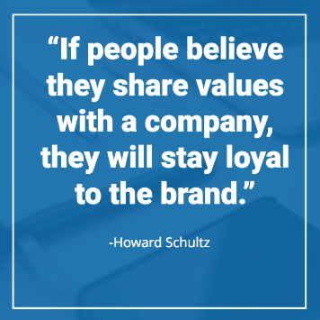
Many people will tell you that you need to have a plan for your business and that is completely as it should be. However, as important is your marketing strategy and this needs to be focussed on what you are trying to achieve in your business. For example, increasing profits by 10%; launch a new holiday club to existing customer base by December 2023 etc.

Knowing and understanding the environment in which you operate is so important and many businesses will produce their marketing materials or social media strategies without really knowing their market. Who are your customers? What do they look like and how do they buy? Who are your competitors and why are they successful (or not).

Knowing this will allow you to more accurately talk to those potential customers in a language that is relevant, targeted and (most importantly) encourage them to get in touch with you to find out more. So, knowing your customers is important but also breaking them down into target groups (segmentation) is important because:

- Not all people are the same with the same attitude to buying
- Not everyone wants the same things (even from the same service)

So, start thinking about the following:
- Think about what your ideal customer looks like – define them clearly in your own mind
- Define the problem – what is their pain point? Respond to these in your service offer
- Tell these people (in simple terms) about your business/service/product – see how it looks from their perspective (not yours)
- What does the market look like – don't use jargon and remember who you are talking to
- Proof of the pudding – use testimonials and recommendations from happy customers
- Think about your internal customers — employees and their capabilities – they need to be using the same consistent messages and act as your ambassadors/promoters
- Where will you fly from – what are the message platforms that you will use to get your message across. Create a short (about 25 words), a medium (about 50 words) and a longer (100+ words) messages. The shorter ones can then be used in tweets, promotional campaigns, flyers, banners etc. the longer ones can be tailored and more detail and testimonials
- Your marketing plan doesn't need to be pages long – it just needs to be clear, concise and focused on the outcomes you would like to achieve in your business.
Below you will find a template for your marketing plan – take the next steps in growing your business

Appendix

Marketing Plan for <name of setting>

What are my marketing priorities? (these will link directly to your business objectives and you should have no more than 3 or 4 eg to raise the profile of my business in 2 local schools)

Who are my customers? (e.g. lone parents, students, working parents, and also thinking about the area that you operate in (ethnicity, disadvantage etc) and your own skills and experience)

How am I going to reach them? (Remember relevant messages for relevant target groups)

What do I need to do? (Market research, type of promotional materials you might need, talking to other childcare providers etc)

How much will it cost? (You need to work out the costs of your marketing activities and include in your financial planning)

How will I know that my marketing has worked? (You will need to monitor and evaluate your marketing so that you do not waste money on activities that provide little or no results. Always ask people where they have heard about you, ask other providers what they have found to be the most successful ways. If it doesn’t work – don’t do it!

