Community Short Breaks Summer Holiday Activities 2024

Dear Parents and Carers

The Booking Hotline for Summer Holiday Activities will be open from Monday 1st July 2024 until Friday 5th July 2024 from 09.00am until 4.00pm.

Please call 024 76 975464 to book. Bookings can also be made online at www.coventry.gov.uk/bookashortbreak during this period.
Bookings either online or by telephone that are outside of the dates and times stated will not be processed.

Please note places in sessions are limited; you will be able to select one venue for your child or young person to attend across the week as part of your ‘activity’, you can also select one venue as a second option if the first choice is not available. If activities are not required, please select ‘not required’.

Sessions will be delivered for children and young people aged 5 – 11 years old or 12 -17 years old registered with Community Short Breaks unless stated otherwise. Please find this information below the named activity.

If your child or young person has never attended a Community Short Breaks activity, we will require a completed Short Breaks passport and DLA letter or supporting letter.
An induction visit is required prior to attending an activity this will be arranged by Development Officer. Please let us know at the point of booking if you require this information.

Please note we cannot support siblings in activities unless stated.
Please Read: Important information about activities and venues

Date | Activity | Venue
WEEK ONE
Monday  22nd July 2024 | Sensory Play with Balls  (with crafts and games)  (5 – 8 years)  9:30am – 11:00am  Outdoor Games with crafts activities.  (9 – 17 years)  11:15am – 12:45pm | Woodside Family Hub  Upper Ride  Coventry  CV3 3GL  Woodside Family Hub  Upper Ride  Coventry  CV3 3GL
Tuesday  23rd July 2024 | Short Breaks Football and mixed games  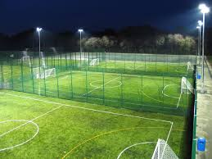  (8 – 17 years)  10:00am to 11:30am  Short Breaks Family Splash Pool  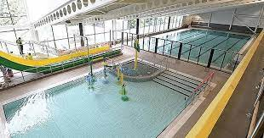  (5 – 11 years)  2:00pm – 3:00pm | Powerleague Coventry  The Woodlands School,  Broad Lane  Coventry  CV5 7FF  Please ensure your child dresses for the weather as football will be outdoors and it may be hot on the day.  A hat, suncream and bottle of water will be required.  Sports footwear (no studded footwear).  Centre AT7  12 Bell Green Road  Coventry  CV6 7GP  Please provide all children’s names on the Booking Form attending Family Swim (5 – 11 years old).  Children must be within the family household.  Public Pool Rules: All children aged 8 and under must be accompanied by an adult.  Any child that is not able to swim must be accompanied by an adult.  Parent/carers must stay at the pool side if not swimming with children.  £1.00 will be required for individual lockers.  If a child has a medical history, please notify the Short Breaks staff member/lifeguard on duty on arrival in case of an emergency.
Wednesday  24th July 2024 | Painting using dinosaurs, animals, and dolls.  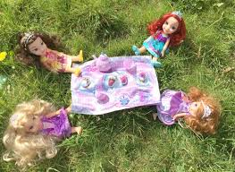  (5 – 7 years)  10:00am – 11:30am  Water Gun Art or Bubble Art  (with a selection of crafts and games)  (8 – 11 years)  11:45pm – 1:15pm  How to make a salt Pendulum  (with board games and crafts)  (12 – 17 years)  1:30pm – 3:00pm | Broad Park House  Logan Road  Coventry  CV2 1AG  *Activities can be amended to meet the interests of children.  Broad Park House  Logan Road  Coventry  CV2 1AG  Please wear clothes that can get messy (paint may not wash out) and a change of clothes.  Broad Park House  Logan Road  Coventry  CV2 1AG
Thursday  25th July 2024 | One Body One Life (OBOL)  One Body One Life activity promotes a healthy lifestyle programme consisting of fun activities that include parachutes, bats and balls and outdoor games.  (5 – 11 years)  12:15pm – 1:45pm  Indoor and Outdoor activities  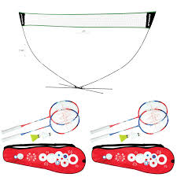  (12 – 17 years)  2:15pm – 3:45pm | Families For All  454 Foleshill Road  Foleshill  Coventry  CV6 5LB  Families For All  454 Foleshill Road  Foleshill  Coventry  CV6 5LB
Friday  26th July 2024 | Chocolate Chip Muffins  (5 – 11 years)  10:00am – 11:30am  Chocolate Chip Muffins  (12 – 17 years)  12:00pm – 1:30pm | Pathways Family Hub  Lawrence Saunders Road  Coventry  CV6 1HD  Please notify Development Officer of any food allergies, food intolerance or diet preferences.  Pathways Family Hub  Lawrence Saunders Road  Coventry  CV6 1HD  Please notify Development Officer of any food allergies, food intolerance or diet preferences.
WEEK TWO
Monday  29th July 2024 | Water play with crafts and games.  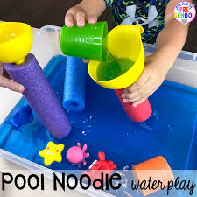  (5 – 8 year’s)  9:30am – 11:00am  Edible Frosting Play Dough with crafts and games.  (9 – 17 year’s)  11:15am – 12:45pm | Woodside Family Hub  Upper Ride  Coventry  CV3 3GL  Woodside Family Hub  Upper Ride  Coventry  CV3 3GL  Please notify Development Officer of any food allergies, food intolerance or diet preferences.
Tuesday  30th July 2024 | Short Breaks Football and mixed games  (8 – 17 years)  10:00am to 11:30am  Short Breaks Family Splash Pool  (5 – 11 years)  2:00pm – 3:00pm | Powerleague Coventry  The Woodlands School,  Broad Lane  Coventry  CV5 7FF  Please ensure your child dresses for the weather as football will be outdoors and it may be hot on the day.  A hat, suncream and bottle of water will be required.  Sports footwear (no studded footwear).  Centre AT7  12 Bell Green Road  Coventry  CV6 7GP  Please provide all children’s names on the Booking Form attending Family Swim (5 – 11 years old).  Children must be within the family household.  Public Pool Rules: All children aged 8 and under must be accompanied by an adult.  Any child that is not able to swim must be accompanied by an adult.  Parent/carers must stay at the pool side if not swimming with children.  £1.00 will be required for individual lockers.  If a child has a medical history, please notify the Short Breaks staff member/lifeguard on duty on arrival in case of an emergency.
Wednesday  31st July 2024 | TIGER FEET  (11 - 17 years)  10:00am - 11:30am  Flour Piping Sensory Activity with crafts and games activities.  (5 – 7 years)  11:45am – 1:15pm  Pizza Rolls with crafts and activities.  (8 – 10 years)  1:30pm – 3:00pm | Broad Park House  Logan Road  Coventry  CV2 1AG  Broad Park House  Logan Road  Coventry  CV2 1AG  Broad Park House  Logan Road  Coventry  CV2 1AG  Please notify Development Officer of any food allergies, food intolerance or diet preferences.
Thursday  1st August 2024 | One Body One Life (OBOL)  One Body One Life activity promotes a healthy lifestyle programme consisting of fun activities that include parachutes, bats and balls and outdoor games.  (5 – 11 years)  12:15pm – 1:45pm  Chalk Art with crafts and games.  (12 – 17 years)  2:00pm – 3:30pm | Families For All  454 Foleshill Road  Foleshill  Coventry  CV6 5LB  Families For All  454 Foleshill Road  Foleshill  Coventry  CV6 5LB
Friday  2nd August 2024 | Raspberry Oat Bars  (5 – 11 years)  10:00am – 11:30am  Raspberry Oat Bars  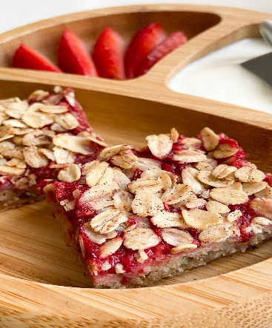  (12 – 17 years)  12:00pm – 1:30pm | Pathways Family Hub  Lawrence Saunders Road  Coventry  CV6 1HD  Please notify Development Officer of any food allergies, food intolerance or diet preferences.  Pathways Family Hub  Lawrence Saunders Road  Coventry  CV6 1HD  Please notify Development Officer of any food allergies, food intolerance or diet preferences.
WEEK THREE
Monday  5th August 2024 | Shortbread Biscuits  (5 – 8 years)  9:30am – 11:00am  Shortbread Biscuits  (9 – 17 years)  11:15am – 12:45pm | Woodside Family Hub  Upper Ride  Coventry  CV3 3GL  Please notify Development Officer of any food allergies, food intolerance or diet preferences.  Woodside Family Hub  Upper Ride  Coventry  CV3 3GL  Please notify Development Officer of any food allergies, food intolerance or diet preferences.
Tuesday  6th August 2024 | Short Breaks Football and mixed games  (8 – 17 years)  10:00am to 11:30am  Short Breaks Family Splash Pool  (5 – 11 years)  2:00pm – 3:00pm | Powerleague Coventry  The Woodlands School,  Broad Lane  Coventry  CV5 7FF  Please ensure your child dresses for the weather as football will be outdoors and it may be hot on the day.  A hat, suncream and bottle of water will be required.  Sports footwear (no studded footwear).  Centre AT7  12 Bell Green Road  Coventry  CV6 7GP  Please provide all children’s names on the Booking Form attending Family Swim (5 – 11 years old).  Children must be within the family household.  Public Pool Rules: All children aged 8 and under must be accompanied by an adult.  Any child that is not able to swim must be accompanied by an adult.  Parent/carers must stay at the pool side if not swimming with children.  £1.00 will be required for individual lockers.  If a child has a medical history, please notify the Short Breaks staff member/lifeguard on duty on arrival in case of an emergency.
Wednesday  7th August 2024 | Tiger Feet  (11 – 17 years)  10:00am – 11:30am  Breakfast Sundaes (with crafts and activities).  (5 – 8 years)  11:45am – 1:15pm  Strawberry Banana Smoothie (with activities)  (9 – 11 years)  1:30pm – 3:00pm | Broad Park House  Logan Road  Coventry  CV2 1AG  Broad Park House  Logan Road  Coventry  CV2 1AG  Broad Park House  Logan Road  Coventry  CV2 1AG
Thursday  8th August 2024 | One Body One Life (OBOL)  One Body One Life activity promotes a healthy lifestyle programme consisting of fun activities that include parachutes, bats and balls and outdoor games.  (5 – 11 years)  12:15pm – 1:45pm  How to make Fluffy Slime  (12 – 17 years)  2:15pm – 3:45pm | Families For All  454 Foleshill Road  Foleshill  Coventry  CV6 5LB  Families For All  454 Foleshill Road  Foleshill  Coventry  CV6 5LB
Friday  9th August 2024 | Spinach Frittata  (5 – 11 years)  10:00am – 11:30am  Spinach Frittata  (12 – 17 years)  12:00pm – 1:30pm | Pathways Family Hub  Lawrence Saunders Road  Coventry  CV6 1HD  Please notify Development Officer of any food allergies, food intolerance or diet preferences.  Pathways Family Hub  Lawrence Saunders Road  Coventry  CV6 1HD  Please notify Development Officer of any food allergies, food intolerance or diet preferences.
WEEK FOUR
Monday  12th August 2024 | Music Time:  Musical instruments and sound toys  (5 – 8 years)  9:30am – 11:00am  Karaoke and music  (9 – 17 years)  11:15am – 12:45am | Woodside Family Hub  Upper Ride  Coventry  CV3 3GL  Woodside Family Hub  Upper Ride  Coventry  CV3 3GL
Tuesday  13th August 2024 | Short Breaks Football and mixed games  (8 – 17 years)  10:00am to 11:30am  Short Breaks Family Splash Pool  (5 – 11 years)  2:00pm – 3:00pm | Powerleague Coventry  The Woodlands School,  Broad Lane  Coventry  CV5 7FF  Please ensure your child dresses for the weather as football will be outdoors and it may be hot on the day.  A hat, suncream and bottle of water will be required.  Sports footwear (no studded footwear).  Centre AT7  12 Bell Green Road  Coventry  CV6 7GP  Please provide all children’s names on the Booking Form attending Family Swim (5 – 11 years old).  Children must be within the family household.  Public Pool Rules: All children aged 8 and under must be accompanied by an adult.  Any child that is not able to swim must be accompanied by an adult.  Parent/carers must stay at the pool side if not swimming with children.  £1.00 will be required for individual lockers.  If a child has a medical history, please notify the Short Breaks staff member/lifeguard on duty on arrival in case of an emergency.
Wednesday  14th August 2024 | Tents and Tunnel Play (with crafts and games)  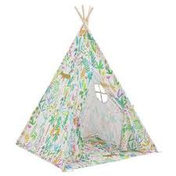  (5 – 8 years)  10:00am – 11:30am  Camping tents and den building with smores and fruit juice.  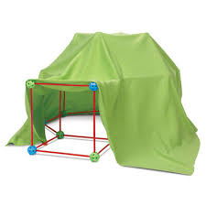  (9 – 11 years)  11:15am – 12:45pm  Camping tents and smores with fruit juice (with crafts and games)  (12 – 17 years)  1:15pm – 3:00pm | Broad Park House  Logan Road  Coventry  CV2 1AG  Broad Park House  Logan Road  Coventry  CV2 1AG  Please notify Development Officer of any food allergies, food intolerance or diet preferences.  Broad Park House  Logan Road  Coventry  CV2 1AG  Please notify Development Officer of any food allergies, food intolerance or diet preferences
Thursday  15th August 2024 | OBOL  One Body One Life activity promotes a healthy lifestyle programme consisting of fun activities that include parachutes, bats and balls and outdoor games.  (5 – 11 years)  12:15pm – 1:45pm  Make your own healthy sandwiches and wraps (with crafts and games).  (12 – 17 years)  2:15pm – 3:45pm | Families For All  454 Foleshill Road  Foleshill  Coventry  CV6 5LB  Families For All  454 Foleshill Road  Foleshill  Coventry  CV6 5LB  Please notify Development Officer of any food allergies, food intolerance or diet preferences
Friday  16th August 2024 | Broccoli Cheese Cups  (5 – 11 years)  10:00am – 11:30pm  Broccoli Crust Pizza  (12 – 17 years)  12:00pm – 1:30pm | Pathways Family Hub  Lawrence Saunders Road  Coventry  CV6 1HD  Please notify Development Officer of any food allergies, food intolerance or diet preferences.  Pathways Family Hub  Lawrence Saunders Road  Coventry  CV6 1HD  Please notify Development Officer of any food allergies, food intolerance or diet preferences.
WEEK FIVE
Monday  19th August 2024 | Chocolate Chip Cookies (with crafts and games)  (5 – 8 years)  09:30am – 11:00am  Chocolate Chip Cookies (with crafts and games)  (9 – 17 years)  11:15am – 12:45pm | Woodside Family Hub  Upper Ride  Coventry  CV3 3GL  Please notify Development Officer of any food allergies, food intolerance or diet preferences.  Woodside Family Hub  Upper Ride  Coventry  CV3 3GL  Please notify Development Officer of any food allergies, food intolerance or diet preferences.
Tuesday  20th August 2024 | Short Breaks Football and mixed games  (8 – 17 years)  10:00am to 11:30am  Short Breaks Family Splash Pool  (5 – 11 years)  2:00pm – 3:00pm | Powerleague Coventry  The Woodlands School,  Broad Lane  Coventry  CV5 7FF  Please ensure your child dresses for the weather as football will be outdoors and it may be hot on the day.  A hat, suncream and bottle of water will be required.  Sports footwear (no studded footwear).  Centre AT7  12 Bell Green Road  Coventry  CV6 7GP  Please provide all children’s names on the Booking Form attending Family Swim (5 – 11 years old).  Children must be within the family household.  Public Pool Rules: All children aged 8 and under must be accompanied by an adult.  Any child that is not able to swim must be accompanied by an adult.  Parent/carers must stay at the pool side if not swimming with children.  £1.00 will be required for individual lockers.  If a child has a medical history, please notify the Short Breaks staff member/lifeguard on duty on arrival in case of an emergency.
Wednesday  21st August 2024 | Chalk and Water Play  (with crafts and games)  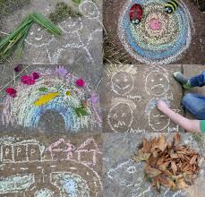  (5 – 8 years)  10:00am – 11:30am  Rainbow Bubble Foam (with crafts and games)  (9 – 11 years)  11:45am – 1:15pm  Candy floss and fruit drinks (with board games)  (12 – 17 years)  1:30pm – 3:00pm | Broad Park House  Logan Road  Coventry  CV2 1AG  Please bring a change of clothes.  Broad Park House  Logan Road  Coventry  CV2 1AG  Please bring a change of clothes.  Broad Park House  Logan Road  Coventry  CV2 1AG  Please notify Development Officer of any food allergies, food intolerance or diet preferences.
Thursday  22nd August 2024 | OBOL  One Body One Life activity promotes a healthy lifestyle programme consisting of fun activities that include parachutes, bats and balls and outdoor games.  (5 – 11 years)  12:15pm – 1:45pm  Milkshakes and Popcorn (with crafts and games).  (12 – 17 years)  2:15pm – 3:45pm | Families For All  454 Foleshill Road  Foleshill  Coventry  CV6 5LB  Families For All  454 Foleshill Road  Foleshill  Coventry  CV6 5LB  Please notify Development Officer of any food allergies, food intolerance or diet preferences.
Friday  23rd August 2024 | Cinnamon Rolls with Milk Shakes (crafts and games)  (5 – 11 years)  10:00am – 11:30am  Cinnamon Rolls with Milk Shakes (crafts and games)  (12 – 17 years)  12:00pm – 1:30pm | Pathways Family Hub  Lawrence Saunders Road  Coventry  CV6 1HD  Please notify Development Officer of any food allergies, food intolerance or diet preferences.  Pathways Family Hub  Lawrence Saunders Road  Coventry  CV6 1HD  Please notify Development Officer of any food allergies, food intolerance or diet preferences.
WEEK SIX
Monday  26th August 2024 | BANK HOLIDAY | BANK HOLIDAY
Tuesday  27th August 2024 | Short Breaks Football and mixed games  (8 – 17 years)  10:00am to 11:30am  Short Breaks Family Splash Pool  (5 – 11 years)  2:00pm – 3:00pm | Powerleague Coventry  The Woodlands School,  Broad Lane  Coventry  CV5 7FF  Please ensure your child dresses for the weather as football will be outdoors and it may be hot on the day.  A hat, suncream and bottle of water will be required.  Sports footwear (no studded footwear).  Centre AT7  12 Bell Green Road  Coventry  CV6 7GP
Wednesday  28th August 2024 | Outdoor Water Play with activities and crafts.  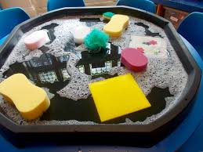  (5 – 8 years)  10:00am – 11:30am  Lemon Tarts  (with crafts and games)  (9 – 11 years)  11:45am – 1:15pm  Lemon Tarts  (with crafts and games)  (12 – 17 years)  1:30pm – 3:00pm | Broad Park House  Logan Road  Coventry  CV2 1AG  Please bring a change of clothes.  - Activity could change depending on the weather and safety.  Broad Park House  Logan Road  Coventry  CV2 1AG  Please notify Development Officer of any food allergies, food intolerance or diet preferences.  Broad Park House  Logan Road  Coventry  CV21AG  Please notify Development Officer of any food allergies, food intolerance or diet preferences.
Thursday  29th August 2024 | OBOL  One Body One Life activity promotes a healthy lifestyle programme consisting of fun activities that include parachutes, bats and balls and outdoor games.  (5 – 11 years)  12:15pm – 1:45pm  Oil Marbling  (with crafts and games)  (12 – 17 years)  2:15pm – 3:45pm | Families For All  454 Foleshill Road  Foleshill  Coventry  CV6 5LB  Families For All  454 Foleshill Road  Foleshill  Coventry  CV6 5LB
Friday  30th August 2024 | Cheddar Cheese and Chives Scones  (with crafts and games)  (5 – 11 years)  10:00am – 11:30am  Cheddar Cheese and Chives Scones (with crafts and games)  (12 – 17 years)  12:00pm – 1:30pm | Pathways Family Hub  Lawrence Saunders Road  Coventry  CV6 1HD  Please notify Development Officer of any food allergies, food intolerance or diet preferences.  Pathways Family Hub  Lawrence Saunders Road  Coventry  CV6 1HD  Please notify Development Officer of any food allergies, food intolerance or diet preferences.

