November 2021
Progress reviews and formal assessments are both statutory requirements for induction and when they are due will be completed via ECT Manager. Below is some advice and guidance for completing both.
Progress Reviews: are not formal assessments, however, they are statutory and are expected to be conducted with sufficient detail to ensure that there is nothing unexpected for the ECT when it comes to their formal assessment - there should be no surprises!
The templates for progress reviews are available to view on ECT manager at https://coventry.ectmanager.com
A progress review is expected to be completed via ECT Manager and must be provided to the ECT at the end of each term where a formal assessment is not due, (in terms 1, 2 4 and 5) clearly stating whether the ECT is on track to successfully complete induction and confirming evidence and development targets are being recorded by the tutor. It is also expected that objectives are reviewed and revised in relation to the government teachers’ standards and the needs and strengths of the individual ECT.
ECTs must have the opportunity discuss, read, sign and add their own comments to the progress reviews forms. ECTs will also be asked to confirm that they have received their statutory entitlements during this period of induction.
Additionally, it is also expected that the induction tutor notifies the appropriate body where they identify the ECT is not making satisfactory progress. In such cases, it is expected tutors provide an additional support action plan targeting areas of the government teaching standards causing concern and detailing the plan they have put in place to assist the ECT in getting back on track.
As part of their quality assurance procedures the Appropriate Body will read a sample progress reviews which will help to determine that schools are providing an appropriate system of monitoring and support for their ECTs throughout their induction period.
Formal Assessments: Completing end of year formal assessment forms is also a statutory requirement for induction. They must be completed by the induction tutor/head/principal and must contain brief descriptive evidence of an ECTs progress towards embedding each element of the government teaching standards into their practice including. part 2 - personal and professional conduct.
They must also state clear development targets for the upcoming period even if an ECT is leaving your school/college - the next school/college will want to know exactly where an ECT is up to with induction, the same as you should expect if you were receiving an ECT who has partially completed induction elsewhere at another institution.

If an ECT leaves a post partway through induction and before the next progress review or assessment point, an interim assessment will be required to capture progress up to the leaving date.
Key points to remember when completing formal assessments:
All sections on the formal report must be completed
- The formal assessment reports should clearly show assessment of the ECTs performance against Teachers’ Standards at the time of the assessment.
- They must be evidence based providing evidence of progress made during year reporting on.
- They must be in the context of and make reference to each of the government teaching standards and how they are being met/embedded including addressing any previous targets.
- They must state clear development targets relating directly to the government teaching standards
- They must not be a self-assessment by the ECT (no part of your assessment should read as if written by the ECT)
- They must be written 'about' ECTs, not 'to' them.
Also, please; -
- Avoid listing/bullet pointing evidence, the aim should be to briefly describe it and how your ECT is progressing towards fully embedding each element of the government standards.
- No two ECT reports should ever read the same.
- Proofread for errors, spelling mistakes, typos etc before discussion with your ECT and final submission to the appropriate body
- They must be submitted by the due date - particularly relevant where an ECT is leaving you or where there are performance related issues.
*Please note
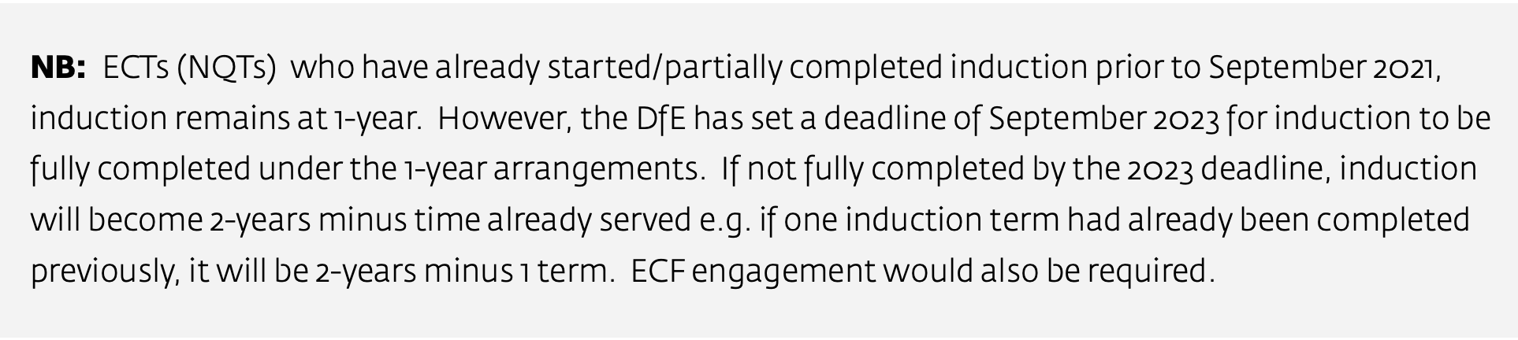
If you have any queries about completing reports for one-year ECTs (NQTs) or about the progress reviews -please do not hesitate to contact me.
Information summarised – Induction for Early Career Teachers March 2021 (paras-2.46-2.57) and Appropriate Body Guidance March 2021 (paras 5.1-5.2)
Cathy
Coventry Appropriate Body- Induction lead.

