How to Start and Complete the Early Help Assessment
From the ‘Active Early Help Episode’ stage ensure the Decisions tab is highlighted in blue.
From this screen you can select the 1st option from the Outcomes – Start / Restart / Update Early Help Assessment by clicking on the grey Start button
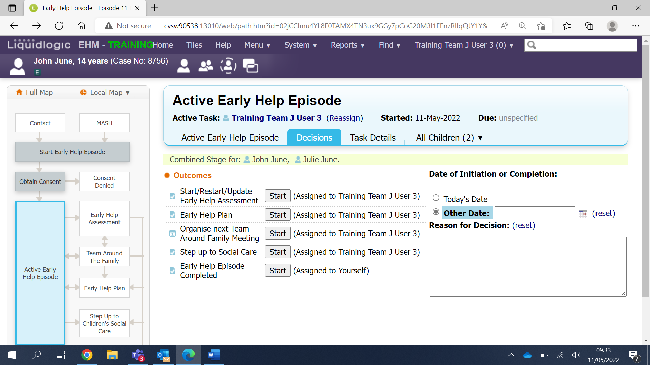
From this screen select either Today’s date or an Other day by using the calendar icon
Next click on the grey Confirm button
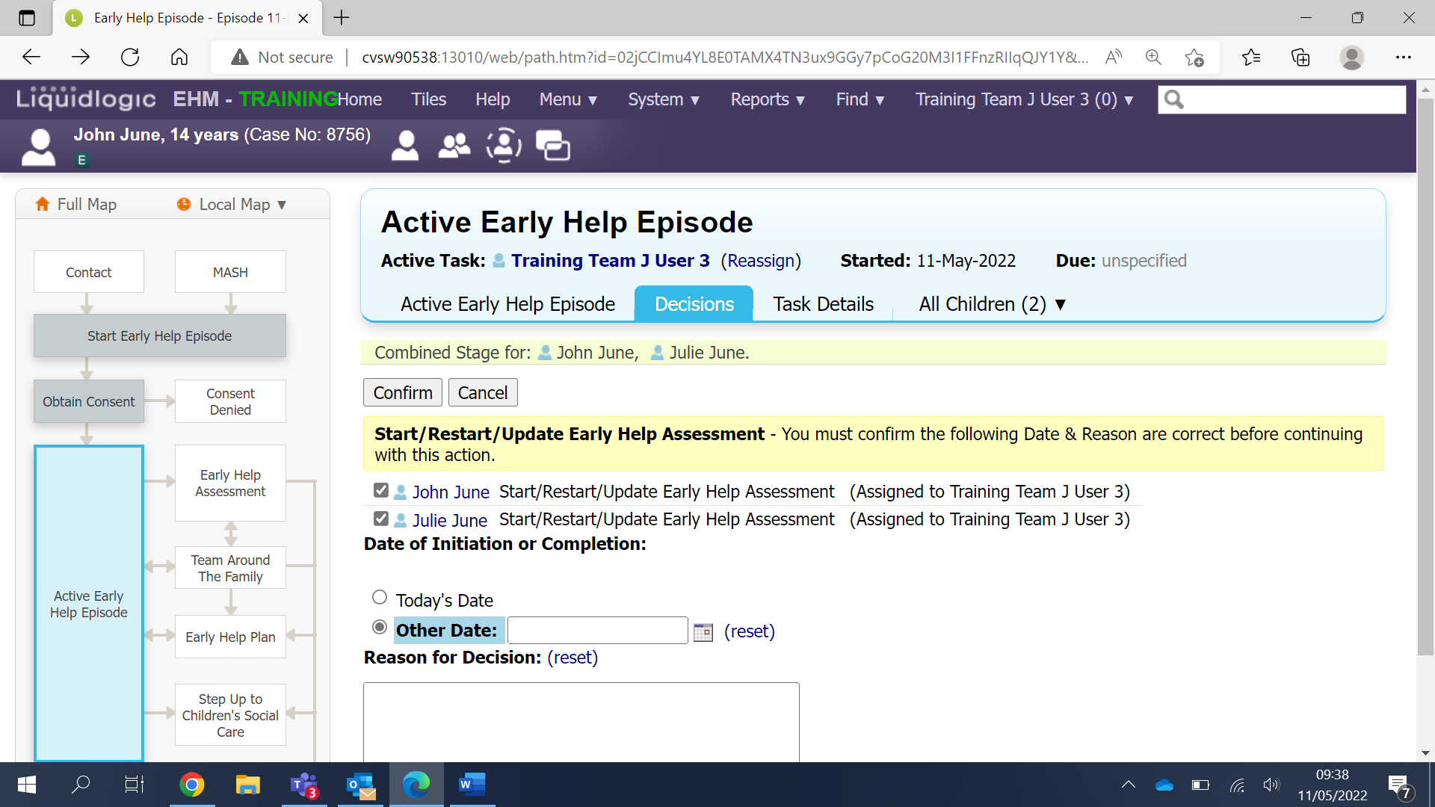

You’ll now see that the ‘Early Help Assessment’ stage has turned blue on the case pathway
Now click on the grey Start Assessment button
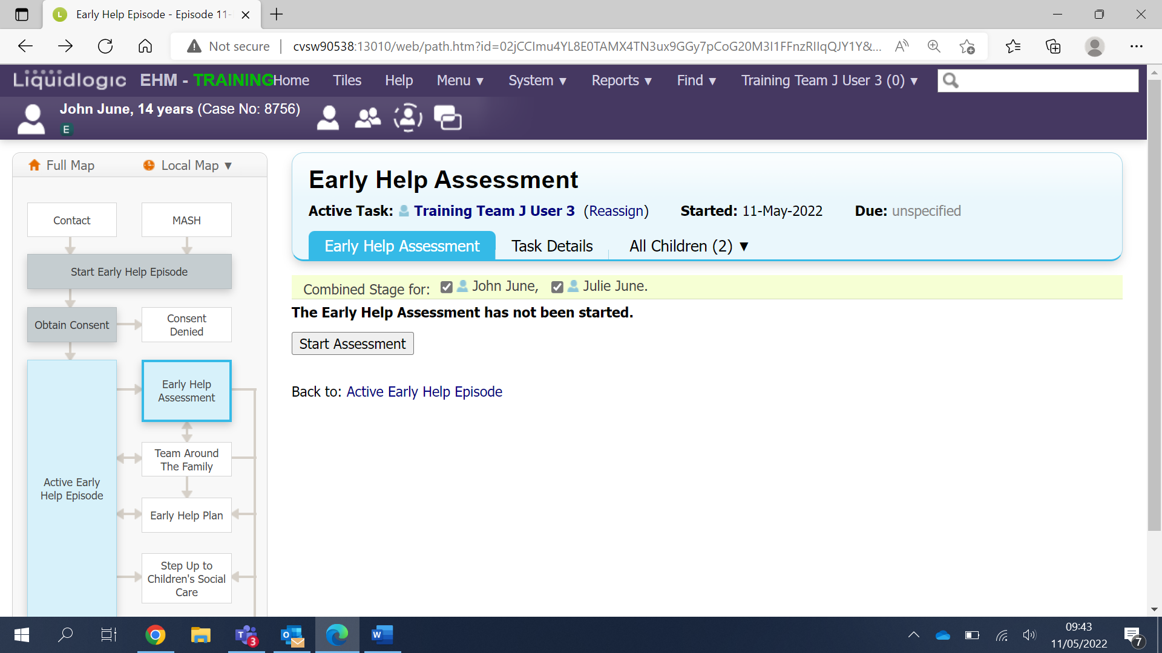
You can now copy forward any information you have already completed from the previous stages. To do this click on the grey Copy Forward Selected button
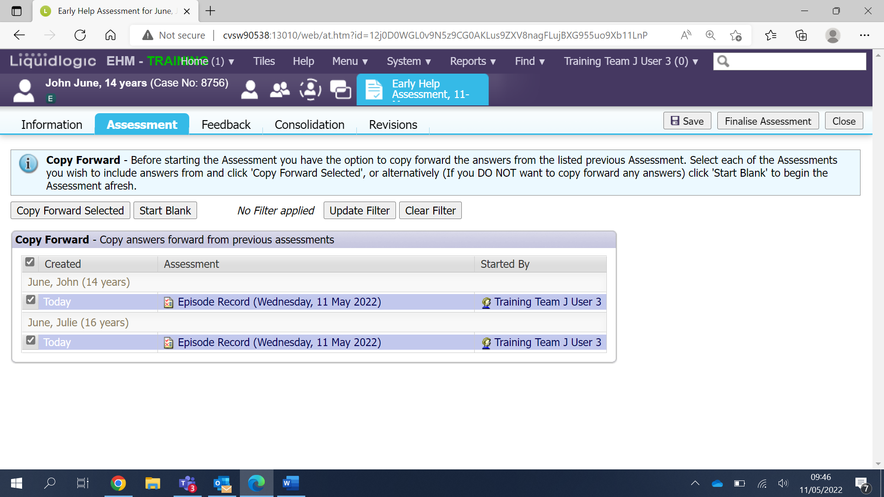

Now you are on the assessment. You can see the different sections of the assessment on the left-hand side
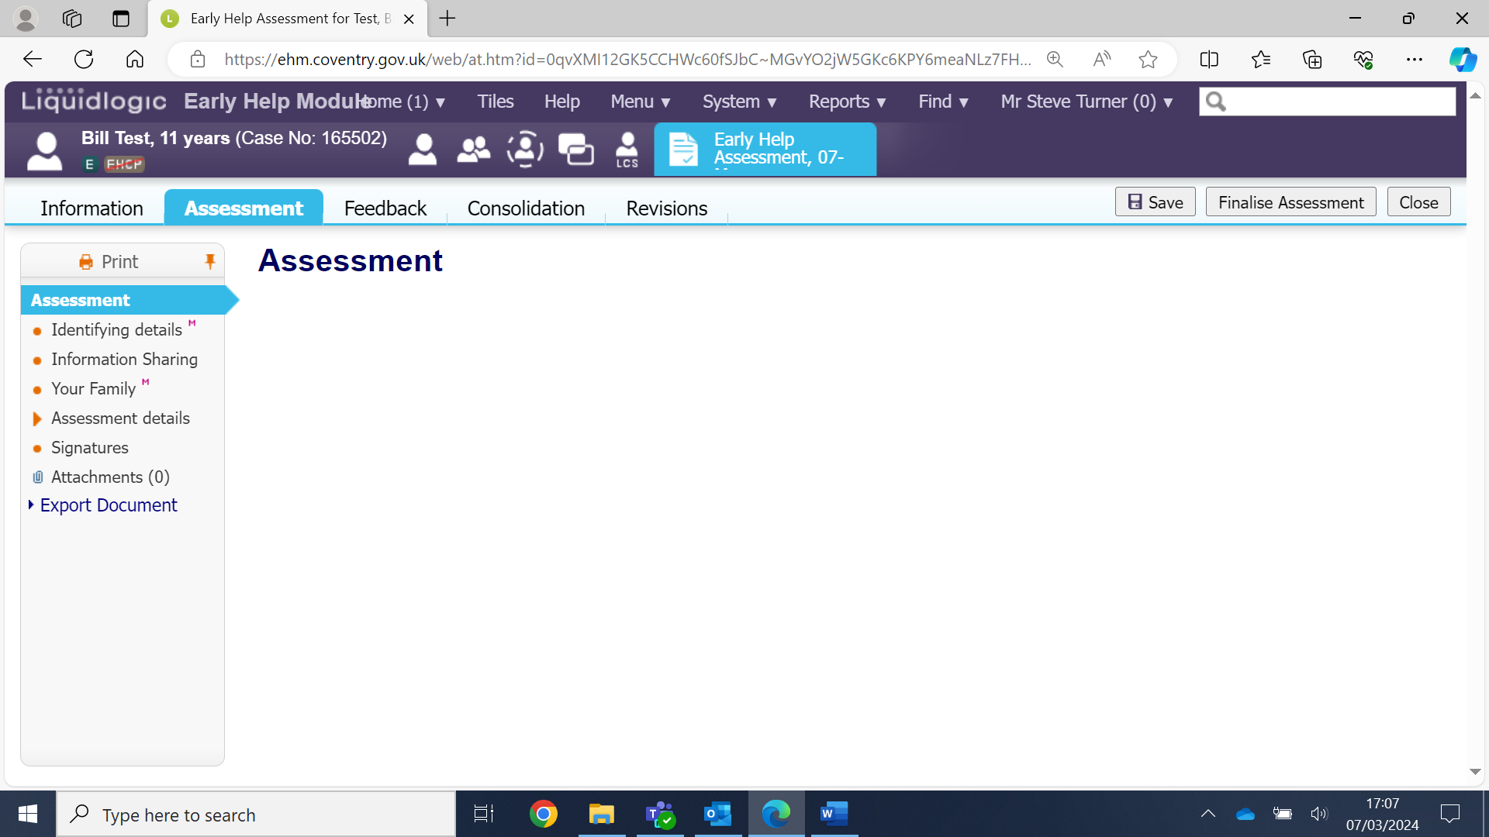
Identifying details:
On this section you can enter the relevant dates in the red mandatory fields, and you can select if this assessment is being completed by Children’s Services
Please note: The system does auto save at regular intervals, but it is recommended to click the grey Save button once a section has been completed and whenever you have entered a lot of information.
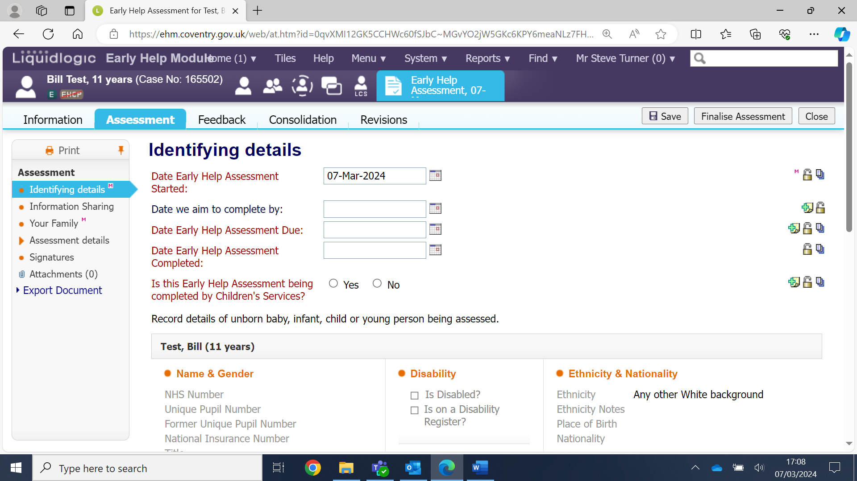

You can leave the assessment stage at any time by clicking on the grey Close button
If you close the assessment or if you log out, you can easily access the assessment again by selecting the assessment task from you Task Tray on the Home page.
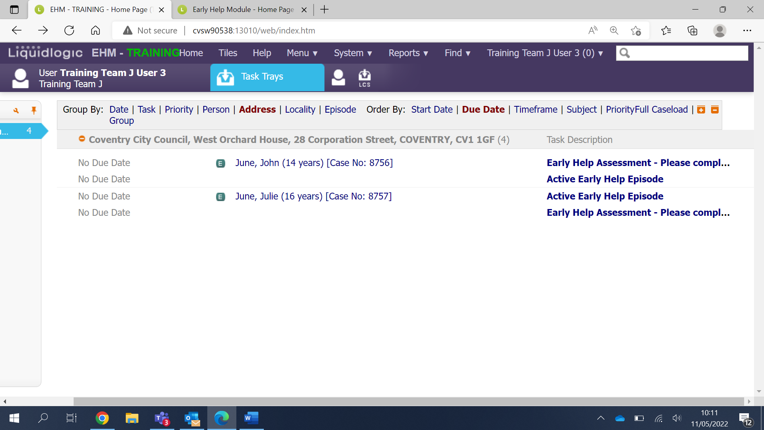

Information Sharing:
There is nothing to fill in on this section, this section contains information you have copy forwarded from the other sections of the episode
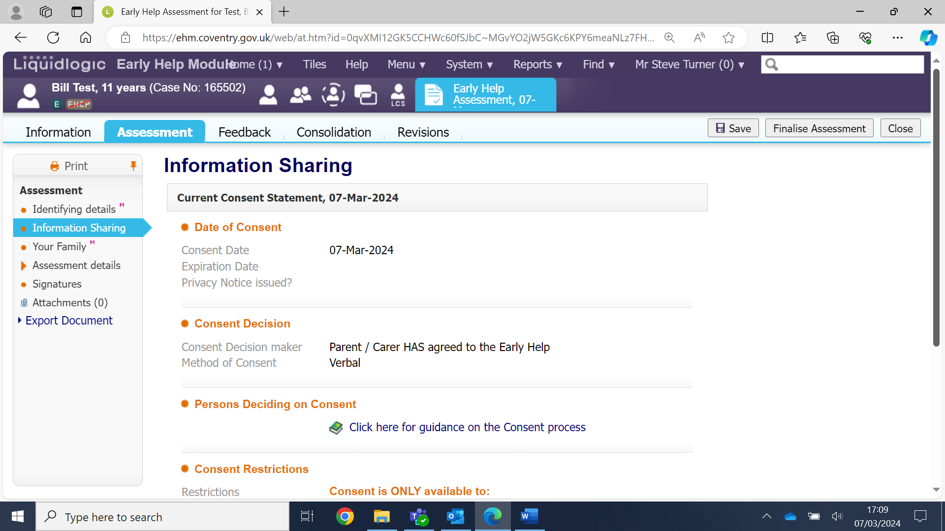
Your Family:
Continue to work your way down this section, filling in all the necessary fields
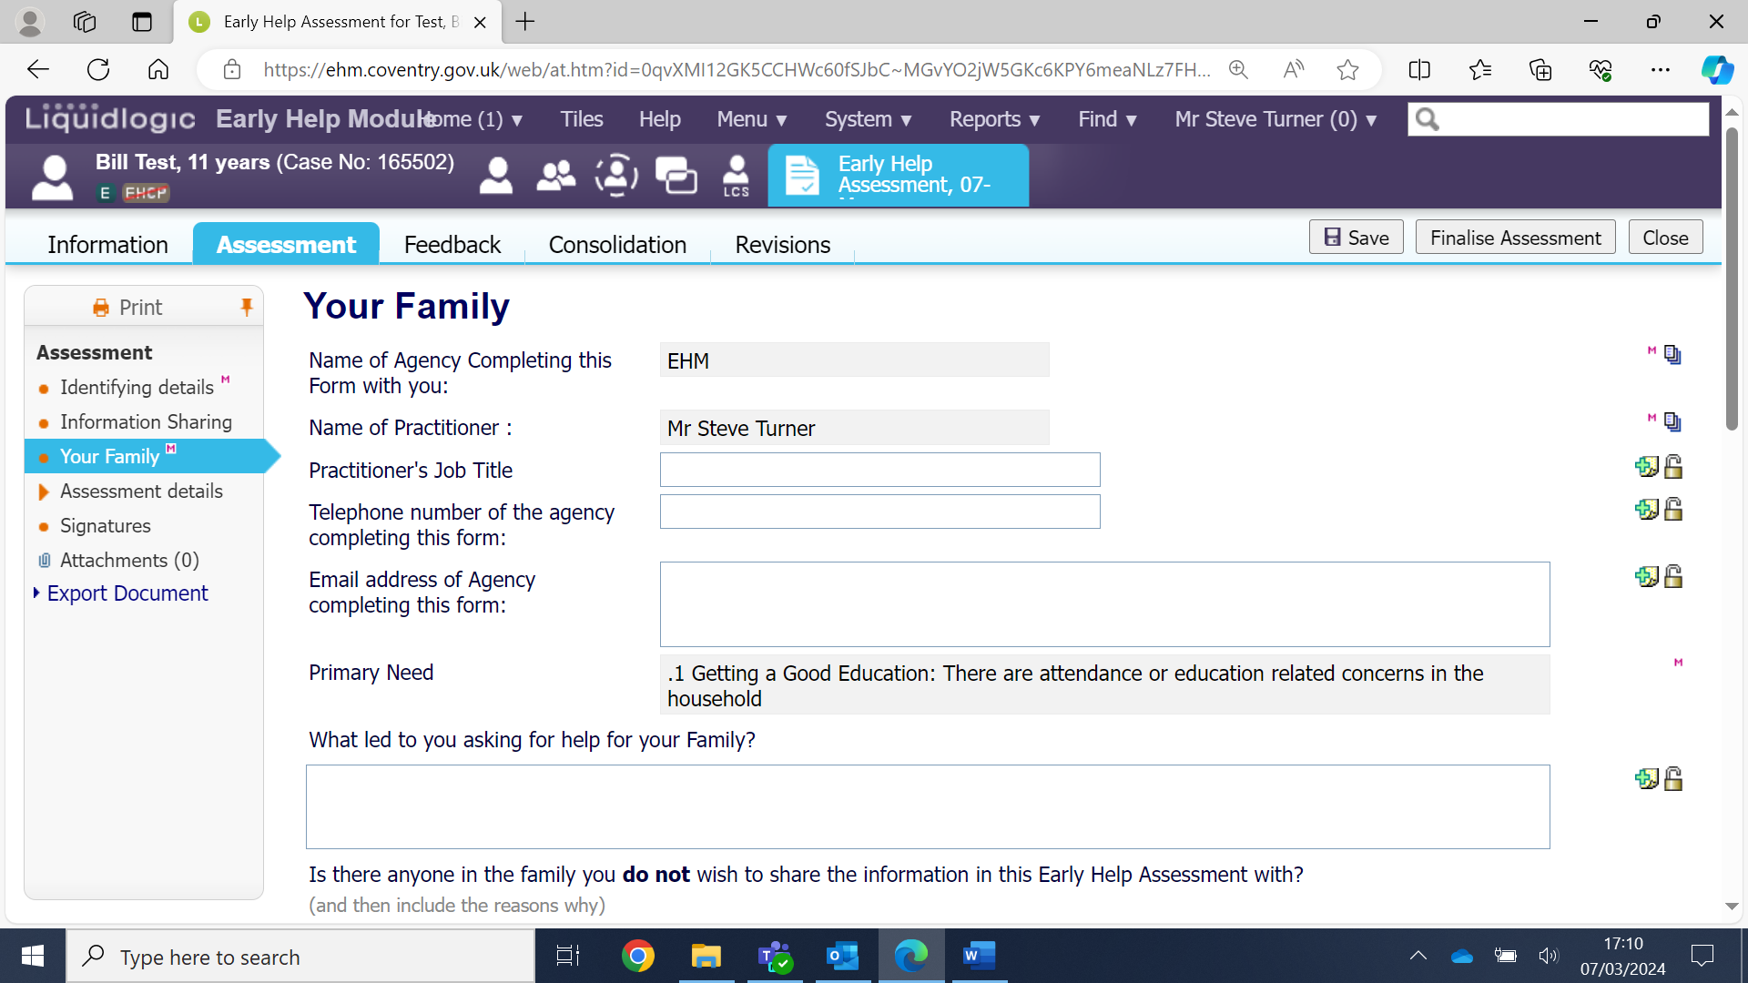

Assessment details:
Continue to work through the various fields of this section, you will notice that this section has sub sections.
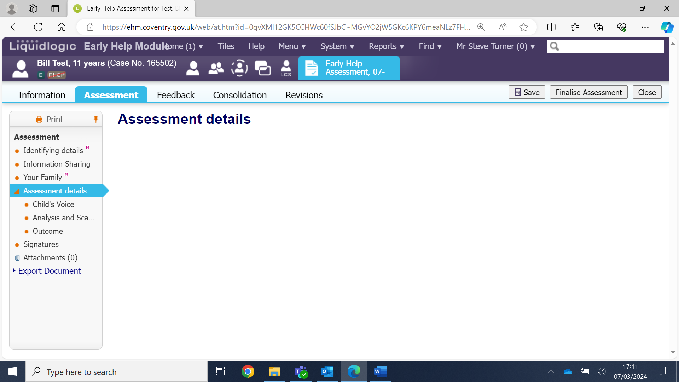
Child’s Voice
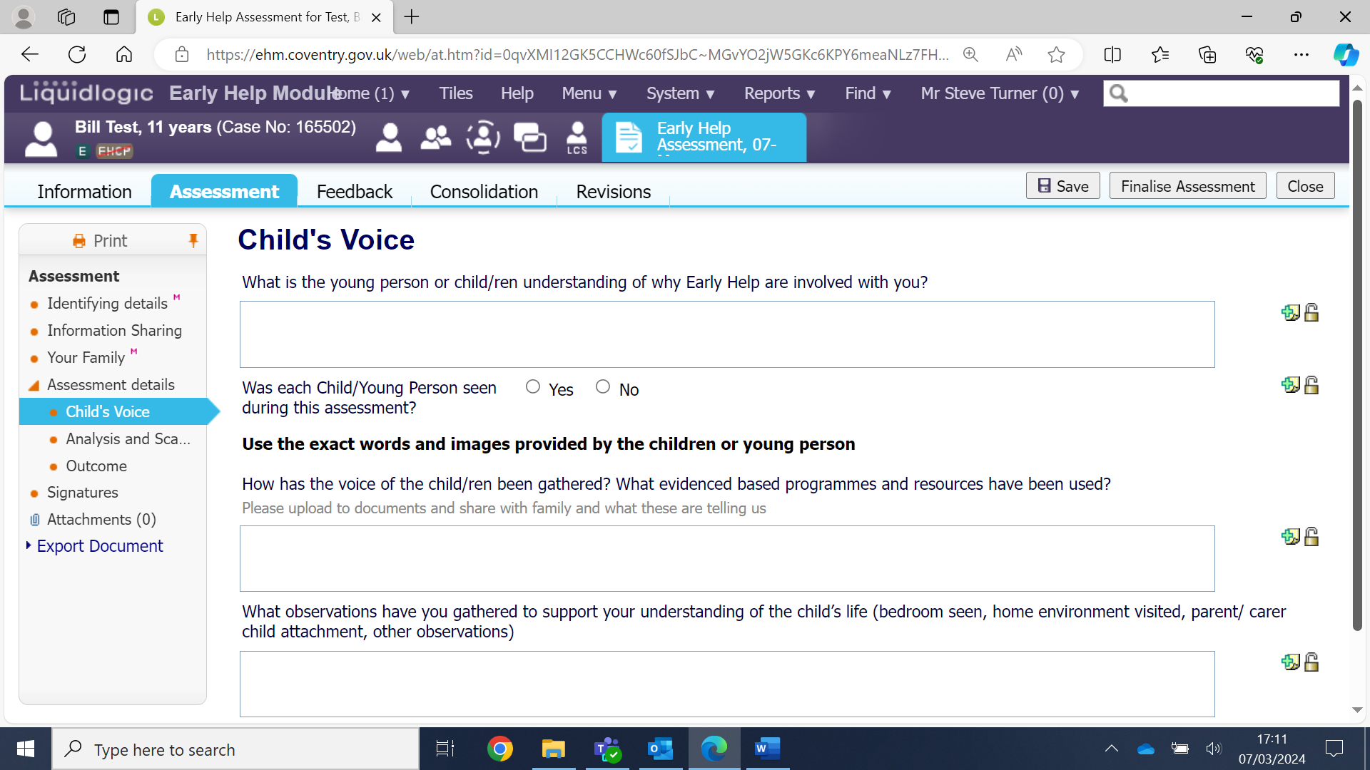

Analysis and Scaling
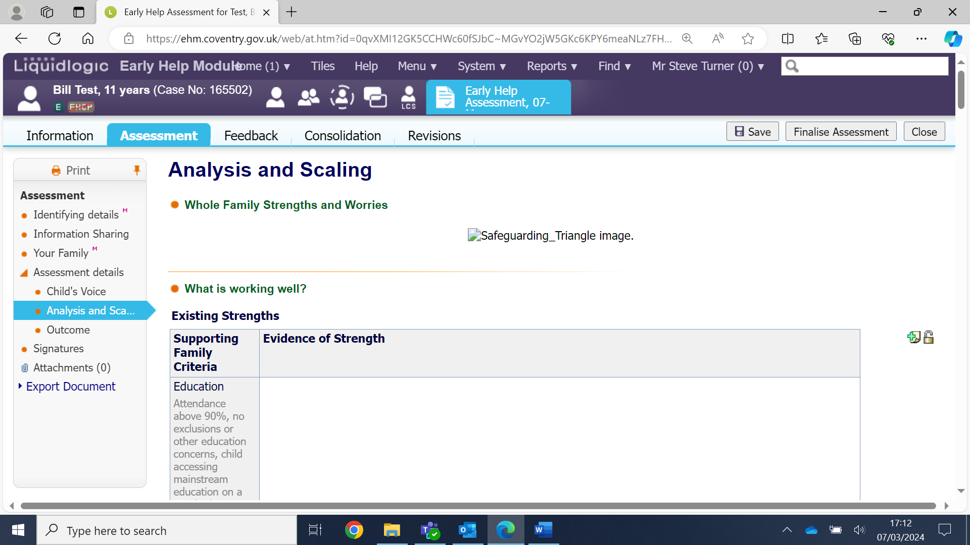
Outcome
This is the final section of the assessment.
Ensure you complete all the red mandatory fields, if you select Yes to first 2 questions then you must also start the Supporting Families Form by clicking on the blue link– please see the separate guidance on how to complete this form.
As you scroll down this section you must select the correct Right Help Right Time level (usually level 3 – Multi-agency – Early Help Plan). Click in the box next to Continue with Existing Process and enter your reason for this outcome (‘To continue with the early help support and progress to the plan’)
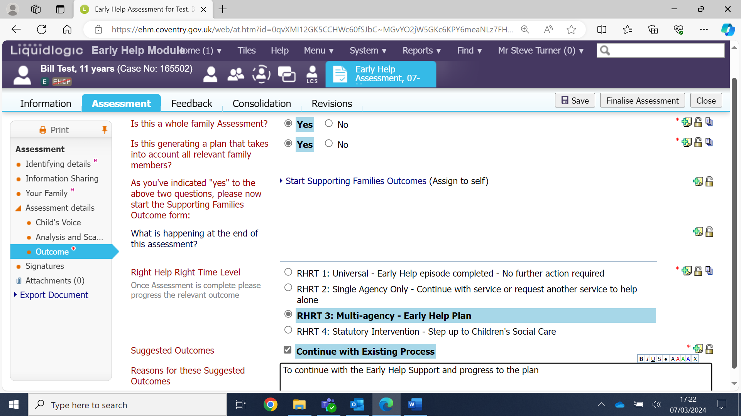
Once you have completed all the fields of the assessment and you have clicked Save you can export the document to word so it can be printed and shown to the family.
How to export the document is covered in another guidance we have created.
Please note – It’s important to save the assessment and not finalise because if the family read through the assessment and want to make any changes this can be done. Once the assessment is finalised it cannot be changed.
Finalise the assessment
Presuming the family have seen the assessment you are now ready to finalise it.
Click on the grey Finalise button.
Click Ok to confirm
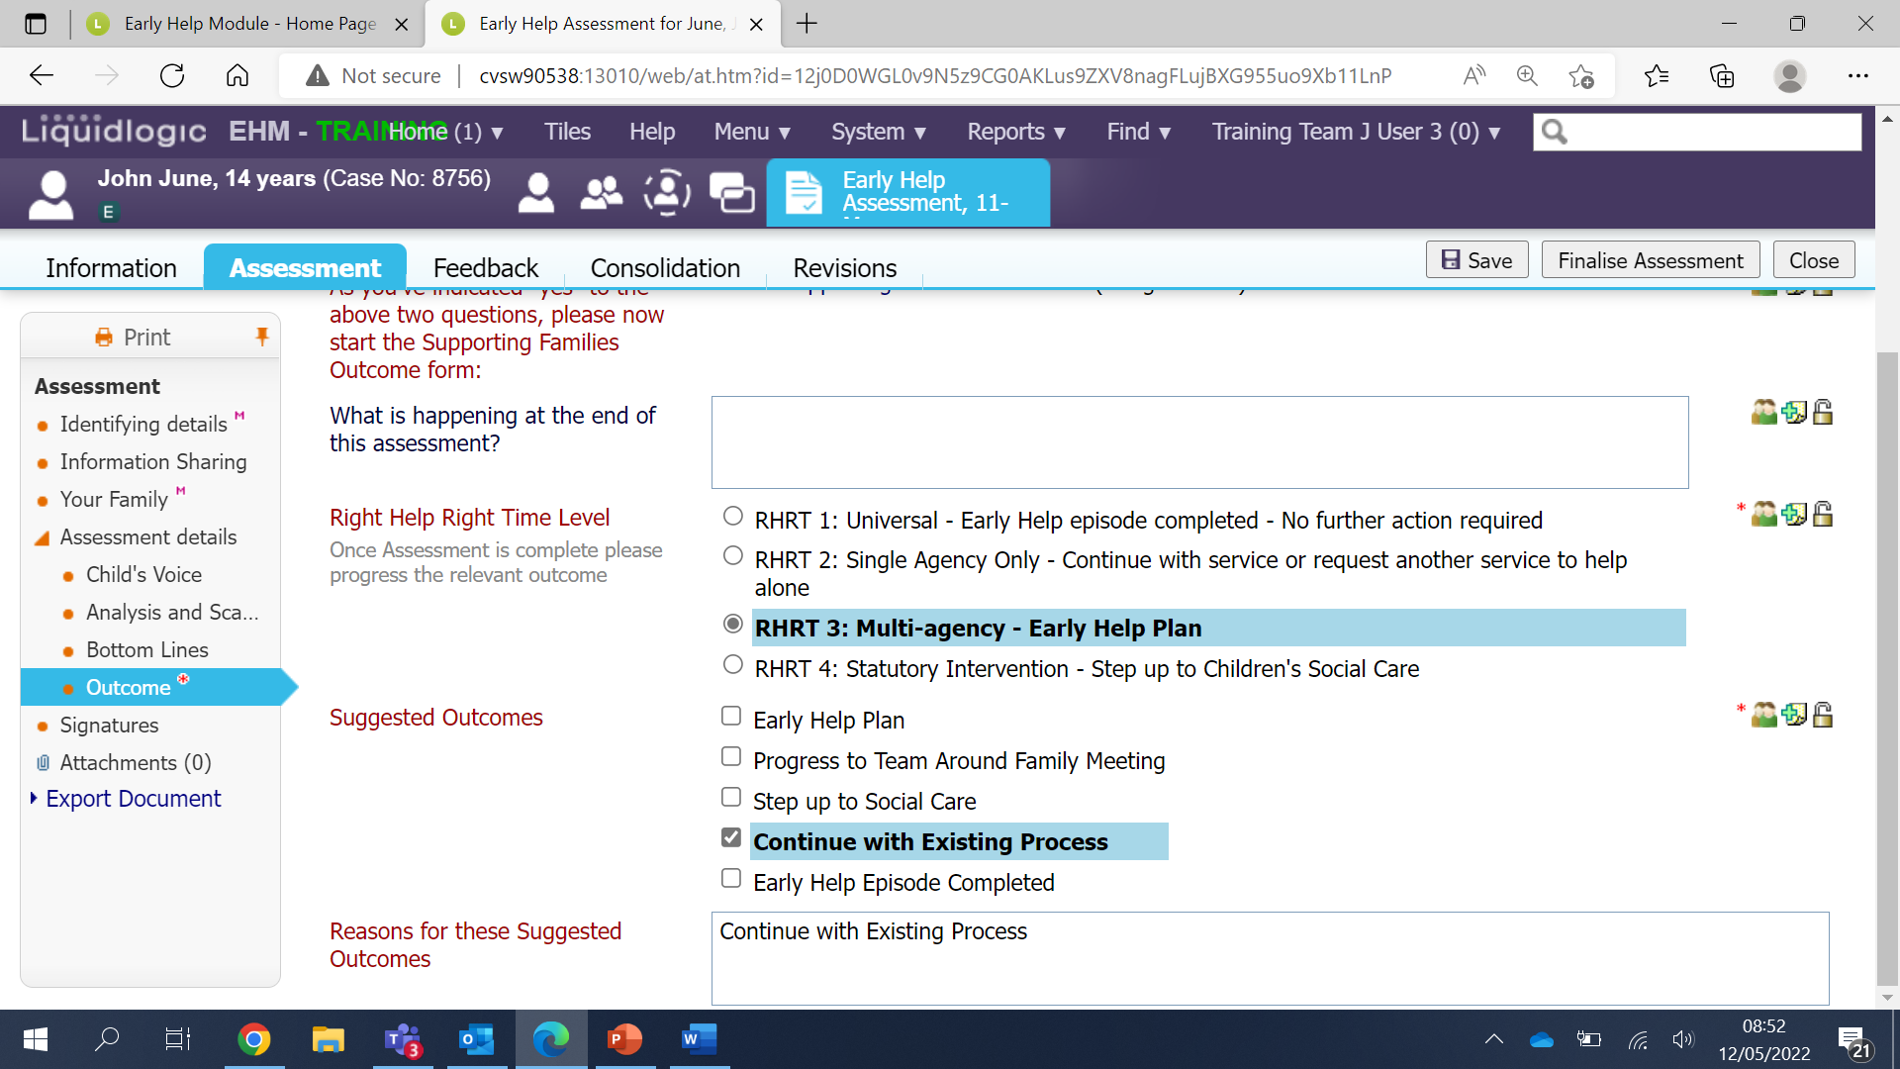

Once you have selected to finalise the assessment the next step is to authorise it.
This is the authorisation step. Click on the blue link to update the early help assessment.
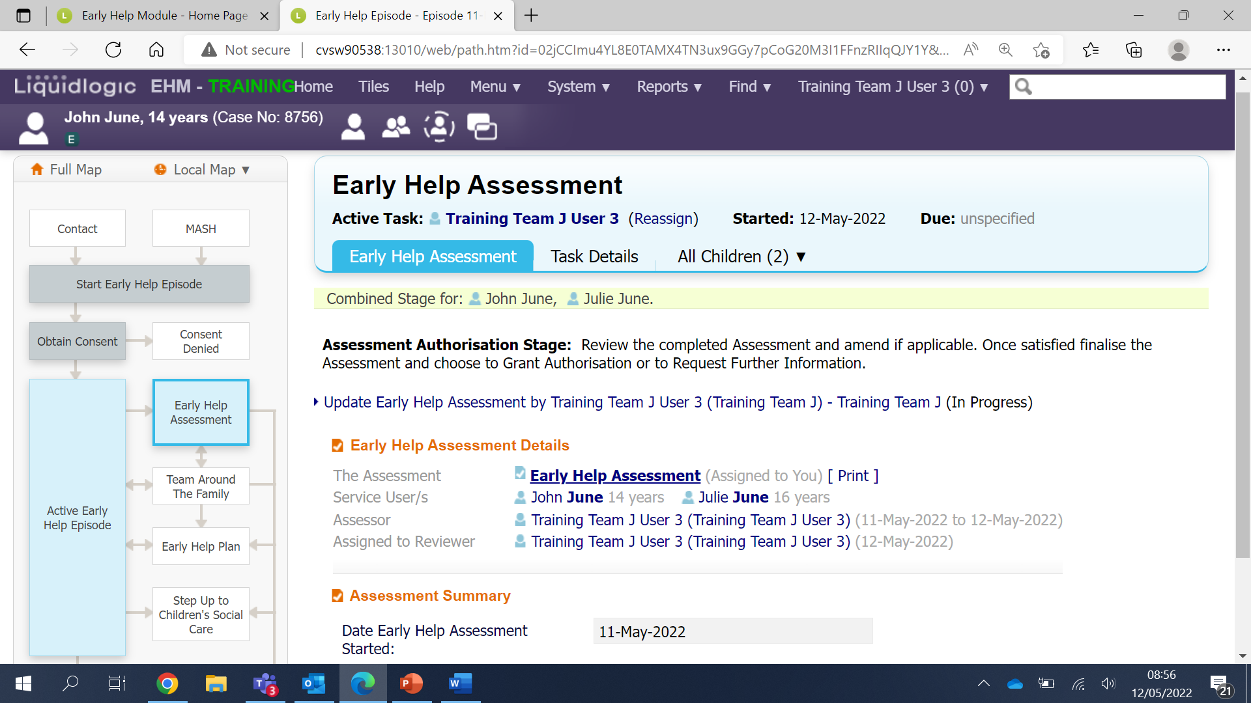
You are now back at the assessment – Click on the grey Finalise Assessment button.
Click Ok to confirm.
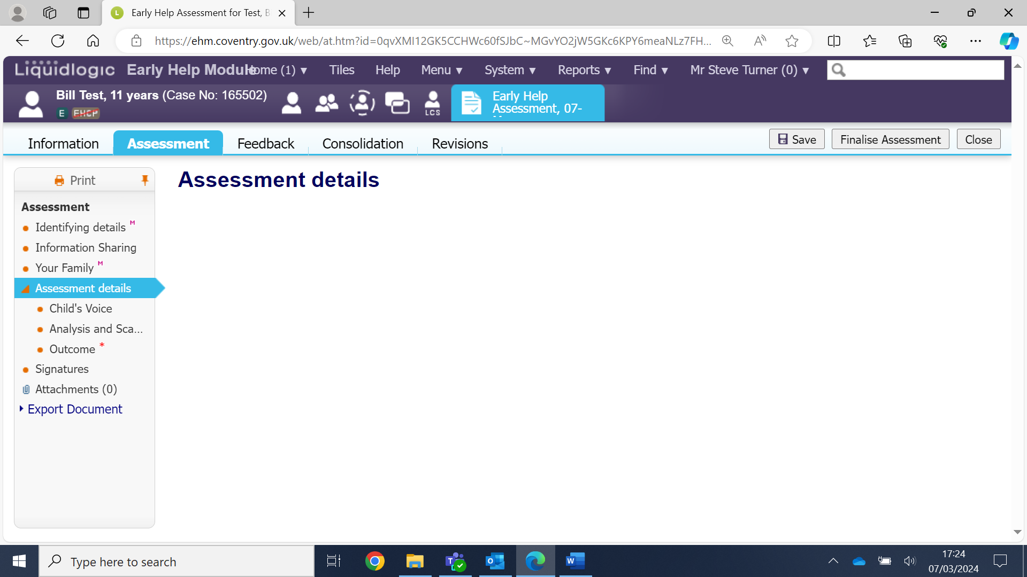

Now click the grey Authorise button. And click Ok to confirm.
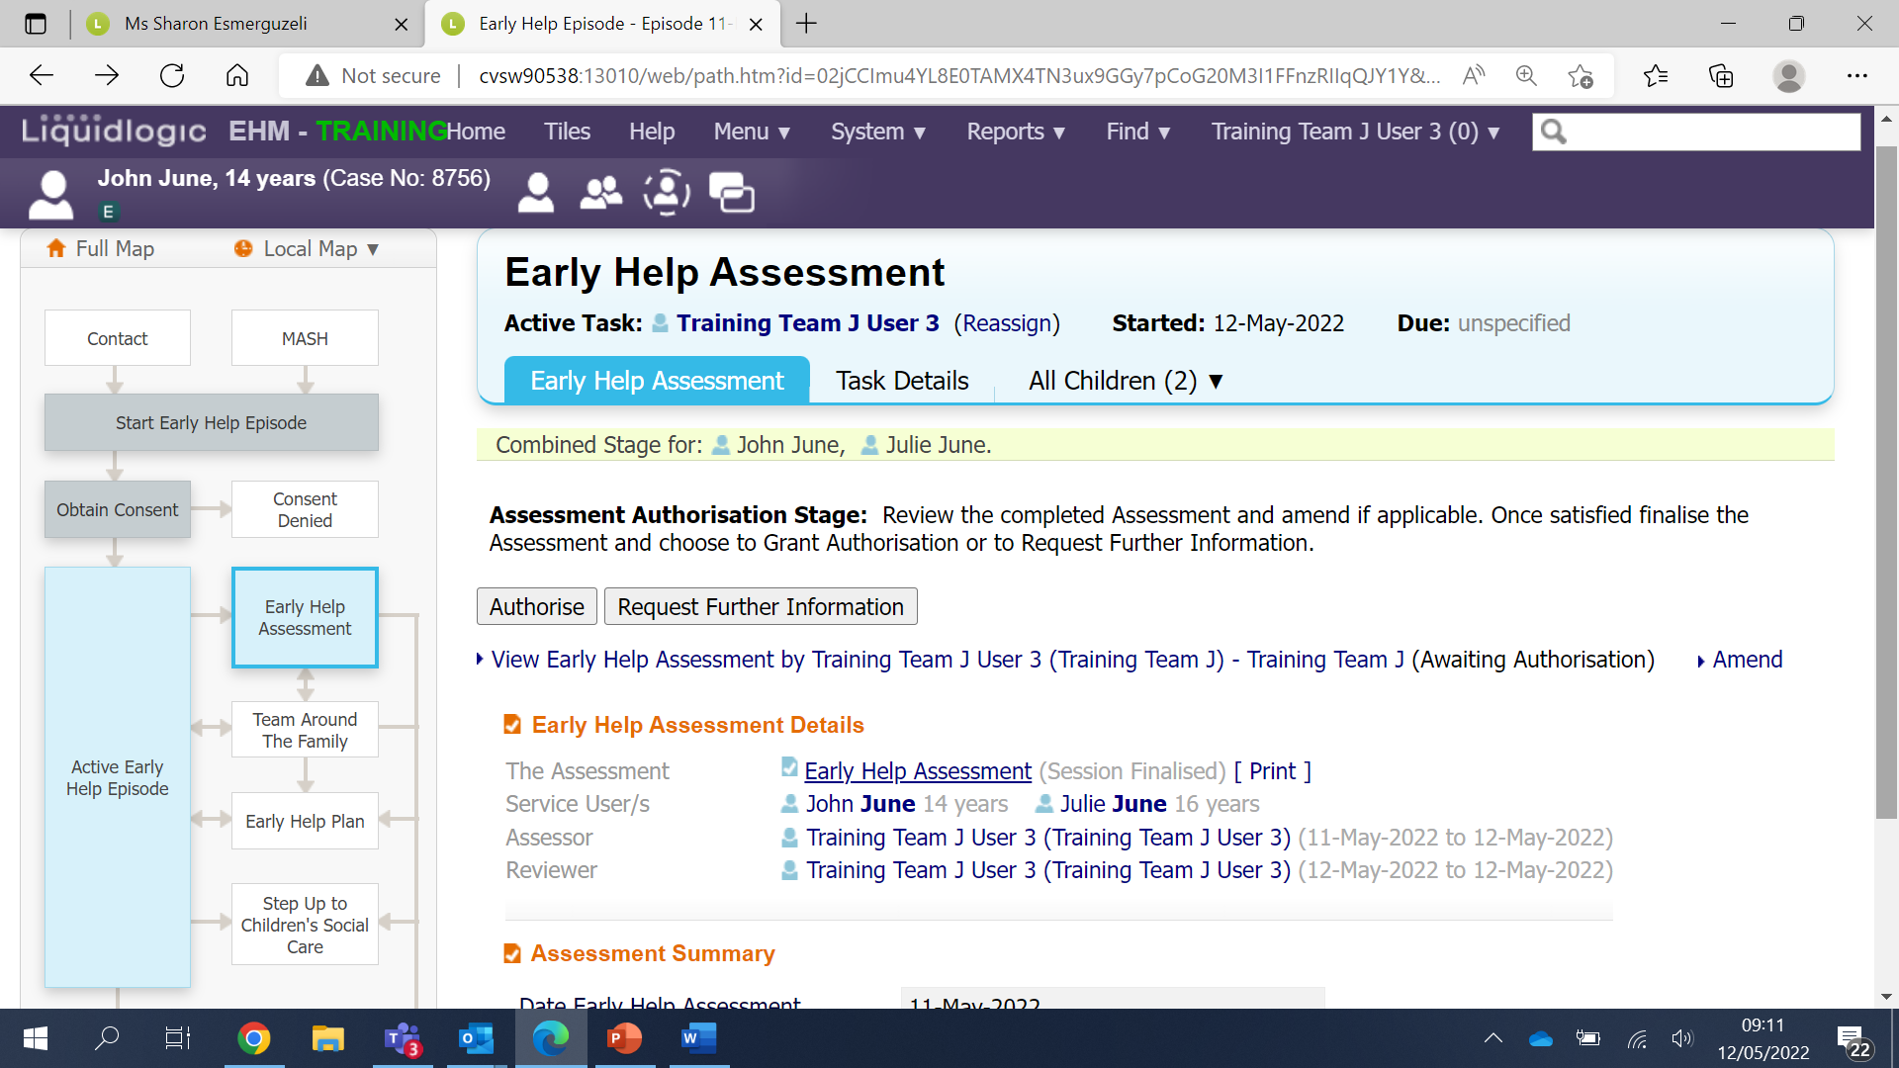
Click the grey Start button.
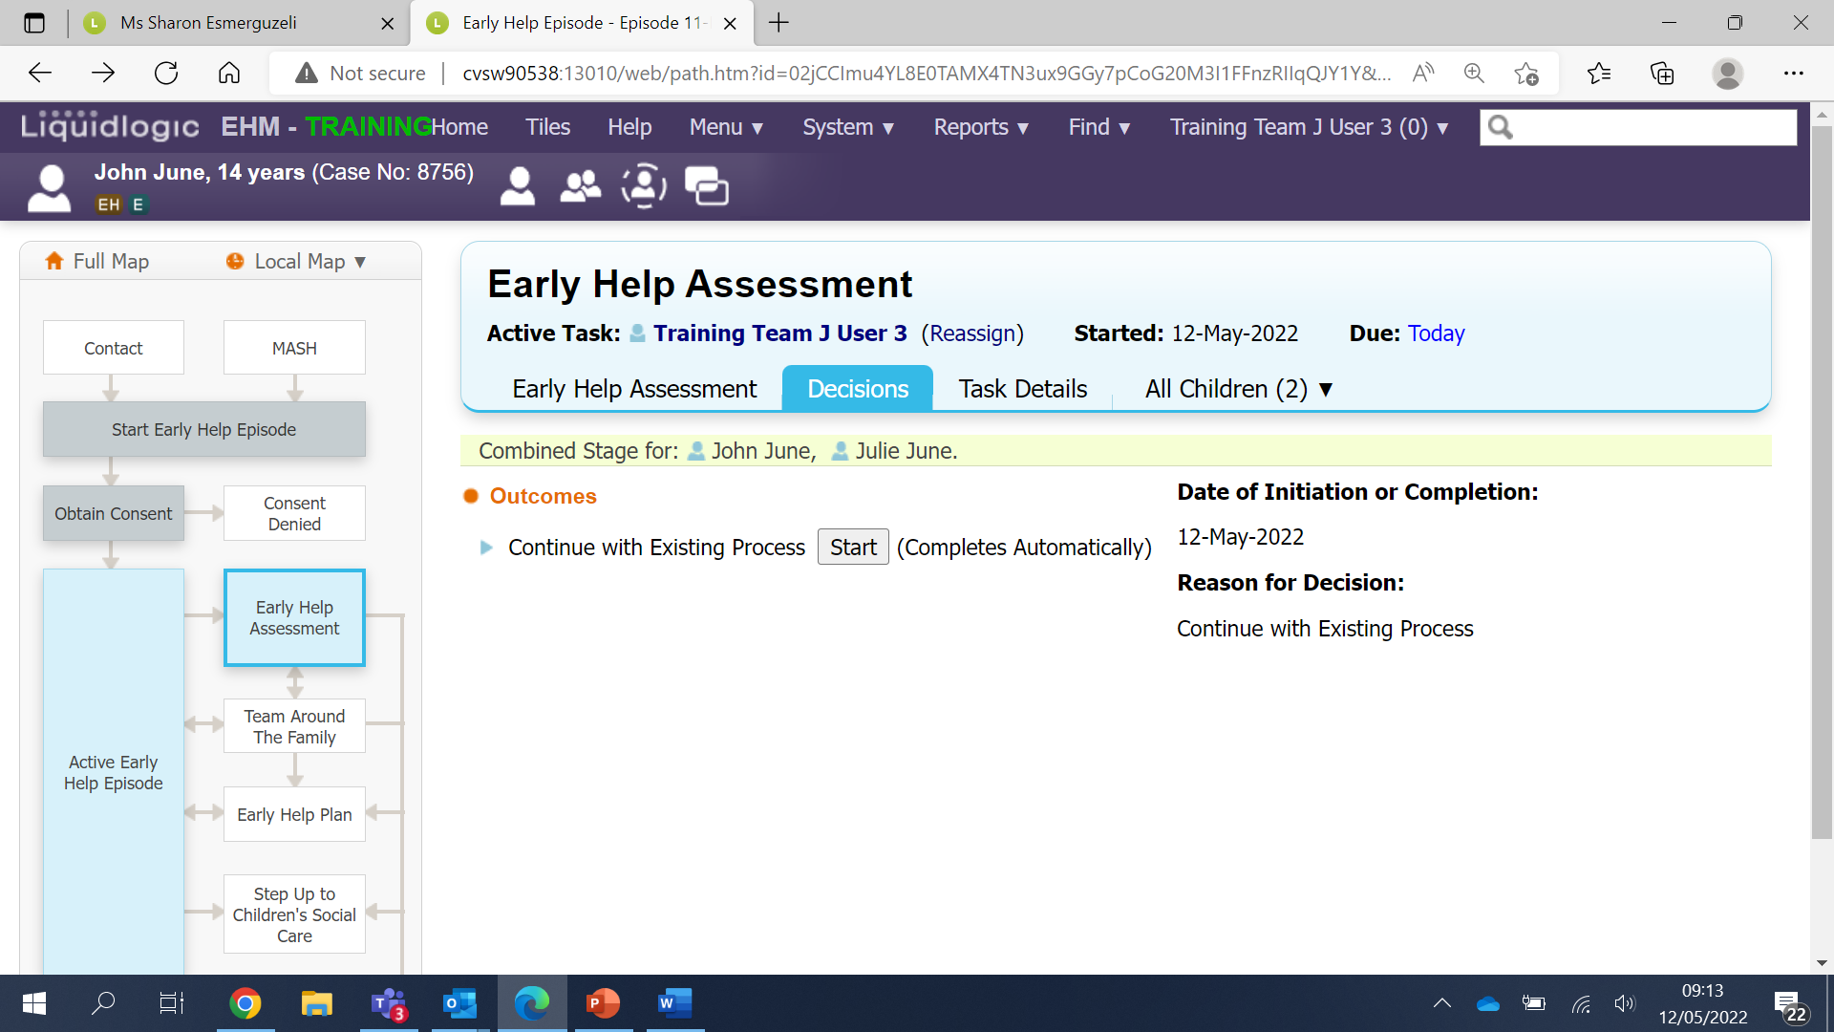

Click the grey Confirm button
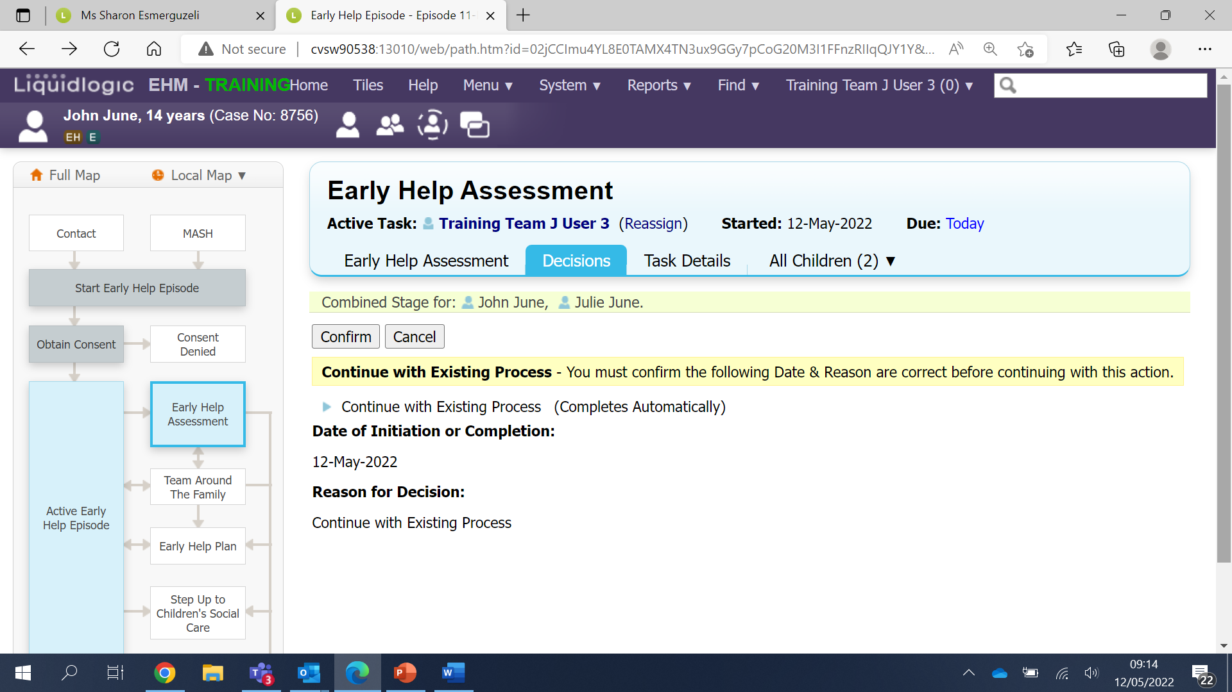
You’ll now see the Early Help Assessment stage has turned grey on the case pathway to indicate the stage is now completed.
You can also see the EH flag appears next to the E flag under the child’s name.
From here you can select Home to take you back to your task tray.
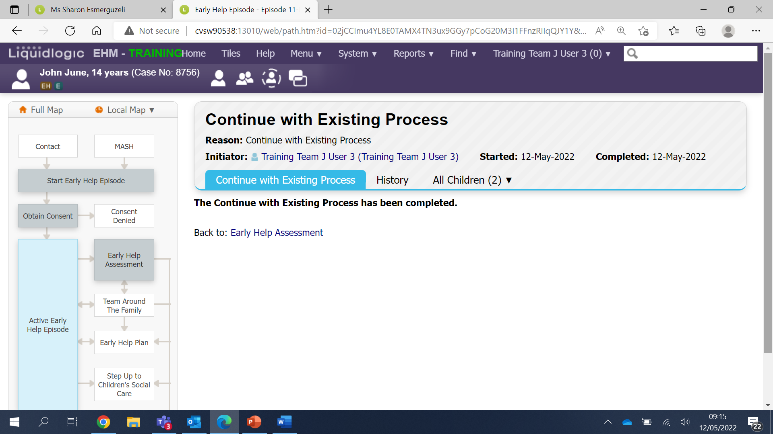
Please note – To print the finalised version of the assessment refer to the guidance on How to Export a Document.

The Supporting Families Outcome Form
It’s important to complete the front page of the Supporting Families form as soon as you have started it from the assessment stage.
From your task tray on the Home page select the Supporting Families Outcome
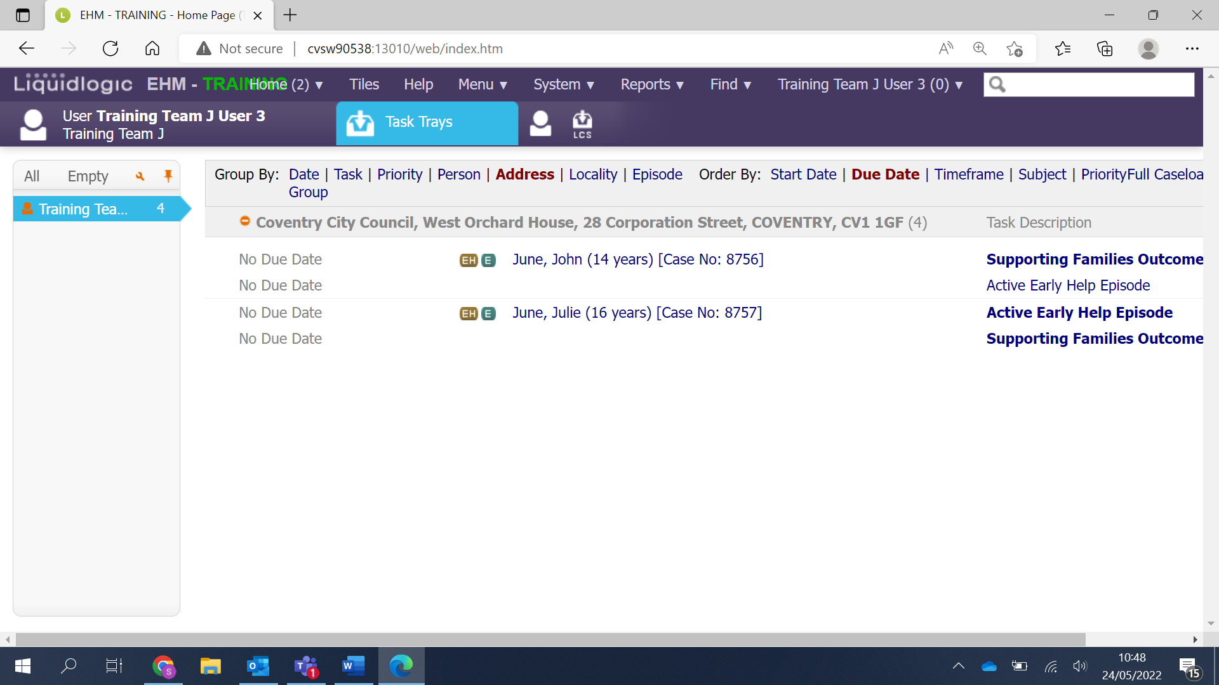
This will take you to the front page of the form.
Work your way down the form completing each of the fields. Ensuring an answer is given to each of the red mandatory fields.
Once you have completed the front page click the grey Save button. The form will remain in your task tray for you to access at anytime.
