How to Start and Complete the Early Help Plan
In your task tray on the home page you will see the Active Early Help Episode task. Click on this.
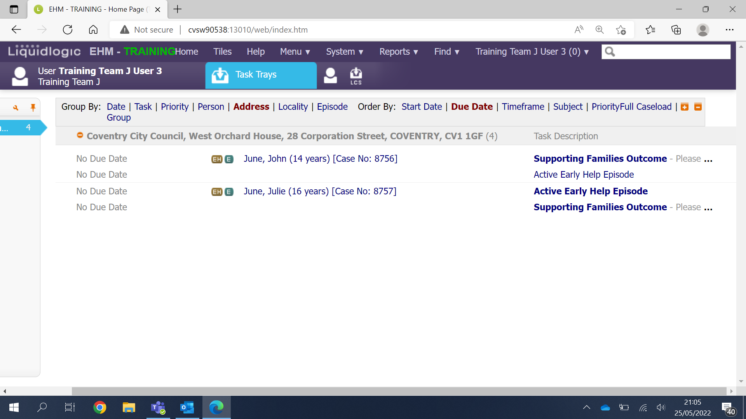
This will take you to either the Active Early Help Episode Tab or the Decisions tab. Select the Decision tab.
From here select to Start the Early Help Plan.
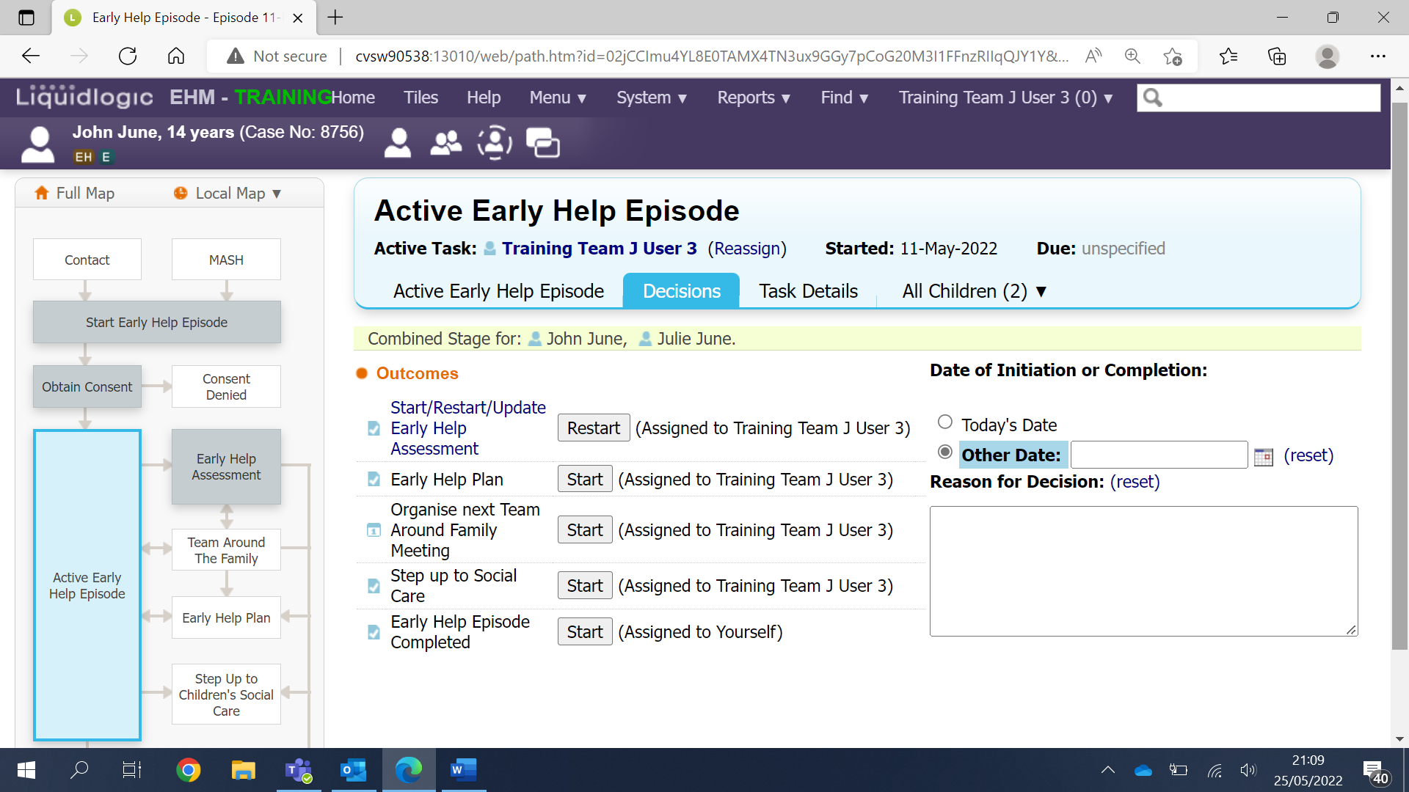

Select Today’s Date and click the grey Confirm button.
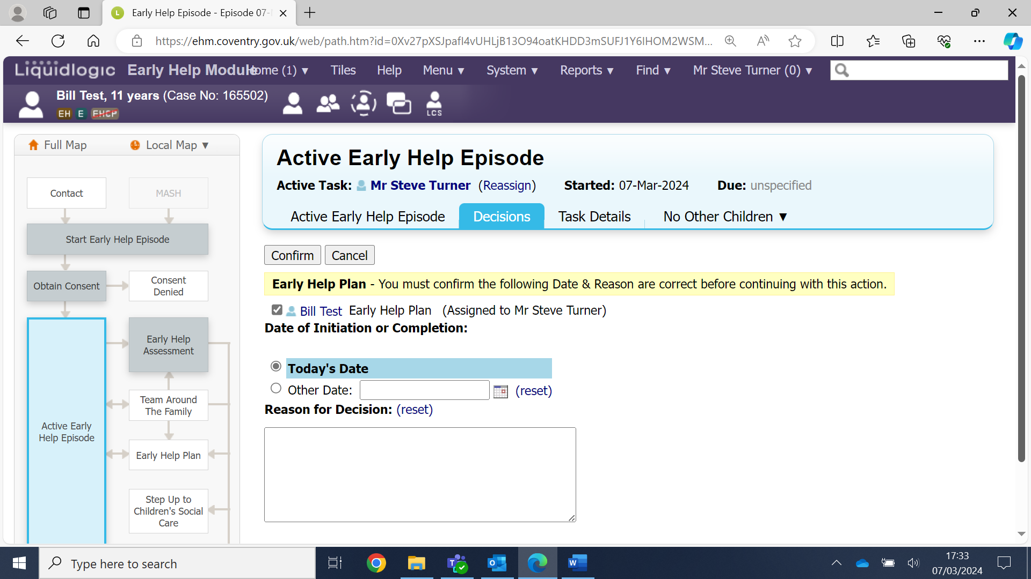
Now you will see the yellow notice to inform you the task is in your work tray.
Click on Home to go to your task tray.
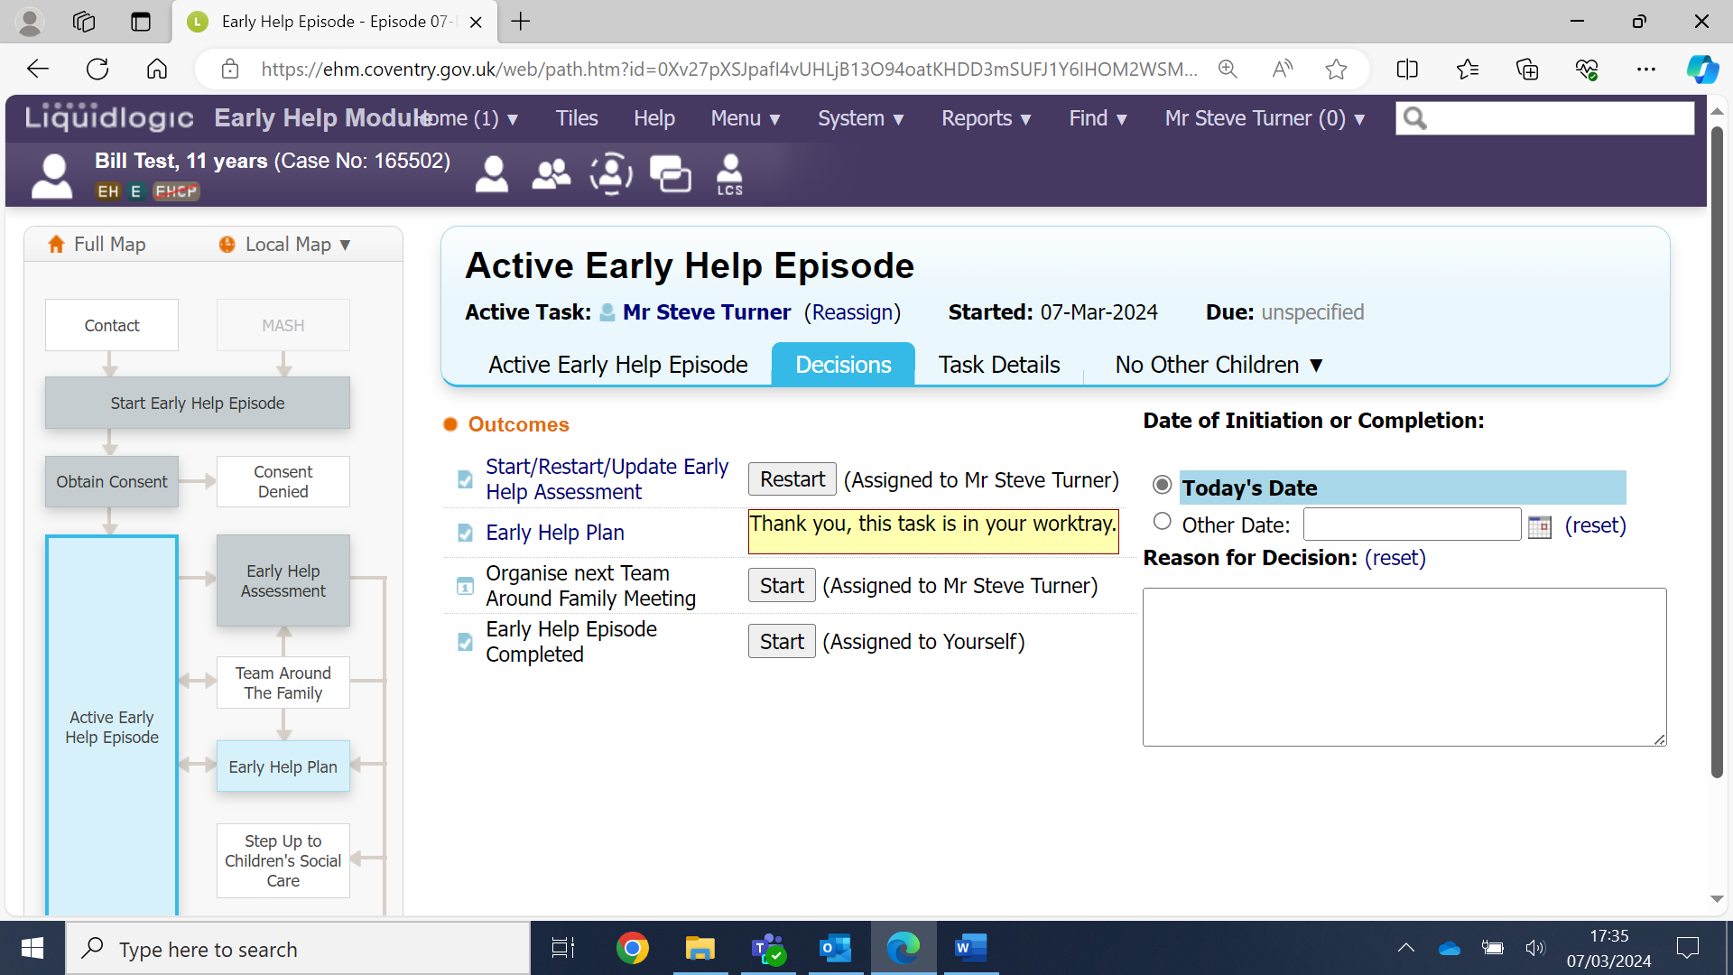

You will see the Early Help Plan task in your task tray. Click on the task.
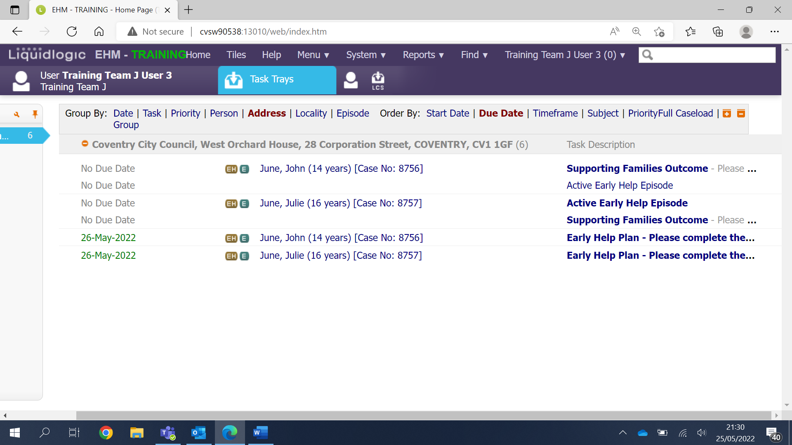
You can now see the Early Help Plan stage has turned blue on the case pathway.
Click on the grey Start Early Help Plan button.
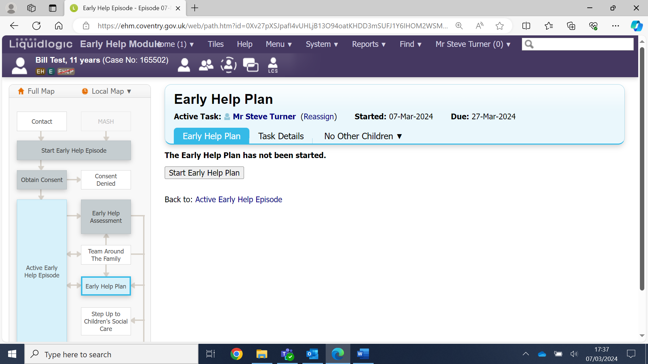

On this screen you can select to Copy Forward certain pieces of information from the Early Help Assessment. This is important as it will copy the worries you have identified.
Click on the grey Copy Forward Selected button.
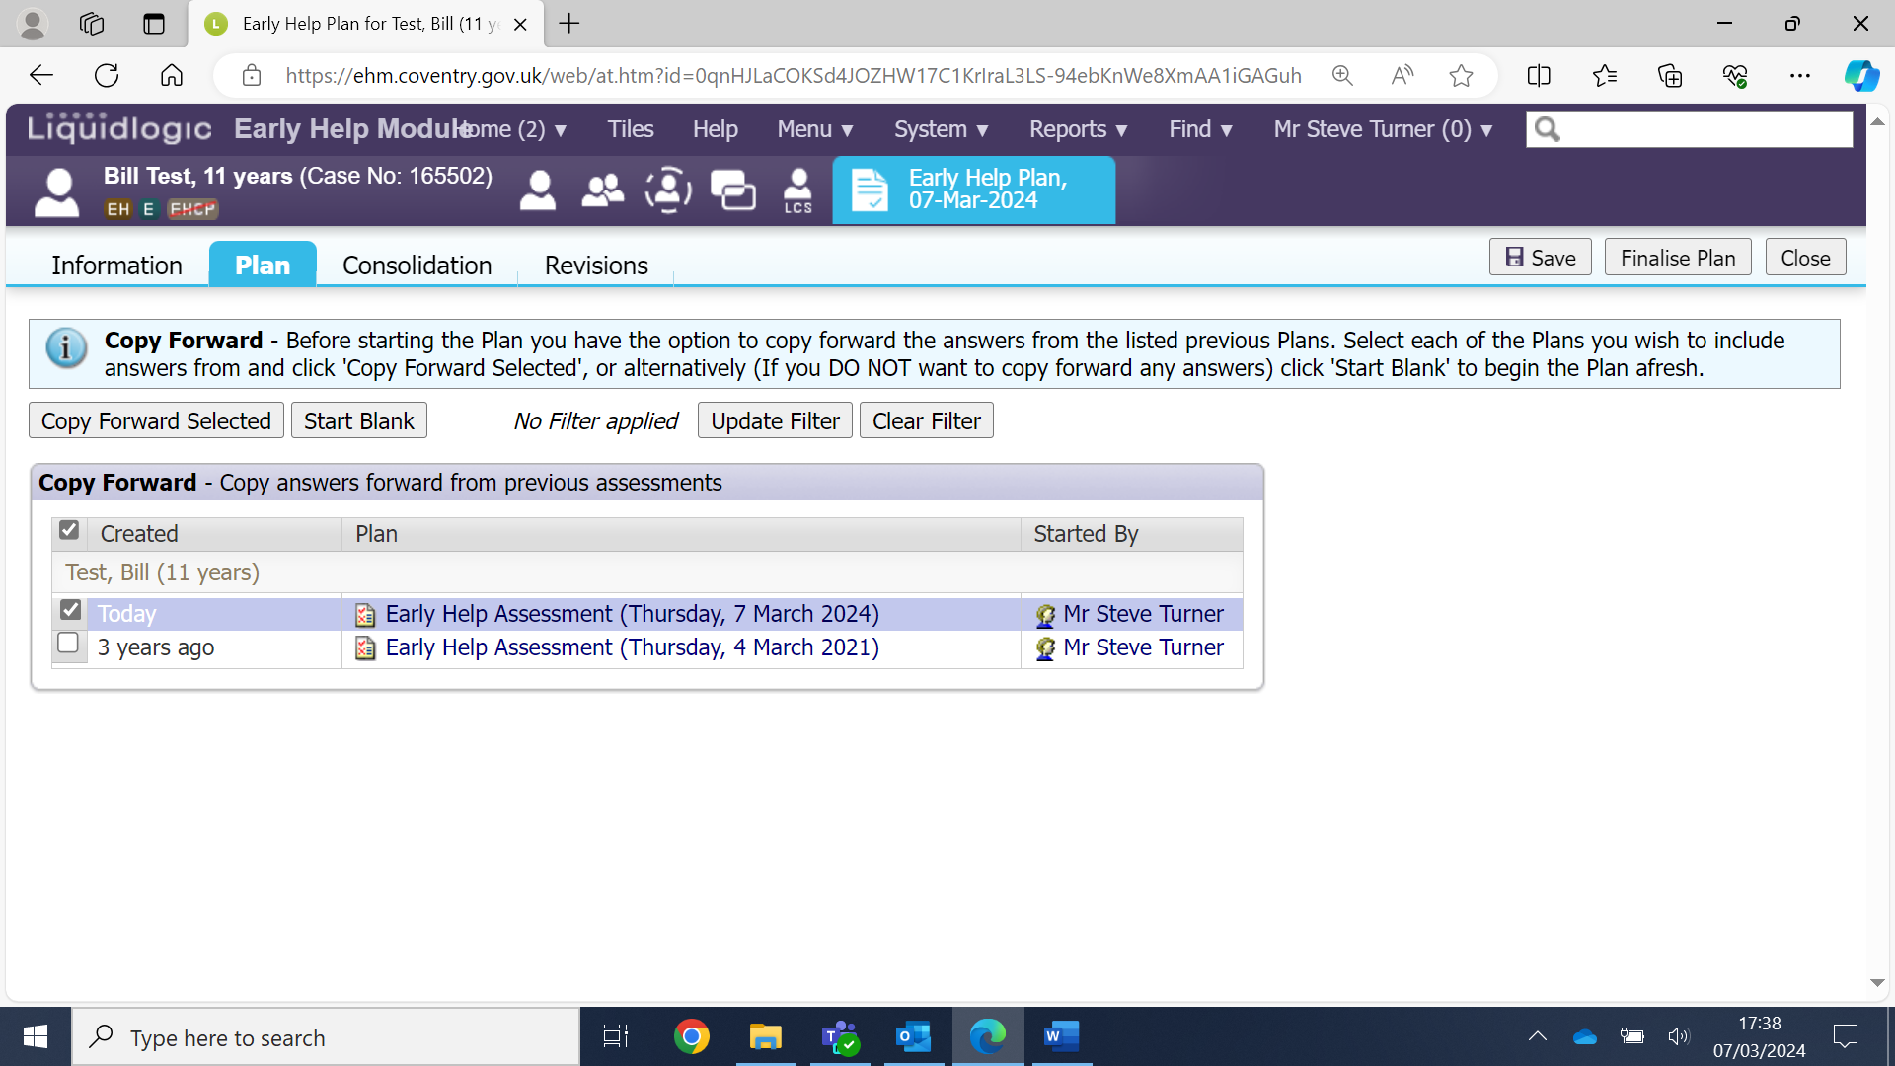
You can now work your way down the screen completing all the necessary fields.
Please note: It is advisable to click the grey Save button at regular intervals.
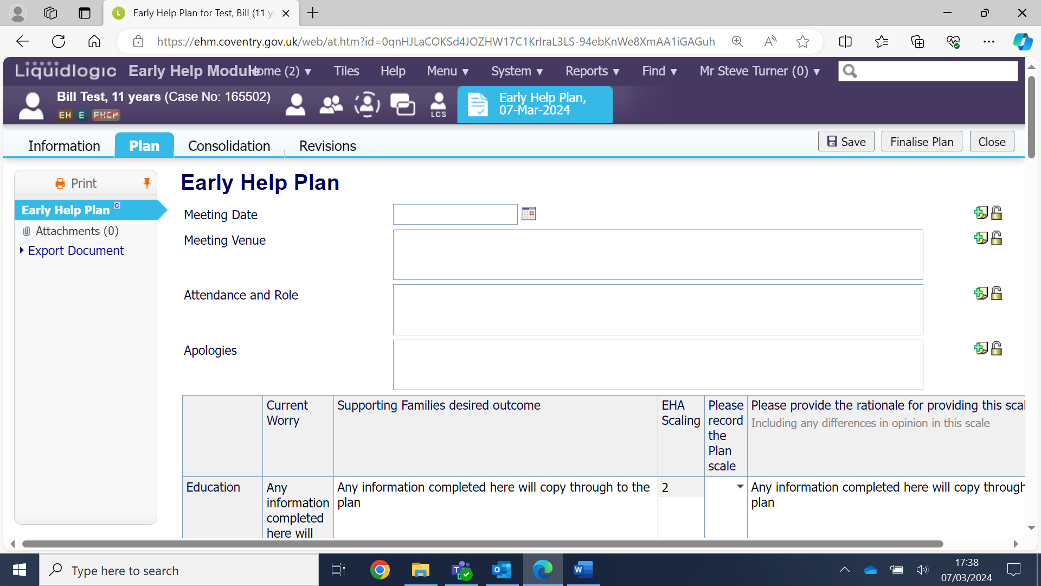

As you reach the end on this Early Help plan screen you will see 3 red mandatory questions.
If a Team Around the Family meeting is going to take place, then select Yes to the first question. If you select Yes then you must now fill in the date and time of the forthcoming meeting: The format is: 25/05/2022 13:00. Add a venue and who needs to attend.
Select ‘Continue with Existing Process’ for Suggested Outcomes
Type Continue with Existing Process in the Reasons for these suggested outcomes field.
If you have completed all the fields, you can now click the grey Finalise Plan button.
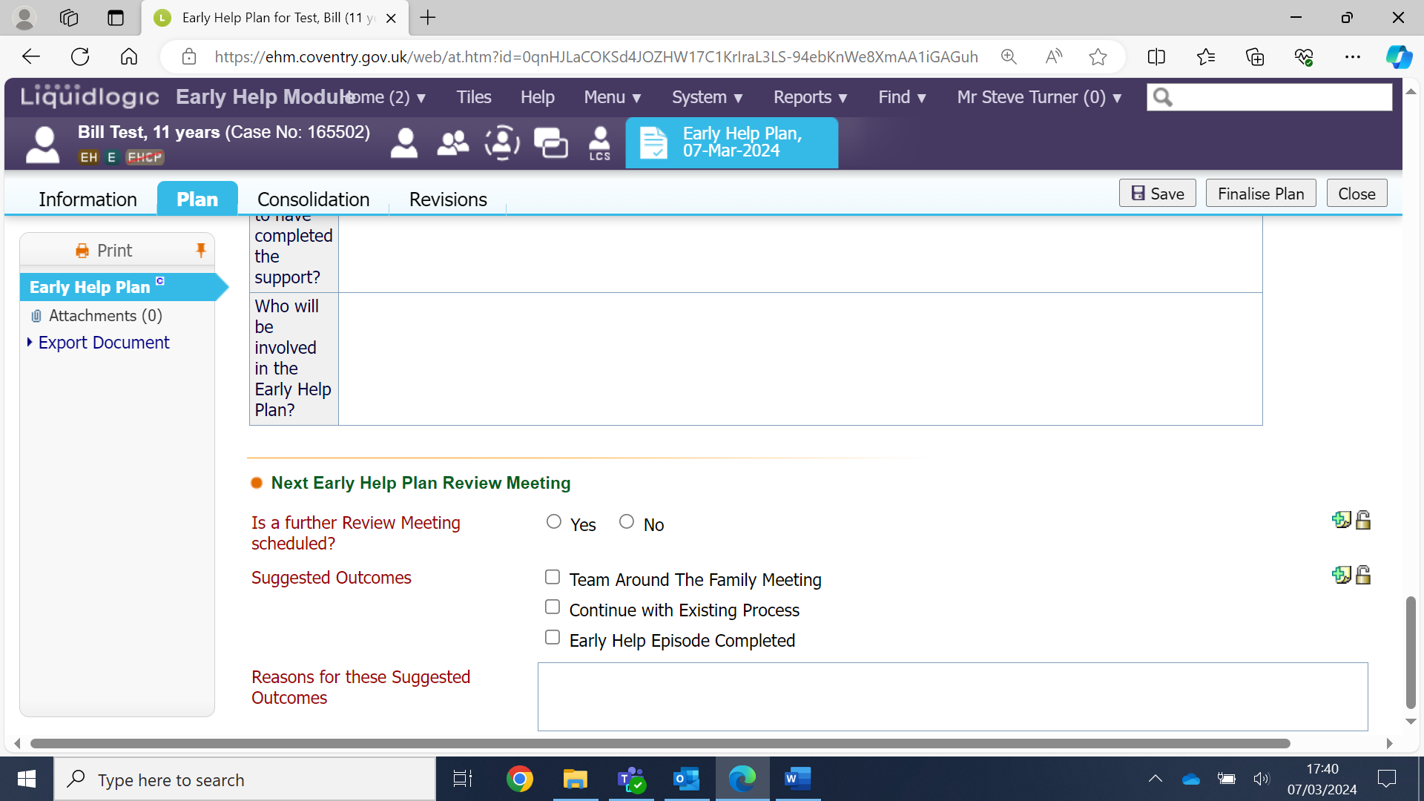
Click Ok to confirm
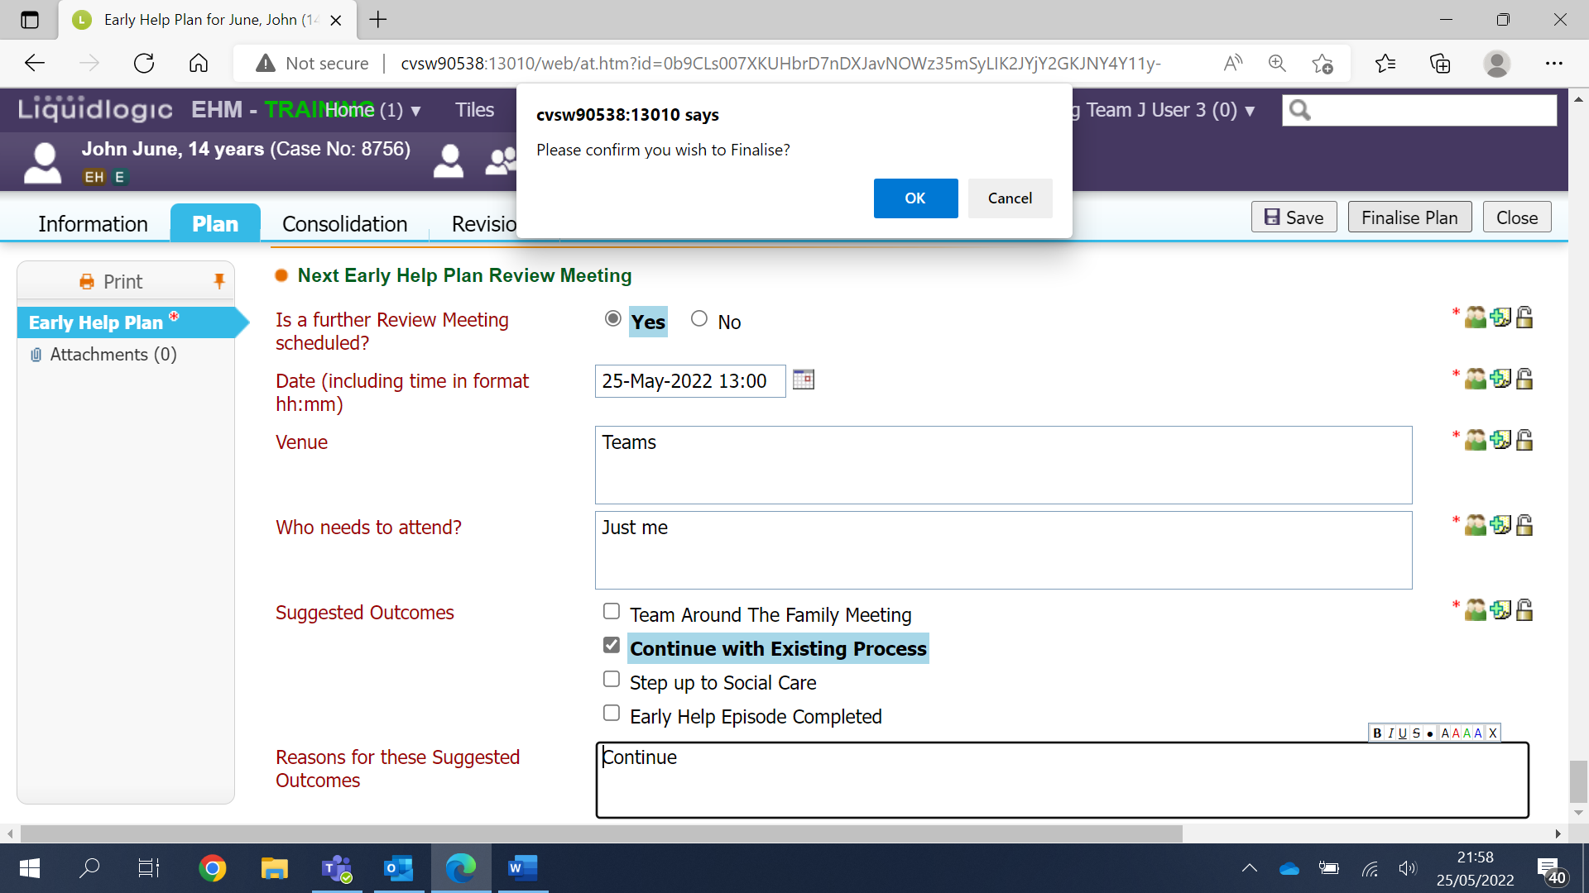
You now have to authorise the Early Help.
Click on the blue Update Early Help Plan link.
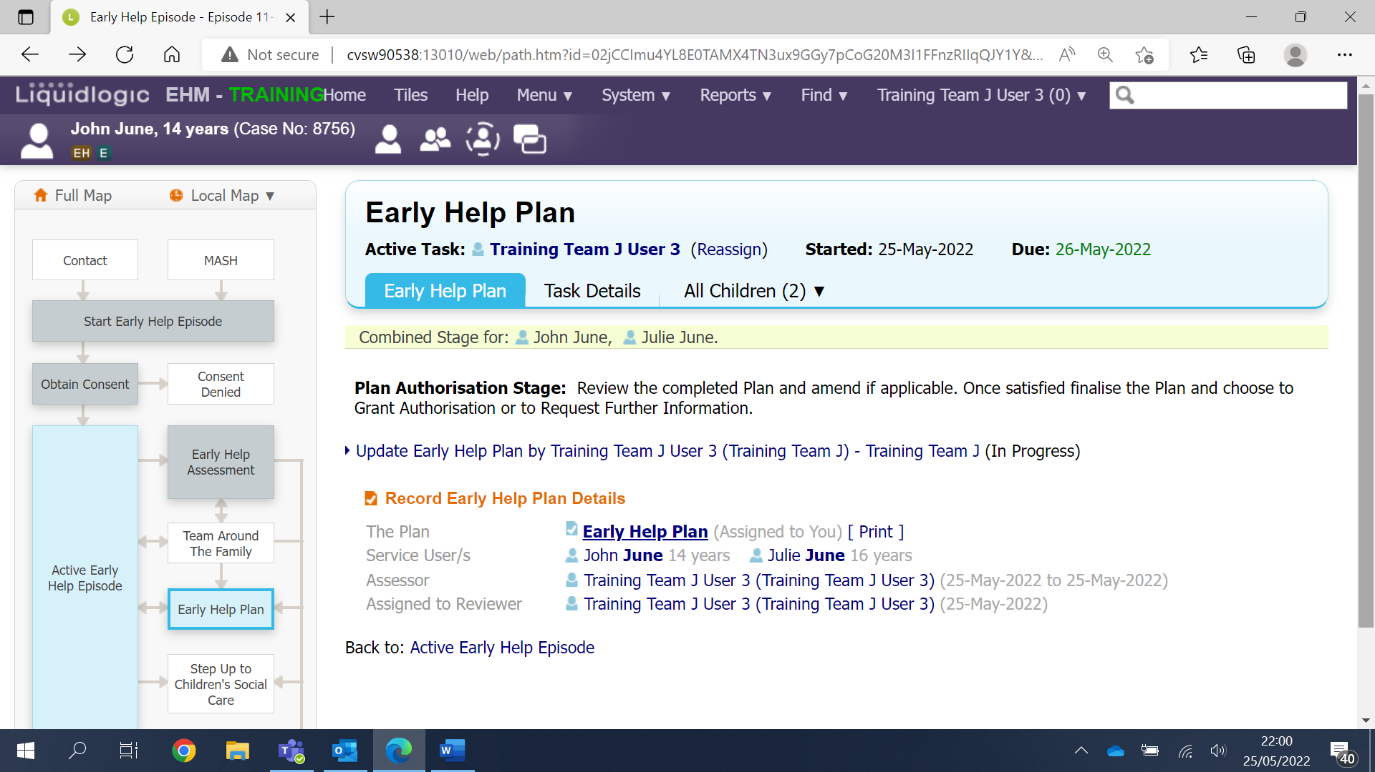
You are now taken back into the plan and have the opportunity to amend it if you need to.
Once you have double checked the plan you can click on the grey Finalise Plan button.
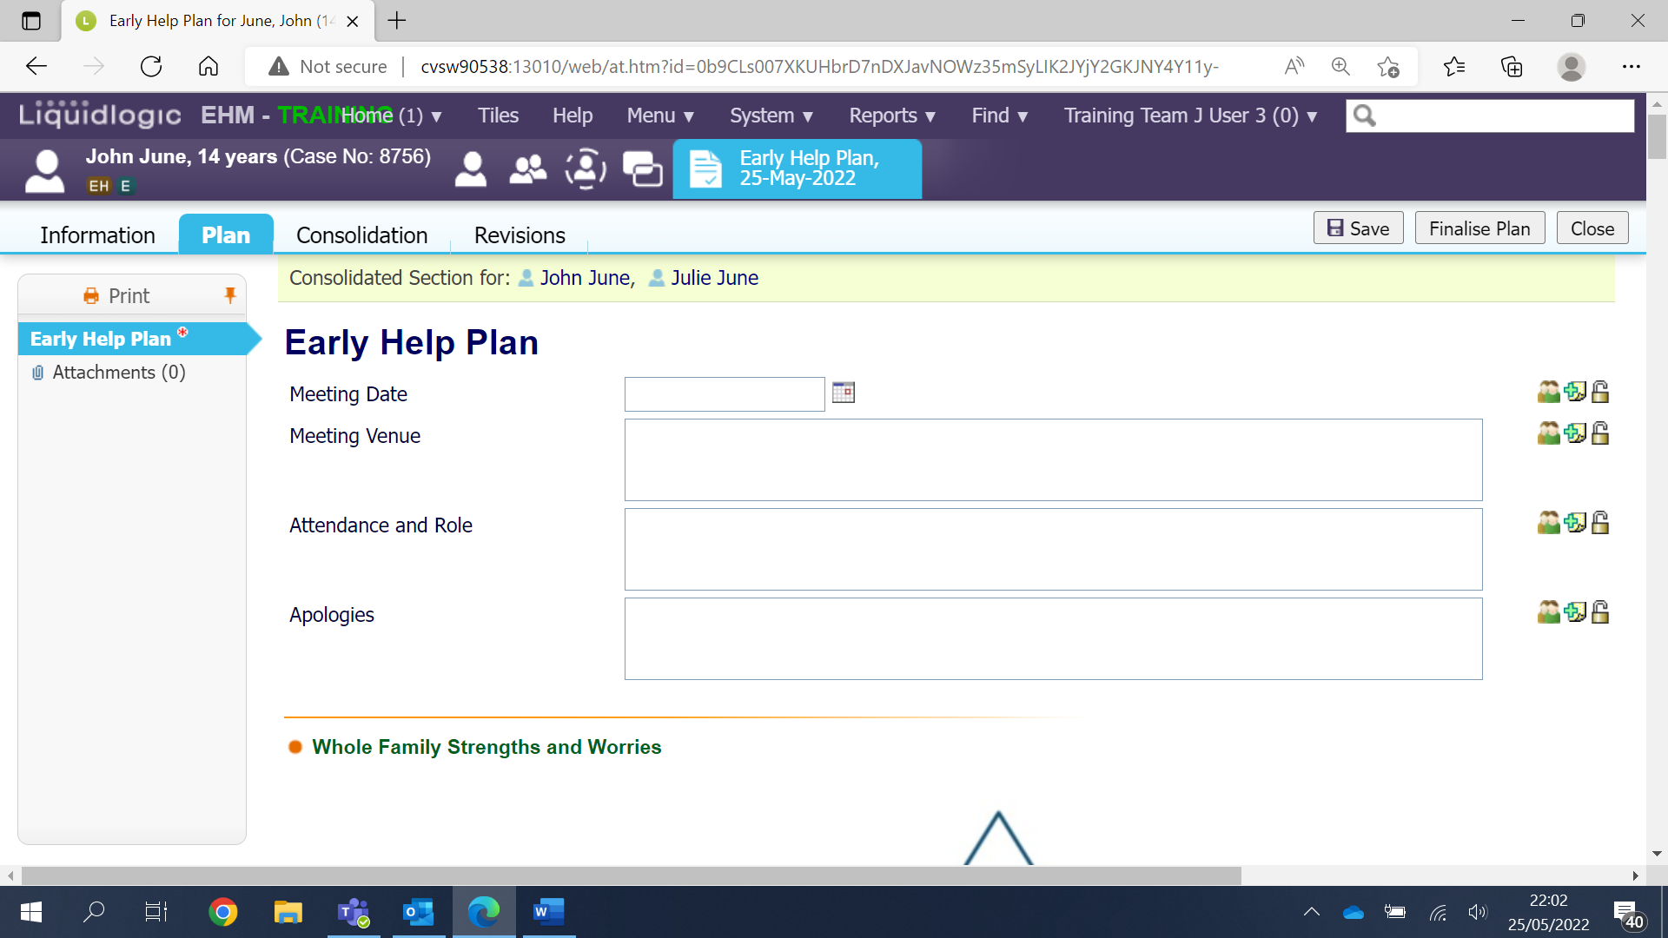

Click Ok to confirm
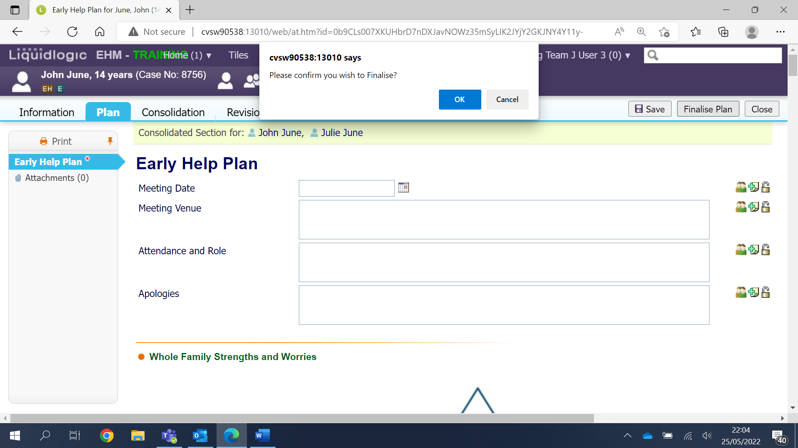
Now click the grey Authorise button.
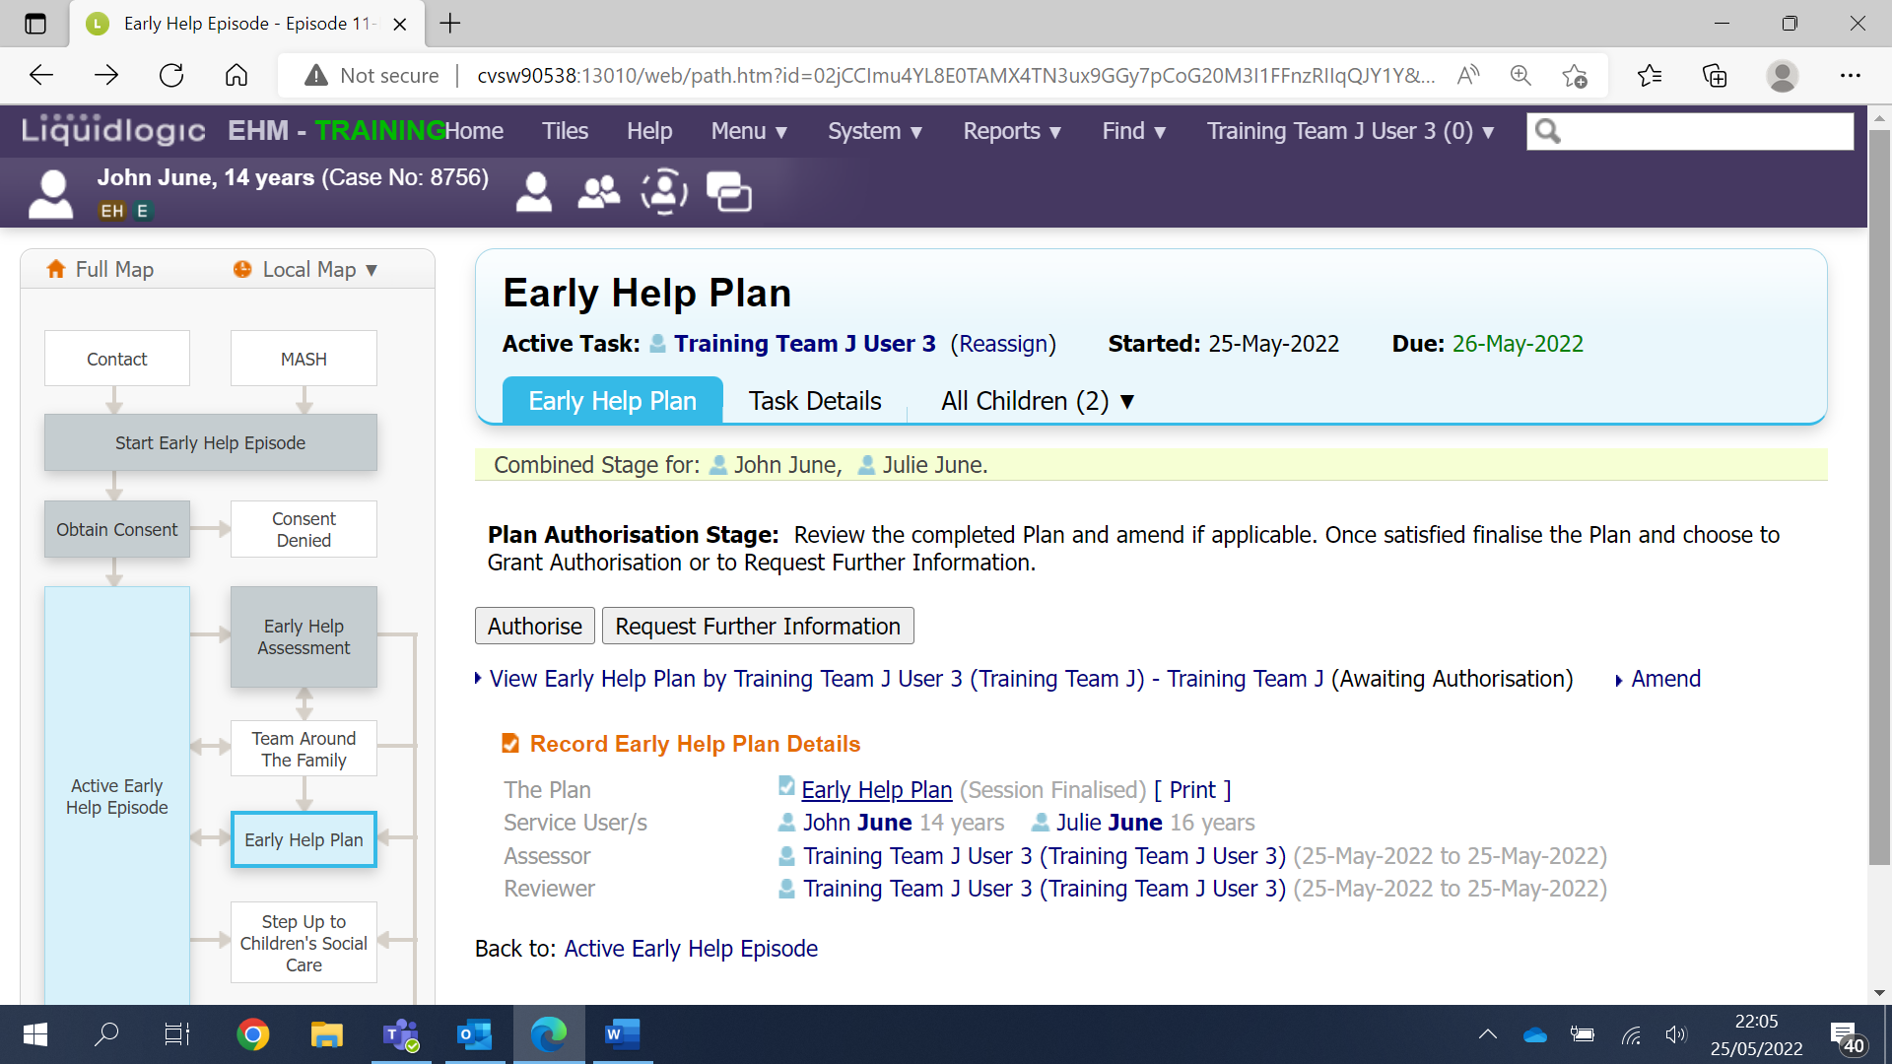

Click Ok to confirm
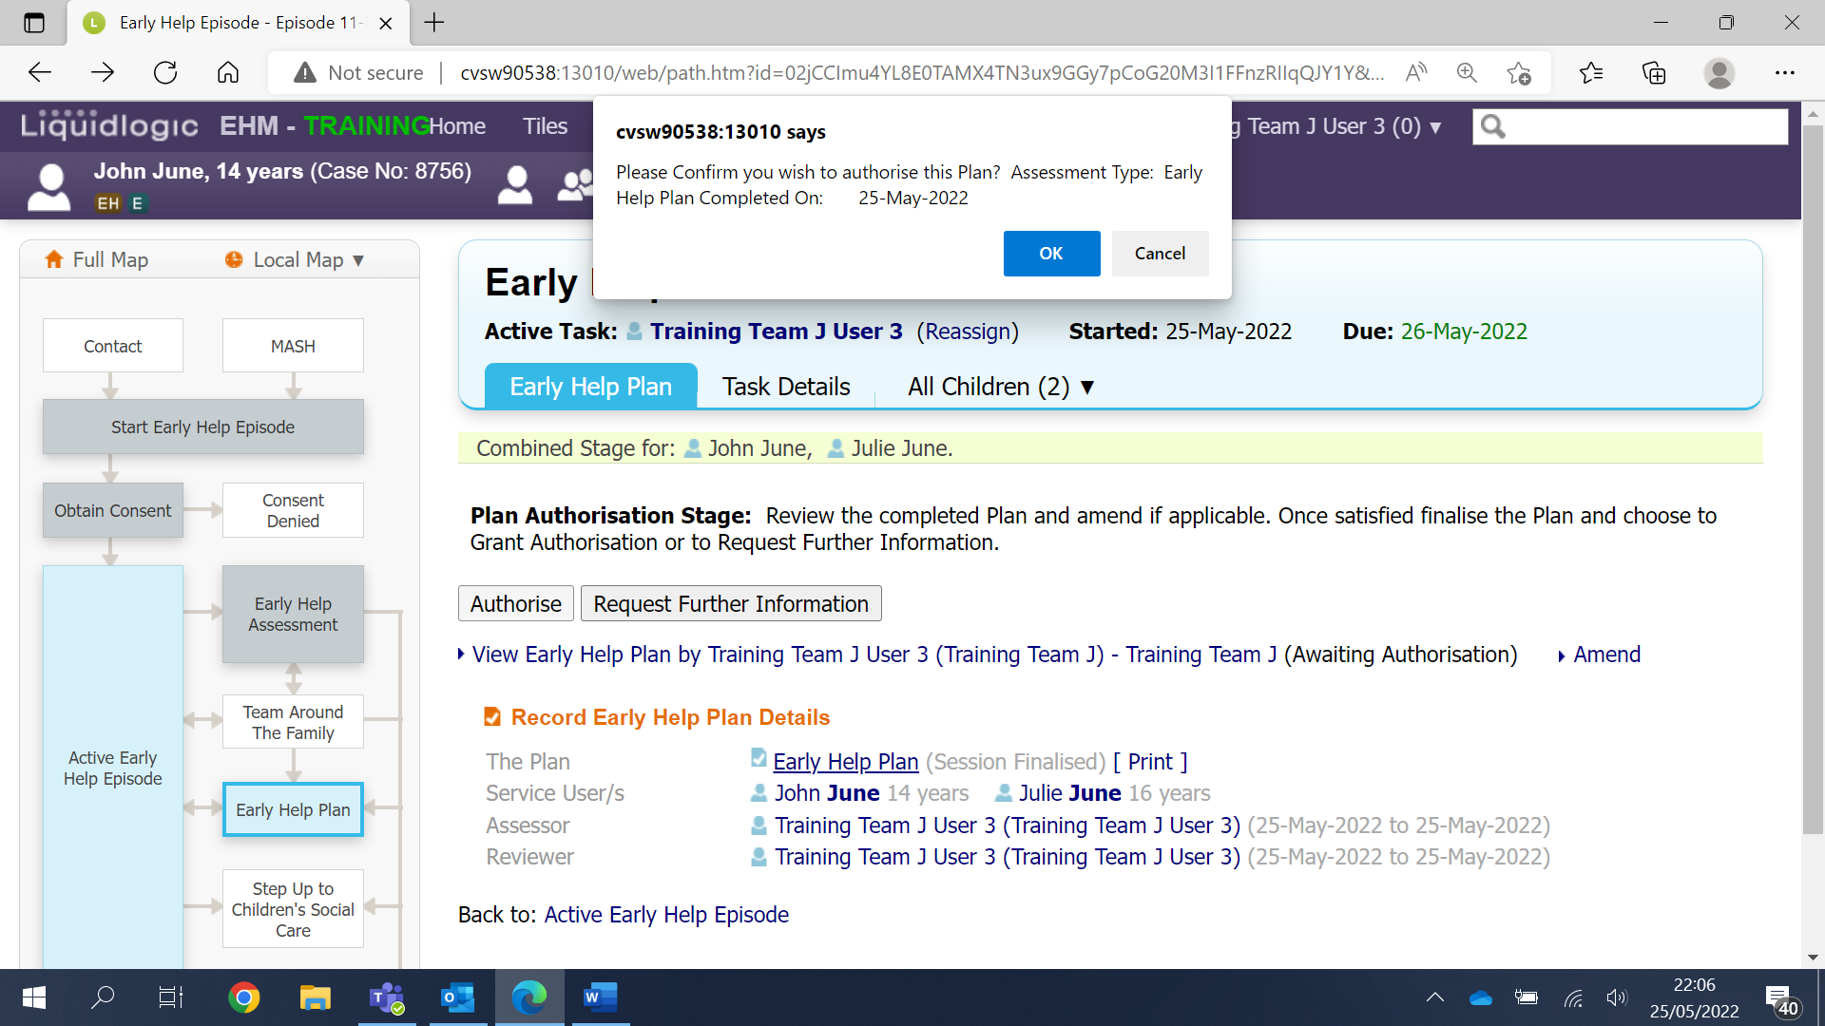
Click the grey Restart button.
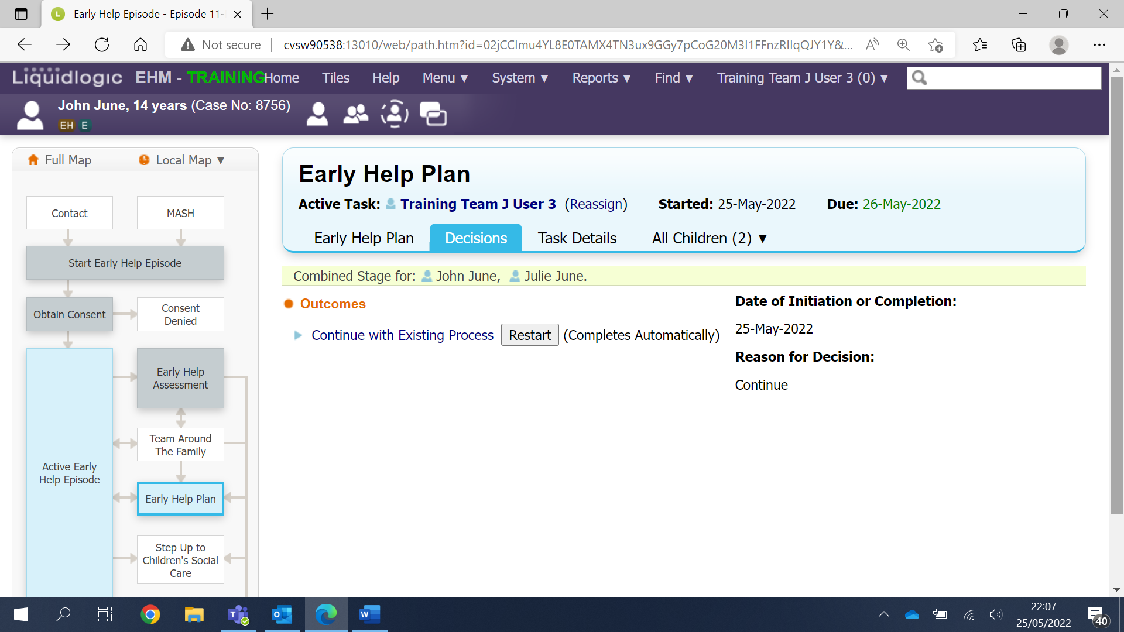

Now click on the grey Confirm button.
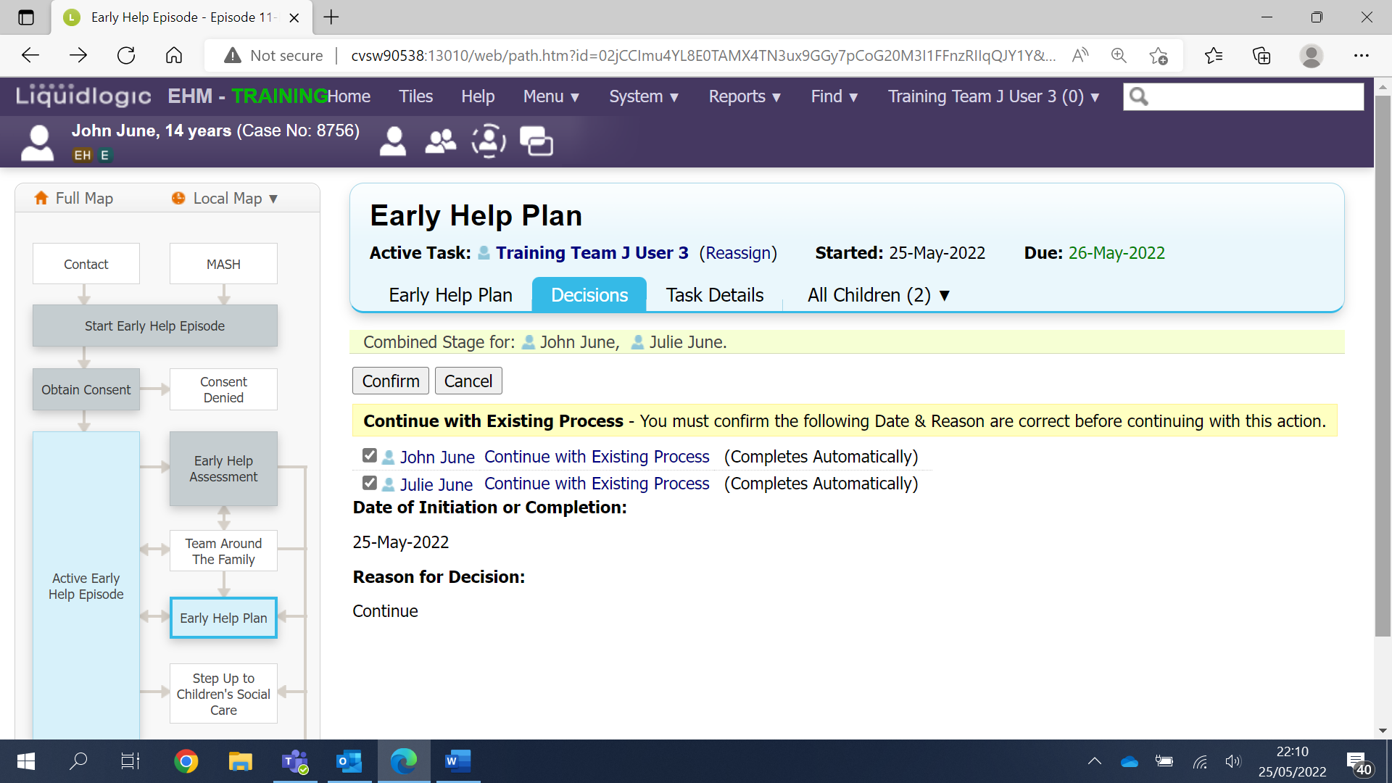
You will now see the Early Help Plan stage on the case pathway has turned grey to indicate the stage has been completed.
