How to Start and Complete the Team Around The Family Meeting stage
On your task tray on the home page, you will see the Active Early Help Episode task. Click on this.
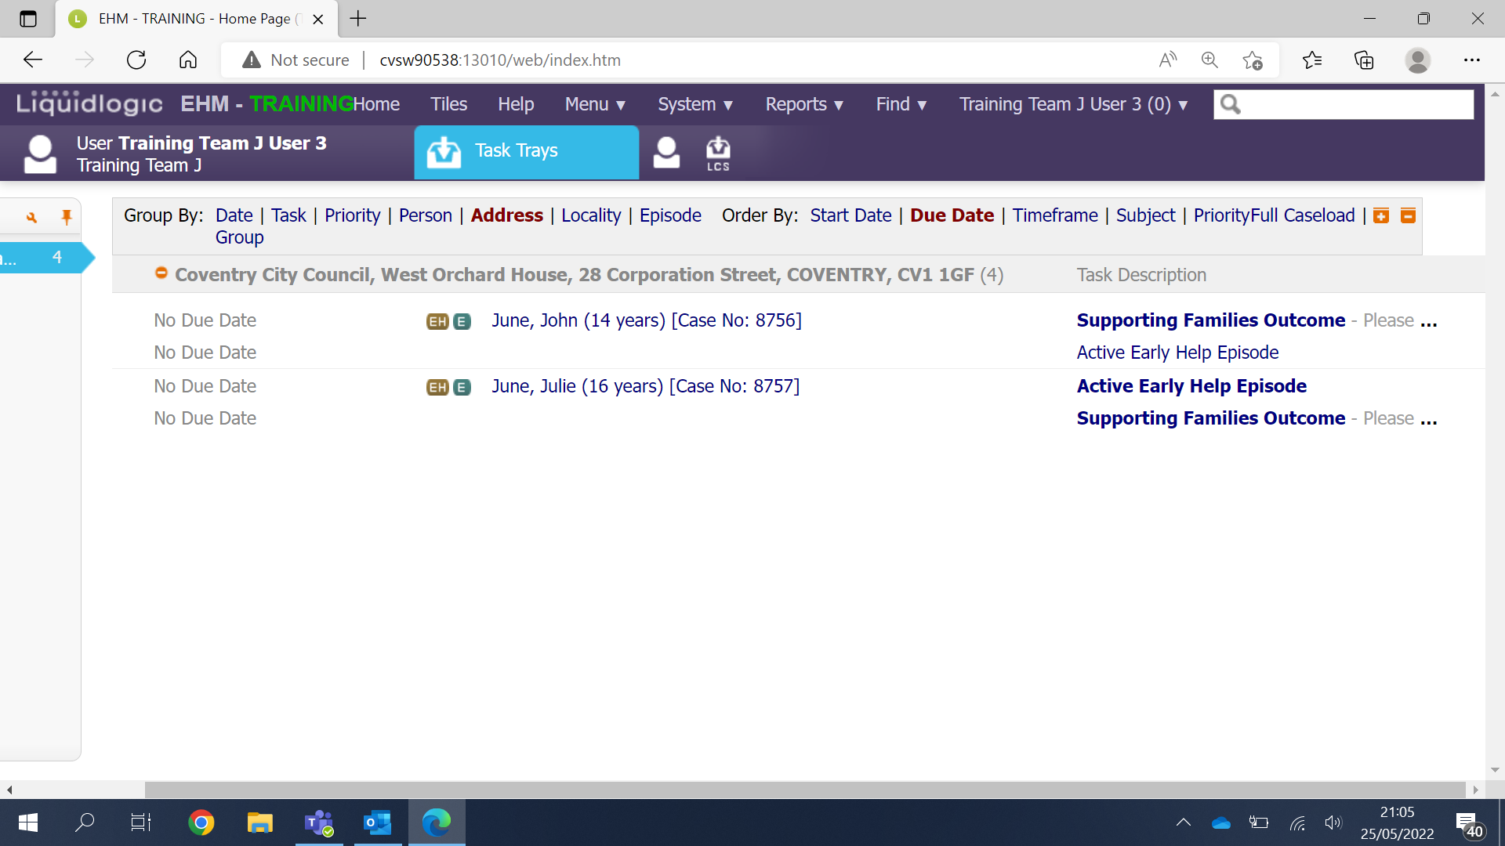
This will take you to the Decisions tab on the Active Early Help Episode stage.
From here select the grey Start button next to Organise next Team Around Family Meeting.
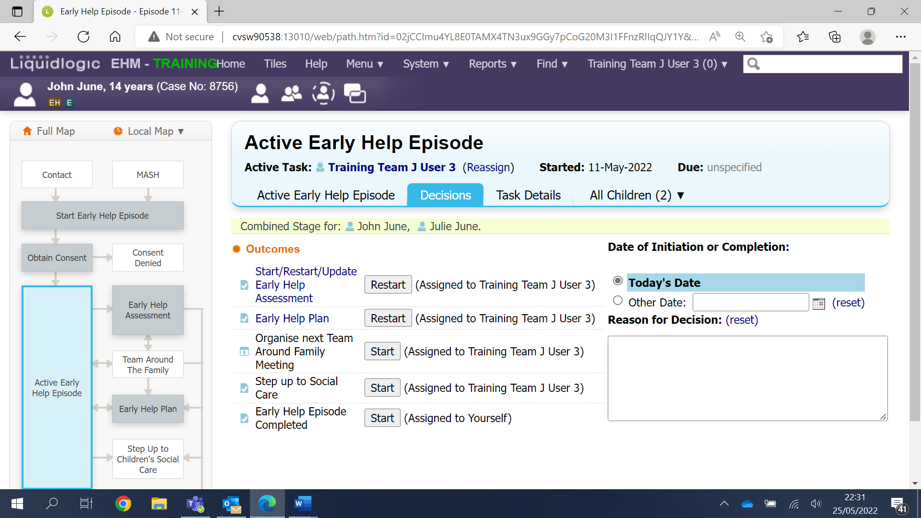

Select Today’s date and click the grey Confirm button.
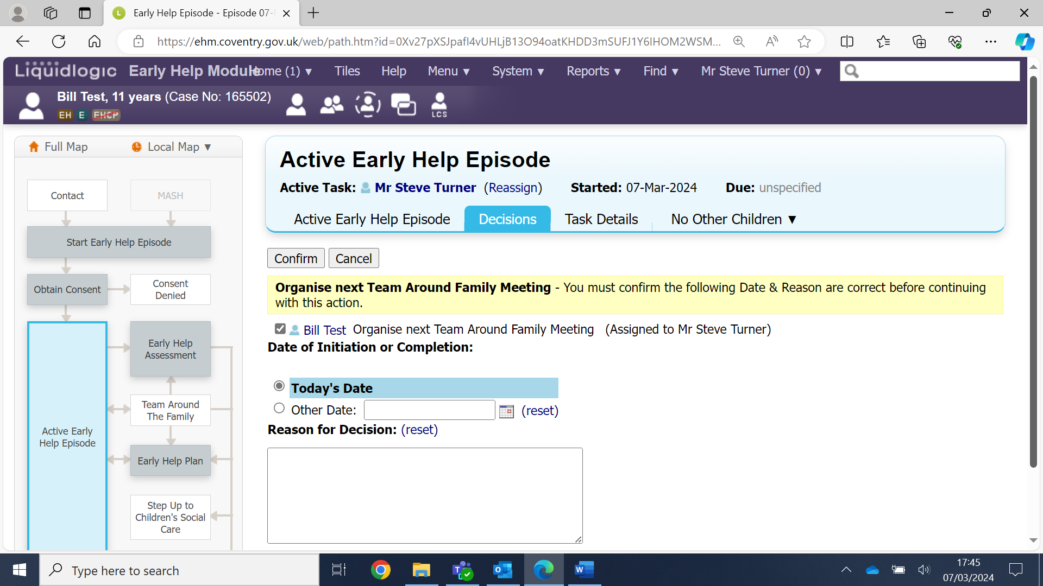
You can see the Team Around The Family Stage has turned blue on the case pathway.
From this screen the first thing to do is Update Meeting Details and Scheduling, click on the blue link.
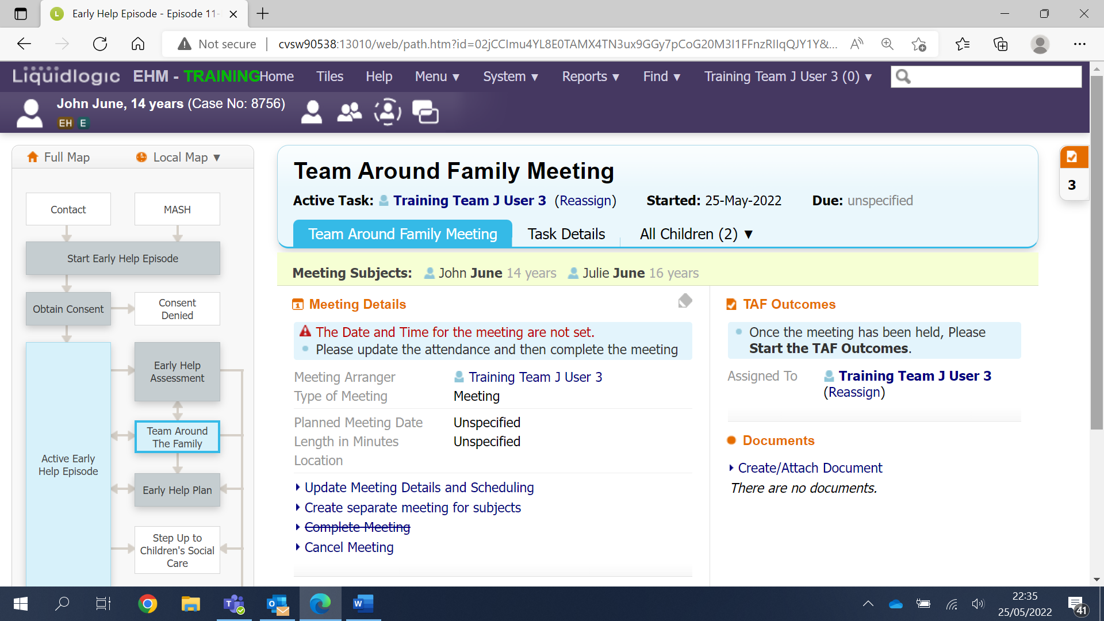

You can now fill in the Planned Meeting Date field (click on the calendar icon to select the date)
Length in minutes
Location.
Once you have filled in these 3 fields click the grey Update button.
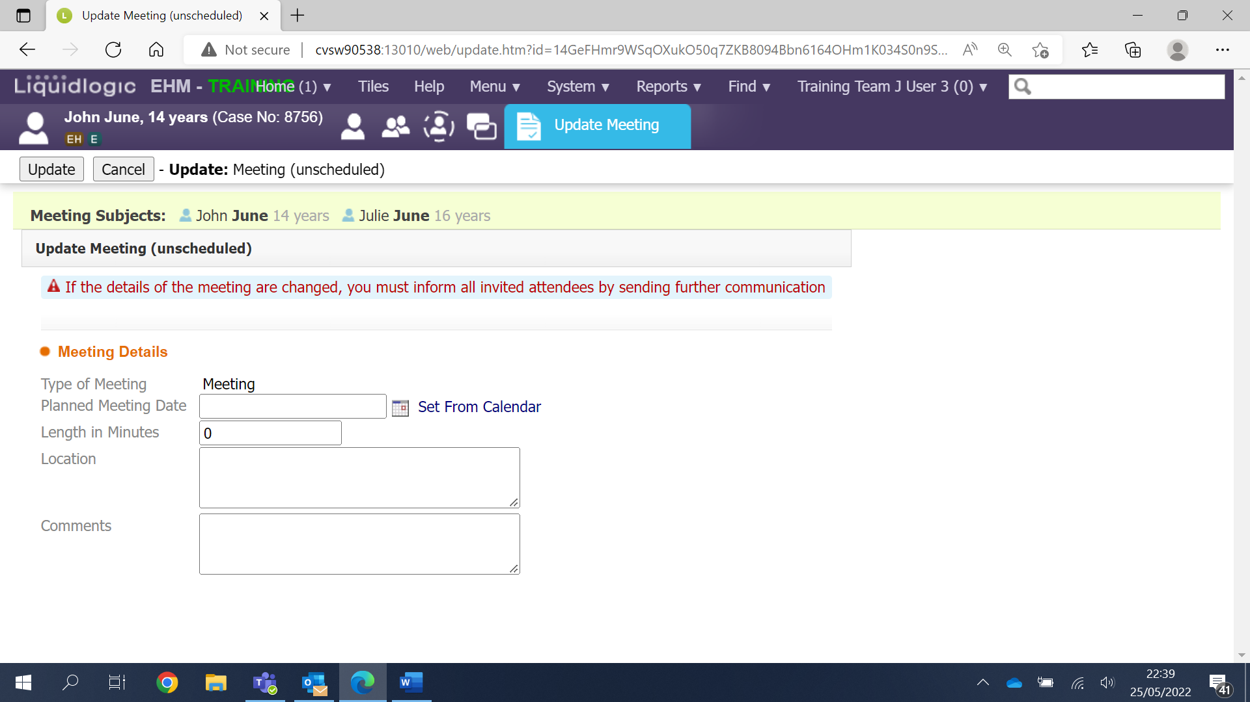
Now the meeting Details section has been filled in you can navigate to TAF Outcomes and click the Meeting Held – Write up Outcomes blue link.
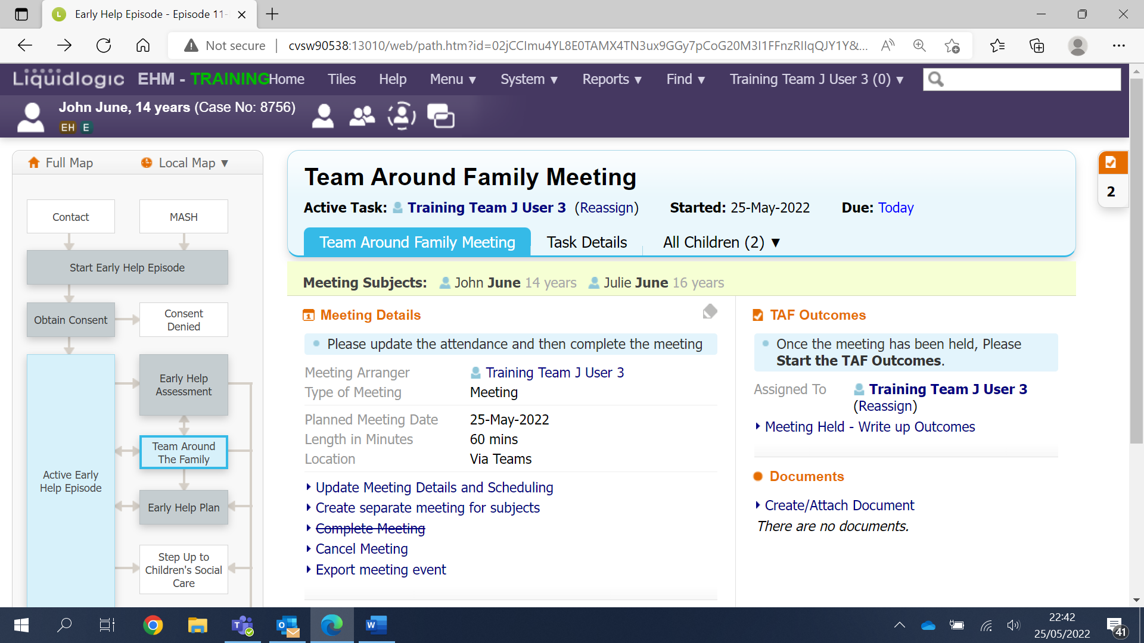

Click Ok to confirm
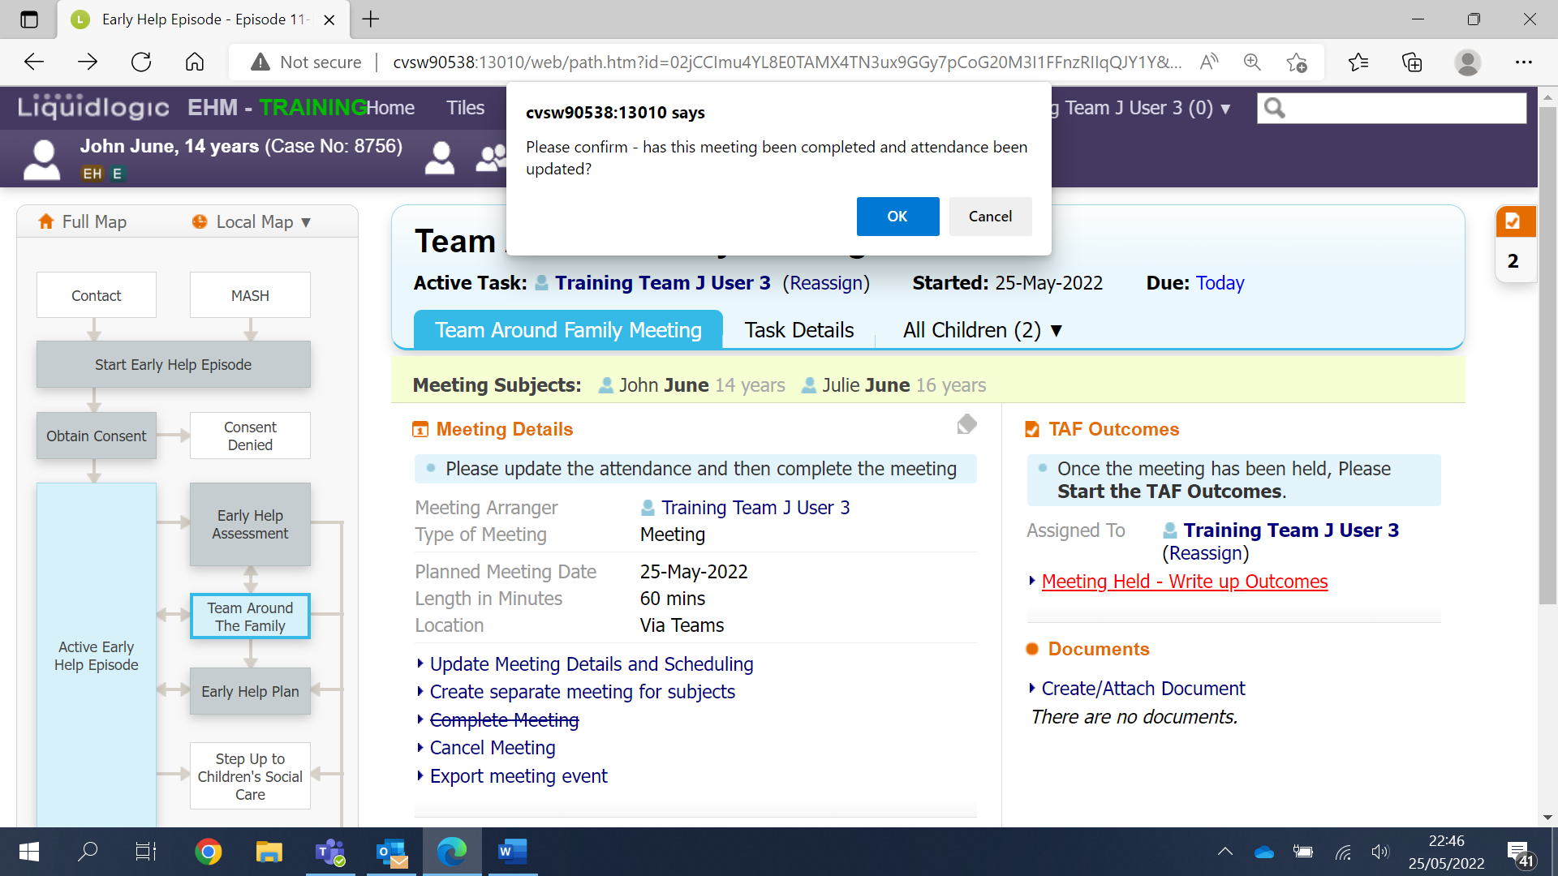
Use the calendar icon to select the same date you entered on the previous planned meeting date field.
Then click the grey Update button.
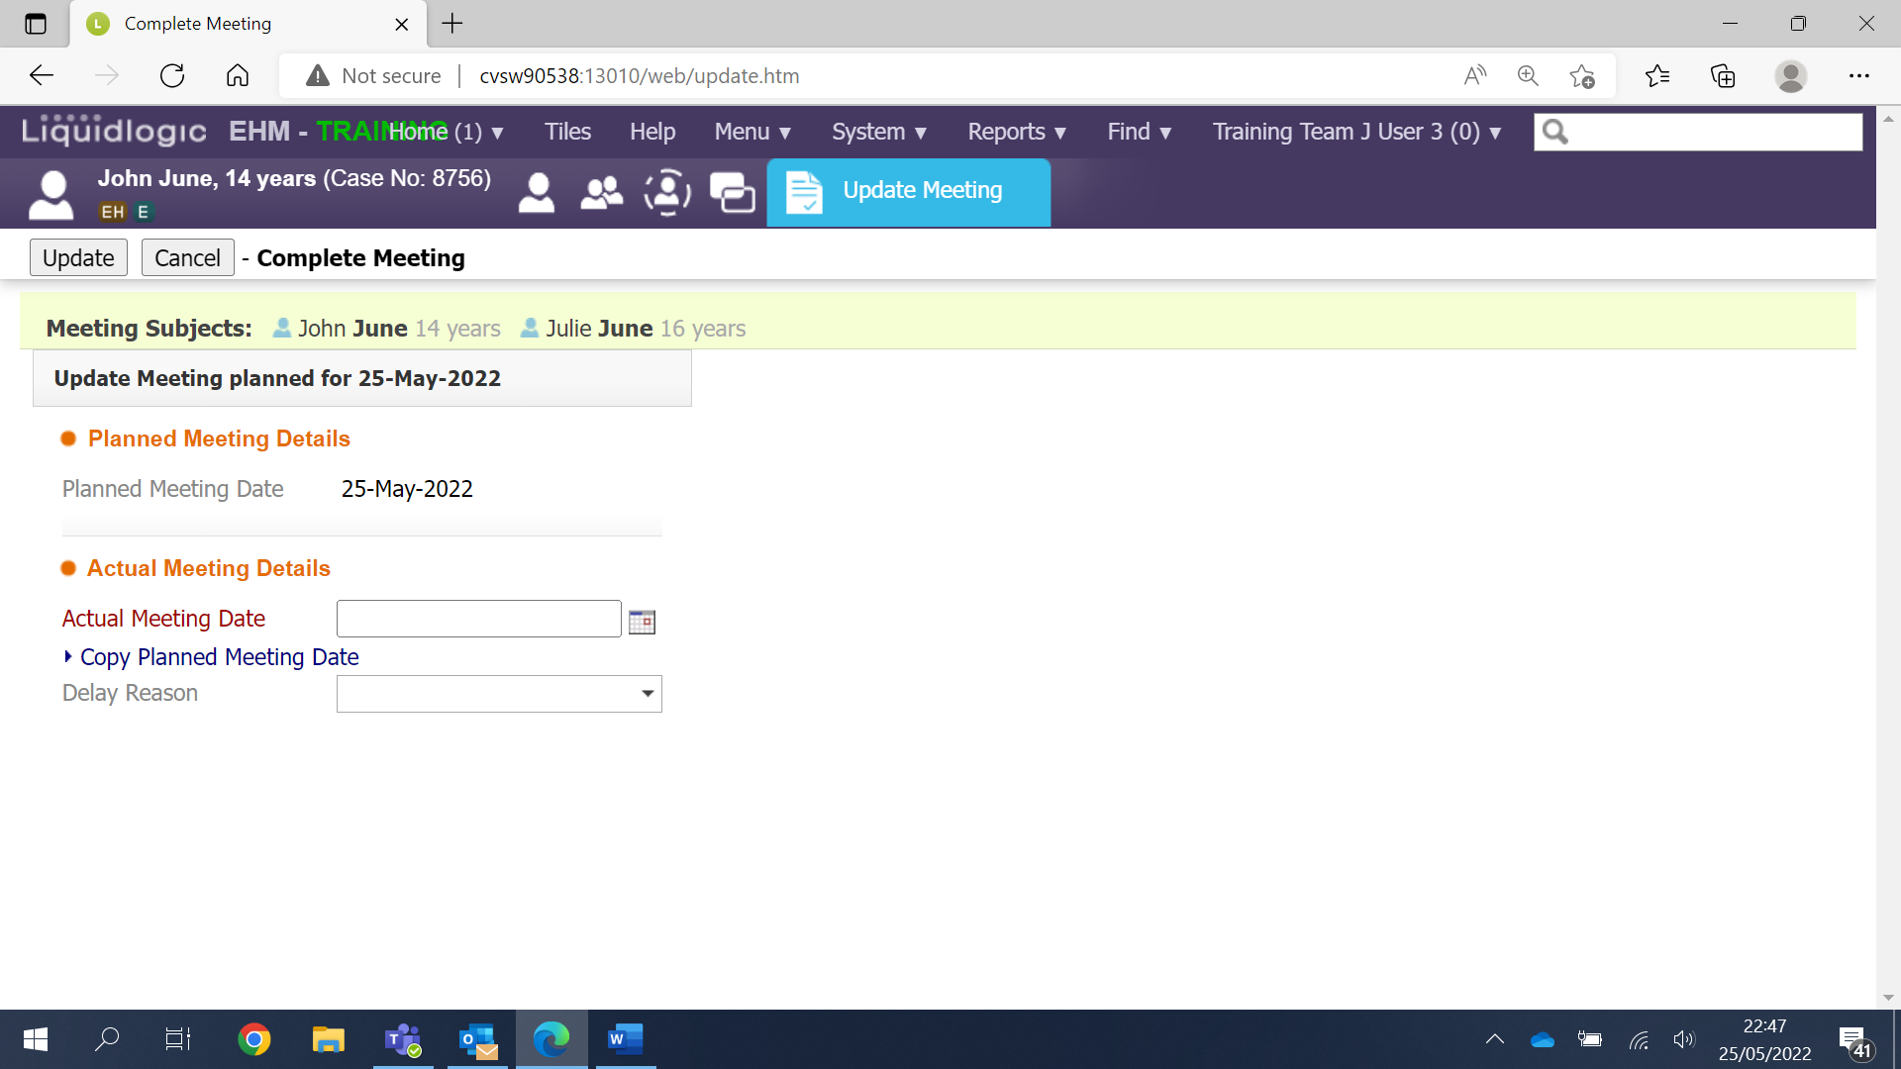

On this screen you can select to Copy Forward certain pieces of information from the Early Help Plan. This is important as it will copy the early help plan.
Click on the grey Copy Forward Selected button.
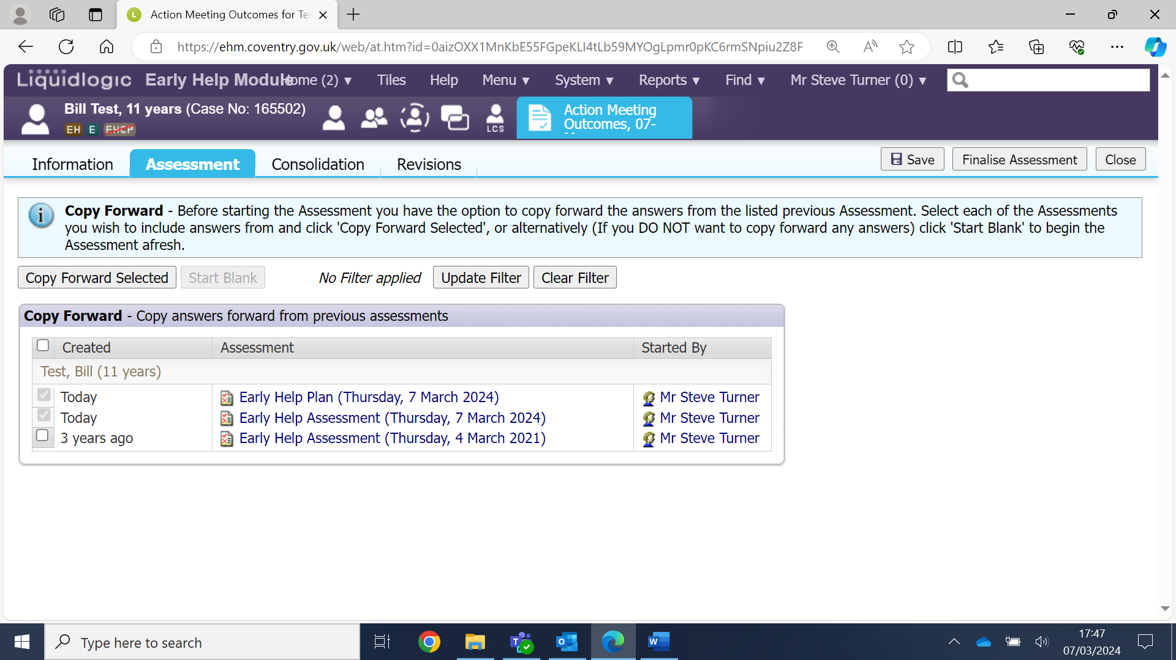
You can now select the Review of your Earl.. section.
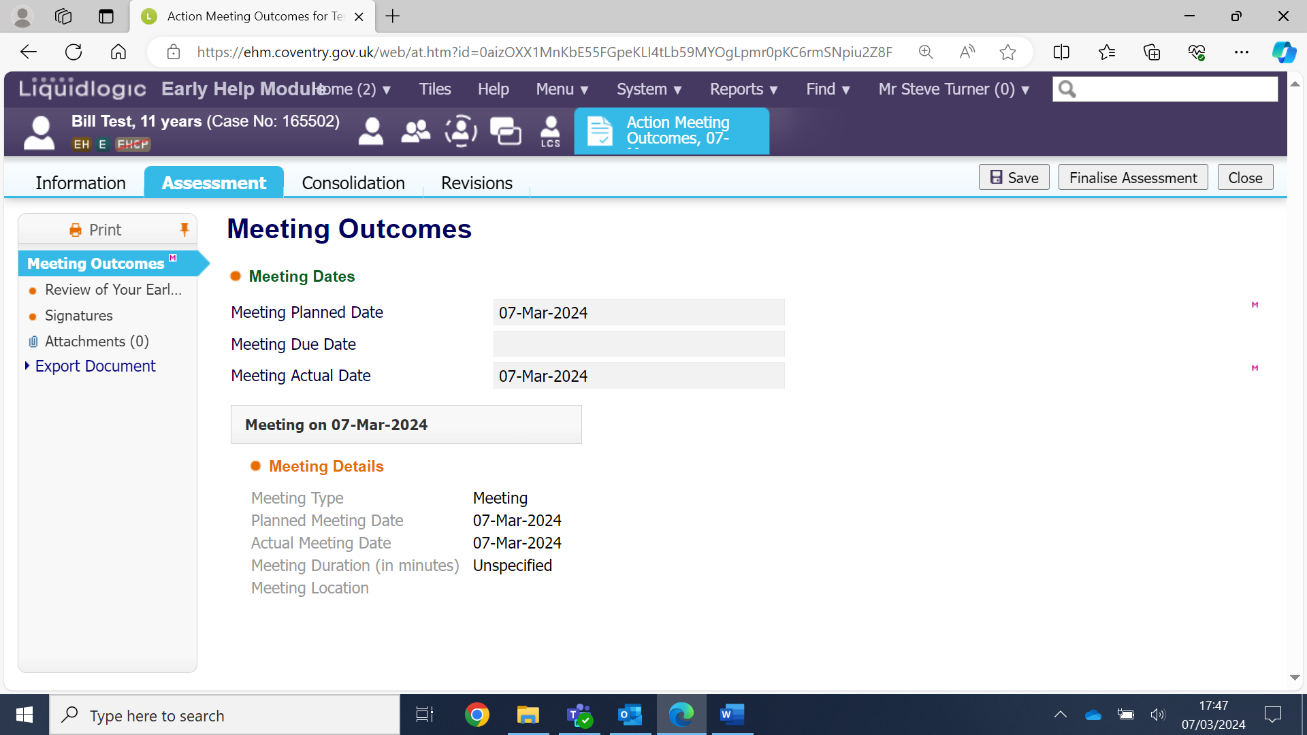

You can now work down the screen filling in the necessary fields.
Please note: It is advisable to click the grey Save button at regular intervals.
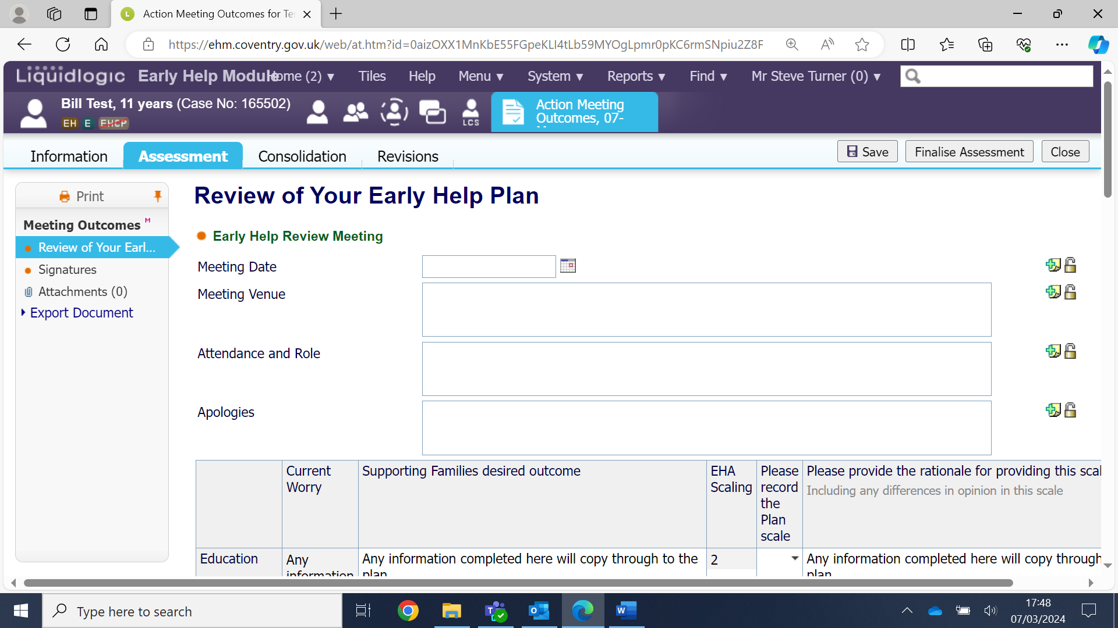
At the bottom of this section, you must answer the red mandatory question – Is a further Review Meeting Scheduled?
If you select Yes then you must fill in the Date and time field (Format is 25/05/2022 13:00), Venue and Who needs to attend?
If you select No then you must complete the summary field.
Once you have done this, click the grey Finalise Assessment button.
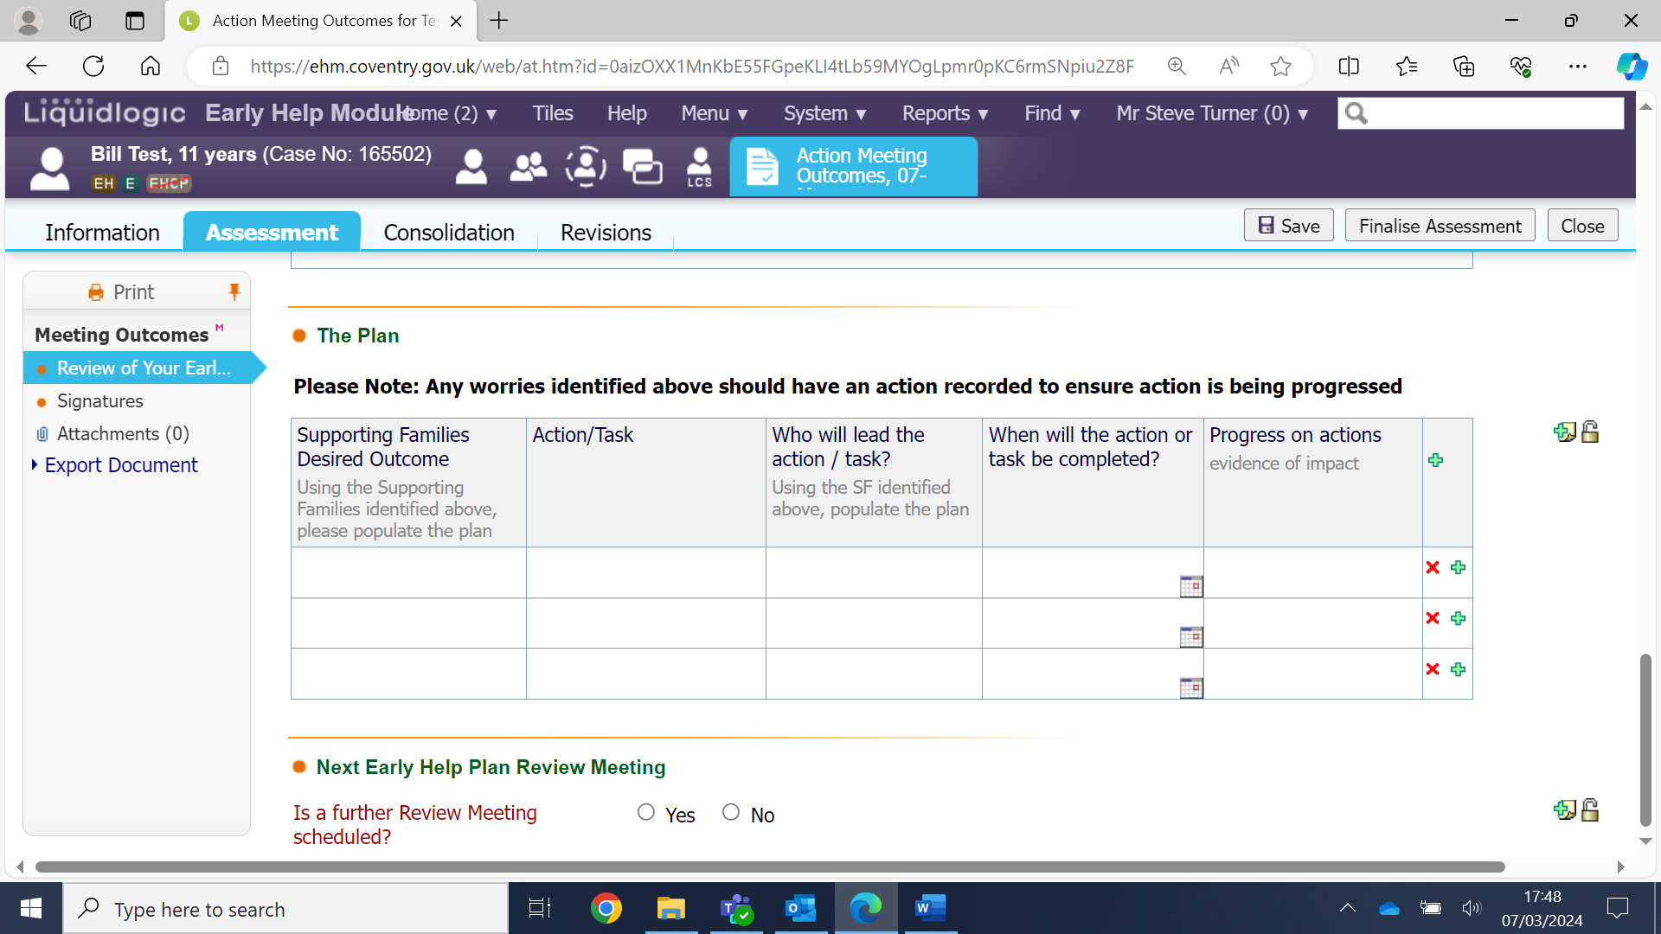
You have now been returned to the meeting stage, you can see the stage is still blue on the case pathway, indicating that this meeting stage is still active and not yet complete.
By finalising the ‘Review of Your Early Help Plan’ you have completed that stage but to complete the rest of the meeting stage you now need to click on ‘complete meeting’ and then OK.

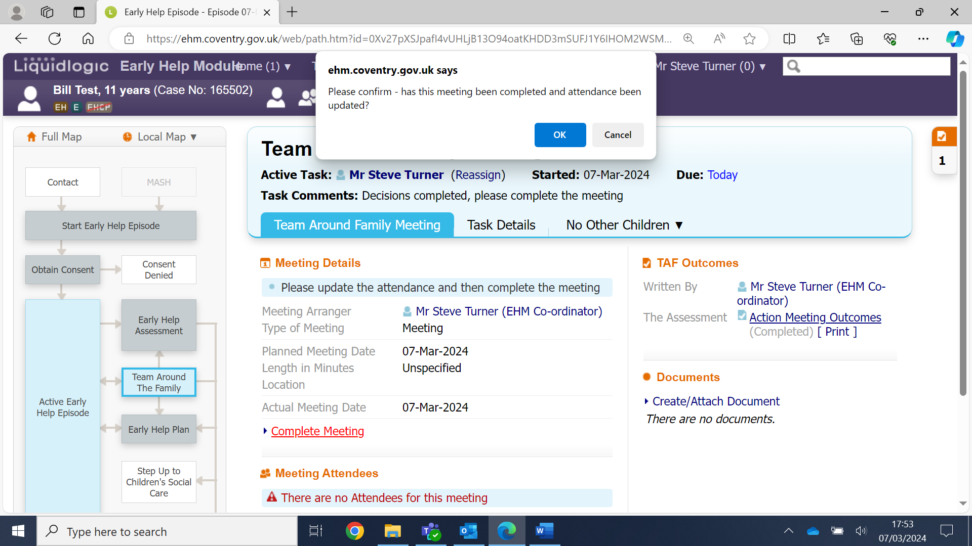

On this screen click the Restart button next to ‘Continue with Existing Process’.

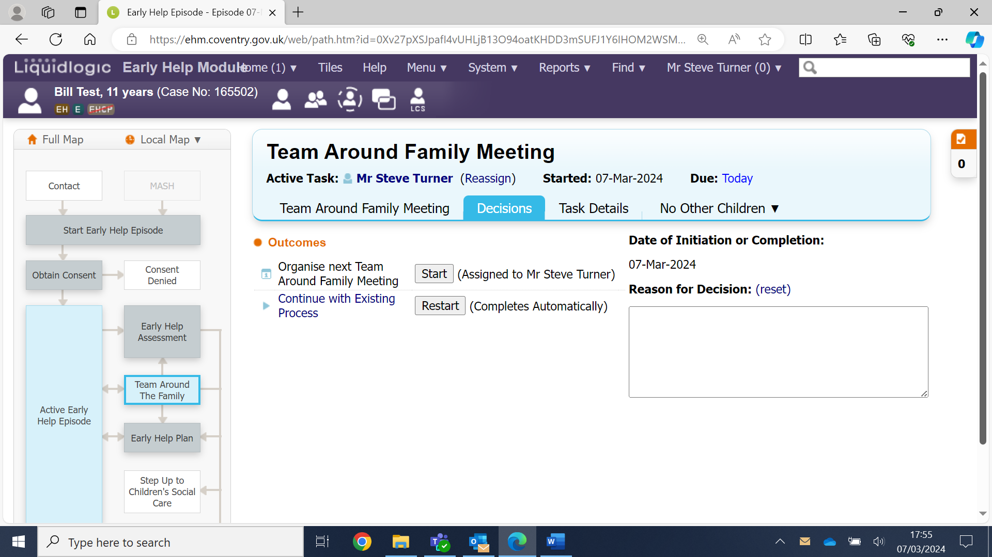

Then click ‘Confirm’.
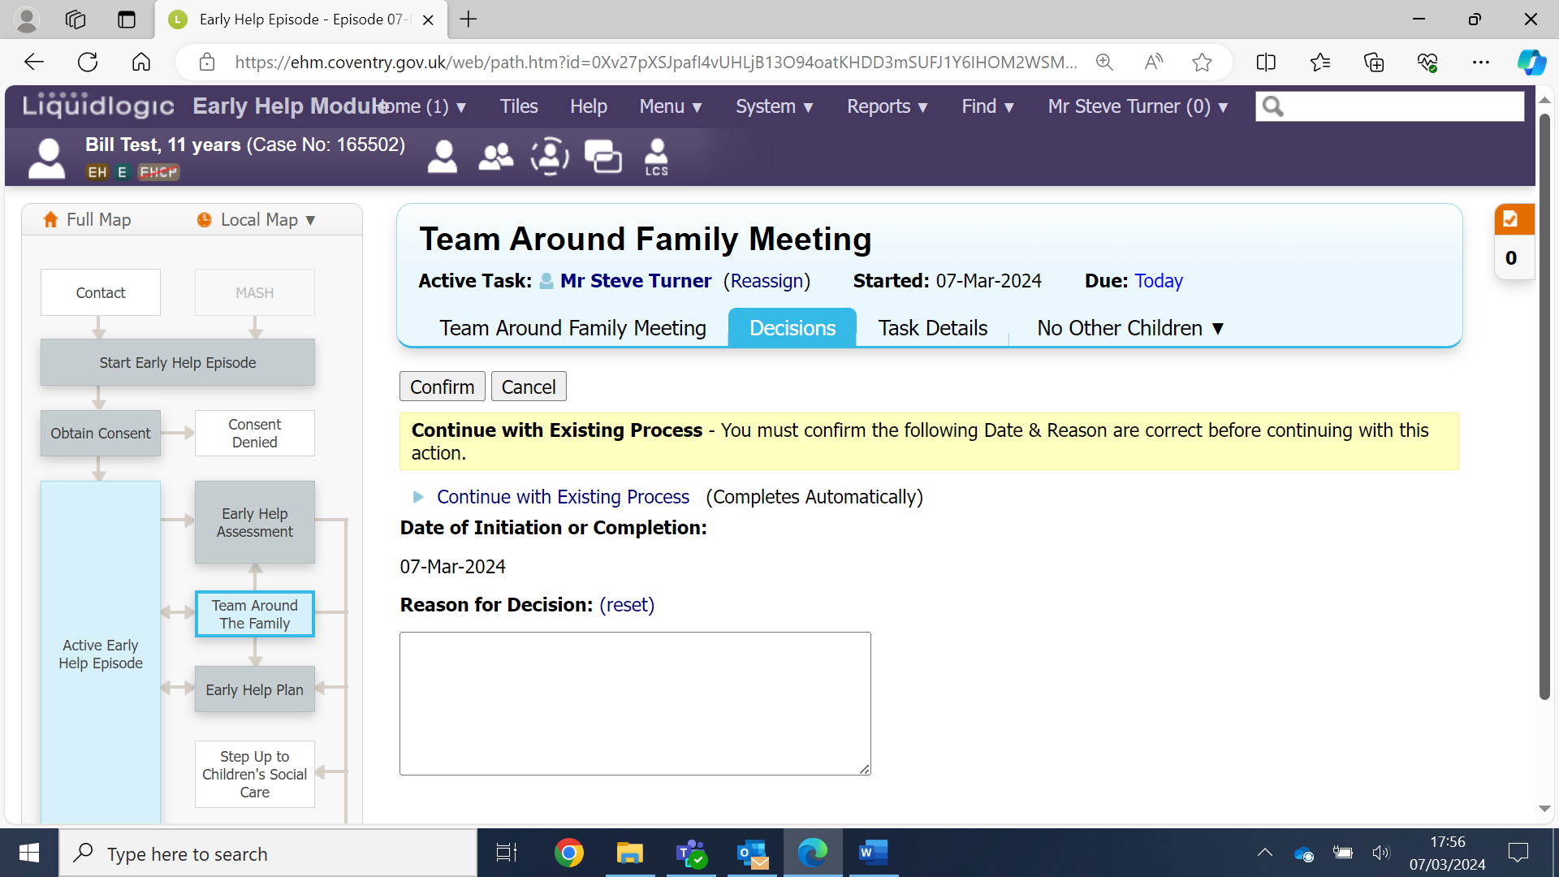

This will then turn the stage grey on the case pathway indicating it is completed.

