**Key Findings:** **Children as victims of domestic abuse**The Domestic Abuse Act 2021 sets out that children are victims of domestic abuse in their own right, when it is perpetrated against their parent or carer. The Panel sought to understand the implications of this for safeguarding practice. The review analysis found that concerns for children were often categorised as ‘emotional harm’ or ‘neglect’ rather than direct abuse. Actions focused on the mother changing her parenting or protecting the children from the behaviour of the perpetrator, rather than identifying that the children were being directly harmed by the abuser and targeting attention on these concerns as a result.

***Impact of abusers’ behaviours on children and young people:***• Pre-birth and babies: nearly all the cases involved death or serious injury to the child through deliberate harm/physical abuse or accidental harm (for example, through co-sleeping).   
• Pre-school age: impacts were similar to babies, but this sample also included cases of non-fatal neglect.   
• Primary school age: co-occurring issues included sexual abuse of the child by family members, and the child demonstrating communication and learning difficulties.   
• Adolescents: five cases involved the child taking their own life. Co-occurring issues included gang involvement, knife crime, criminal exploitation, sexual abuse and exploitation, teenage pregnancy, child/adolescent to parent violence, including one case of murder.  
***Children’s voices and their experiences of services:*** Despite widespread recognition that children and young people can experience multiple negative impacts on their lives due to being victims of abuse, there was a notable absence of children’s voices in the reviews that were considered.  
***The impact of COVID-19 lockdowns:*** The impact of COVID-19 restrictions was present in several of the cases reviewed, specifically in terms of ‘enabling’ controlling and coercive behaviour and exacerbating risks for children.  
***Children, young people and families from diverse backgrounds:*** There was a significant lack of recording about children & families characteristics such as: religion, gender identity, sexual orientation, ethnicity and physical or learning disabilities.

**Background:** The Child Safeguarding Practice Review Panel (the Panel) reviews cases where children have died or been seriously harmed, and abuse or neglect is known or suspected. In 2020, **domestic abuse** was a factor in over 40% of cases notified to the Panel, and its annual report highlighted this as a key area of work. The report sets out key findings from a thematic analysis of rapid reviews and local child safeguarding practice reviews where domestic abuse featured. It summarises the most common themes that emerged in relation to multi-agency safeguarding for children who are victims of domestic abuse, and includes examples of practice and recommendations.

**Key Findings: Multi-agency join-up in safeguarding children when there is domestic abuse**  
There was no evidence of a coordinated multi-agency response to domestic abuse. Notably, very few specialist domestic abuse services, for adults or children, were referenced in the reviews, and none appeared as members of review panels.

***Lack of understanding of domestic abuse:*** The Panel’s review of cases found that most practitioners those writing rapid reviews and local child safeguarding practice reviews, use the term ‘domestic abuse’ without full exploration, assessment or understanding of the nature of the abuse and its impact on the child and family. There appeared to be an assumption that simply naming ‘domestic abuse’ as a concern for a child is enough for all practitioners to understand the situation and respond appropriately.

***No ‘whole system’ response:*** Multi-agency working was evident only in cases deemed as ‘high risk’, where practitioners had used the risk identification checklist known as the DASH (Domestic Abuse, Stalking, Harassment and Honour Based Violence risk identification checklist).

***Distinguishing domestic abuse from ‘parental confict’:*** Non-physical incidents of domestic abuse were viewed as ‘low level’ and therefore not responded to appropriately. For example, in some cases, first-known incidents or incidents without physical violence reported did not lead to any response for either child or adult victims. These ‘low level’ incidents of domestic abuse were often conflated with the term ‘parental conflict’. Parental conflict and domestic abuse require different types of intervention and action from services. It is therefore essential that practitioners are able to distinguish and differentiate the two in order to correctly manage risk in the household.



**One Minute Guide**

September 2022

**Aims & Objectives:** The Panel’s aims and objectives for the commissioned analysis were to:   
• Understand the effectiveness of multi-agency practice in safeguarding children where domestic abuse has contributed to the serious incidents notified to the Panel.  
 • Understand, from recent research and evidence, what works in response to protecting children from domestic abuse.  
 • Understand how services and practice might be improved to support children as victims of domestic abuse.

**Four Core Practice Principles:**   
The analysis identified four core practice principles that should underpin practice approaches when working with children and young people, their parents, wider families and networks in relation to domestic abuse. These principles are described below; they are not prescriptive about how services or practitioners work but aim, instead, to provide a common approach. They are not to be seen as separate, but interlinked and interdependent.

**Domestic Abuse Informed:** A domestic abuse-informed response names the source of the harm and describes the behaviours of the abuser and the impact on adults and children, seeing both as direct victims who are entitled to support.  
**Trauma-informed:** Being trauma-informed means responding to individuals and families in a non-judgemental, non-blaming and strengths-based way that prioritises building trusting relationships and avoids re-traumatisation.  
**Intersectional:** An intersectional approach to domestic abuse means services must seek to understand the unique experiences of each family, including their histories, characteristics, and current context, and to see these in the context of unequal societal structures.  
**Whole family:** A whole-family approach does not separate the abusive behaviours of the parent from the impact on children. It considers the parenting of the abuser, as well as the impact of their abuse on the non-abusing parent and their care for the children.  
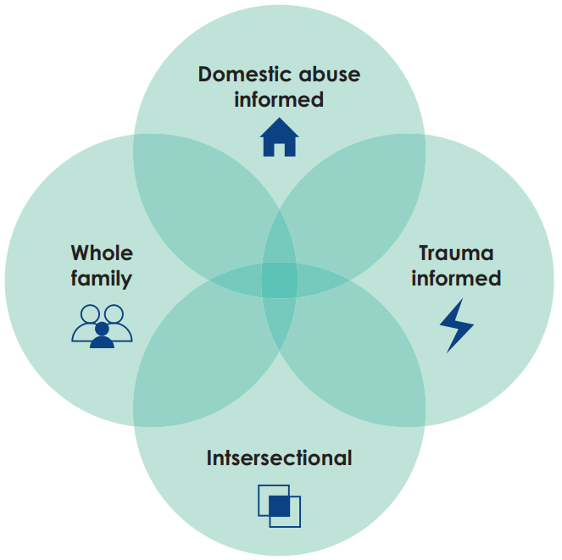

* **Recommendations for Safeguarding Partners**Reflecting the priority in the new Domestic Abuse Plan to bring national government departments together in a whole-system response. Safeguarding parents should recognise their central role in their response & work closely with the community safety partnership and domestic abuse board.
* Local safeguarding & domestic abuse partnerships should involve specialist domestic abuse services and experts in the development of strategies, local responses and service design.
* Partnerships should look at safeguarding systems and responses as a whole, focusing not only on the ‘front door’ and move beyond the need to ‘manage demand’ resulting from domestic abuse notifications.
* Training should be embedded across all safeguarding partners for all practitioners to ensure they provide a domestic abuse-informed response & for this to be supported within supervision/reflective opportunities.
* Rapid review & SPR’s should involve local specialist domestic abuse services in every review where domestic abuse is mentioned.
* Rapid review & SPR’s should identify & record the protected characteristics of each family member along with details of the whole family to ensure any diverse needs are identified.
* Safeguarding partners should improve how they work with specialist domestic abuse services by establishing stronger working relationship and clear information sharing protocols.
* Safeguarding partners must be committed to the commissioning of domestic abuse services & ensure all staff understand support available in their area.
* Appropriate responses to domestic abuse should feature in any National Child Protection Practice Framework

Useful resources:  
Full report: <https://assets.publishing.service.gov.uk/government/uploads/system/uploads/attachment_data/file/1107448/14.149_DFE_Child_safeguarding_Domestic_PB2_v4a.pdf>

Safe to Talk website: <https://www.safetotalk.org.uk/>  
CSCP Website: <https://www.coventry.gov.uk/lscb>  
Coventry Haven: <https://www.coventryhaven.co.uk/>