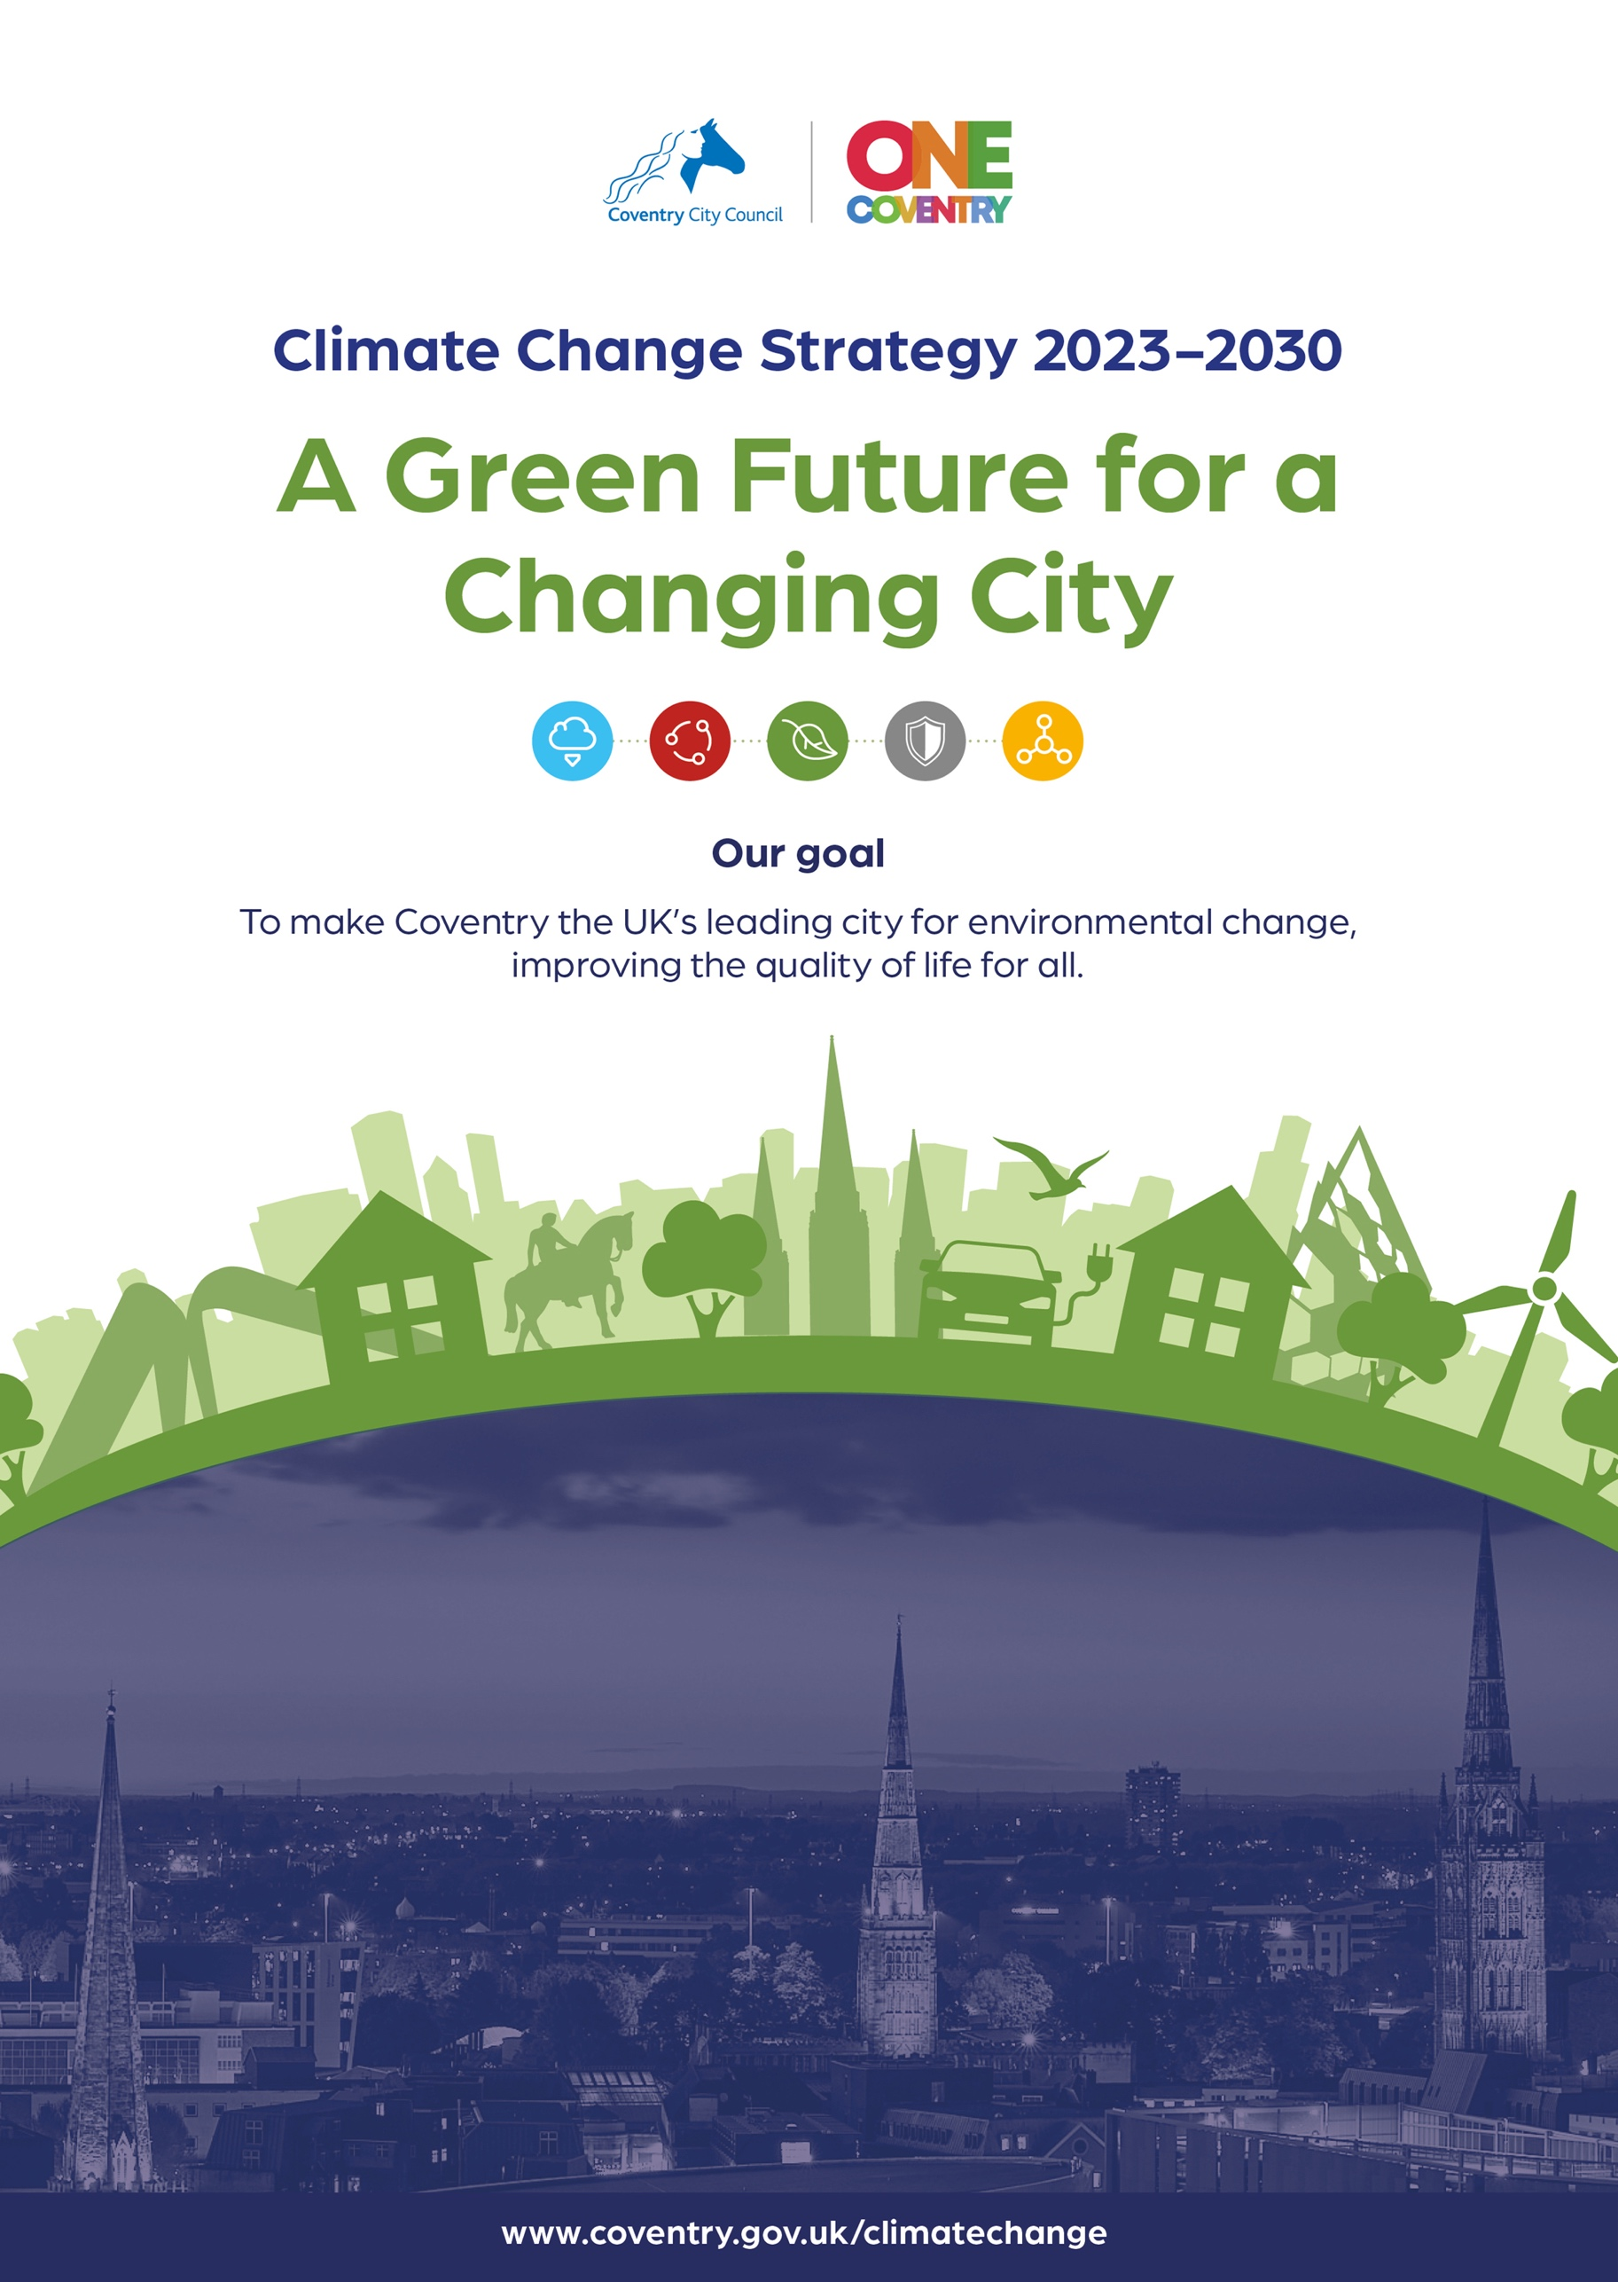

**Table of Contents**

Contents

**Foreword – by Cllr J. O’Boyle** 3

**1.0** **Introduction** 5

**2.0** **Our ‘One Coventry’ Approach** 6

**3.0** **Vision** 11

**4.0** **A key priority for delivering ‘The One Coventry Plan’** 11

**5.0** **Corporate Challenges** 13

**Addressing the Five Pathways** 18

**6.0**  **Low Emissions - Climate Change** 18

**7.0** **A Circular Economy** 26

**8.0** **Equitable and people centred** 34

**9.0** **Nature Based** 44

**10.0** **Resilient** 48

**11.0** **Relationships and interactions** 50

**12.0** **Measuring and evaluating our impact and effectiveness** 51

**13.0** **The Financial Imperative – finding resources for making things happen** 52

**14.0** **What next?** 56

# **Foreword – by Cllr J. O’Boyle**

In June 2019, the UK government passed legislation committing it to achieving ‘net zero’ greenhouse gas emissions by 2050. This is significantly more challenging than government’s previous target to reduce net emissions by 80% compared with 1990 levels by 2050. Achieving net zero will require changes that are unprecedented in their scale and scope, including changes to the way electricity is generated, how people travel, how land is used and how buildings are heated.

Climate change, pollution and other impacts upon the environment affects us across the City, our quality of life, health and wellbeing. This Strategy is just as much about people and recognises the need to address inequities where those families from the lowest incomes facing the greatest challenges these environmental changes present with poorer air quality impacting upon the most vulnerable, rising fuel costs and inflationary rises in food prices. Our planet is facing unprecedented challenges the issues are complex and interact in ways which threaten the very support systems life is dependent upon for its survival.

Coventry City Council like all other local authorities across the world has an important leadership role to play in tackling the biggest threat to life on earth and the future of our planet. It recognised the importance of this issue well before many authorities were declaring emergencies. In 2008 the City Council was a founding signatory of the Global Covenant of Mayors which has set a target of achieving carbon neutrality by 2050.   We are witnessing atmospheric pollution from human activities affecting not only our health but also the stability of our weather systems with dramatic climate change at a pace and scale like never before.   In 2021 the Leader Cllr George Duggins signed the Declaration Covenant of Mayors interim target of achieving a 55% reduction in carbon emissions to 1990 levels by 2030.

We are addressing the direct impact the City Council has on the environment and climate change and with regards to the latter we recognise that the City Council only directly accounts for about 1% of the impact across the City as a whole.   It is for that reason that we facilitated the development of an independent Climate Change Board where the City Council in its leadership role representing the interests of its citizens brings together the leading stakeholders in the private, public and voluntary sectors in sharing ideas and resources to develop solutions to these difficult and complex issues affecting our City and its people.    We will also engage with residents and community organisations to develop projects on the ground and encourage behavioural change.

Whilst we understand the importance of carbon emissions on climate change there are wider impacts of our activities which go beyond that which we will also need to address to create a sustainable city such as targeting waste, air and water pollution, loss of biodiversity risk of flooding and heat stress.

The sustainability and climate change agenda also provides the city with a major opportunity to become the country’s leading centre for the development of the Green Industrial revolution creating jobs and boosting the local economy in a post Covid world.  Initiatives like the development of Very Light Rail for example will not only help to reduce carbon emissions by providing a comfortable hassle-free means of travel as an alternative to the private motor vehicle but it will provide jobs as we showcase a product that Cities around the world could well have an interest in. Coventry will also be the UK’s first Electric Bus City where all services across the City as a whole will be electric.

The City Council and its partners on the Independent Climate Change Board are committed to addressing the UN’s 17 Sustainable Development Goals and to do this we have adopted the International Council of Local Environmental Initiatives’ five Development Pathways. <https://iclei.org/our_approach/#:~:text=The%20five%20ICLEI%20pathways%20towards,the%20built%20and%20natural%20environments>.

This Strategy focuses on these pathways as it aims to create opportunities for the whole of the City Council working in partnership with others to address this broad spectrum of issues.    Our “Making it Happen” booklet illustrates Coventry’s track record for developing partnerships for innovation and addressing the issues in a positive dynamic way.   Our ability to address sustainability and Climate change issues is critical to our future economic success as well as helping to address the inequalities many of our citizens face.

The following Strategy is an important part of our ‘One Coventry Plan 2022-2030’ and I would urge you to read what we have to say about the rationale behind the proposed actions and how they would help us to address the challenges we are facing over the coming years.   We welcome your views and comments please visit our website <https://letstalk.coventry.gov.uk/climate_change/forum_topics/how-can-we-tackle-climate-change> and complete our online survey.

Help us to make Coventry the UK’s leading Sustainable City with a vibrant successful circular economy.

Cllr Jim O’Boyle

Cabinet Member

# **1.0 Introduction**

**Facing a major challenge Climate Change, loss of biodiversity, pollution and waste and their effects on society, health and quality of life**

1.1 People are becoming increasingly aware of the effects of human activity, the complexity of issues and the adverse impacts they have on our planet and its life support systems.   Human society is recognising the critical need for changing the way we live our lives and doing business in the future.

1.2 Coventry residents and businesses are now facing some of the greatest challenges in the history of the City which are impacting upon sustainability, contributing to climate change and the quality of life of its citizens especially those who are the least well off in society.

1.3 The Council as the elected body representing its citizens has a critical leadership role to play in partnership with others, its policies can shape future development; its use of regulatory and enforcement powers protect the environment; its potential to use fiscal measures to incentivise and steer more positive sustainable behaviour change amongst the populace, and custodian of the city’s natural and cultural heritage. As a service provider delivering essential services mindful of potential impacts upon the environment and sustainability; as a big customer using its purchasing power to influence the provision of products and services in a more sustainable way; as an enabler and an influencer working in partnership with others to secure funding attract in kind support; intelligence and connections to help create new opportunities for social enterprise, wealth creation and employment for the people of Coventry.

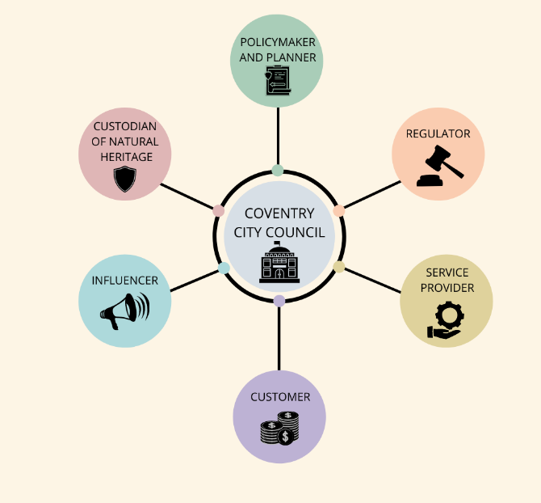

# **2.0 Our ‘One Coventry’ Approach**

2.1 Tackling the causes and consequences of climate change is one of the three key objectives of the One Coventry Plan. The Sustainability and Climate Change Strategy establishes the framework of how Coventry City Council plans to work as a local authority, and through its arms-length operating companies, to meet sustainability objectives combatting waste and pollution, promoting biodiversity and its focus on the need to tackle climate change and adapt to the inevitable changes to our climate in Coventry and the UK. The Strategy also provides a foundation for how we will work with partners to address sustainability and climate change. Our work with Partners in the Climate Change Board has helped to inform some of the actions in this Strategy and it is envisaged in time the work of the Board will develop into a collective plan of action.

2.2 The Strategy highlights the City Council’s priorities to take it to the year 2030 when it hopes to achieve a 55% reduction in Carbon emissions to 1990 levels which it signed up to last year as part of the Commitment of the Covenant of Mayors. This is an interim target as the City Council and its partners work together to achieve a common goal set by the UK Government of achieving a 100% reduction of Carbon emissions to from 1990 levels and possibly if it is ever possible to achieve this target by 2041 as laid down by the West Midlands Combined Authority (WMCA). The settings of targets for Cities are a critical step in making progress and from a practical point of view these targets are necessary for the City Council to ever achieve an ‘A’ Rating from the highly prestigious CDP an international body which accredits and verifies the calculated emissions levels and Carbon savings against our targets.

2.3 In November 2021 the City Council facilitated the development of an Independent Board Chaired by Margot James of the Warwickshire Manufacturing Group with Cllr Jim O’Boyle, consisting of senior representatives from major businesses, public agencies, charities and voluntary organisations based in the City to work in collaboration on developing and implementing a Strategy and Action Plan to address sustainability and climate change issues across the City.   Since its launch the Board now has representatives from 25 organisations actively involved and is now working towards establishing effective ways of engaging with residents and community organisations.

2.4 Both the City Council and the Board have adopted the UN’s 17 Sustainable Development Goals

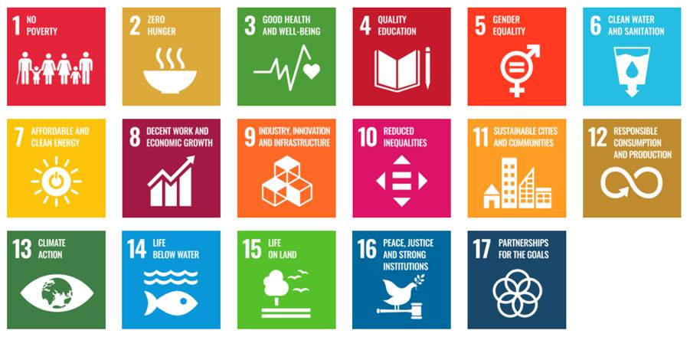

2.5 The City Council and its partners aim to do this by addressing a series of specific actions across the 5 International Council for Local Environmental Initiatives (I.C.L.E.I’s) Pathways.

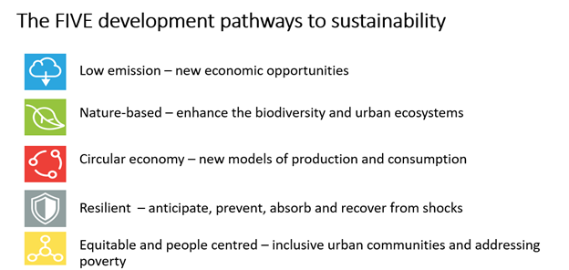

2.6 The Strategy also focuses on a series of corporate commitments which address the Council’s culture and way of working. The introduction of policy impact assessments to question the effects our decisions may have on sustainability, the environment and any effects on climate change will form an important part of our decision-making process.

2.7 As one of the core commitments in the One Coventry Plan, the Strategy is cross cutting. It recognises the fact that everyone working across the organisation has a role to play in supporting what will be a cultural shift across the whole of the organisation. We will examine existing practices and see where we can improve efficiencies and eliminate waste.

2.8 The City Council with its partners on the Climate Change Board and its five Pathway Groups will ultimately work together to stimulate lasting and meaningful change. The City Council’s Sustainability Strategy aligns with these Pathways to work collaboratively with a range of stakeholders for creating a ‘Sustainable Zero Carbon City’.

2.9 **Low Emissions Pathwa**y – the City Council is actively seeking partners to invest in a plan and develop the new environmental technologies such as the generation of power using renewables such as solar, energy from waste, retrofitting properties to make them more energy efficient and supporting a major modal shift in transport with the electrification of vehicles (as fossil fuel powered vehicles are phased out of production by 2030) the further development of new forms of public transport and the creation of networks for active travel and improving access to facilities by better design to make the concept of a 15 minute city closer to a reality.

2.10 **Circular Economy Pathway** – using the waste management hierarchy with the minimisation of waste and maximising the participation rates in recycling activities from the public and businesses across the City. This is a major challenge as participation rates were adversely affected by COVID. There is a need to examine and to support businesses with energy and environmental management encouraging and supporting the transition to a circular economy with greater emphasis on the repair and re-use of goods and services to extend their life and supporting businesses in developing new economic & business models for the delivery of goods and services.

2.11 **Nature Based Pathway** – There is a vital need to obtain information regarding the distribution of species and their conservation status. The City Council aims to gather more intelligence to better target resources to promote biodiversity. Overall there is a need to place greater emphasis on the importance of biodiversity through the planning system with major opportunities through the advancement of Biodiversity Net Gain for investment in habitat creation the linking up of areas of biodiversity value with networks and wildlife corridors. The need for more stringent planning conditions with the necessity for monitoring the effectiveness of mitigation measures is to be introduced. In addition to creating more habitats like introducing wildflowers in roadside verges the City Council will also need to place greater emphasis on improving conservation management of areas of open space and to attract more wildlife to parks and open space through the use of more biodiversity conscious management methods. The Strategy will aim to work more closely with volunteers restoring their interests following the significant decline in engagement as a result of COVID.

2.12 **Resilient Pathway** – To address some key risks with the change in climate and a greater incidence of extreme weather events such as flooding, heatwaves and droughts. The City Council and its partners are planning changes in the way the city is run in the future such as preparedness for incidents like flooding and other extreme weather events. The focus is also to be on the use of Sustainable Urban drainage Schemes and planting of vegetation in built up areas to help cool the city and improve air quality. There will be a greater emphasis on finding ways to adapt and be more resilient to the climatic changes that will be confronting us and addressing the needs of those who are most vulnerable.

2.13 **Equitable & People Centred Pathway** - A recognition that the effects of climate change and environmental deterioration affect communities disproportionately. The Strategy identifies the key risks to health and the impacts of fuel and food poverty and the need for targeted support to protect those on lower incomes who are most likely to be the first to suffer the consequences of climate change. Creating new accessible open spaces is recognised as a challenge as the City has some of the lowest levels of access and use of open spaces especially in relation to deprived areas in the region if not the country. Coventry is aiming to work in partnership with other local authorities and the energy sector in introducing energy efficiency retrofit measures to scale for the thousands of properties with poor energy performance. Working with the Coventry Food Network on combatting food poverty with the development of new community growing spaces and support in the development of cookery and healthy eating skills.

**Corporate Action**

CV

CV

**Circular Economy**

**Low Emissions**

**Nature Based**

**Equitable & Person Centred**

**Resilient**

2.14 **Monitoring progress in delivering outcomes and its impact upon our Quality of Life.** A series of performance measures will be introduced, and the plan is to produce a regular State of the City Report charting the progress towards sustainability over time.

2.15 The City Council was the first Unitary Authority to achieve corporate membership status with the Institute of Environmental Management & Assessment (IEMA) the leading professional body concerning environmental and sustainability matters. the City Council plays an active role with IEMA in reflecting the local authority perspective in National policy, helping to promote and develop the highest standards in professional practice for delivering on environmental management and sustainability.

2.16 The City Council also sees itself identifying issues, barriers and proposing practical solutions to address and using its lobbying, campaigning and advocacy role at a regional, national and international level proposing new policies, practices, standards and frameworks which will help to build a more sustainable future.

# **3.0 Vision**

*3.1* ***To make Coventry the UK’s leading Sustainable City improving the quality of life for all.***

**4.0 A key priority for delivering ‘The One Coventry Plan’**

4.1 Recently the City Council launched its One Coventry Plan 2022 – 2030 which identifies three key areas to address:

* Increasing the economic prosperity of the City and region
* Improving outcomes and tackling inequalities within our communities
* Tackling the Causes and consequences of climate change

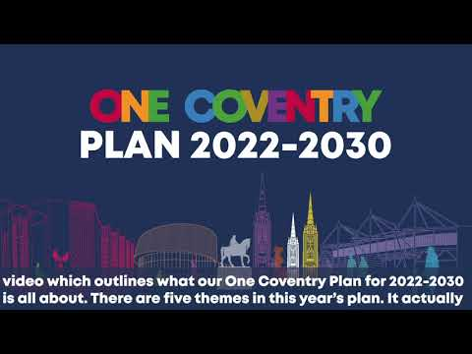

4.2 It is worth noting that this Climate Change Strategy will play a significant role in assisting the delivery of all three of the above objectives and not just the tackling of the causes and consequences of climate change it also addresses wider sustainability issues.

4.3 Sustainability is often considered to be all about the environment when in fact it is also as focused on tackling economic and social issues as well as environmental and sustainable development is about addressing those three areas in an integrated way.

4.4 **Increase economic prosperity**

In 2019 the UK Parliament passed legislation to commit the UK to reducing net emissions of greenhouse gases by 100% by 2050. Reaching net zero will require significant changes right across the economy, there will be a need for substantial levels of investment in developing the new technologies and business activities to improve the efficiency of use of raw materials and energy and to minimise waste and pollution.

4.5 The UK’s Climate Change Committee estimates that the UK will need to invest £1.4 trillion between 2020 to 2050 to reach Net Zero. Official estimates suggest that the UK’s green economy already supports 200.000 to 400,000 jobs and that growth in the green economy could grow to between 1.4 and 2.5 million jobs in total (source: Green Growth: Opportunities for the UK a report for the Lloyds Banking Group July 2021). The areas of activity identified in the Low Emissions and Circular Economy Sections of the strategy are the ones most likely to contribute to the increased economic prosperity whilst the Resilience activities would help to safeguard areas from economic loss.

4.6 **Tackling Inequalities**

Diminishing resources and rising costs of the essentials in life such as fuel, food, transport and shelter are becoming an increasing burden especially upon the most disadvantaged in society. A growing number of people especially the unemployed or those on low incomes are now living in poverty when they did not before.

4.7 The UN’s 10th Sustainable development goal is focused on tackling inequalities, many people in the UK who live in the priority neighbourhoods are subjected to higher levels of pollution and are more likely to suffer from respiratory illnesses. An inability to afford better insulation in their homes results in fuel poverty and a risk of suffering a range of long-term health conditions as a result cardio-vascular disease, respiratory illness, impacts upon mental health, hypothermia for the elderly in winter months. Access to fresh food also affects health and the cost of food and availability of fresh food in deprived areas is decidedly less resulting in increased risk of obesity and type 2 diabetes etc.

4.8 Accessibility also differs across the City and in comparison to many other cities Coventry has a higher percentage of the population that do not have access to a private motor vehicle placing increasing importance on the value of and importance of public transport and promoting active travel to provide opportunities for access to leisure, jobs and services.

4.9 This Strategy aims to address the environmental wider determinants of health. In addition to the growth in the local economy the proposed areas of work in the Equitable and Person Centred and the Nature Based Sections of the Strategy will help to address these issues and also promote health as outlined in the Government’s Marmot Review.

**5.0 Corporate Challenges**

**Strengthening the corporate culture for delivering sustainability across the Council**

5.1 Following a series of meetings with Heads of Service the City Council has identified a number of key actions it will need to focus on across the organisation which are relevant to all divisions across the City Council.  These are measures which focus on creating cultural change across the organisation embedding core values, knowledge and skills which respect the environment to meet the key objectives for delivering a sustainable future.

5.2 Officers of the City Council will look at ways in which they currently do business and attempt to measure their environmental impacts to see if there are alternative ways in minimising waste and improving the way it delivers services to the public. This will require the use of methods and processes e.g.‘LEAN Methodology’ (a method to remove waste, wasteful activities and improve efficiency originally adopted in the Japanese motor industry resulting in dramatic efficiency improvements), environmental audits and impact assessments. There is clearly a strong commitment across the organisation to develop new skills and to be increasingly conscious of the environmental impacts of the activities the Authority has on the world outside.

5.3 The proposal for an independent review to ensure the functions of the Sustainability Team and other areas of activity across the City Council are fit for purpose and have a part to play in addressing sustainability and climate change. The question we need to ask of the City Council does it have an adequate capability to oversee the delivery of a complex series of activities and programmes which will occur across the Council Departments and divisions of the City Council. This should include a clarification of core competencies across the City Council which can be incorporated in the Personal Development Reviews for employees who all have a role to play in delivering elements of the Five Pathways

5.4 A Policy Exchange study commissioned by the Equality Trust, National Union of Students (NUS) and the Institute of Environmental Management & Assessment (IEMA) revealed that in the UK only 3% of environmental professionals are from minority backgrounds and the environment professionals are the second least diverse profession in the UK. The Sustainability Team will be actively exploring ways of attracting the interest of young people from minority backgrounds with placements and internships wherever possible.

5.5 There is an opportunity to recruit and train volunteers amongst the workforce to act as advocates for sustainability to help monitor progress and promote a culture of continuous improvement and mutual support in achieving improved standards in sustainability and consciousness.

**New approaches**

**to**

**Finance &**

**Investment**

**Training & Skills**

**Evidencing Need**

**Monitoring**

**Performance**

**Outcomes**

**linked to**

**Quality of Life**

**Measuring**

**Quality of Life**

**& Sustainability**

**Assessing**

**Impacts**

**of policies**

**and actions**

**Nurturing**

**Creativity & Innovation**

**Working**

**collaboratively**

**across divisions**

**‘The clock**

**is ticking’**

**Focused on**

**Milestones**

**and targets**

**LEAN**

**Minimising**

**Waste**

**&**

**Maximising**

**Efficiency**

**A whole life**

**approach**

**to procurement & commissioning**

**Focused on**

**influencing**

**behaviour change**

**Learning**

**from others**

**outside**

**Coventry**

**Co-Production**

**with communities**

**Lobby for change**

**Awareness**

**& Confidence**

**to challenge**

**Commercialisation**

**& Social**

**Enterprise**

**Changes in behaviours and practices**

5.6 The recent development of the Institute of Environmental Management & Assessment’s a Blueprint for a Green Workforce Transformation provides a coherent approach to skilling up and raising the awareness of members of the workforce to be better equipped and able to address sustainability and climate change issues. The City Council now has IEMA accredited trainer status and is developing sustainability & Climate change awareness courses for staff across the organisation and also local businesses.

5.7 The Local Authority will develop an initial basket of sustainability indicators for measuring the performance and impact of the 5 pathways in the Strategy in delivering outputs and outcomes after the first six months of its operation.

5.8 The Local Plan is a very significant policy and land use planning document that dictates and influences the nature of permitted land uses and future development of buildings, infrastructure and the public realm.   It is our opportunity to shape how we would like the City to develop in the future and to protect those aspects of the Built and natural heritage that we hold dear.  We are approaching a window of opportunity where the City Council has the chance to review its Local Plan and to consider where it could place greater emphasis on specific policy areas - such as those which address a number of climate change and sustainability issues which will impact across all five of the identified pathways.

The Plan Review process will be wide ranging and should in particular consider opportunities to;

1. further promote energy conservation in buildings and the development and use of renewables for energy generation.
2. further protect and enhance biodiversity.
3. promote high quality design that promote active travel.
4. ensure accessibility to public transport and active travel and minimise the need for the use of the private motor vehicle.
5. further reduce the risk of flooding) and minimise the opportunities for heat gain.

5.9 These proposed universal corporate areas of activity are detailed below:

U1.       To conduct an independent review of the structure and organisation of the City Council and the Sustainability Team to ensure sufficient levels of resourcing and staffing are present with a structure and organisation that is fit for purpose and that the City Council has the capacity and capability to deliver a complex programme of work across the Five Pathways.

U2. To provide detailed guidance to support the drafting of environmental/ sustainability paragraphs in reports to the City Council identifying the likely impact of recommendations in reports on the development of Partnerships and business ventures

U3.       To carry out a Formal Internal Audit to develop an assessment framework with the Sustainability and Climate Change Team and to conduct audits of the standard of Sustainability reporting, alongside an informal self-monitoring guide for service areas

U4.      To introduce a Procurement Strategic Framework and practical toolkit to ensure sustainability criteria are incorporated in decision making when:

1. Purchasing new goods and services
2. Selecting a partner organisation to do business with
3. Selecting conditions to attach to a major planning application to address social value and sustainability issues

U5        To engage with partners in the development of a ‘State of the City Report ‘which would be reviewed Annually or Biannually depending on the level of resourcing required across the organisation as a whole. The Report will be used to assess progress over time and relate outcomes of specific projects and programmes by the City Council and its partners and the quality of life of its citizens and the state of the environment.

U6.       To Develop a set of performance indicators to measure outputs and outcomes in the delivery of projects, services and activities These could be related to the state of the City Report which will reflect the circumstances faced by citizens.

U7. To work with organisations like Climate View to develop effective measures to monitor and model impacts of changes in practices and behaviours upon carbon emissions and climate change.

U8. To ensure the SMART Cities Sherbourne Project includes opportunities to address sustainability and environmental issues such as utilising the use of real time monitoring systems to more efficiently manage resources and energy across the City and minimise the risk of pollution with improvements to water and air quality.

U9.       To work with IEMA and the LGA on the development of accredited Carbon Literacy and sustainability knowledge and awareness courses for staff across the City Council and also offered to personnel in partner organisations to attend as part of their professional development programmes.  This would help to promote the highest standards in terms of skills, knowledge and awareness of the sustainability criteria.

U10.     To initiate discussion with other local authorities in the WMCA area to introduce a set of sustainability criteria for the West Midlands Pension fund to ensure it supports environmentally sustainable projects and activities.

U11.     To work with the Personnel Department on the performance frameworks for staff to ensure key knowledge, skills and behaviours are fully conversant with meeting sustainability criteria.

U12 To work with the Personnel Department, schools, colleges and universities on the promotion of the environmental professions as a career to minority groups through positive action with the provision of work experience placements and internships where possible for environmental and sustainability related posts.

U13.     To recruit a number of sustainability champions to promote the Strategy and advocate continuous improvement in achieving higher standards in environmental and ethical practice in the workplace within their division or service area and to keep colleagues up to date about the latest news concerning sustainability & climate change.

U14 To promote and further the development of sustainable travel, promotion of activetravel, cycle and shared electric vehicles for staff, and public transport.

U15.     To promote loans for bicycle, public transport passes and car leasing agreements for Council employees including installation of home charging facilities.

U16.    To improve the Council’s monitoring of resource consumption (electricity, gas & water), air quality, water quality, transport movements, waste generation & disposal, recycling etc to help the Local Authorities CDP Assessments etc using automated technologies where possible and help in improved planning for the measurement of resource consumption.

U17.     To explore new means of financing initiatives in the future including engaging with communities and businesses in the development of Community Investment Plans crowdfunding or securing loans from the UK Infrastructure bank and the development of Green Municipal bonds as in Warrington etc.

U18. To demonstrate the City’s commitment to addressing climate change by driving a rapid transition from diesel to electric for our vehicle fleet with livery messaging to communicate this commitment to the public.

U19. For the Central Communications Team to provide support for the City’s Sustainability Strategy with targeted communications and engagement of communities and businesses etc.

U20. To support schools where possible with educational programmes to promote awareness and understanding of all environmental and climate change issues and to encourage positive action and behaviour change with increases in the numbers of schools participating in positive initiatives such as Eco-Schools, Food for Life Schools, and Forest Schools.

U21. To follow on from COP26 for the City Council to play a leading advocacy role in championing the Sustainability agenda and lobbying at the regional, national and international level for change on behalf of the City and others in local government aiming for the highest standards in policy and practice.

U22 To engage professionals across the Local Authority in the Review of the Local Plan to amend policy statements relating to sustainability and climate change where appropriate.

# **Addressing the Five Pathways**

# **6.0 Low Emissions - Climate Change**

6.1 The planet’s life support systems which regulate our climate will not be able to cope if we let the average temperature increase by more than 1.5 degrees centigrade. If we allow the temperature to rise above this level by 2030 we will have reached a tipping point with catastrophic changes to our global climate that will be a significant threat to life and have seriously adverse consequences to our health and the economy.

6.2 Last November at the COP26 Global Summit in Glasgow the world’s leaders fell short of reaching an agreement to develop actions to achieve this critical target and uncertainty prevails.   It is not just up to national government; a recent report from the UK’s National Audit Office recognises the important role Local Authorities have to play and recommended to the UK Government’s Environmental Audit Committee that Central Government needs to create the right national policies and programmes to support the efforts of local authorities which have a key leadership role to play at the local level each making a valuable contribution to achieving the overall national zero carbon goal of zero growth in 1990 levels by 2050.

6.3 Coventry’s last Climate Change Strategy ran from 2012 to 2020 and was successful in addressing a number of issues including the reduction of the City Council’s Carbon footprint by 27.5% six years ahead of target.

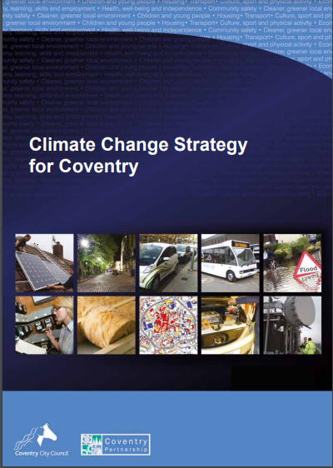

6.4 This does not mean that the amount of carbon entering the atmosphere had reduced by this amount, many of these buildings still exist it is just that they are now being run by different organisations (e.g. The Sports Trust) providing services to the public and the carbon emissions were no longer directly attributable to the City Council. The challenge of addressing the emissions from these buildings remains and the City Council will need to work with these organisations in finding solutions to their carbon footprint. The following annotated graph charts the Council’s progress in reducing emissions from its property assets over recent years.

**g
**

**Figure 1 Key to Explain Decreases / Increases:**

2009/10: A 2009 Carbon Management Plan (completed by the Carbon Trust) outlined numerous projects with potential annual carbon saving of 7,121 tonnes over subsequent years that had funding already secured or earmarked via sources such as Salix. Examples include: Schools for the Future project, replacement of street lighting, solar PV projects at schools, lighting upgrades across offices.

2012/13: this year displayed an increase in emissions compared to the previous accounting year. This was primarily due to the extreme period of cold weather experienced over 2012/13 which saw a 24% increase in demand for heating.

2013/14: Heatline (the city heat network linked to the energy from waste facility) became operational. Estimated carbon dioxide savings made by heating the Council House and Civic Centre 1 - 4 using Heatline will be 650 tonnes per year.

2018/19: rationalisation of Council properties means that a number of properties that have previously been included in our emissions have been sold off and therefore, the Council’s property portfolio has reduced. Most notably, Civic Centres were no longer included in figures and there is a subsequent drop.

2019/20: One Friargate connected to the Heatline (Waste to Heat energy supply). Connecting to the Heatline has led to a 23% reduction in liquid fuel and gas consumption since 2018/19.

In 2019/20 we increased our ‘Scope 3’ emissions data gathering. The last column displays the new methodology in use and therefore an increase in GHG emissions. This is mainly due to reporting schools and buildings that haven’t previously been reported on. 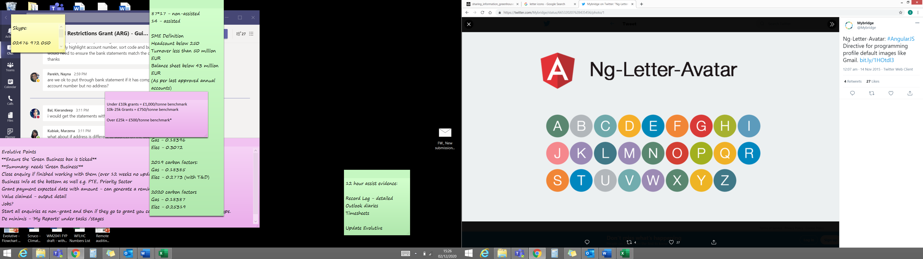

Impact of the Coronavirus Pandemic and further schools becoming academy (no longer included in scope 3 emissions).

6.5 The Sustainability Team has improved the amount of information they are able to capture for our Carbon Disclosure Programme (CDP) reporting as one can see it is the indirect impacts i.e. Scope 3 which make the largest overall contribution to Carbon emissions which includes the goods and services we procure.  This is an internationally recognised verification system which gave the City a B rating.   Scope 3 is the most difficult area to capture data for and has been historically under reported.  There will be a need to tighten up our procurement policies and practices to address this.

6.6 In fact we know that today the Local Authority is only responsible for an estimated 1% of the City’s total energy use, it is for that reason that this Strategy is focusing beyond the City Council and is using its powers, relationships and influence to impact upon the City as a whole. We know from BEIS data the contribution that each sector makes to the City’s overall Carbon footprint and how much we collectively have managed to reduce this over the years.

Coventry’s Annual Emissions (ktCO2e) 2015-2019

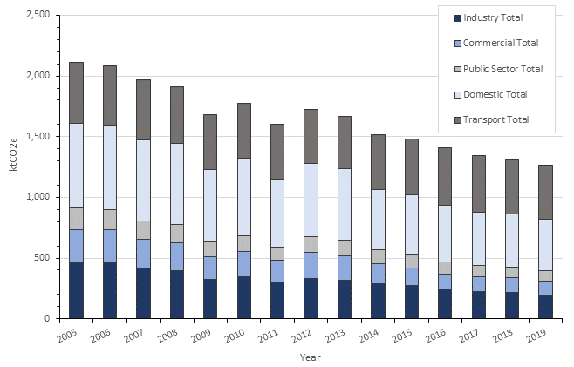

Text Box

6.7 Coventry recently concluded its Innovate UK funded Regional Energy Systems Operator (RESO) Project in partnership with WMCA, Cadent, Camirus, Western Power, Enzen, Electron, Places in Common, University of Warwick & University of Birmingham etc to examine ways of managing the supply and demand of energy across the City in the future.

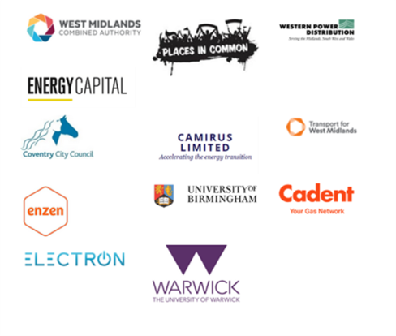

6.8 The project reviewed a wide variety of technologies including the development of renewables.   There will be an increased demand upon an already stretched electricity grid to improve capacity as electricity demand will increase to accommodate the increase in electric vehicles and to meet the needs of business for zero carbon energy such as the proposed Gigafactory for the manufacture of batteries for the automotive sector.

6.9 Coventry is a member of the Placed based Climate Action Network (PCAN) some 17 or so local authorities which have established independent partnerships of major organisations in the private, public and voluntary sectors making a collective commitment to collaborative working together to address the challenges their City faces.

6.10 The City Council and the Climate Change Board has commissioned Professor Andy Gouldson to undertake research into the City’s Carbon budget and to identify those factors which contribute the most to emissions citywide and to assess the costs and benefits of addressing Climate Change and to develop a Zero Carbon Routemap for Coventry. Professor Gouldson is an economist and environmentalist who has worked closely with Central Government and is founder director of the Economic & Social Research Council’s (ESRC) Centre for Climate Change Economics & Policy.  His methodology is recognised by the UK Government and has been used to create Zero Carbon Routemaps for other major cities like Edinburgh, Glasgow, Belfast, Leeds, Swansea and Cambridge.

6.11 The Routemap should inform our target commitments and help the partnership to develop an achievable pathway to net zero in keeping with national and international recommendations. We already know the scale of the challenge and investment required means we cannot do this alone. The Council working with the Low Emissions Pathway Group aims to pull together all those with the talents and experience to build the new future in a post COVID-19 world and to limit the impact from climate change working towards net-zero emissions.

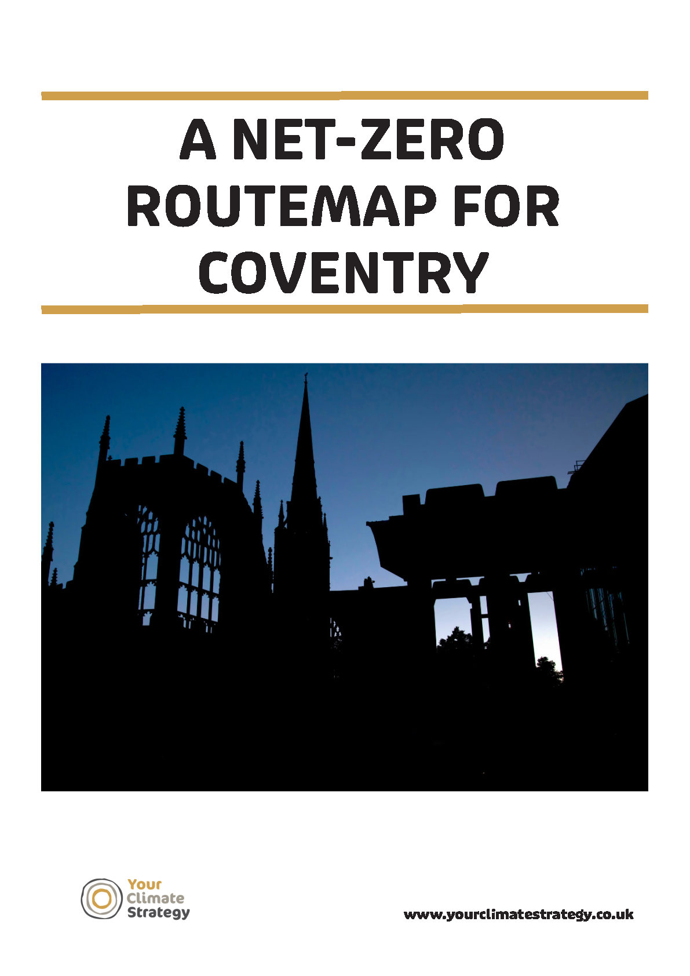

6.12 The Routemap will identify a series of actions to address Climate change some of which will be able to generate an income and be good investment propositions whilst others should be able to break even in terms of financial return. Some examples of the categories of initiatives and activities the route map will cover are:

* Transformation of transportation to renewable sources e.g. EV Vehicles
* Promoting modal shift from private motor vehicles to active travel, shared and public transport
* Use of renewables technology to generate zero carbon electricity e.g. solar farms
* Energy from waste projects
* Heating improvements to homes and buildings e.g. heat pumps & networks
* Lighting improvements
* Energy efficiency improvements in businesses
* Insulating domestic buildings

6.13 The Routemap will enable Coventry to benchmark itself against other Cities and share and learn from the experiences of others which should help to improve practices to become more cost effective at addressing the issues.

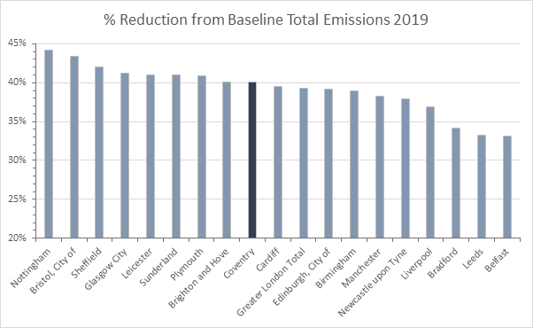

6.14 Yet there are a number of interventions that are difficult to proceed at present without a level of subsidy from the Government.   One of the key concerns is the need to retrofit domestic properties which account for approx. 30% of all emissions.  Coventry was successful in securing over £6m in grant last year which covered external wall insulation and other energy efficiency measures for 600 homes, the number of properties with households on low incomes below a C Energy Performance Certificate (EPC) rating is over 13,000.   For this reason the City Council is working with other City Councils in the region on finding a solution to this problem in an effort to speed up and scale up the retrofit programme and potentially create jobs across the region.   The City Council is also working in partnership with Housing Associations on addressing the issues on their estate.

6.15 The following Government requirements will have a specific impact for the local authority and for others within the city with some specific deadlines and milestones which the Strategy and Action Plan will have to address:

* **Public Buildings emissions** – all public sector buildings are required to reduce emissions by 50% by 2030 and 75% by 2037 (from a 2017 baseline).
* **Energy Performance Certificate ratings** – all commercial buildings must have an EPC of a minimum of B by 2030.
* **Gas boilers** – gas boiler sales will be banned from 2035.
* **Vehicles** – phase out of new petrol/diesel cars and vans by 2030 and new non-zero emissions HGVs under 26tonnes by 2035 and all HGVs by 2040. From 2022 building regulations will require EV charge point in all new homes and new and existing non-residential buildings.
* **Power system** – plans to be zero carbon by 2035.

6.16 These requirements will guide some of our activity, but we will seek to go beyond just what is required and deliver opportunities which ensure a long-term sustainable future for Coventry.

6.17 The level of investment needed and the expertise from the energy sector make it critical for the City Council to work with specialists in the energy industry and financial institutions with an understanding of the energy market in order to design and develop the zero-carbon energy infrastructure that this City will need to meet future needs industry & commerce, transport, housing and regeneration.   Building on the successes of Heatline, Coventry like a number of other Cities in the UK will need to seek joint venture partners to secure the necessary investment and to design and build this infrastructure and develop new services.

6.18 Coventry has a strong history of inventiveness and creativity with a successful track record in adapting to change and this is just another exciting chapter in that history. Coventry City Council recognises that meeting what must be the greatest global challenge it has yet to face needs a co-ordinated partnership approach not only engaging departments across the Council but also working in partnership with its citizens, voluntary organisations, public agencies and businesses can achieve.

6.19 The areas for focusing our attention on in the coming years will build upon the City Council’s work on the RESO Project, the need for revision of the City’s Local Plan to strengthen the energy policy and to provide a clear framework for new builds to adopt significantly higher standards of energy efficiency targeting than at present and address the opportunities identified in the Zero Carbon Routemap covering a range of actions such as the below:

**Property & Infrastructure**

LE1       To establish a joint venture partnership capable of designing and planning for the development of energy generation, storage and efficiency services and infrastructure for a zero-carbon future and securing the necessary investment to do so with an opportunity to generate income and social value for the City’s sustainability programme.

LE2       To secure funding for the retrofitting of domestic properties across the City to improve their energy performance ratings from below an Energy Performance Certificate rating of a ‘C’ to at least a ‘C’ or above.

LE3 To promote the development of skills and training in the construction sector including the building related trades e.g. heating engineers for the advancement in the use of the latest renewable zero carbon and more energy efficient technologies in the retrofitting of existing properties and new build developments of zero carbon homes.

LE4 Working in partnership with the City of Wolverhampton and Birmingham in a 3 Cities Project to identify solutions to the domestic retrofit of Council Owned and Housing Association social housing properties particularly those in fuel poverty who cannot afford the investment to undertake the work that is required.

LE5       To develop renewables projects on the ground such as solar farms and solar panels on rooftops as a source of renewable energy.

LE6 To establish ways of securing finance for independent organisations occupying Council owned buildings and assets to incentivise them to improve the energy efficiency of the buildings they occupy and so reduce their energy costs e.g. Academy Schools, Tenants in Council owned office buildings.

LE7 Building upon the current work funded by Catapult UK on the development of local heat networks to identify opportunities to extend the development of heat networks across the City.

**Transport**

LE8 To develop the infrastructure to manage the transition from fossil fuel based transport to transport powered by renewable energy e.g. Electric Bus City, expansion of EV Charge points, the Zero Carbon Airport, Cycle and footpath network development, electrification of the Council’s vehicle fleet etc.

LE9 To establish improvement to the zero-carbon public transport infrastructure and services across the City including the electrification of the total bus fleet, the development of a unique first in the UK a Very Light Rail autonomous tram.

LE10 To establish ways of incentivising and encouraging businesses to develop commuter plans for employees commuting to work.

LE11 To support innovation partnerships for the development of zero carbon low emission technologies in the automotive & transportation sector e.g. zero carbon airport.

LE12 Key Services (such as urban design, planning, highways and city centre placemaking) to work together, creating a greater sense of place; making services and attractions pedestrian friendly and more accessible by means of active travel.

**Businesses**

LE13     To secure inward investment and facilitate the development of the necessary zero carbon infrastructure for the Gigafactory for the manufacture of batteries for the production of electric vehicles by the UK automotive industry.

LE14 To promote the use of electric vehicles by the provision of rental electric vehicles for trial periods and to promote the development of EV Charging points on business premises.

LE15     To support initiatives which advise and assist employers to promote commuter plans and car sharing schemes for commuting to work to reduce carbon emissions.

LE16 To support businesses in the Coventry & Warwickshire region in improving the energy efficiency of their business including buildings and processes and to provide advice and guidance in the transition from fossil fuels to renewables.

LE17 For the Local Plan Review to ensure that energy consumption is taken into consideration, along with current and future changes in Building Regulations.

# **7.0** **A Circular Economy**

**New models of production and consumption**

7.1 The City produces 290,000 tonnes of municipal waste a year of which 29% is recycled against a national target of 50%. Coventry’s Municipal Waste Strategy 2008-2020 fell well short of its target and will need to increase the participation rates from the public and businesses across the City. Coventry is one of the UK’s fastest growing Cities with 25,000 more homes which means it is likely to handle increasing levels of waste. It is likely that the Environment Act will set higher targets for Local Government on waste minimisation in the near future which will add to the challenges the Authority will have to face.

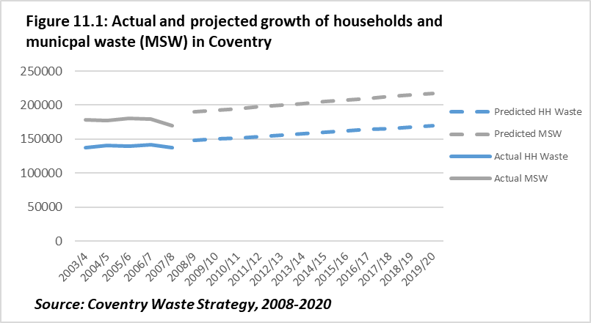

7.2 To get an idea of what the composition of our waste stream is like we can refer to the Waste & Resources Action Programme (WRAP) latest analysis for local authorities across England.

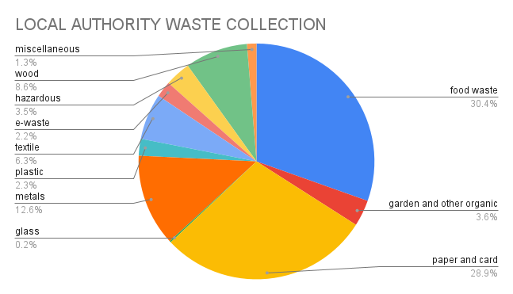

7.3 The UK Government’s waste management hierarchy places emphasis on preventing waste and re-use wherever possible. The objective for the City is in fact to reduce all forms of waste wherever possible. The recent announcement of the introduction of a plastics packaging levy in April 2022 where a charge will be made on any company which uses plastics in packaging of their products that contains less than 30% recycled plastic in each component of the packaging or the containers that are used to ship the products whilst in transit should help to increase the amount of plastics recycled and encourage alternatives to current practice.

**The Hierarchy of Waste Management**

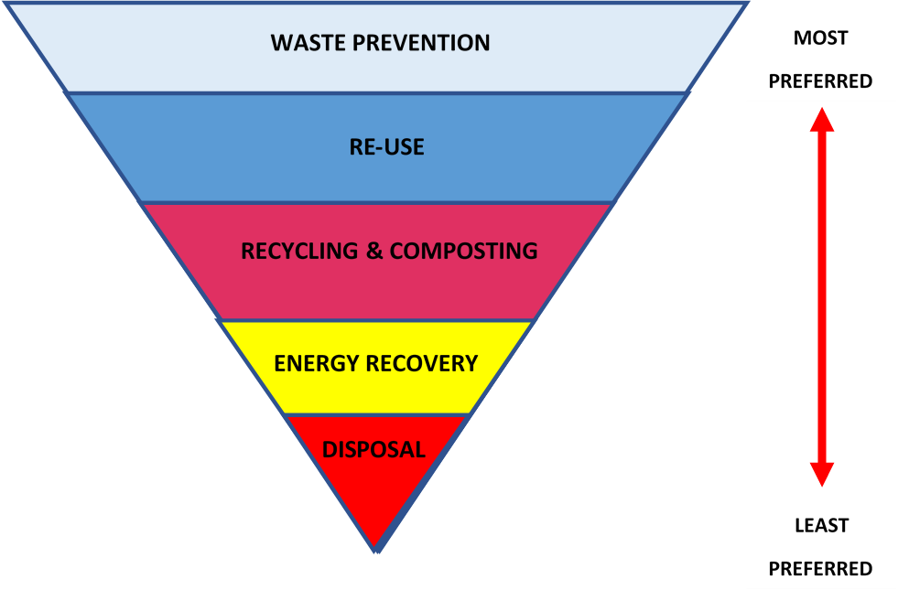

7.4 In fact, only a small percentage of the City’s waste goes to landfill (only 3% of household waste) the least attractive option in the management of waste. Most of that waste which cannot be recycled (approx. 60%) goes to heat recovery which along with unrecyclable waste from Solihull and other neighbouring authorities provides energy to the Heatline network heating an increasing number of buildings in the City Centre. The following pie chart illustrates the breakdown of the total household waste composition in England (Source of Data WRAP2017) this is collected by Local Authorities and private waste management companies:

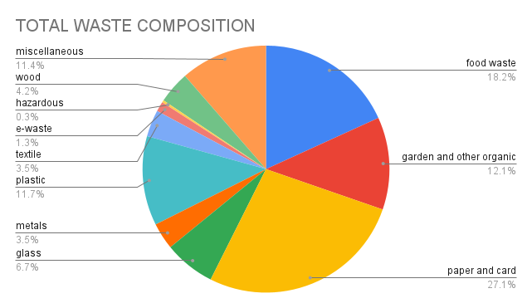

Whereas household waste is collected by or on behalf of local authorities.

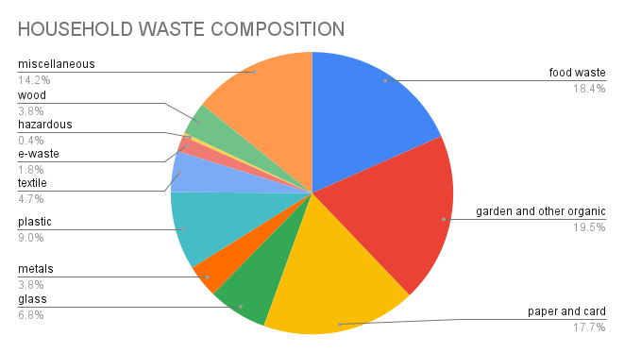

7.5 There are still some significant challenges which lie ahead notably increasing the levels of materials collected for recycling, there are considerable differences in the participation rates across the City and the amounts of recyclables collected. The City Council makes it easy for residents to participate as unlike many other local authorities residents are not required to separate out the recyclables as the Council does that for them all they have to do is place all recyclables in the one container. There is a need for a more targeted communication with communities to increase not only the participation rates in recycling but also the quality materials separation for recyclables.

7.6 Areas where there are transient populations such as students, or people in short term private rented accommodation or who live in high rise apartments are the least likely to participate in recycling as they may not know on which days recyclables are collected or lack the facilities to separate their waste and store their recyclables. The Waste management and recycling Team have built up a knowledge over the years noting the tonnage figures from their daily routes and have tried a range of initiatives to encourage participation but with limited success. There is small team who promote education and awareness about recycling and its importance, and they target those key areas where participation rates are low.



7.7 Another important area to target is the collection of food waste which at present can be included with garden waste, the percentage of food waste which is collected is low and there is a need to raise public awareness of the need to do this. Food waste is also a significant issue in the commercial sector e.g. restaurants and fast-food outlets etc. Evidence has shown that as people collect and separate out their food waste, they become increasingly aware of the levels of waste they produce, and they take steps to reduce their levels of waste by reducing unnecessary consumption and saving money.

7.8 The City Council working in Partnership with eight neighbouring authorities is building a Materials Recycling Facility (MRF) for handling recyclables at a scale where the quality of the separation and quality of the recyclable materials will be significantly improved which will also help to improve the income generated from the sale of higher volumes of higher quality separation of recyclables.

7.9 The City Council also aims to enhance its services to businesses in collecting commercial waste and separating out the recyclables. The following table details the total composition of waste collected from Businesses in England (Source: WRAP National municipal commercial waste composition 2017)

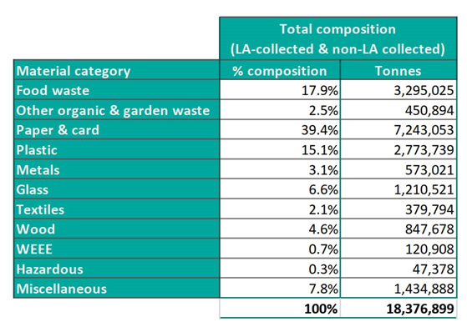

7.10 Similarly the City Council’s arms length waste management company which handles trade waste is to invest in the development of a Materials Reclamation Facility focused on commercial waste will dramatically help to improve the quality of separation and income from recyclables.

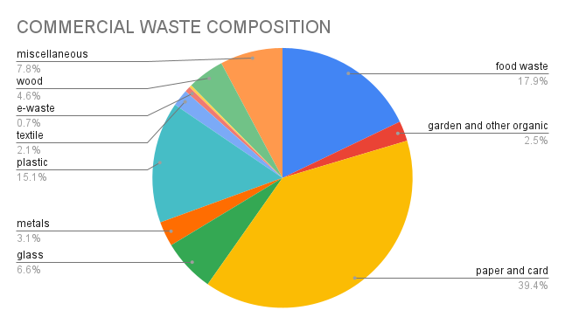

7.11There is considerable potential for the arm’s length company to expand operations and dramatically improve the quantity and quality of separation of trade wastes operating to a scale which makes it nationally competitive.

7.12 Specific areas of operation such as metals recycling are particularly important to the automotive sector. The Warwickshire Manufacturing Group and the Circular Economy Pathway Group of the Climate Change Board are planning work with scrap metal companies in changing the ways in which they operate so that scrap metal does not need to be exported out of the country to process so that higher grade metals can be processed in the UK.

7.13 **Supporting Businesses with energy & environmental management**

The City Council is one of the few local authorities in the Country which works very closely with local businesses providing environmental and energy consultancy services and supporting businesses with environmental and energy management improving efficiencies and reducing waste all helping companies to reduce their bottom-line costs and increase their competitiveness and in some instances helping to safeguard jobs.

7.14 The Green Business Team has supported over 290 small to medium enterprises to date with over £3m of ERDF grant funding to help companies improve their efficiencies in energy and environmental management with a Carbon saving of over 13,000 tonnes of carbon from the atmosphere and helped to create 60 jobs. The success of the Green Business Team far exceeded expectations and demonstrated the potential for businesses to not only improve their environmental performance but also save money and enhance their competitiveness.

**Green Business Team’s Record of achievement:**

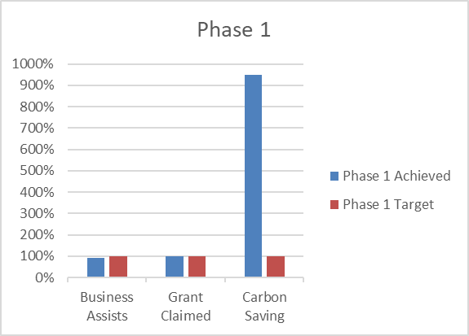

7.15 On the subject of job creation the growing demand for energy efficient environmentally sustainable products is ever growing and will require new skills and expertise from the workforce. Centres of excellence in the West Midlands carrying out research into the innovative management of waste and the potential to develop symbiotic relationships between companies where one company’s waste becomes another’s raw material will prove key to the progress of the West Midlands as a driver of the Green Industrial Revolution.

7.16 A sustainability Business Network with over 1,200 members meet regularly to learn from each other and to develop their practical skills and share case studies. Each month the number of companies attending events increases and now podcasts are also now available to an increasing number of local businesses subscribing to the Network’s newsletters and podcasts.

7.17 Business Sustain provides environmental consultancy services to some 160 or so large prestigious organisations assisting them in obtaining ISO14001 Standard for Environmental management. There is scope for this and the Green Business Team to diversify their activity in the future to meet expressed needs from clients to support companies with their Health & safety as well as Energy Management compliance with standards such as ISO50001

7.18 The City will be working towards enhancing the benefits from its heat network whilst maximising the amount of recyclable materials taken out of the waste stream working with local businesses on reducing waste production and help for creating symbiotic relationships with other businesses which can use one companies waste material as an other companies raw material for manufacture of new goods and services.

7.19 The City Council working in partnership with the Universities and WMG have collectively made some significant strides in supporting businesses especially the SME’s with energy and environmental management and to date they have helped to create 60 jobs and reduce emissions by 13,559 tonnes Carbon per annum.  The West Midlands Circular Economy Routemap recognises the very important role Coventry and Warwickshire has to play in promoting the decarbonisation of the manufacturing sector and the opportunities to be at the heart of the green industrial revolution such as the development of the proposed Gigafactory to provide the much needed batteries to accommodate the Nation’s transition to electric vehicles by 2030.

7.20 The City Council and its partners recently adopted the City Council’s Social Value Sustainability Framework which would help the Council and its partners to reduce the Scope 3 emissions in particular when the City Council and its partners in the Anchor Alliance are procuring goods and services. A series of criteria are currently being developed to help assess the goods and services being procured or to stimulate the inclusion of social value and sustainability criteria in major developments sent before planning.

7.21 Progress in supporting the circular economy provides a major opportunity for the development of new products and services. Coventry has always been a centre for innovation it holds the second largest number of patents per head of population in the country, it contributed to the WMCA’s ‘Kickstarting the West Midlands Circular Economy and as a City has tremendous potential as a catalyst for change. Coventry sees itself as showcasing new environmental technologies and demonstrating their use in the city as a shop window for the world. Working with local businesses and the WMG for example on the development of Very Light Rail or working with materials scientists in Universities to help the waste products from one company to be the raw materials for another.

7.22 There are a number of charities and social enterprises across the City which address the circular economy especially for those families on limited incomes who cannot afford to buy new goods and services such as furniture recycling, white goods repair, toy libraries, tool stores etc and also advisory services like Act On Energy and Energy Action which provide valuable services that help to minimise waste. Support for the development of social enterprises in this sector will not only help many into the labour market but also provide some valuable goods and services which address the needs of those on low incomes.

**Waste minimisation**

CE1 To develop a detailed understanding of the efficacy of waste collection and recycling participation rates to provide a valuable insight to enable recycling rates to be increased.

CE2 To build Materials Recycling Facilities to improve the quality of materials separation for recyclables:

A) Household Waste;

B) Commercial Waste.

CE3 To carry out a number of behavioural change projects and initiatives at the Citywide and community level to encourage:

A) an increase in recycling participation rates;

B) greater support for re-use and repair.

CE4 To develop an online resource promoting re-use and repair with advice on how to extend the life of products combined with a media and comms strategy.

CE5 To develop and further enhance existing neighbourhood based and citywide re-use, hire and repair services across the City e.g The Coventry FabLab <https://fablabcov.coventry.ac.uk/>

CE6 To develop links and new products and services with Tom White Waste, the Green Team and Business Sustain.

**Support and advice to businesses to minimise waste and maximise efficiency**

CE7 To seek continued funding and opportunities for securing funding and income for the Green Business Team’s following the end of ERDF funding from the EU in July 2023.

CE8 To expand the Business Sustain Service as a consultancy with a concerted media and marketing strategy delivering a wider range of services as requested by the clients.

CE9 To refine the procurement guidance in relation to the Social Value and Sustainability criteria.

**Support with the development of innovation and symbiosis for businesses**

CE10 To work with materials scientists and others at the universities to seek funding and resources for a research and advisory support service to business for the development of existing and new products.

CE11 To showcase new green products and their application across the Sub Region and promote them to the rest of the world.

CE12 To seek support for the development of social enterprises in the community which can help to encourage re-use and the more efficient uses of costly materials whilst providing valuable skills and work experience for the long term unemployed so assisting their progression into the labour market.

# **8.0 Equitable and people centred**

**Inclusive urban communities and addressing poverty**

8.1 We are often aware of the effects of extreme climatic conditions and environmental disasters on communities around the world and that people in the developing countries of the world bear the greatest burden and are impacted upon the most by climate change. Whilst there are clearly global inequalities these also exist closer to home within our own City. Nearly 20% of the City are in the Nation’s bottom 10% most deprived neighbourhoods with 33% of our children in low income families.

8.2 There are some significant differences in the life expectancy of people living in Coventry, Overall life expectancy in the city is currently averaging out as 82.4 years for females and 78.3 for males and has consistently remained below the regional and national averages. On average men living in the most affluent areas of the City have a life expectancy 10.7 years longer than those living in the most deprived areas whilst for women the difference is 8.4 years. The growing number of elderly people living in the City will also increase the number of people who are vulnerable to the effects of climate change with an estimated additional 8,900 people aged over 65 and an additional 2,000 people aged over 85 by 2029. A third of the population growth will be concentrated in one tenth of the City.

8.3 Coventry is one of seven cities in the UK that is a member of the Marmot Network to improve health and reduce inequalities in the City. The Director of Public Health’s Report ‘Bridging the Gap’ recognises the significance of the impacts of the environment and living condition upon health.

8.4 Exposure to pollutants, access to a healthy diet, opportunities for an active lifestyle, living conditions, prospects for employment, fear of crime, relationships in our family and local community all impact upon our health and wellbeing. The quality of our local environment is also one of the wider determinants of health and there are distinct differences in a whole range of environmental parameters across the City which will have a direct or indirect affect on health and mental wellbeing some of these are

1. Traffic levels with associated noise and air pollution;
2. Access to parks and open space;
3. Access to a means of affordable transport and access to essential services
4. Prospects for employment;
5. Access to fresh food and growing places;
6. Engaging communities in creating quality neighbourhood environment
7. Supporting behavioural change

**Air Quality**

8.5 In 2021 the City was named as one of 28 towns and Cities in England where Nitrogen Dioxide (NO2) levels in the atmosphere from motor vehicles and the burning of fossil fuels in wood stoves were forecast to exceed legal limits. The City was at risk of having to introduce road charging but thanks to the Council’s Robust Air Quality Action Plan the Government felt this was enough to negate the need for road charging. 15% of the City has excess levels of the pollutant and the actions in the Air Quality Management Plan aim to address these through a range of activities including improvements to the use of the road space, promotion of active travel e.g. new cycle routes and integration with transport hubs etc.

8.6 Much of our air quality monitoring is based upon the use of diffusion tubes which reveal average levels of exposure over time and do not pick up incidents when levels have been exceeded at any moment in time. There is a need to learn from the DEFRA national pilot project for obtaining more real time data using lower cost remote sensing equipment to monitor pollutants in localities in real time and to develop a better understanding of the factors effecting atmospheric pollution and how it can be most effectively addressed.

EPC1 To build upon the work of the ‘Air Quality Management Plan’ and to learn from the results and findings of the DEFRA National Air Quality Monitoring Pilots to identify low-cost ways of recording more accurate real time data on key atmospheric pollutants NO2, PM2.5, PM10, O3 and NOx across the City to inform future arrangements relating to traffic management., layout and design.

EPC2 To develop an awareness programme with teachers and children in schools which links with STEM subjects in the National Curriculum by actively investigating traffic levels and vehicle emissions near schools and where possible relating them to health and wellbeing.

**Access and transport**

8.7 There is a direct relationship between promoting active travel and public transport for families on low incomes and how this can help contribute towards improvements in localised air quality by reducing the number of private motor vehicles (especially older vehicles with lower Euro ratings which contribute more to emissions than he more recent Euro 6 vehicles. Covid 19 resulted in a loss of confidence in using public transport in a recent study carried out by Coventry University a number of actions were identified to improve confidence in using public transport such as sanitisation and social distancing procedures, public information regarding realtime information, promoting active travel e.g. e.bikes and multi-modal access as well as highlighting the need for more EV charge points. the development of initiatives

8.8 Coventry’s last census showed Coventry to have just 409 vehicles licensed per 1000 people (ranked 298th out of 348 Local authority areas in England & Wales. Coventry has a lower than average percentage car ownership and whilst the number of people owning cars has grown the numbers using their cars to commute to work had declined much of this is attributable to more people working from home more with just over 1% of the population doing so in 1981 rising to over 7% by 2011 and now post Covid that has risen nationally to 14% of the workforce (ONS). Reducing commuting to schools and places of work will help reduce the levels of congestion and improve air quality and the incidence of respiratory, cardiovascular disease and Cancer.

8.9 There are usually in the region of 600 to 700 casualties on the road each year due to Covid 2020 this has dropped significantly to 395 with 6 fatalities and 67 serious injuries. The impact traffic levels have on local communities and opportunities reduces the opportunities for social interaction changing the priorities for streets in neighbourhoods to encouraging more active travel and placing a greater emphasis of a sense of place can assist community cohesion and help to reduce traffic speeds through effective design of streets and the public realm with greater priorities for people and safety over cars.

EPC3 To look at further innovative opportunities to encourage developers and employers to develop commuter plans to reduce the need for trips in private motor vehicles and to promote commuting by public transport and active travel

EPC4 To work with Universities and various user groups to develop a greater understanding to the barriers for accessing and using public transport and modes of active travel in a post Covid World addressing real issues and negative perceptions including marketing and promotions and targeted research to inform future approaches to behavioural change, including possible incentives marketing and promotions.

EPC5 To learn from other local authorities applying the ‘Link & Place’ methodology for changing priorities for streets creating a greater sense of place and supporting the development of the 15-minute City where all key services are accessible using public transport or active travel.

**Fuel Poverty & affordable warmth**

8.10 In the current economic climate with the security of energy supply becoming more of a threat to the UK the risk of rising levels of fuel poverty are becoming increasingly significant. In 2021 there were nearly 26,000 people (19% of the population) living in cold poorly insulated homes in Coventry which directly impact upon health exacerbating the problems for those with cardiovascular and respiratory disease, mental health anxiety and depression. Within Coventry the differences in the levels of fuel poverty can be significantly contrasting within the City itself.

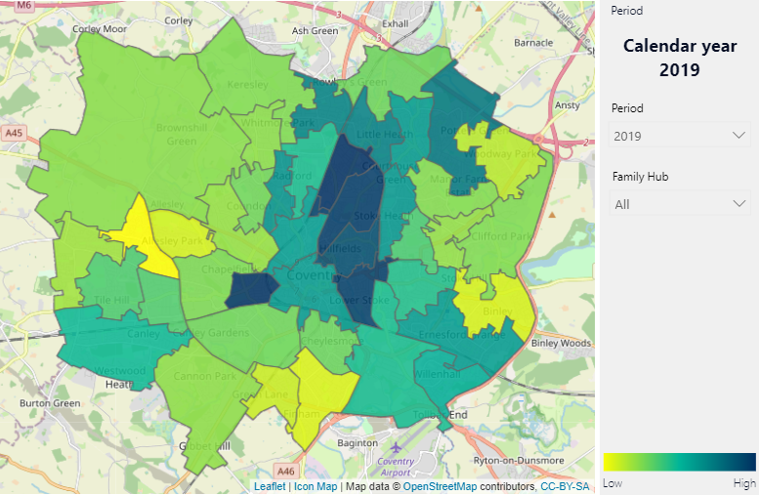

8.11 There are also issues relating to debt in low-income families with disproportionate percentage of their overall income being spent on fuel and rent resulting in less available for other essentials with direct impacts upon diet and nutrition. With people facing some dramatic rises in energy costs (in some instances up to 300% increases) the numbers in fuel poverty is very likely to increase. Currently 19% of families are in fuel poverty.

8.12 The City Council’s Affordable Warmth Programme is likely to face an increasing level of demand from the public. ‘Act on Energy’ a Stratford based Charity is currently commissioned by the City Council to provide advice and support to households affected by fuel poverty and helps with practical advice and access to funding from the City Council for replacement boilers and energy efficiency retrofit funding from the Local Authority Delivery Scheme (LADS), the Social Housing Decarbonisation Fund (SHDF) for those living in social housing, the Energy Company Obligation (ECO) via the utilities, the Warm Home Discount and the Priority Services Register

EPC6 To work with Utilities in adopting a strategic approach to the promotion and use of Energy Company Obligation (ECO) Funding to support the retrofitting of residential properties.

EPC7 To develop a partnership with Wolverhampton and Birmingham City Councils for the 3 Cities Retrofit Initiative to target more than 165,000 social housing properties which will be able to secure funding, resources and expertise for energy efficiency, green heating and energy generation schemes across the social housing estate.

EPC8 To work in partnership with Housing Associations and other Registered Providers and private landlords in securing resources for improving the energy efficiency of properties for tenants especially those suffering from fuel poverty due to the rising prices in fossil fuels.

EPC9 To establish ways of improving the City Council’s Affordable Warmth service and access to grants and other support to improve energy efficiency and assist with fuel payments for the increasing numbers of families expected to be in fuel poverty due to the rising prices in fossil fuels.

**Access to open space – mental wellbeing**

8.13 Green spaces help to cool cities down and provide areas of respite and reflection from the stresses of daily life and are known to contribute to mental and physical wellbeing. A study of over 19,000 people in England looked at the effects of spending 2 hours or more a week in or around open green spaces. The results showed a significant increase in the likelihood of people reporting good health or high wellbeing

8.14 The average number of visits made by residents across the West Midlands to the natural environment (natural England’s Monitor of Engagement with the Natural Environment Survey (MENE)) is well below the national average. In fact, Coventry has the lowest figure in the region with 57 average estimated weekly visits against a national average of 90. Those neighbourhoods with the poorest access to private transport have the lowest areas of nearby greenspace

8.15 The level of perceived greenness of a City notably, parks, gardens and playing fields has an important role to play in determining the wellbeing people derive from their environment. Over 20% of Coventry’s total area are green spaces but from an accessibility point of view – despite this Coventry trails behind regional average for accessible open green space provision by population. The New Economic Foundation carried out a survey of local authorities across the West Midlands and beyond and discovered that Coventry ranks 141 out of the 373 local authorities across England for its average combined size of parks, public gardens and playing fields accessible to households within a 1km radius compared to Birmingham which is 19 and Solihull 45.

8.16 There is a close correlation between the levels of deprivation and the population pressures on available green space, there is a need to ensure a greater level of provision for green spaces in the most densely populated areas where the highest levels of deprivation exist.

8.17 The City Council’s Parks Team had put in considerable effort in supporting the establishment of community Friends of Parks Groups and enhancing support with Allotment associations to encourage local ownership for parks, allotments and areas of open space this was adversely affected by the incidence of COVID and needs to be revived. Working in partnership with these groups and with the use of Section 106 funding through the planning process we should be able to secure funding and resources to support local residents and groups with the development and maintenance of sites on the ground.

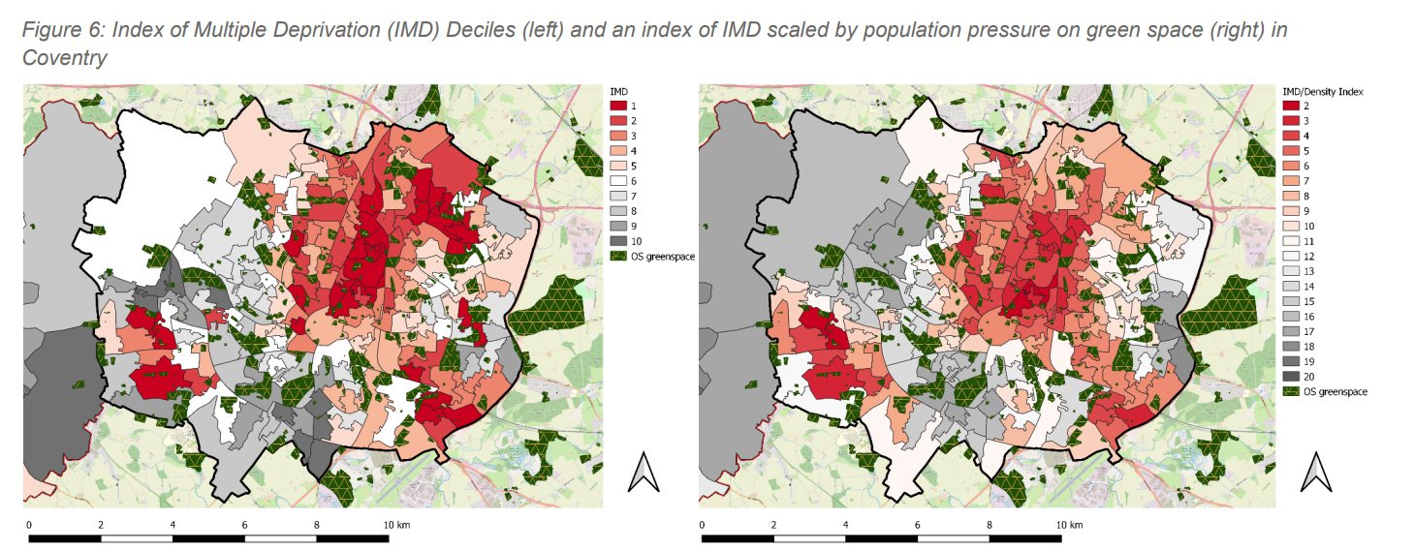

EPC10 To support the further development of Friends groups and to work in partnership with the Trust for Conservation Volunteers, the Wildlife Trust, Canals and Rivers Trust, Heart of England Community Foundation, the WMCA and others to seek funding for projects on the ground.

EPC11 To develop training and skills in land management, horticulture, urban forestry, adaptation and wildlife conservation practices for volunteers across the City,

EPC12 To work with local schools on the development of the green environment in the schools and to promote membership and participation in Eco Schools, Food for Life and Forest Schools programmes and initiatives.

**Prospects for employment**

8.18 The Green industrial revolution provides considerable opportunities for future employment and Coventry’s Economic development Strategy identifies the opportunities which exist to address the Government’s ‘Ten Point Plan for a Green Industrial Revolution’. The development of retrofit technologies and their installation along with renewables such as solar and heat exchange systems provide considerable opportunities for employment. It is estimated that more than 21,000 jobs could be created in new green industries across the West Midlands with 92,000 new jobs

8.19 The development of innovative technologies such as the Very Light Rail System and the manufacture of batteries for electric vehicles such as the Gigafactory offer considerable employment potential.

8.20 The £130m boost in funding for the development of green technology skills across the West Midlands will help to train the locally unemployed or low skilled workers with new skills such as electric vehicle maintenance, installation of electric vehicle charging points and retrofitting homes for example all skills which will be in demand over the coming years.

EPC13 To work in partnership with Adult Learning, Colleges and Universities on the development of the new skills needed to support the growth of environmental technologies, goods and services

EPC14 To work with local social enterprises in creating employment and training opportunities in the hiring of goods and services in the re-use, recycling, service and repair sector as well as land based industries relating to sustainable agriculture and horticulture.

**Fresh Food and Healthy Diets**

8.21 The City Council is a member of and aims to work closely with the ‘Coventry Food Network’ whose Food Charter highlights the following principles for action:

1. Proclaims the universal right to food
2. Promotes a community food culture
3. Enables food producing environments and reduces food waste
4. Supports ethical business and social enterprise
5. Works for food justice

 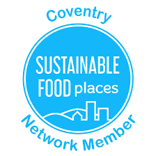

8.22 Coventry was awarded Sustainable Food Places Status for the work of its Strategy with a discounted food scheme, school holiday hunger projects, community café with ‘The pod’, the social supermarket in Foleshill, food growing projects and cooking programmes.

8.23 To learn from Warwick County Public Health Dept’s successful Food for Life Programme which was introduced to schools, early years settings and hospital trusts and consider the benefits of the programme and how it may be applied in the Coventry context.

EPC15 To work with the Food Network and the University of Warwick in the development of a mobile green grocers to tour locations across the City and target areas where fresh fruit and vegetable produce is less readily available and to work on choice management and behavioural change projects to increase access to healthy food and to encourage the development of cooking skills across the community.

EPC16 To further refine the Food Strategy including finding areas of land suitable for community food growing in key target areas of need across the City and to apply for Bronze status for the Edible Food Places Award.

**Engaging Communities in creating liveable spaces**

8.24 The quality of the environment and sense of place play a very important part in making people feel comfortable with the places in which they live and where we can design out crime where people can feel safe. Quality urban design involves and engages local communities helps to understand what characteristics people value and how they use space.

8.25 By talking to local residents and businesses and studying public life we can help to create a greater sense of place which addresses people’s needs and place a stamp of local distinctiveness that evokes civic pride whether it be public art or the sensitivity of the design and landscaping etc.

EPC17 To work with communities in shaping neighbourhoods and using techniques like Future Search, Action Planning, Planning for Real, Participatory Budgeting, etc we can help to target those locations where we need to rebuild a sense of place that people can be proud of.

8.26 A recent study of the region commissioned by WMCA and carried out by the New Economics Foundation <https://www.nefconsulting.com/our-work/clients/wmca-green-space-access-social-inequity/> looked critically at access to green space and found that the most deprived more densely populated areas had the least accessible green space in the City. The Black, Asian and Minority Ethnic (BAME) populations in Coventry showed greater population pressure on green space than other segments of society.

EPC18 To identify areas of neglected open space which has the potential for accessible community open space for formal amenity and semi natural green spaces of value for wildlife and places of refuge to provide rest and relaxation to enhance mental wellbeing.

8.27 The City Council’s Public Health function working in close collaboration with the NHS Trusts, Integrated Care Boards (ICB’s), Children’s Services and Adult Social Care has a major role to play in addressing health inequalities, it would be helpful if this work was also looked at in the context of the UN Sustainable Development goals many of which have a focus on health and wellbeing.

EPC19 To review progress in the effectiveness of the Health & Wellbeing Strategy in addressing the wider determinants of health and creating an equitable sustainable city.

**Creating a Green cultural legacy**

8.28 Arts and culture plays a significant part in promoting emotional wellbeing and celebrating diversity and cultural identity whether at the City or neighbourhood level. The City of Culture Trust working with the City Council ran a very successful programme of events and activities with an environmental theme mainly focusing on our natural heritage and the appreciation of wildlife and natural habitats. A number of activities that were organised were specifically targeted at underrepresented ethnic groups and many events that were organised were fully booked within the week they were advertised to the public. People who were not previously engaged in nature conservation and environmental issues demonstrated an interest.

8.29 There is now an amazing opportunity to build upon the City of Culture’s Green Legacy with a series of arts and cultural events across the City ranging from small scale community based events and public art through to major exhibitions and festivals like the Godiva Festival where we promote awareness of sustainability and Climate Change in new and interesting ways and help to build a sense of place, identity and purpose for Coventry as a Green City and home to the new green Industrial Revolution.

8.30 The Major arts organisations in the region worked together with training and support provided by the Trust in changing the way they operate not only to reduce their environmental impact but also to raise the awareness of their visitors and audiences.

8.31 The City Council intends on working with the City of Culture Trust in the development of a Green Legacy that builds upon the experiences from the City of Culture Year and to use the arts and cultural events as a means of raising the awareness and interest of the general public inspiring changes in attitude and responsiveness to call for action for developing sustainable futures.

EPC20 To work in collaboration and partnership with the City of Culture to create a Green Legacy for Coventry with:

1. a clear code of practice for the future running of events and venues to minimise their impact upon the environment.
2. A programme of events and activities which celebrate a Green City and the distinctiveness of the various neighbourhoods which make the City as we know it today.

**Advancing awareness of sustainability and supporting Behavioural Change**

8.32 All the work of Partner organisations across the City will amount to a little if we do not manage to see a cultural shift in not only the way the individual members of our organisations work across the city work in the future and their commitment to change but also how individuals and wider society, the public, adjust and change their behaviours to minimise the impact they have on the environment. As mentioned earlier there is not much time left to effect the necessary changes so how we all go about this is going to be critical to our success

8.33 Schools have a major role to play in raising public awareness of environmental issues and encouraging action to address climate change not only through what they teach in the classroom but also the examples they set to the children and their parents in the way they manage the school and through examples of good environmental stewardship for present and future generations.

8.34 The Library Service will organise special awareness raising events and activities as part of its community programme with the setting up of book sections and public information directories devoted to sustainability and climate change and promoting the services use of environmental technologies to reduce its carbon footprint.

8.35 How do we create a balance between incentives and penalties to encourage and support the right behaviours and how do we raise awareness of the issues, engage people in problem solving and explain the reasons why certain courses of action are recommended how do we frame our communications to elicit a positive response. These are all challenges which lay before us and there are no easy answers.

EPC21 To work with the various institutions and universities and stakeholders including community representatives in

1. Creative problem solving that cross professional and geographical boundaries to address issues of concern and to propose practical solutions to often complex and difficult issues;
2. Applying the use of nudge theory, behavioural economics and other similar techniques to encourage behavioural change and to conduct research into their effectiveness and to learn lessons to help improve the effectiveness of future practice.

EPC22 To develop a set of resources and a programme of support for schools which inform and encourage a greater awareness of sustainability and climate change issues adapted for all subjects across the curriculum and to assist schools in implementing the highest standards for reducing their ecological & carbon footprint.

EPC23 Working with environmental professionals across the Council and partner organisations to promote opportunities for practical and experiential learning across the whole curriculum in locations outside of the classroom across the City.

EPC24 Libraries to work across the City with themed events and activities aimed at raising public awareness of Sustainability issues and the provision of practical information with sources of advice and guidance.

# **9.0 Nature Based**

**Enhance Biodiversity and Urban Ecosystems**

9.1 England’s ‘State of Nature’ Report (2019) is revealing some dramatic changes in the levels of abundance of species with 45% of species affected (when in 1970 it was 23%) with a widespread loss and degradation of habitats. Of the 7,615 species found in England 13% are threatened with extinction. The problem for those involved in wildlife conservation in Coventry is that we do not know anywhere near enough about the species living within Coventry and surrounds their habitats or their conservation status. The Habitat Biodiversity Audit has surveyed habitats across Warwickshire, Coventry and Solihull but this concentrates on the most important sites across the sub region and now there is a need to focus on Coventry and develop a comprehensive strategy to enhance biodiversity and the appreciation of habitats and natural places across the City.

9.2 The UN Biodiversity Conference (COP15) agreed a set of goals to halt the extinction of threatened species and reverse nature loss with the effective recovery and conservation of habitats by 2030. These habitats provide vital ecosystem services that help to protect the planet. In addition to climate change the destruction of habitat for developments, pollution, exploitation of natural habitats for food all contributes to the loss of biodiversity. COP15 has set a target of addressing these pressures and conserving and managing 30% of land, inland waters, coasts and oceans by 2030.

9.3 Capitalising on the UK Environment Act’s (2021) introduction of a minimum 10% biodiversity net gain in UK planning applications will help to resource actions to enhance the conservation of habitats and the value of the ecosystem services they provide.

9.4 The Wildlife Trust has played a very important role in promoting biodiversity across the City with ‘Living Landscapes’ projects like the Sowe Valley Project investing millions to enhance areas for public amenity and wildlife and now a multimillion pound project with commitments from the Wildlife Trust, Severn Trent Water, the Environment Agency and City Council to open up parts of the River Sherbourne for wildlife and the public to enjoy. The Trust also played an active role in the development of community engagement activities in the City of Culture’s environmental theme.

9.5 Under the Natural Environment and Rural Communities (NERC) Act 2006 Local Authorities had a duty placed upon them to consider the conservation of biodiversity when carrying out their functions. The conservation of biodiversity has been addressed with a Biodiversity Action Plan produced by a Local Nature Partnership which covered Warwickshire and Solihull as well as Coventry. The Strategic vison that was developed in 2013 is now in need of a major review for a number of reasons including changes in legislation which has created new opportunities for securing funding for practical action to promote biodiversity. Now the ‘The Environment Act’ has received Royal Assent It was agreed that the City needs to ensure it identifies its priority designated areas for wildlife conservation and to prioritise those areas where Biodiversity Net gain can be applied which will as a minimum provide a 10% net gain in biodiversity for a series of locations secured by formal obligations and covenants for locations within the City or owned by the City Council for a minimum of 30 years onwards.

9.6 In addition to developing species conservation strategies and protected sites strategies the City’s Partnership will also need to work with Warwickshire County Council and or the WMCA in the development of the Local Nature Recovery Strategy ensuring that locations in Coventry are identified for the benefit of not only wildlife but also our citizens with benefits to health and mental wellbeing.

9.7 The nature conservation policies in the Local Plan will need to be reviewed with the possibilities of providing supplementary guidance for developers with respect to protecting existing sites of conservation value and ensuring there is a minimum of a 10% improvement in abundance and diversity of wildlife in relation to the whole of the site as it was prior to the development. In addition to ensuring there is a commitment from developers for wildlife conservation improvements, that existing sites of nature conservation value are protected and built into the design of the development. There will also need to be a commitment to monitoring the effectiveness of any mitigation methods such as the translocation of species to inform corrective measures and future recommended practices.

9.8 The management of parks, gardens and open spaces are a vital resource, Coventry has five of its 24 City Parks which have achieved Green Flag Award status I.e., Allesley Park, Caludon Castle Park, Coombe Abbey Park, Longford Park and War Memorial Park for the City Council and also Coventry University Campus and the Coventry Canal. The development of Friends of Parks Groups is an important contributor to the success of parks as well are conservation volunteers, tree wardens and allotment holders all of whom given the right advice, training and support can help to promote biodiversity as well as build pride in the quality and beauty of our open green spaces across the City.

9.9 There is a need to review the way areas of open space are managed and maintained across the City in order to maximise wildlife with the need for specialist skills training for staff and volunteers to improve the standards for conservation management which are beneficial for wildlife.

9.10 Already roadside verges are being seeded with wildflower or pollinator friendly plants to attract more wildlife as well as add colour to the urban landscape. there are opportunities to green more areas and to encourage local residents to attract wildlife into gardens with initiatives like the ‘Bee Line’ project supported by the City of Culture Trust , Warwickshire Wildlife Trust, Coventry City Council , The Canals and Rivers Trust and the Historic Coventry Trust working with schools and communities across the City to create new pollinator pathways across the City. Miniforests supported by Severn Trent and Earthwatch are being planted in schools as part of the carbon offsetting commitments for the Commonwealth Games. there is also an opportunity for rewilding areas such as near Brandon March

9.11 Coventry’s Urban Forestry Strategy 2019 –2029 recognises the importance of urban trees and forests in serving an ecosystem function for the City helping to cool the City down, clean the air and, contamination in soils, reduce the risk of flooding, improve water quality and enhance the urban visual landscape. We must not forget that trees are also vital wildlife habitats. The city has over 200,000 trees (44,000 CCC Trees) in open spaces, 17 woodlands and 18% canopy cover. The City is planning on planting a tree for every Coventry citizen amounting to 360,000 trees by 2031.

9.12 It is important to note that there are clear links between the proposed work of the other thematic Pathway Groups such as Adaptation and Resilience, Person Centred Equitable and Low Emissions etc all of which can also contribute to enhancing biodiversity and natural habitats across the City whether it’s a Sustainable Urban drainage scheme providing a wetland habitat, a cycle route with a wildlife corridor or a project where local residents grow food on an allotment in a wildlife friendly way etc.

**Establishing Plans, data monitoring and analysis**

NB1 Establish a group to bring together a variety of partners creating a ‘Biodiversity Action Plan’ (BAP) including a regular ‘State of Nature Report’ and contribute to the regional Nature Recovery Strategy for the WMCA area.

NB2 To develop a database of the City’s land assets and their potential nature conservation value on the Council’s GIS System including conservation management and species data records.

**Habitat Creation and enhancement**

NB3 To identify opportunities for habitat creation in areas within parks and areas of open space which can be managed for nature conservation purposes and to use these venues as an opportunity to engage with the public and promote habitat creation in private gardens etc.

NB4 In conjunction with the identified work on the Biodiversity Action Plan to work with internal and external stakeholders to identify small areas of land of current low biodiversity and develop targeted interventions to create biodiversity rich areas

NB5 To establish partnership projects to enhance areas of biodiversity value e.g. the £2m Sherbourne Valley Project to restore the river for wildlife with the creation of new wetlands and to reconnect local communities with the river

NB6 To work with neighbouring local authorities on the development of a major high profile rewilding project in the City and surrounds e.g. Brandon Marsh which could become a major visitor attraction and create a unique experience for the citizens of Coventry especially those who do not have the opportunity to visit areas of outstanding natural beauty or major wildlife conservation areas.

NB7 To consider the importance of being sensitive to the needs of wildlife when introducing flood prevention and Sustainable Urban drainage or landscaping of urban spaces and to approach such schemes in a more holistic way from a biodiversity perspective.

**Maintenance of sites**

NB8 To establish options and implement a solution to upskill existing staff and volunteers including the development of training programmes which enhance their capacity and ability to undertake conservation management work for respective habitats in parks and areas of open space on the land within the City whether they are public or privately owned.

NB9 To identify areas within parks and open spaces for which conservation management techniques could be applied to and encourage community engagement in practical wildlife conservation activities

**Engaging volunteers and public**

NB10 To engage senior managers across the local authority in considering how their specific actions and means of delivering services can impact upon biodiversity with considerations of opportunities for the future.

NB11 To develop educational interpretative materials to encourage positive action for the benefit pf wildlife.

NB12 To encourage and stimulate opportunities for communities to plant trees, the right tree in the right place linked to the GIS survey of vacant land with the target of 36,000 trees by 2031.

**Education and Awareness**

NB13 To contribute to the WMCA Regional Local Nature Recovery Plan promoting linkages between sites and wildlife corridors and improving access to green spaces for the general public which are within walking distance to nearby communities with accompanying interpretative information notice boards, the website and social media etc

NB14 Promote family and public awareness events and initiatives which attract greater interest in wildlife conservation and promote positive actions such as promoting measures to attract wildlife to private gardens e.g. Coombe Abbey events, Bee Line, dawn chorus walks, bat nights, WATCH Groups etc to attract greater awareness and interest in wildlife conservation and the importance of promoting biodiversity.

NB15 Work with schools on the development of wildlife conservation areas to be used in cross curricular teaching and to promote greater awareness appreciation and understanding of the importance of promoting biodiversity.

# **10.0 Resilient**

**Anticipate, Prevent, Absorb and Recover from shocks**

10.1 We know from researchers in the field and modelling of weather patterns in the Midlands that the future predictions of more extreme weather incidents is highly likely and that the citizens of Coventry are likely to experience warmer wetter winters and hotter drier summers.

|  |  |  |  |  |
| --- | --- | --- | --- | --- |
|  | **2050s**  **RCP2.6**  **(50th Percentile)** | **2050s**  **RCP6.0**  **(50th Percentile)** | **2080s**  **RCP2.6**  **(50th Percentile)** | **2080s**  **RCP6.0**  **(50th Percentile)** |
| **Mean annual Temperature** | +1.2oC | +1.2oC | +1.3oC | +2.4oC |
| **Mean winter Temperature** | +1.1oC | +1.1oC | +1.2oC | +2.0oC |
| **Mean summer Temperature** | +1.7oC | +1.5oC | +1.9oC | +3.2oC |
| **Mean summer**  **Precipitation** | -15% | -15% | -19% | -26% |
| **Mean winter Precipitation** | +6% | +5% | +9% | +14% |

*UK Climate Projections for West Midlands RCP2.6 is roughly a 2 0c rise in global temperature and an RPC6.0 is a 4 oC rise in temperature (Met Office UK Climate Projections)*

10.2 The latter is a particular concern due to the likely health impacts associated with heat stress and the impact such conditions have on water quality and the strain they place on water supply in a part of the Country classed by the Secretary of State as seriously water stressed. The use of natural vegetation in cities and particularly the planting of trees helps to cool the City down and also reduces the rate of water run off so helping to reduce the risk of flooding.

10.3 As for flooding, owing to the location of the rivers feeding the City they are closer to their source therefore flooding incidents are likely to arise with little warning although it is likely they will be short-lived.

10.4 The West Midlands Climate Change Risk Assessment and Adaptation Plan 2021 – 2026 developed by the Environment Agency and Sustainability West Midlands was informed by the National Flood and Coastal Erosion Risk Management Strategy for England (2020) and the Living Better with a Changing Climate Report (2021) under the Climate Change Act.

10.5 In line with our concerns for inequalities it should be noted that the impacts of climate change will be felt more severely in communities with the highest levels of deprivation.

10.6 An ecologically sensitive approach with the development of Sustainable Urban drainage schemes using natural rates of filtration, the use of wetlands to retain water helps to slow the rate of flow and provides a natural filter that assists the improvement of water quality.

10.7 The changes in climate will affect vegetation particularly species of tree, the Forestry Commission has set up a ‘TreeAlert’ system to monitor the effects of climate change on trees and the Commission recommends using seed stock from trees 2 degrees latitude south of our location to be better adapted and acclimatised to the changing conditions plants are likely to face in the future.

R1 For the City Council to develop an adaptation and Resilience Plan which addresses the local perspective identifying areas at risk of flooding and impacted up by heat stress in relation to the heat island map of the City for the hot dry summer months.

R2 To promote the use of natural courses of filtration as part of the City’s Sustainable Urban Drainage Systems and to develop a series of coherent land use policies to promote the use of natural vegetation rather than engineered hard landscaping features which speed up the flow of water and risk of flooding incidents.

R3 To promote the City’s plant a tree scheme and link in with the City’s biodiversity objectives and where appropriate consider the further development of wetland

Areas.

R4 To promote reflective materials on roofs and where possible the planting of green roofs and green walls to help cool the city down by reducing the levels of absorption of radiant heat.

R5 Working with the Environment Agency and other bodies to secure funding where needed and rollout of strategic flood defence schemes and ensure that any properties that are not protected by such schemes, but that are still vulnerable to an increasing flood risk, are   
 prioritised for property-level flood protection measures.

R6 Working with our partners in health and social care to ensure climate risks to health, buildings and infrastructure that affect hospitals, care homes, GPs and other health and care settings are embedded into corporate risk / business continuity plans.

# **11.0 Relationships and interactions**

11.1 Many of the areas of activity relate to one another, in many instances the delivery of one action impacts upon another. It is important to understand the interrelationships between the pathways and how action upon one may benefit or potentially hinder another. We will aim to ensure that activities across the different areas of activity and those involved will have to take into account their colleagues work and how their work relates to one another in a beneficial way and how close monitoring can provide the necessary feedback to enable us to adapt and change where necessary.

11.2 For example in the past people have addressed the risk of flooding by the use of hard landscaping which has sped up the rate of flow to remove potential flood waters which not only shipped the problem further downstream but also had a negative effect on riparian ecosystems removing important habitat for endangered species like the water vole.

11.3 We will also need to look at the opportunities for actions in one area may present new opportunities for other areas of activity. Take for example the development of active travel networks these can also provide a major opportunity to create wildlife corridors connecting areas of natural biodiversity with others across the City these in turn will also help to address human health issues by encouraging exercise whilst also helping to reduce pollution levels across the City and in turn improve access to facilities for those on low incomes who are less likely to be able to use a private motor car.

11.4 Many of the specific actions will benefit others’ areas of activity and add value to the efforts of all involved dialogue between those leading on the delivery of activities and projects will need to understand the nature of these linkages between their project/s and those of others in order to ensure we work to greatest effect and where possible pool and share resources.

# **12.0 Measuring and evaluating our impact and effectiveness**

**How do we know what effect we are having and whether it is**  **working?**

12.1 Once we have agreement for the specific actions outlined in an Action Plan to deliver the Strategic objectives we have identified in the final strategy. We will need to be able to measure progress over time not only in terms of the actions we manage to deliver but also how effective they are at addressing the issues of concern. We will need to know if we are helping to change the outcomes and how these in turn affect our ability to address climate change and be sustainable from the perspective of the UN’s 17 key sustainable development goals.

12.2 Coventry is one of 5 Cities (Newcastle, Nottingham, Cambridge & Dundee) Piloting the use of transition goal indicators for carbon using ‘Climate View’. This is proving very difficult as we try to find accurate, timely meaningful measures which will enable us to assess and model the impact of specific courses of action on climate change.

12.3 In addition to measuring Carbon emissions using Climate View the City Council and its partners will need to assess the level of progress across all 17 UN Development Goals and the opportunity to pilot the use of ‘Future Fit for Business’ benchmark indicators used by major corporations like Unilever may provide a useful measure of performance in delivering sustainability objectives.

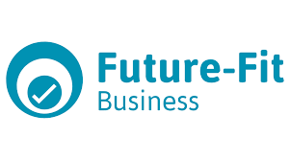

**Measuring our activity and its impact upon climate change and sustainability outcomes and how they may contribute to the State of the City and its impact upon climate change & sustainability.**

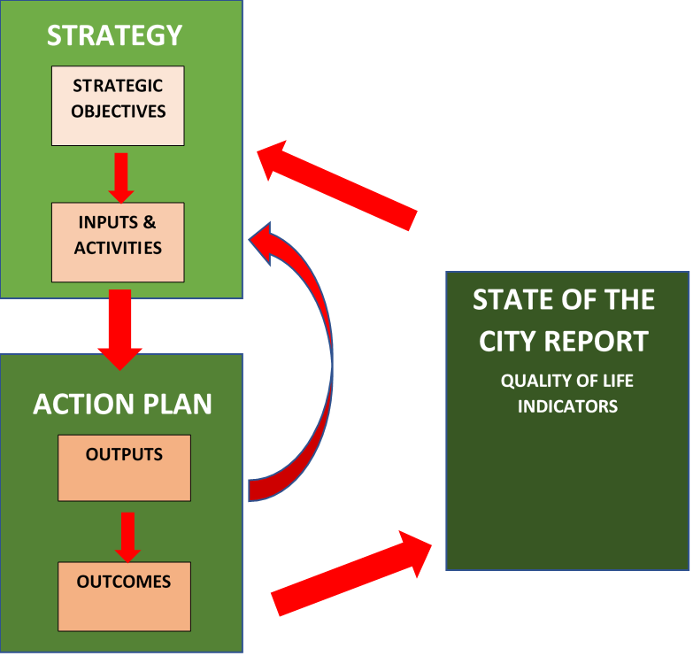

# **13.0 The Financial Imperative – finding resources for making things happen**

13.1 The major challenge that we collectively now face is finding significant levels of funding to be able to make the necessary changes to reduce carbon emissions, loss of biodiversity, pollution and the adverse impacts upon human health, wellbeing and the economy. We are also beginning to understand that the costs of delay in delivering the necessary changes are likely to be greater on the economy and society in the long term.

13.2 We very much need to continue our approach to financial business case accounting which takes into account the whole lifetime costings of our investments and assets. An approach which also in future takes a proper account of the costs of environmental impacts upon our environment and the essential life support services it provides. This means we will need to reflect fully the costs of the energy and materials used and their impacts in manufacture & construction the impacts during the lifetime of a product or building’s use and the final costs of re-use and/or responsible recycling/ disposal. We will be faced with choices that will need to account for the whole cost during the lifetime of an asset including an assessment of the costs of doing nothing.

13.3 For example:

*do we demolish an energy inefficient building and build a new zero carbon designed property in its place which requires more energy and resources overall as the endogenous energy used in its original construction is to be disposed of?*

OR

*do we undertake what might be a costlier refurbishment of a building but which uses less materials and energy overall as the original building and the materials and energy utilised in its construction are in effect being re-used which has a lower carbon footprint and reduced levels of waste produced ?*

13.4 The independently produced Zero Carbon Route-map is indicating that environmental actions fall into 3 categories of ‘cost effective’, ‘cost neutral’ and ‘technically viable’. The first category includes actions which at present day prices and cost will return clear cut savings in expenditure in the short to medium term

(15 yrs). There are other initiatives in the ‘cost neutral’ category which could recover their financial investment costs over time, whilst providing net environmental benefits. The third category however where there are technically viable actions producing net environmental benefits, would not at present prices and cost assessments provide a positive or neutral financial return. The City-wide investment requirements are set out at a summary level in section 13.6 below.

13.5 The financial and environmental business case for each investment opportunity will be assessed locally to determine financial and environmental effectiveness, both individually, and compared to other potential investments to inform priorities. Where there is positive financial benefit, there may be opportunity to reinvest benefits to support other environmentally sustainable but less cost-effective development programmes to help decrease the pressures on achieving the carbon reductions by the target date of 2050 set by the Government

**Cost-effective**

* Invest £67m p.a. for 15 years
* Cut the energy bill by £86m p.a. by 2032
* Create 2,028 years of extra employment
* Close the gap to net zero by 17%.

**Cost-neutral**

* Invest £94m p.a. for 15 years
* Cut the energy bill by £64m p.a. by 2030
* Create 3,257 years of extra employment
* Close the gap to net zero by 23%.

**Technically viable**

* Invest £559m p.a. for 15 years
* Cut the energy bill by £144m p.a. by 2030
* Create 20,407 years of extra employment
* Close the gap to net zero by 59%.

**Coventry’s Carbon Reduction Potential  
Costs and Benefits (Available Options)**

13.6 The independently assessed levels of investment required to achieve the necessary carbon reductions illustrated in the graph are estimated below:

**Cost-effective**

* Invest £67m p.a. for 15 years
* Cut the energy bill by £86m p.a. by 2032
* Create 2,028 years of extra employment
* Close the gap to net zero by 17%.

**Cost-neutral**

* Invest £94m p.a. for 15 years
* Cut the energy bill by £64m p.a. by 2030
* Create 3,257 years of extra employment
* Close the gap to net zero by 23%.

**Technically viable**

* Invest £559m p.a. for 15 years
* Cut the energy bill by £144m p.a. by 2030
* Create 20,407 years of extra employment
* Close the gap to net zero by 59%.

13.7 All environmental investment opportunities will be considered both from a City Council and a City-wide partnership perspective to determine, not only the potential investment and levels of return, but also the delivery strategy to inform financing arrangements and benefit realisation. As stated above, where opportunities exist to reinvest financial benefits from cost effective propositions into less financially sustainable programmes, this will be considered in order to help the City to decrease the pressures on its ability to achieve the carbon reductions by the target date of 2050 set by the Government.

13.8 Despite, the modelled actions there is still a gap in reaching the 2050 target, but this is likely to be addressed by future innovations and advances in technology, also the introductions of taxation and financial incentives from the Government in future years may render more of the current technically viable options into more economically viable ones especially if they create jobs and stimulate the economy.

13.9 It is for these reasons that it is vital that the City Council find collaborative partnerships to share the financial and delivery burden and to develop commercial business venture opportunities which can take advantage of the expertise of those in the energy sector to develop the necessary services and infrastructure to support a zero-carbon society and economy.

13.10 Also the Government’s Procurement Policy note 6 is mandating the need to take account of Carbon Reduction Plans in the procurement of major government contracts it is no longer acceptable to be able to pick products and services at the lowest price if they have higher adverse impacts upon carbon emissions. This in turn will affect the cost of projects in the short term but with evidenced long term environmental benefits.

**Funding Opportunities and Options**

13.11 Innovate UK, BEIS, DEFRA and other Government Depts are focusing on grant funding regimes which seek to address the causes of climate change. The City Council has currently benefited from such grants as the Local Authority Delivery Schemes (LADS) and the Social Housing Decarbonisation Fund (SHDF). As an authority it is imperative that we prioritise our resources to create the capacity to put together applications for grant funding or interest free Government loans such as the Salix Fund, whilst also lobbying the Government to create additional funding necessary to drive the pace of change required towards full cost accounting and establishing ways to incentivise more sustainable options for the future.

13.12 The sources of finance required to drive the necessary change cannot rely solely on Government Grant, or indeed public money alone. It is likely to be diverse, including Government grants, levies like the Energy Company Obligation (ECO4) and private sector investment from financial institutions and pension funds, more and more of which are finding investment in addressing the Zero Carbon agenda as increasingly more attractive propositions.

13.13 The Council’s own Treasury Management Strategy, which sets the framework for its own borrowing and investment activity, will need to consider and accommodate the Climate Change agenda, striking an appropriate balance between financial stewardship, return on investment and environmental benefit. Alternative financing arrangements (to traditional treasury loans) may be available which achieve both, including for example the Government’s UK Infrastructure Bank which focuses on investment in technologies and initiatives which tackle climate change clean energy, transport, digital, water and waste. Other examples include Municipal Bonds or crowdfunding platforms.

13.14 The consideration of joint ventures in partnership with third parties including the private sector, local communities, higher education, private charitable trusts and foundations as well as mobilising volunteers within the community to support projects may also provide opportunities to identify funding solutions for some initiatives. The River Sherbourne Project for example is a partnership between the Environment Agency, Severn Trent Water, Warwickshire Wildlife Trust and the City Council leveraging £1.8m funding from the National Lottery to restore stretches of the river for the benefit of the public and wildlife.

F1 To learn from other organisations which are looking at accounting methodologies which take account of the full life environmental and sustainability costs of investments and costing the long-term consequences of the environmental impacts upon the economy, environment and society.

F2 To modify the cost benefit analysis approach to financial decision making used by the City Council to address full life costings and the costs of impacts upon environmental quality and climate change.

F3 To see the corporate Finance Team reflecting sustainability and climate change into the existing treasury management strategy which sets the framework for borrowing and investment decisions by the City Council.

F4 Where appropriate to consider using derived benefit generated from cost-effective measures to invest in delivering the wider Strategy and ensuring the organisation prioritises resource to provide sufficient capacity to bid for external grant funding and loans to secure sustainable zero carbon initiatives and programmes

F5 To support the development of appropriate commercial ventures and arms-length companies which are capable of securing investments to address sustainability & climate change issues.

F6 To consider suitable projects and initiatives (and when to apply them) which may under the right fiscal conditions have the potential to secure public support through the use of Municipal Bonds and crowdfunding.

# **14.0 What next?**

**Where do we go from here?**

14.1 This Strategy will help to provide the context and lay out the path for future action, you will see there are 103 areas of activity outlined that cut across the organisation and its partner stakeholders working across the City. Within each area of activity there could well be a number of specific projects and actions. Some of these will be aspirational and long term where further research may be required before taking a particular course of action, others where opportunities for external funding may need to be sought. On the other hand, there will also be actions that are easily resourced and can be delivered in a short space of time.

14.2 The City Council and its Partners will be lobbying regional and national Governments for change it has an important role to play especially with providing the right national framework and funding to help support the delivery of our programmes for a sustainable zero carbon future at the city level.

14.4 We would like to hear your views about the proposed areas of activity and any ideas you may have for addressing what are sometimes complex difficult issues. We have designed a simple questionnaire which focuses on the corporate issues and the 5 pathways and would very much like to hear if you agree and which you see as the priorities for the future.

14.3 There will be specific action plans which will explain the actions the rationale and justification for each along with details of lead personnel resources, targets and milestones, partner organisations and ways in which we will measure their delivery the inputs, outputs and outcomes along with the quality of life measures they relate to in our proposed State of the City Report.

