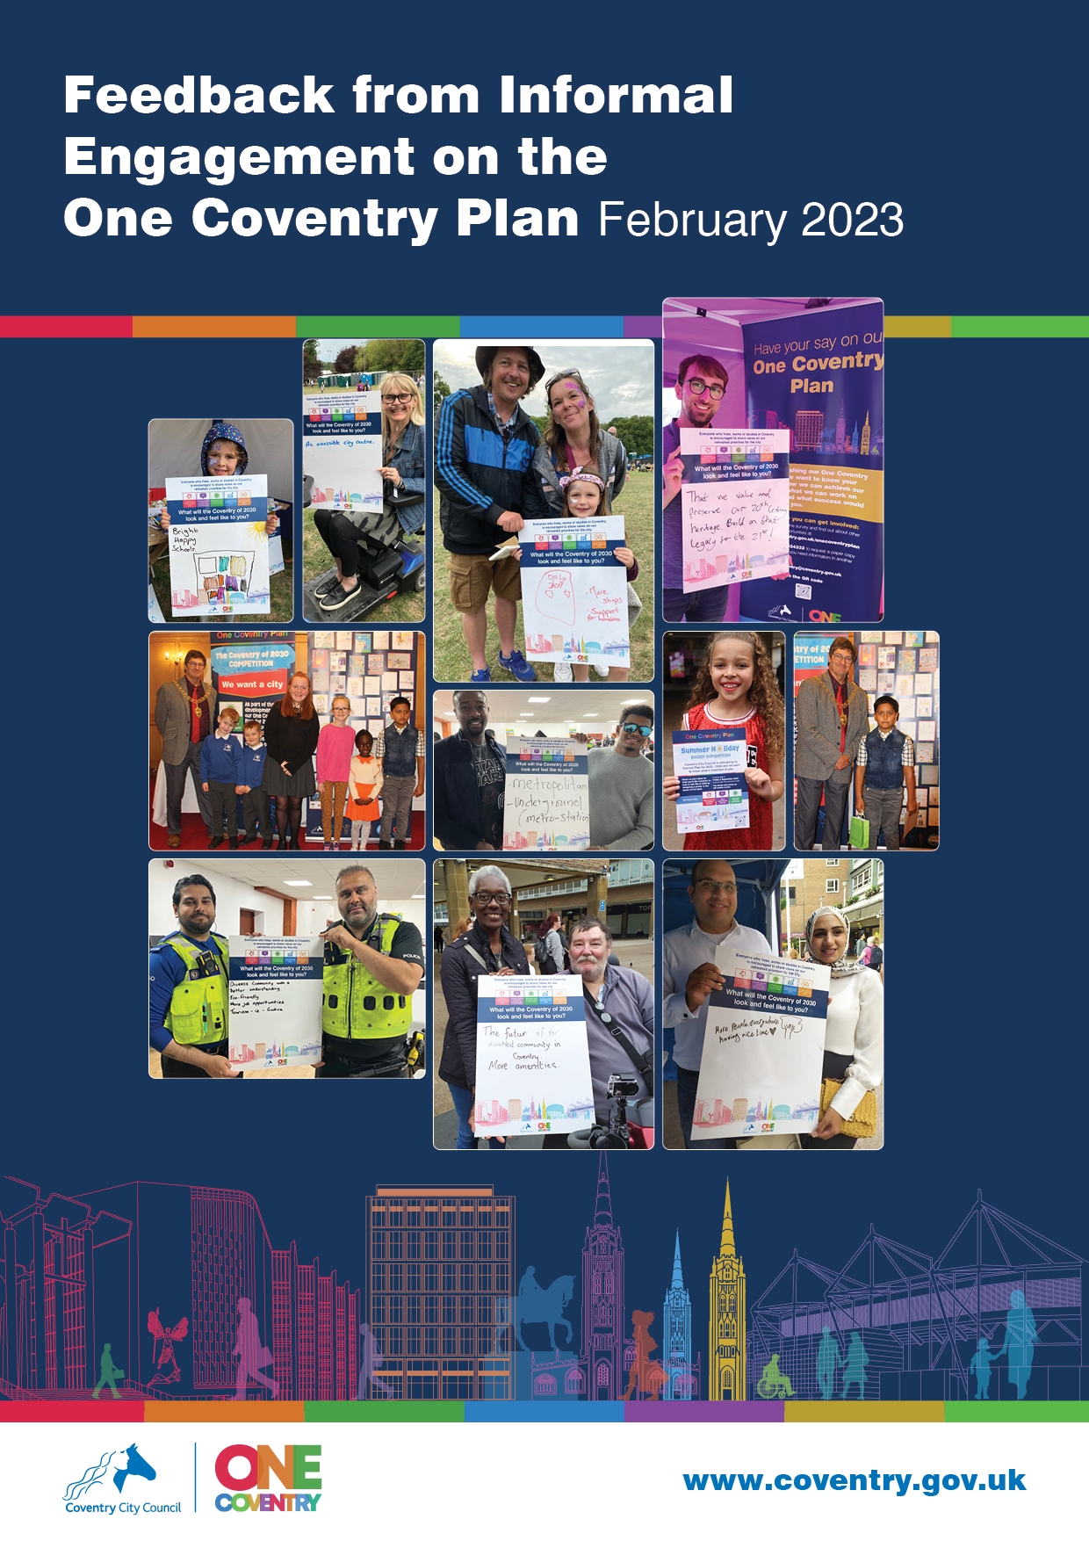

Contents

Background 3

Overarching Themes 3

Transport and Commuting 4

Cultural Activities 5

Climate Change and Environment 6

City Centre 7

Activities for Young People 8

Innovation and Investment in the City 9

Inclusion and Diversity 10

Communication, Engagement and Collaboration 11

Promote the City More 12

Access to Services 13

Next Steps 14

## Background

This is a summary of feedback, gained via informal, in person, engagement sessions and through the use of white boards.

The informal engagement focused on posing the question **“If we are successful with delivering our priorities what could Coventry look and feel like to you”.**

Face to face engagement was carried out in the city centre, as well as at events such as Sports Fest and Godiva Festival, as well as other community events across the city. Specific events were attended such as Conversation Cafes and Rhyme Time sessions in various libraries. White boards were placed in all Family Hubs and Libraries across the city.

Feedback has also been included from a Strategy Carousel Event (7th July 2022). The Strategy Carousel was a drop in event where residents, partners and colleagues could talk to Council Officers, to find out more and ask questions about the One Coventry Plan and other key strategies being developed alongside it. Examples of some of the other strategies shared at the event included: Coventry Food, Economic Development, Equality Objectives, Skills, Transport and Urban Forestry.

The informal engagement sessions were mainly quick conversations with people rather than following a set structure as in the formal workshops, therefore the responses are much shorter statements.

Over 740 people were engaged through this activity.

## Overarching Themes

All of the feedback was considered and this identified common themes, as shown below:

## Title - Coventry in 2030. Image of the things you said are most important: -Transport and commuting -Cultural activities -Climate change and environment -City Centre -Activities for young people -Innovation and investment in the city -Inclusion and diversity -Communication, engagement and collaboration -Promote the city more -Access to services

For each of those themes identified above, a summary of feedback has been provided including examples of suggestions and a selection of quotations from the raw feedback received.

## Transport and Commuting

**Examples of the suggestions received for the theme ‘Transport and Commuting’:**

* Coventry should have
  + Reduced traffic in the city centre
  + More travel solutions such as trams/cycleways
  + Improved and affordable public transport
  + More promotion and encouragement to use other forms of transport
  + Better road repairs

**A selection of quotations received from raw feedback relating to the theme ‘Transport and Commuting’:**

*“Only (electric) buses and taxis in the centre…less traffic more greenspace”*

*“Pedestrian and cycling friendly/safe”*

*“Create better transport links with Birmingham – could we have a tram joining the two cities?”*

*“The city centre has shown a lot of improvement over the last 10 years what needs to be sorted is the ring road and it’s strangle hold on the city centre – people are too frightened to drive into Coventry because of it”*

*“More shared decision making with communities, sustainable mobility/policy transport Protect wildlife and big mature trees - more efficient public transport - less cars on the road”*

*“Reliable public transport. I agree with the priorities. The Council is talking to people and helping people”*

*“Bus routes and timing mean people cannot accept some work - not using bus impacts pollution”*

*“Better public transport (inc park and ride)”*

*“Too many cars - improve public transport provision. Cycle lanes are good but need to encourage uptake.”*

*“Do proper repairs on roads - these temporary repairs don't last.”*

## Cultural Activities

**Examples of the suggestions received for the theme ‘Cultural Activities’:**

* Coventry needs
  + More entertainment
  + To make better use of its history
  + To build on the legacy from City of Culture
  + To hold more events that celebrate Coventry’s culture

**A selection of quotations received from raw feedback relating to the theme ‘Cultural Activities’:**

*“Live music and cultural venues”*

*“Historic sites - make sure accessible for all and we promote it well to encourage tourism”*

*“Wanted the Council to promote arts and culture for all taste”*

*“Essential to keep the buzz from the city of culture and keep Godiva festival”*

*“We will have continued with the legacy of #COC21 and visitors will come and enjoy our history, heritage, Culture!!”*

*“Coventry will be a modern progressive city that takes into account the concern for the presentation of history and historical value.”*

*“Showcase Heritage”*

*“More events that celebrate Cov.”*

*“More cultural events – affordable”*

*“More cultural events - bring Assembly Gardens back, pop up events in parks. More immersive experience e.g., Art Galleries. Carry on legacy of City of Culture”*

*“2 tone history - changed culture by putting black and white on stage together - this caused a decline in racism and fostered better cultural tolerance - we were the first city brave enough to do this and we need to celebrate and make more of this.”*

## Climate Change and Environment

**Examples of the suggestions received for the theme ‘Climate Change and Environment’:**

* Coventry should
  + Be cleaner
  + Be greener
  + Have less traffic
  + Have more cycle lanes
  + Have more trees/plants
  + Have improved recycling facilities
  + Have a more attractive city centre
  + Involve the community to become “eco champions”/ grow food
  + Better facilities in parks
  + Have more family friendly spaces/ places to sit in the city centre
  + Stop building on the greenbelt

The overwhelming majority of responses focused on the need for Coventry to become a “greener city” and a “tidier/cleaner” city.

**A selection of quotations received from raw feedback relating to the theme ‘Climate Change and the Environment’:**

*“Clean city of Coventry - littering is the main issue. to build the economy and green city. The city should start from a clean platform”.*

*“Less traffic more greenspace”*

*“More Green Spaces, wildlife corridors – wildflowers”*

*“More pocket parks and car free areas for people to enjoy PLANT TREES!”*

*“Improved recycling facilities i.e. electrical goods and non standard”*

*“Eco champions in our community”*

*“More green spaces - Family friendly city - Electric recycling points”*

*“More cycle lanes. Put them all over the city”*

*“More green areas. more fountains to play in. more accessible spaces!”*

*“Cleaner air, less litter. Getting more people into the city”*

*“Tramline - improve air - bring Assembly Gardens back * pop up events in parks *”*

*“Communities who work together and see everyone as an extension of their family. Planting trees & flowers, community plots for growing vegetables. sustainable energy.”*

*“More trees & wild spaces - spaces for other species much less concrete”*

## City Centre

**Examples of the suggestions received for the theme ‘City Centre’:**

* The city centre needs
  + More independent shops/wider range of shops
  + More family friendly/leisure spaces
  + To feel safer
  + To be cleaner/tidier
  + To feel more vibrant
  + More seating areas
  + The return of the Assembly Gardens
  + Better accessibility

**A selection of quotations received from raw feedback relating to the theme ‘City Centre’:**

*“Boutique shops and cafes & wider pedestrian zones”*

*“Independent shops + vibrant centre”*

*“Safe & attractive nightlife with a range of bars and restaurants”*

*“Improved shopping offer in City Centre - looking forward to City Centre South”*

*“Likes what 's happened in the city centre (public realm)”*

*“Pop up exhibition spaces for local artists (e.g., Empty shop units) - better retail offer”*

*“The city centre is nicer now it's car free - also the water features in the precinct”.*

*“More attractive city centre- cleaner streets”*

*“Improved retail offer. More affordable places to eat.”*

*“More attractive city centre- cleaner streets, more recycling bins and places to sit”*

*“The return of Assembly Festival gardens. More green areas. Coventry Positive vibe.”*

*“Shops to be filled in City centre. Accessible pavements for wheelchairs. Better access over Ring Road to City”.*

*“A decent Hotel in the City Centre - in prime position - we need to have events and do something on that square.”*

*“More family spaces in City centre”*

## Activities for Young People

**Examples of the suggestions received for the theme ‘Activities for Young People’:**

* Coventry needs
  + More family friendly spaces
  + More youth clubs/Summer clubs
  + Better sports equipment in parks
  + More activities in the city centre for young people

**A selection of quotations received from raw feedback relating to the theme ‘Activities for Young People’:**

*“More family friendly activity space for events”*

*“More spaces for children to play (suitable for young and older children)”*

*“More activities and things to do for children”*

*“More youth centres to help tackle crime”*

*“More youth clubs and constructive things for people to do”*

*“Summer activities for teenagers 14 – 16”*

*“Better play park equipment. things like basketball courts that are there fixed”.*

*“More opportunities for girls football + funding to help clubs grow”*

*“Activities for children to do in the city centre”*

*“More safe spaces for teenagers!”*

*“More kid friendly, cheaper swimming pools.”*

*“Giving skills to young people, places to go and things for everyone.”*

## Innovation and Investment in the City

**Examples of the suggestions received for the theme ‘Innovation and Investment in the City’:**

* Coventry needs to
  + Encourage investment
  + Make better use of its buildings/infrastructure
  + Support community sector
  + Encourage more job creation

**A selection of quotations received from raw feedback relating to the theme ‘Innovation and Investment in the City’:**

*“A city continuing to grow and be attractive to future investors”*

*“More independent businesses are needed. The Council could do something to support the independent businesses with rent and business rates”*

*“More diversity, more businesses, nicer architecture”*

*“Need to diversify and not focus on one industry only e/g/ cars, students. Think about the future - need to focus on technology changes etc. to keep up. Don't put economic eggs in one basket.”*

*“A city that empowers all people to aspire and achieve their potential”*

*“Expand the river”*

*“Encourage the use of community centres and provide support for communities who want to set up local initiatives”*

*“Jobs that keep ex-students & families here.”*

*“No poverty, well paid jobs, people valued for a variety of skills”*

## Inclusion and Diversity

**Examples of the suggestions received for the theme ‘Inclusion and Diversity:**

* Coventry needs to
  + Continue being inclusive
  + Embrace diversity
  + Become more accessible
  + Promote more activities for all
  + Think about digital inclusion

**A selection of quotations received from raw feedback relating to the theme ‘Inclusion and Diversity’:**

*“Inclusive celebrating our diverse, brilliant city”*

*“Coventry 2030 should be inclusive, respectful to all ages and abilities”*

*“More diversity & representation”*

*“Coventry will be multi-cultural and hopefully no racism”.*

*“More languages taught from young age - primary school”*

*“Peaceful, safe with communities working together with less inequality”*

*“Kerbs are not always low enough - even the dropped kerbs - could do simple things to allow access - a little thought could make a difference”*

*“Make access and being able to go out for those with disabilities – like changing facilities”*

*“Autism/ neurodivergent friendly”*

*“More social activities for older people but not stereotypical activities like knitting”*

*“Digital inclusion is a barrier - lack of digital presence/ ability is huge”*

*“Communication needs to consider everyone - not just online, send letters/ leaflets as well (if you are not online you feel excluded)”*

## Communication, Engagement and Collaboration

**Examples of the suggestions received for the theme ‘Communication, Engagement and Collaboration’:**

* Coventry needs more
  + Resident/community engagement
  + Community spirit
  + Inter departmental working
  + Transparency
  + Partnership working
  + Communities working together
  + Inclusive communications
  + Community hubs/one stop shops

**A selection of quotations received from raw feedback relating to the theme ‘Communication, Engagement and Collaboration’:**

*“Community engagement is key”*

*“People’s views are listened to and considered”*

*“Proper meaningful early consultation before a decision is made … More shared decision making with communities”*

*“More community spirit and care, less prejudice and hate”*

*“Need to help people work together as a council with local residents and their ideas, a great example is Motofest – Council doesn’t have to lead or provide funding always it can help with social media promotion or advice etc”*

*“Engage with schools to make better use of resources”.*

*“Accountable …Collaborative department working…Partnership Working…Transparency…Collaborative”*

*“More activities and things to do for children - community groups working together - improve the local area.”*

*“Empowering others to help themselves to be the change they want to see in the world”*

*“Communication needs to consider everyone - not just online, send letters/ leaflets as well (if you are not online you feel excluded)”*

*“Hubs that provide information placed in the community, possibly in libraries”*

## Promote the City More

**Examples of the suggestions received for the theme ‘Promote the City More’:**

* Coventry needs to
  + Become more vibrant
  + Be a city that people are proud to be from
  + Become a sustainable city
  + Be proud of its diversity
  + Become a tourist destination
  + Have a better night-time economy
  + Stay as it is, great city

**A selection of quotations received from raw feedback relating to the theme ‘Promote the City More’:**

*“A vibrant and sustainable city where everyone feels supported”*

*“Fresh + vibrant A city to be proud of! A city continuing to grow and be attractive to future investors”*

*“A place where everyone wants to be!”*

*“A diverse and prosperous city, who are proud of our culture. Where difference is valued and focused on, creating the best for the residents of Coventry”*

*“A place with art and culture around every corner and available to every visitor and resident of Coventry. it's on the map as an international cultural destination - championing arts for all”*

*“More people enjoying all that Coventry does. Access for all”*

*“Friendly, safe and welcoming. A destination City.”*

*“Happy with Coventry, great hospital and good education for children already”.*

*“Love Coventry as it is. Chose to study here”*

*“Love Coventry as it is”*

*“It’s a great city much better over the last 20 years. I love Broadgate and the fountains in the town”*

## Access to Services

**Examples of the suggestions received for the theme ‘Access to Services’:**

* Coventry needs
  + More joined up services
  + More information/advice services
  + More support for SEND (Special Educational Needs and Disability)
  + Better access to healthcare services
  + Better toilet facilities

**A selection of quotations received from raw feedback relating to the theme ‘Access to Services’:**

*“Inclusive and joined up services”*

*“Help and support for people who need it.”*

*“Libraries, community centres, advice groups support - safe spaces.”*

*“Better out of hours service -what happens when people need support, and the council is closed?”*

*“Youth Centres and Libraries, life services”*

*“More financial support for working families”*

*“Need more activities for older people like dancing”*

*“More SEN Special schools for non-learning delay but a spikey profile”*

*“More wrap around care support i.e. before/after school, school holidays for SEND children so parent/ carer can work”*

*“More SEND school holiday activities. More SEND college/ higher education opportunities. Jobs for SEND Adults. Transport for wheelchair users. /Access”*

*“Health services that are accessible, concerns about getting appointments with the GP”*

*“Public Toilets - should be open later especially parks and family areas”*

*“Adult changing facilities”*

## Next Steps

The engagement has been really valuable and will influence and play a vital role in defining how we deliver the One Coventry Plan going forward. The feedback has been shared with relevant service areas and partners to inform future strategies and service delivery.

To find out more about how we are responding to your views see the Cabinet report for One Coventry Plan 2022-2030.

Further updates will also be shared on Let’s Talk Coventry and on the Council’s website.

