.

**PO App – User guide**

April 2022

.

.

.

.

.

.

.

.

.

.

.

.

.

.

.

.

.

.

.

.

.

.

.

.

.

.

.

.

.

.

.

.

.

.

.

.

.

.

.

.

.

.

.

.

.

.

.

.

.

.

.

.

.

.

.

.

.

.

.

.

.

.

.

.

.

.

.

.

.

.

|  |  |
| --- | --- |
| Document Owner: | |
| Name: | Business Unit (BU): |
| Electoral Services | Electoral Services |

|  |  |
| --- | --- |
| Approved Author(s)/Editor(s): | |
| Name/Group: | Business Unit (BU): |
| Liz Read | Electoral Services |
| Sharon Taylor | Electoral Services |
|  |  |

|  |  |
| --- | --- |
| Approved Distribution: | |
| Name/Group: | Business Unit (BU): |
| Presiding Officers | Electoral Services |
| Polling Station Inspectors | Electoral Services |
|  |  |

|  |  |  |  |  |
| --- | --- | --- | --- | --- |
| Document Control: | | | | |
| **Version:** | **Author:** | **Date:** | **Comments:** | **Status:** |
| 1 | Sharon Taylor | 14/04/22 |  |  |
|  |  |  |  |  |
|  |  |  |  |  |

MEA PO App – Overview

The Mobile Election Application (MEA) includes an application that can be used by Presiding Officers on Election Day called the PO App. To be able to use the PO App the presiding officer must have an active MEA account.

Completion of the PO App is an **essential** part of the role of the Presiding Officer and must be completed throughout the day. It is used to provide reports to Senior Management and the Returning Officer on when the polling stations are open, turn out to the locations, any reports of incidents and also when the polling station is shut.

The PO app can be used on any device that is portable and has a connection with the internet. It is an essential requirement for the role of the Presiding Officer that they have a device that they will use the provide this data throughout polling day. Please ensure that your device is fully charged and that you also carry your charger.

As information is entered and submitted, the Election Office can view the activity taking place at the polling station. The following information can be recorded and submitted:

1. when the station is opened and closed
2. hourly log of ballot paper issues
3. submission of ballot paper accounts at close of poll
4. log visitors to the station
5. record accidents
6. note any changes required to the register when notified by electors

### 

### Supported Browsers

Any device that is portable and has a connection to the internet can be used. The layout is fully responsive and will resize to fit the screen of the device being used. Please ensure the device is running a supported browser, these are:

**Desktop**: Chrome, Firefox, Edge (Chromium), Safari.

**Mobile**: IOS – Safari, IOS - Chrome, ISO – Firefox, Android – Chrome, Android – Firefox

Please note - it is important from a security and compatibility perspective that browsers are kept up to date.

**These browsers are NOT Supported and will not work with MEA**

Very old versions of browsers e.g. Edge from 2018 (now called Edge Legacy) or unsupported browsers e.g. Internet Explorer.

Viewing the PO App on and prior to Election Day

When the Election Office have activated the PO App and the presiding officer has an active MEA account and has accepted the presiding officer role, the PO App will be visible to the presiding officer. This allows the presiding officer to familiarise themselves with the screens they will be using on election day.

Sign into MEA and select the tile with the election name and date

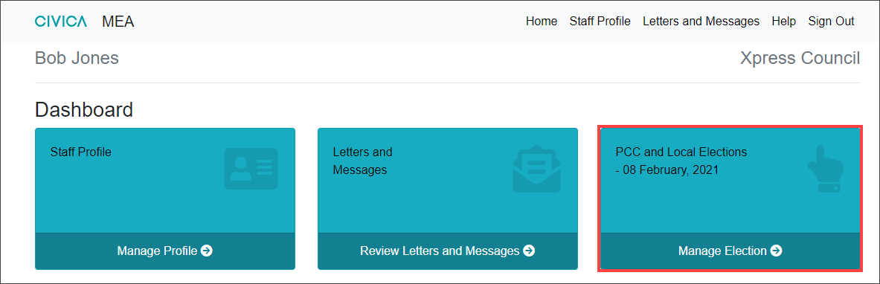

Select the **PO App tile**

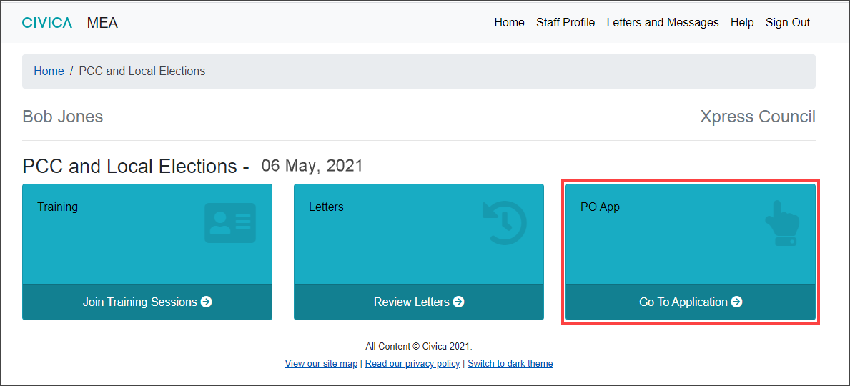

The six tiles that make up the PO App are displayed

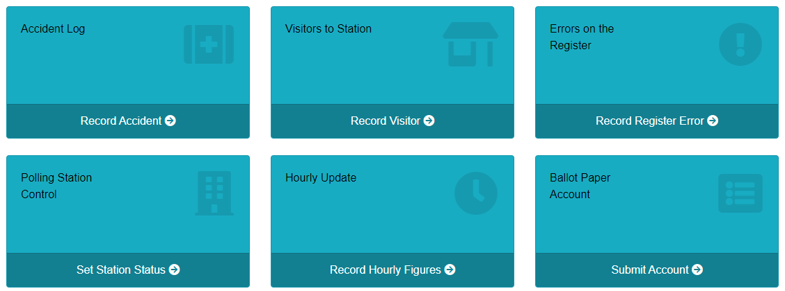

Each tile can be viewed but information can only be submitted on Election Day.

To move between tiles, use the back button or click into the breadcrumb trail shown at the top of the screen to return to the six tiles of the PO App.

PO App - Polling Station Control – ESSENTIAL TASK

Presiding officers MUST confirm that they have arrived at the polling station and again when the Polling Station is open using the **Polling Station Control tile**.

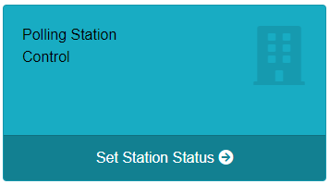

If the screen is being viewed prior to polling day, a banner will show that the page can only be submitted on Election Day.

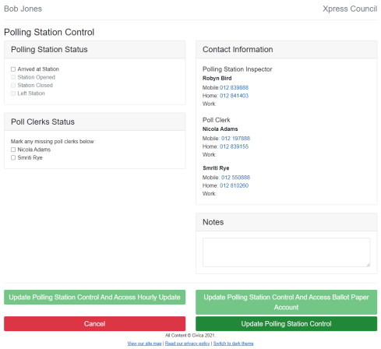The screen provides contact information for the Polling Station’s Inspector (PSI) and the Poll Clerks who will be working at the station.

When viewing from a tablet or smart phone, the telephone numbers displayed can be selected to dial direct.

### 

### Polling Station Status – ESSENTIAL

The Polling Station Status area is used to record the current status of the polling station.

When the Presiding Officer arrives at the **Arrived at Station** box can be ticked

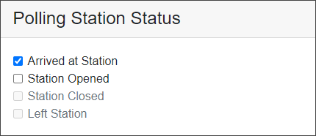

Then select the **Update Polling Station Control** option which will update the system that the Presiding officer has arrived, the elections team can then see tis.



The Presiding Officer will repeat this action for the Station Opened option to inform when the station is opened.

### Poll Clerk Status - ESSENTIAL

The presiding officer can access telephone details for polling staff and log if they have NOT arrived. Please only do this after **7am,** otherwise we may start to look to fill the role.

If a Poll Clerk hasn’t arrived, the presiding officer can log this using the ‘Poll Clerks Status’ section on the left-hand side and ticking the box next to the missing person’s name.

Then select **Update Polling Station Control** to save the information and the Election Office will be notified.

This is **really important** as we need to know if Poll Clerks have not arrived by the start of poll as we will need to withhold pay and find you a replacement.

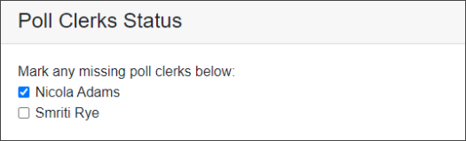

If the Poll Clerk arrives later, the tick can be removed. Then select **Update Polling Station Control** to save the updated information and inform the Elections Office.

### Contact Information

The Contact Information area will show the telephone contact details for the Polling Station Inspector and Poll Clerks that have been assigned to the station.

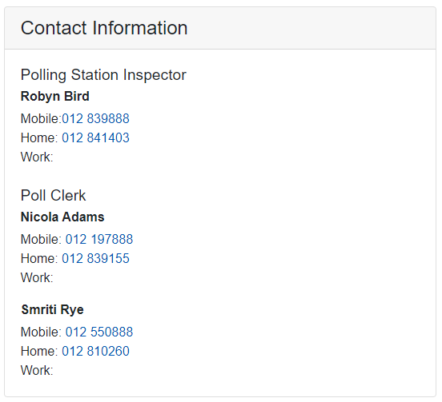

The contact information includes any mobile, home and work phone numbers recorded for these staff.

When viewing these details from a tablet or smart phone, the telephone numbers displayed can be selected to go straight to the calls application of the device being used.

A free type Notes area is available to record any additional information. The box can be extended by selecting the bottom right corner and dragging to extend the box.

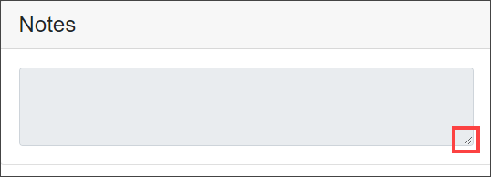

The options at the bottom of the screen are

**Update Polling station Control** – This will save any changes made and remain in the Polling Station Control tile

**Update Polling Station Control and Access Hourly Update** will save the changes and open the Hourly update tile.

**Update Polling Station Control and Access Ballot Paper Account** is used at the close of poll after the close station option has been selected.

**Cancel** – will close the screen and display the six tiles of the PO App.

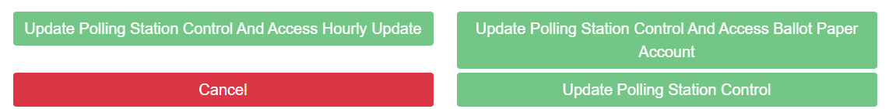

PO App - Hourly Update

The Hourly Update is used to record the handing out of ballot papers over Election day.

Presiding Officers MUST submit hourly updates as these are used by the Electoral Services Office to inform senior management and the Returning Officer on turnout.

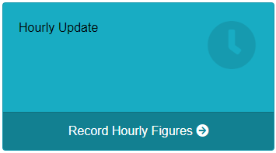Access the Hourly Update screen from the **PO App** tile and then select the **Hourly Update** tile. Alternatively, when the Polling station status is being submitted as open use the **Update Polling Station status and Access Hourly Update** option to go directly to the hourly update page.

### Completing the Hourly Update for split stations

For a split station the ballot papers issued figure will need to be calculated manually.

1. In this instance, enter a 0 into the Next Ordinary Ballot Paper Number to be issued
2. In the **Number of Ordinary Ballot Papers Issued** box, manually enter the actual number of ballot papers entered
3. **Select Submit Hourly Update**

### Record an Hourly Update

The screen will show a tab for the election being held that day.

Underneath is a table showing an hourly time slot for each hour the polling station will be open. The present hour of the election will be highlighted in grey.

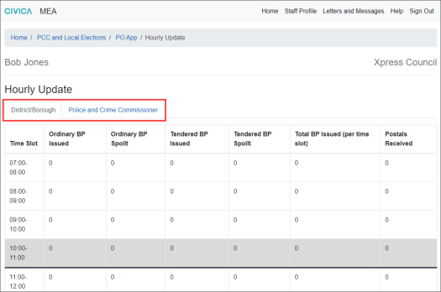

At the bottom of the screen is the area where the ballot paper numbers are entered.

At the top of this area, the election tab that has been selected and the current hourly update time is displayed. This is useful to check before entering information.

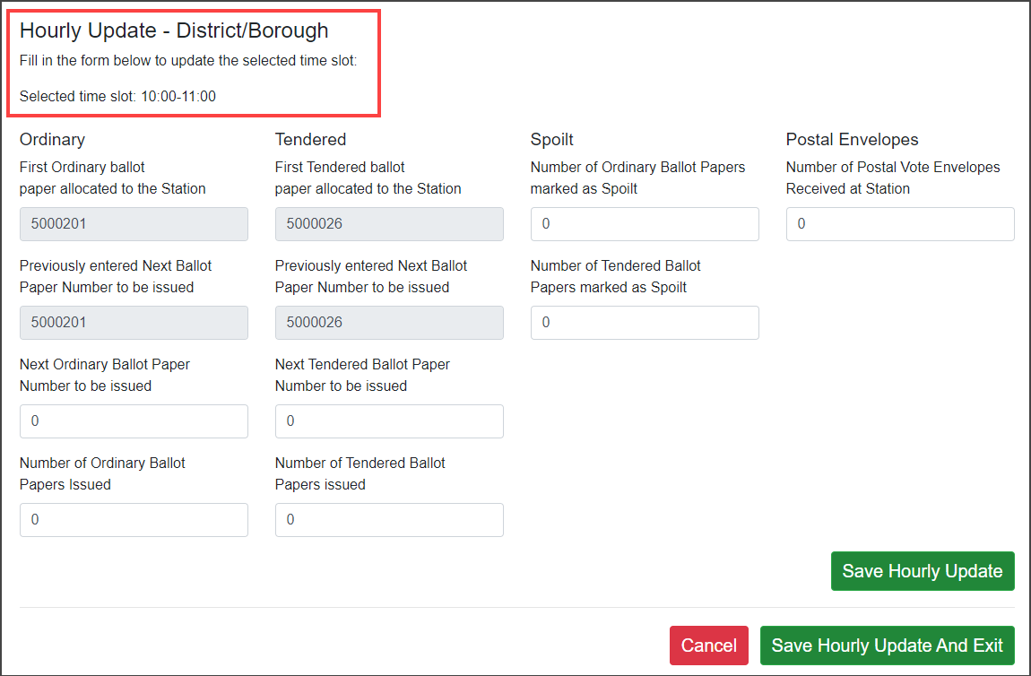

### Completing the current Hourly Update

### 

1. Select the Election tab and scroll to the bottom of the screen. At the top of this area you can check the correct election tab has been selected and the time slot will default to the current hour and is shown in red.

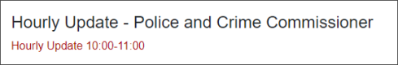

1. The boxes shaded in grey will automatically populate and information cannot be entered here. These boxes display:

* **Next Ordinary Ballot Paper to be issued box** - This is the number of the very first ballot paper to be issued at the polling station
* **Previously entered Next Ballot Paper Number to be issued**- After an update has been submitted, this box will show the next ballot paper to be issued after that update, this will be the last figure entered in the **Next Ordinary Ballot Paper Number to be Issued**

The same process is used for Tendered ballot papers.

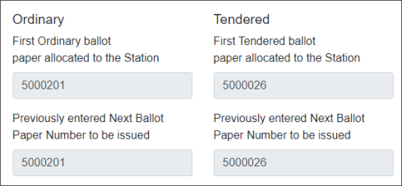

1. To submit an update, enter the next ballot paper number to be issued in the **Next Ordinary Ballot Paper to be issued box**. This will automatically calculate the number of ballot papers issued in the **Number of Ordinary Ballot Papers Issued** box.
2. **IF YOU HAVE CONTACTED THE ELECTIONS OFFICE FOR APPROVAL** and tendered ballot papers have been issued, enter the next tendered ballot paper number to be issued in the **Next Tendered Ballot Paper to be issued box**. This will automatically calculate the number of Tendered ballot papers issued in the **Number of Tendered Ballot Papers Issued** box.

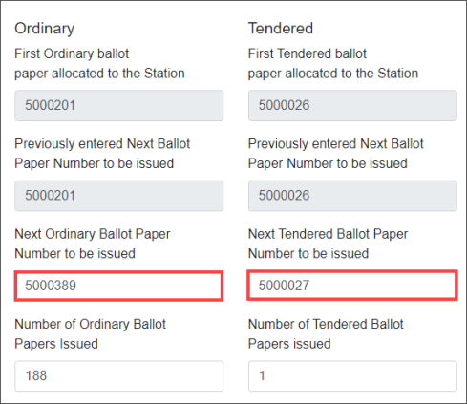

1. If any ballot papers have been spoilt, enter the figures in the relevant spoilt box.

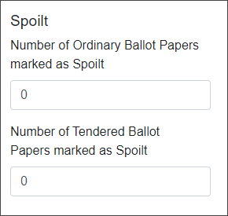

1. The number of any absent votes handed into the Polling Station during that hour is entered into the Number of Postal Vote Envelopes Received at Station box

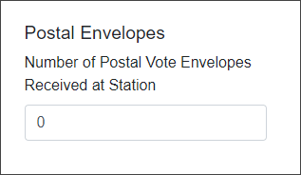

1. Select **Save Hourly Update** or **Save Hourly Update and Exit** to return to the PO App tiles.

A confirmation message appears at the top of the screen and the information submitted will be available to view in Management.

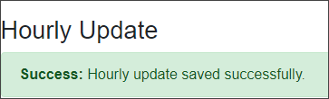

1. As hourly entries are made, and the updates are saved they will show in the table.

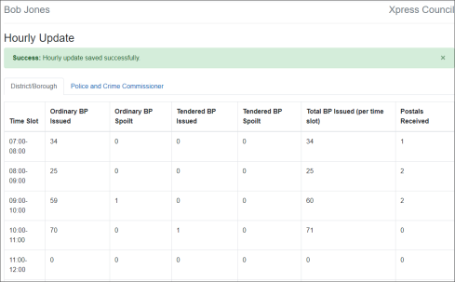

### 

### Completing or amending the Hourly Update for an earlier Time Slot

If an update was missed for an earlier time slot, this can be entered by selecting the relevant Time Slot in the table and then adding the next ballot paper that would have been issued at the end of the time slot into the **Next Ordinary Ballot Paper to be issued box**.

Click **Submit Hourly Update** to save and send the revised entry to the Elections Office.

If an amendment is required to an earlier entry, select the time slot, and correct the information as required.

### Accidentally Issuing Ballot Papers out of order

If ballot papers have accidentally been issued out of order and entering the number of the next ballot paper to be issued would give an incorrect result.

1. In this instance, enter a 0 into the **Next Ordinary Ballot Paper Number to be issued**
2. In the **Number of Ordinary Ballot Papers Issued** box, manually enter the actual number of ballot papers entered
3. **Select Submit Hourly Update**

PO App - Station visit recording

During Polling day, Presiding Officers can record visits made to the station by different agencies, for example police officers, accredited observers, Election Agents and Polling Agents.

To access the Visitors to Station screen from the Presiding officer MEA account, select relevant Election tile, and then the **PO App** tile and then select the **Visitors to Station** tile.

Please refer to the list of Polling/Election Agents and Candidates and your training to ensure that they are allowed to enter.

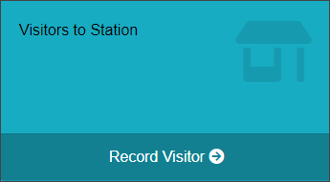

### 

### Log a station visit

1. The Visitors to Station screen will open.

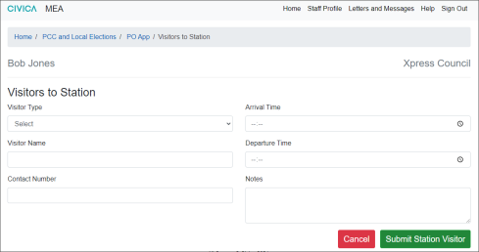

1. In the **Visitor Type** box use the drop-down arrow to show a list of visitor types

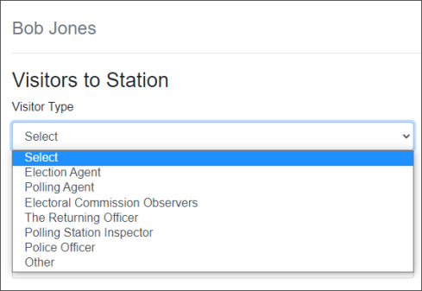

1. Select the visitor type and complete the details of the visitor. If the visitor is a Police officer, their Badge Number can be entered.

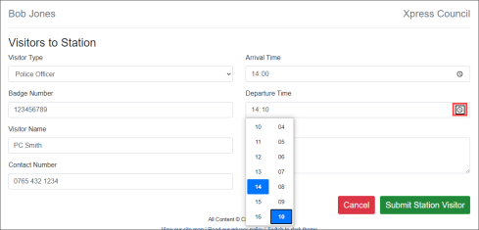

1. To record the time of Arrival and Departure, either manually type in the hour and minutes using 24-hour clock format or alternatively, use the Clock Icon and select the hour and minutes by sliding the hours column and select the relevant time, then slide and select the minutes in the minutes column.
2. Add any further information about the visit in the **Notes** area.
3. Press **Submit Station Visitor** to save the details of the visit. A confirmation will appear at the top of the screen.



1. Repeat these actions for all visitors.

Accident Log –

ENSURE THAT THIS IS COMMUNICATED TO YOUR PSI IMMEDIATELY

During polling day, the Presiding Officer can record details of any accidents that occur in or around the polling station.

To access the Accident Log, the Presiding Officer MEA account, select relevant Election tile, and then the **PO App** tile and then select the **Accident Log** tile.

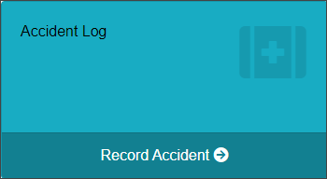

Recording details of an Accident

1. Select the **Accident Log** tile from the **PO App**.
2. The Accident Log screen opens.

Fill in the details of the accident in the form, included the person injured and any witnesses.

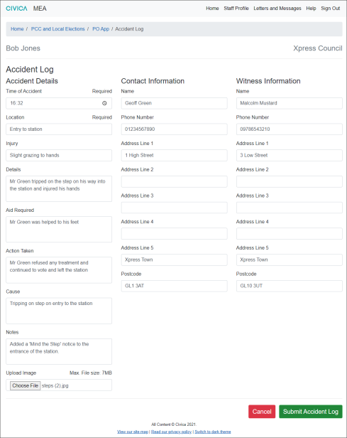

1. An Image can be uploaded if appropriate. Select the **Choose File** option and select the image saved on your device to upload it.
2. Once all the details have been logged, select **Submit Accident Log** to save and send the information to the Elections Office.

A message will appear at the top of the screen to confirm the Accident log has been saved.



Errors on the Register

During the course of polling day, the Presiding Officer can detail any register errors that become apparent on Election Day. For example: a spelling mistake on the elector’s name or that someone has changed their name. This will then be followed up by the Elections team at a later date

Access the **Errors on Register** area from the **PO App** tile and then select the **Errors on Register** tile.

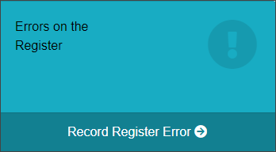

### Recording Errors on the Register

1. Select the **Errors of Register** tile from the **PO App**.
2. The Errors on Register Screen will open. Fill in the details of the elector and the error and their contact details in case the Elections Office need to contact them.

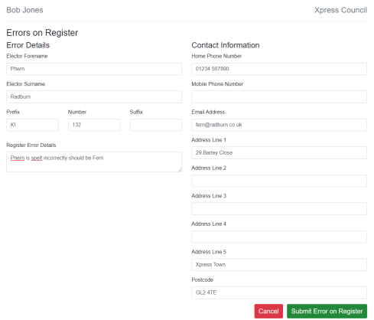

1. Select the **Submit Error on Register** to save the information and send to the Elections Office. A confirmation message will appear at the top of the screen.



PO App - Completing the ballot paper account and leaving the station – ESSENTIAL TASK

At the close of poll, the Presiding Officer will log that the station is closed and submit the Ballot Paper Account.

The Ballot Paper Account will calculate from the hourly updates. It is essential that these have been completed.

The ballot paper Account can be accessed from the Ballot paper Account tile or from the Polling Station Control tile after the Station Closed box has been selected.

### 

### Step 1 - Close the Station

1. Go to the **Polling Station Control** tile.

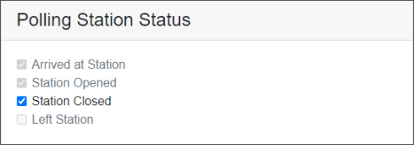

1. In the Polling Station Status area check the Station Closed box
2. Select **Update Polling Station Control and Access Ballot Paper Account** to save the details and go straight to the Ballot Paper Account Screen.

### 

### Step 2 - Submit the Ballot Paper Account

Choose the correct option if hourly ballot paper updates were completed or not.

**Presiding Officer has completed the hourly updates**

The figures will be populated in the Ballot Paper Account. The Presiding Officer can review these figures and manually adjust them where required. The white boxes can be manually adjusted.

**Presiding Officer has not completed the hourly updates or only part completed or issued ballot papers out of order. This should only be used if there has been a problem and this has been reported your PSI/Elections Office.**

The final information can be manually entered into Ballot Paper Account. The Next Ordinary and Next Tendered Ballot paper issued boxes do not need to be completed. The Total Issued and Total Spoilt can be added or updated manually.

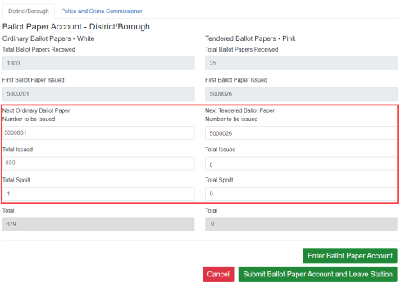

1. When the Ballot Paper Account has been completed, select **Enter Ballot Paper Account** to save. A message will appear at the top of the screen to confirm the Ballot Paper Account has been saved.



Although, the information has been saved it can still be changed and saved again if required.

1. When all Ballot Paper Accounts are complete and correct, select the **Submit Ballot Paper Account and Leave Station** option.
2. A message will display to check if you want to continue with the action and that it cannot be undone. Select **Yes** if you want to submit, selecting No will allow you to check the information again.

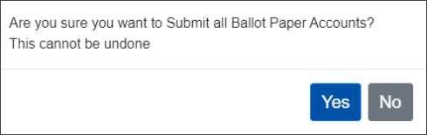

1. Once submitted the **Left Station** box is automatically ticked that you have left the station and the Ballot Paper Account is submitted to the Elections Office.

### 

### Errors on submission of ballot paper accounts

If a ballot paper account has not been completed on selecting the **Enter Ballot Paper Account** a message will appear at the top of the screen advising that it has not saved, and the screen will indicate where the information is missing.

Complete the missing information and select the **Enter Ballot Paper Account** to save the ballot paper account.

In the example below the Ballot paper account for the District/Borough has been saved but the PCC election has not been saved because the boxes that are highlighted in red have not been completed.

In this instance the information would need to be entered and then the **Submit Ballot Paper Account and Leave Station** option would be taken as the ballot paper accounts for both elections have been completed.

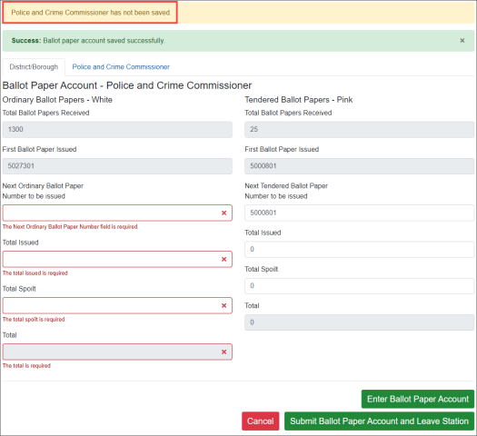

PO and PSI App - Offline Mode

Offline mode is an optional setting which will give PO and PSI App users the chance to save a page of data whilst being offline. Should internet connectivity at their polling station drop, an attempt will be made to cache the last saved information.

You will be notified on-screen when offline mode is active, see red banner below. Where an MEA User knows that they will be visiting a polling station with intermittent internet connectivity, we recommend that they manually disconnect from the wi-fi in order to complete the page of data. This is to avoid the following scenario, using a PSI as an example; the PSI is halfway through completing a polling station checklist and on losing connection, loses checked items off of the list because it’s the last saved information that is cached.

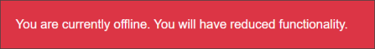

If for any reason the information is not cached, a message will inform you on screen.

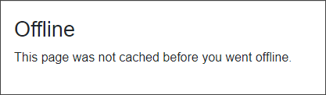

There are various limitations of use due to the last saved information being cached, so as a general rule the MEA user can save one page of data, for example, one Accident Log, or one Hourly Update entry without experiencing a loss of functionality.

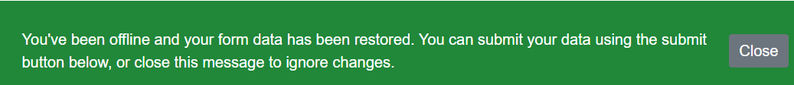

For security, any data saved in the browser cache will be lost when the browser or browser tab is closed. If the MEA user has saved data and internet connectivity is restored, the data will be restored automatically from the cache into the page and they will have the opportunity to commit this data to MEA or ignore to remove the data permanently from the cache. They will also be free to make any changes to this data before committing to MEA.

Copyright Notice:

The content of this document is protected by copyright © Civica UK Limited 2022. All rights reserved.

You may not copy or replicate including extracts of it without Civica’s written consent. You must not sell, share, copy or republish this document.

Copying of this document in any form is prohibited.

If you want further copies of this document, please make a request to the author shown on the front page.