 +

**PSI App - User guide**

April 2022

|  |  |
| --- | --- |
| Document Owner: | |
| Name: | Business Unit (BU): |
| D Pybus | Democracy & Engagement |
| Electoral Services | Electoral Services |

|  |  |
| --- | --- |
| Approved Author(s)/Editor(s): | |
| Name/Group: | Business Unit (BU): |
| D Pybus | Democracy & Engagement |
| Liz Read | Electoral Services |
| Sharon Taylor | Electoral Services |

|  |  |
| --- | --- |
| Approved Distribution: | |
| Name/Group: | Business Unit (BU): |
| D Pybus | Democracy & Engagement |
| Electoral Services | Electoral Services |
|  |  |

|  |  |  |  |  |
| --- | --- | --- | --- | --- |
| Document Control: | | | | |
| **Version:** | **Author:** | **Date:** | **Comments:** | **Status:** |
| 1 | D Pybus | 16/04/21 | Original version |  |
| 2 | Sharon Taylor | 14/04/2022 | Updated as Coventry City Council version | For distribution |
|  |  |  |  |  |

Contents

MEA PSI App - Overview 4

Accessing the PSI App 5

General Checklist tile 6

Further information 8

Number of Visits 9

Viewing the checklists before polling day 9

Recording visits on polling Day 10

PO and PSI App - Offline Mode 13

Copyright Notice: 14

MEA PSI App - Overview

The PSI App is used by polling station inspectors (PSI) to record their polling station visits during Election Day using a smart phone or tablet. Information recorded during the visits can be submitted and viewed at the Election Office and be reported back to Senior Management and the Returning Officer.

To be able to use the PSI app the PSI must have an active MEA account.

Completion of the PSI App is an essential part of the role of the PSI and can be used on any device that is portable and has a connection with the internet. The layout is fully responsive and will resize to match the screen size of the device being used.

As information is entered and submitted, the Election Office can view the information submitted by the PSI. The following information can be submitted:

* Checklist for each polling station
* Collection of postal votes
* Number of visits made

**Supported Browsers**

Any device that is portable and has a connection to the internet can be used. Please ensure the device is running a supported browser, these are:

**Desktop**: Chrome, Firefox, Edge (Chromium), Safari.

**Mobile**: IOS – Safari, IOS - Chrome, ISO – Firefox, Android – Chrome, Android – Firefox

Please note - it is important from a security and compatibility perspective that browsers are kept up to date.

**These browsers are NOT Supported and will not work with MEA**

Very old versions of browsers e.g. Edge from 2018 (now called Edge Legacy) or unsupported browsers e.g. Internet Explorer.

Accessing the PSI App

To access the PSI App, the PSI signs into their MEA account and selects the tile with the relevant election and date.

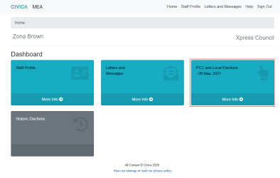

When the Elections Office have allocated the polling stations to the PSI the PSI App tile will be visible.

Select the **PSI App tile**

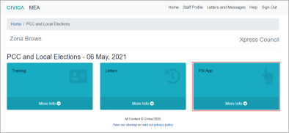

This opens the PSI App screen which has two tiles, the General Checklist and **Allocated Polling Stations**. These tiles can be viewed prior to Election Day allowing the PSI to familiarise themselves with the screens to be completed. 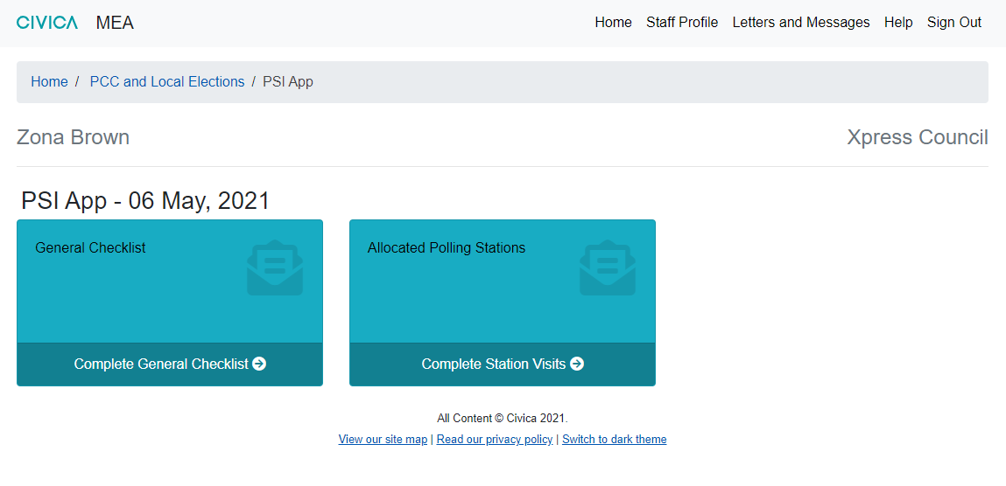

General Checklist tile

The General Checklist is a list of equipment and spares the PSI is required to take with them on their visits.

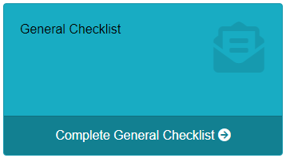

On opening the General Checklist tile a checklist appears showing the items the PSI will need.

**The Elections Office will create the list of equipment and spares required and this may vary from the example shown below.**

The PSI can access the list prior to the election and can tick off the items as received and press the Save General Checklist button to confirm the items are present, this can be repeated if some items are received later.

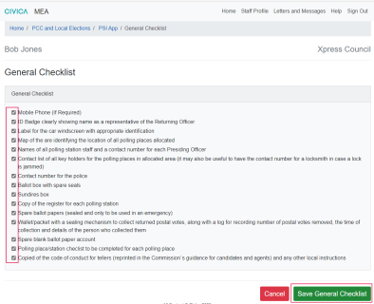

A note at the top of the Checklist confirms the General Checklist has been updated and the office can now view this.

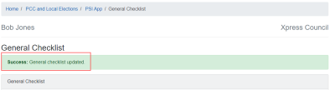

**Allocated Polling Stations tile**

This tile contains a list of the polling stations allocated to the PSI and is used to record the visits made during polling day. This area can be accessed before polling day to allow the PSI to plan their visits and familiarise themselves with the checks required.

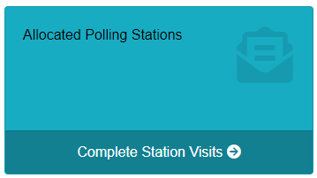

On opening the **Allocated Polling Stations** tile a list of the polling stations allocated to the PSI is displayed.

Depending on the number of polling stations allocated there may be more than one page. The areas highlighted in the screen shot show where:

* The number of entries shown per page can be adjusted in the area above the polling station list.
* The number of entries on screen and the page number is also indicated at the bottom of the screen.
* A search box is available to find stations quickly.

Each column can be sorted using the arrows in the column headings.

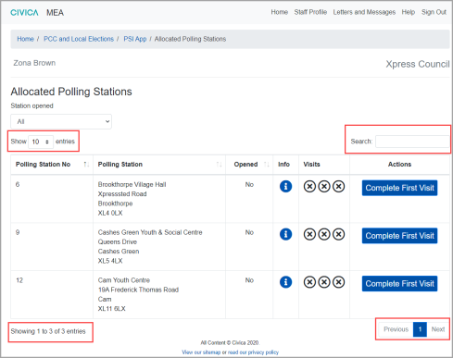

### Further information

The polling station number, name and address is available from the main screen.

Further information is available from the button in the Info column.

The polling station number is shown at the top. A list of blue headings is shown underneath click on each heading for further information.

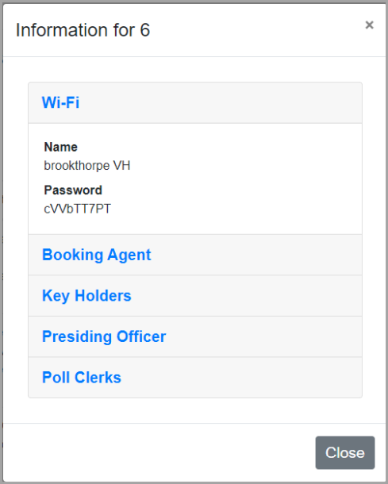If Wi-fi is available at the venue the name and password would be available under the Wi-Fi heading.

If contact is needed with the Booking Agent or Key Holders, click on the relevant option to display contact details.

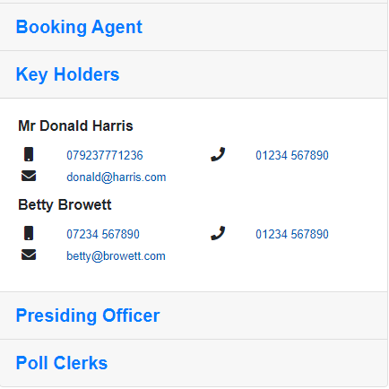If a smart phone or tablet is being used the telephone numbers and email address will be selectable for direct calling or emailing. Telephone details are available for the Presiding Officer and Poll Clerks assigned to the station.

Use the Close option to return to the main screen.

### Number of Visits

The number of visits required by PSIs is decided by the Elections Office. You are required to undertake 4 visits to each of your polling stations.

VISIT 1 – OPEN OF POLL

VISIT 2 – GENERAL CHECK

VISIT 3 – CHECK AND GO THROUGH CLOSE OF POLL WITH PO

VISIT 4 – COLLECT POSTAL VOTES THAT HAVE BEEN HANDED IN AT THE POLLING STATION

VISIT 5 – GENERAL CHECK

In the example below three visits are required, indicated by the three circles in the Visits column. These circles have a cross in them which shows no visits have been completed.

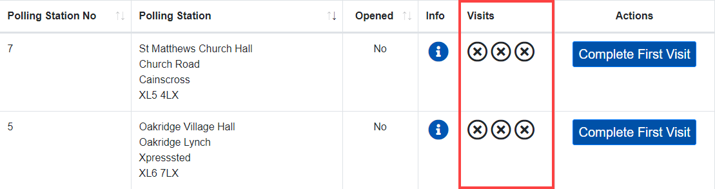

### Viewing the checklists before polling day

To view the checklists before Election Day, select the **Complete First Visit** option in the Actions column.

A banner will display to show that Information can only be saved on Election Day.

The checklist for Visit 1 will be open. If other Visits are required there will be a tab for each visit under the heading.

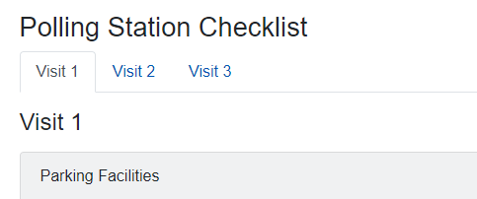

Click on each tab to view the checklist requirements for each visit

### Recording visits on polling Day

The PSI will open the PSI App and the Allocated Polling Station tile.

The PO App is being used by Presiding Officers, the Opened column will showwhich stations have been marked as opened by Presiding Officers. The Station opened drop down filter can be used to see; All stations, or Yes (just opened stations), or No (unopened stations). The PSI MUST contact or visit the unopened stations to check these first.

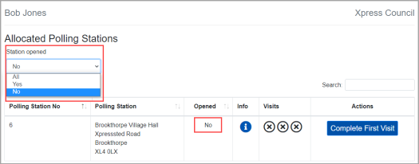

When the PSI arrives to complete the first visit at a polling station the **Complete First Visit** option is selected.

In the example shown on the next page a comprehensive checklist is to be completed for the first visit, the content of the checklist is decided by the Elections Office and may differ to the example shown.

The PSI completes the checklist for Visit 1 and adds any notes as required.

When complete, select the Submit Visit 1 option at the bottom of the screen to save and send the information to the Elections Office.

The information entered for Visit 1 can still be viewed but cannot be amended once it has been submitted.

The following image gives an example of how the visit screen may look.

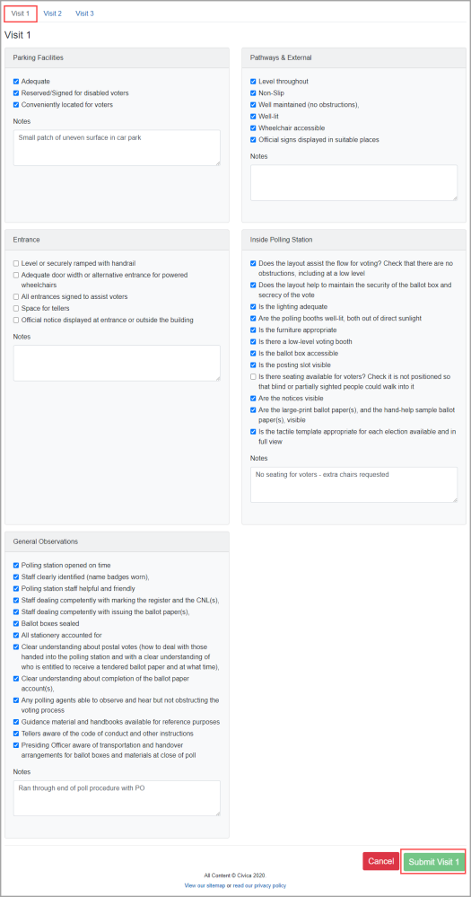

After the Submit Visit 1 option is selected, the main screen is displayed.

The first visit will now show as completed on the main screen, indicated by a circle with a tick.

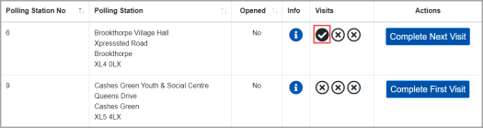

On returning to this station the PSI would press the Complete Next Visit option to open the Visit 2 screen.

The second, third and fourth visits are completed and the screen will then change to display Complete Last Visit

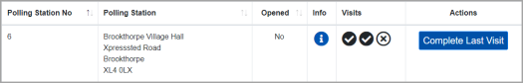

Once the last visit has been completed you can use the View Visits button to look back at the information submitted.

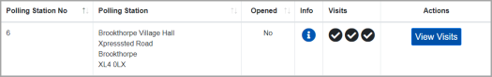

These actions would be repeated for each polling station allocated to the PSI.

PO and PSI App - Offline Mode

Offline mode is an optional setting which will give PO and PSI App users the chance to save a page of data whilst being offline. Should internet connectivity at their polling station drop, an attempt will be made to cache the last saved information.

You will be notified on-screen when offline mode is active, see red banner below. Where an MEA User knows that they will be visiting a polling station with intermittent internet connectivity, we recommend that they manually disconnect from the wi-fi in order to complete the page of data. This is to avoid the following scenario, using a PSI as an example; the PSI is halfway through completing a polling station checklist and on losing connection, loses checked items off of the list because it’s the last saved information that is cached.

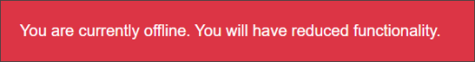

If for any reason the information is not cached, a message will inform you on screen.

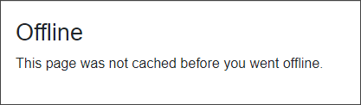

There are various limitations of use due to the last saved information being cached, so as a general rule the MEA user can save one page of data, for example, one Accident Log, or one Hourly Update entry without experiencing a loss of functionality.

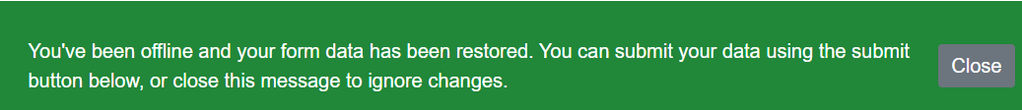

For security, any data saved in the browser cache will be lost when the browser or browser tab is closed. If the MEA user has saved data and internet connectivity is restored, the data will be restored automatically from the cache into the page and they will have the opportunity to commit this data to MEA or ignore to remove the data permanently from the cache. They will also be free to make any changes to this data before committing to MEA.

Copyright Notice:

The content of this document is protected by copyright © Civica UK Limited 2022. All rights reserved.

You may not copy or replicate including extracts of it without Civica’s written consent. You must not sell, share, copy or republish this document.

Copying of this document in any form is prohibited.

If you want further copies of this document, please make a request to the author shown on the front page.