CENSUS 2021 DATA FOR COVENTRY’S POPULATION

- COVENTRY’S POPULATION

The population of Coventry has increased by 8.9%, from around 317,000 in 2011 to around

345,300 in 2021. Since the last census in 2011 the overall population in Coventry has

increased by a greater percentage than the overall population of both the West Midlands (up

by 6.2%) and England (up by 6,6%). See figure 1 below.

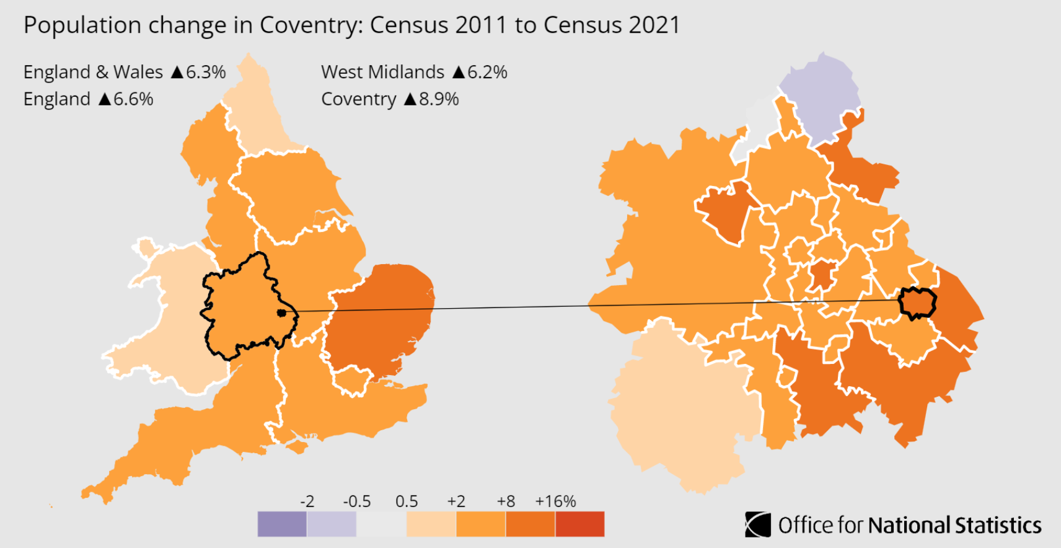
Figure 1

MEDIAN AGE

Between the last two census the median age of Coventry has increased by one year from 34

to 35 years. The median age is the age of the person in the middle of the group, meaning

that one half of the group is younger than that person and the other half is older.

The number of people aged between 50 to 64 years rose by around 8,800, an increase of

18.2%, while the number of residents aged 4 years and under decreased by around 2,000

which equates to around 9.0%. See figure 2 below.
Figure 2

FAMILY
In Coventry, the percentage of households including a couple with dependent children rose from 18.2% in 2011 to 19.3% in 2021. During the same period, the regional percentage fell from 19.7% to 19.0%.
The percentage of households including a couple without children in Coventry fell from 13.7% to 13.3%, while the percentage of households including a couple with only non-dependent children increased from 6.1% to 6.4%. See figure 3 below.

Figure 3

ETHNIC GROUPS
In 2021, 8.9% of Coventry residents identified their ethnic group within the "Black, Black British, Black Welsh, Caribbean or African" category, up from 5.6% in 2011. The 3.3 percentage-point change was the largest increase among high-level ethnic groups in this area.
In 2021, 65.5% of people in Coventry identified their ethnic group within the "White" category (compared with 73.8% in 2011), while 18.5% identified their ethnic group within the "Asian, Asian British or Asian Welsh" category (compared with 16.3% the previous decade).
The percentage of people who identified their ethnic group within the "Other" category ("Arab" or "Any other ethnic group") increased from 1.7% in 2011 to 3.7% in 2021.
There are many factors that may be contributing to the changing ethnic composition of England and Wales, such as differing patterns of ageing, fertility, mortality, and migration. Changes may also be caused by differences in the way individuals chose to self-identify between censuses.

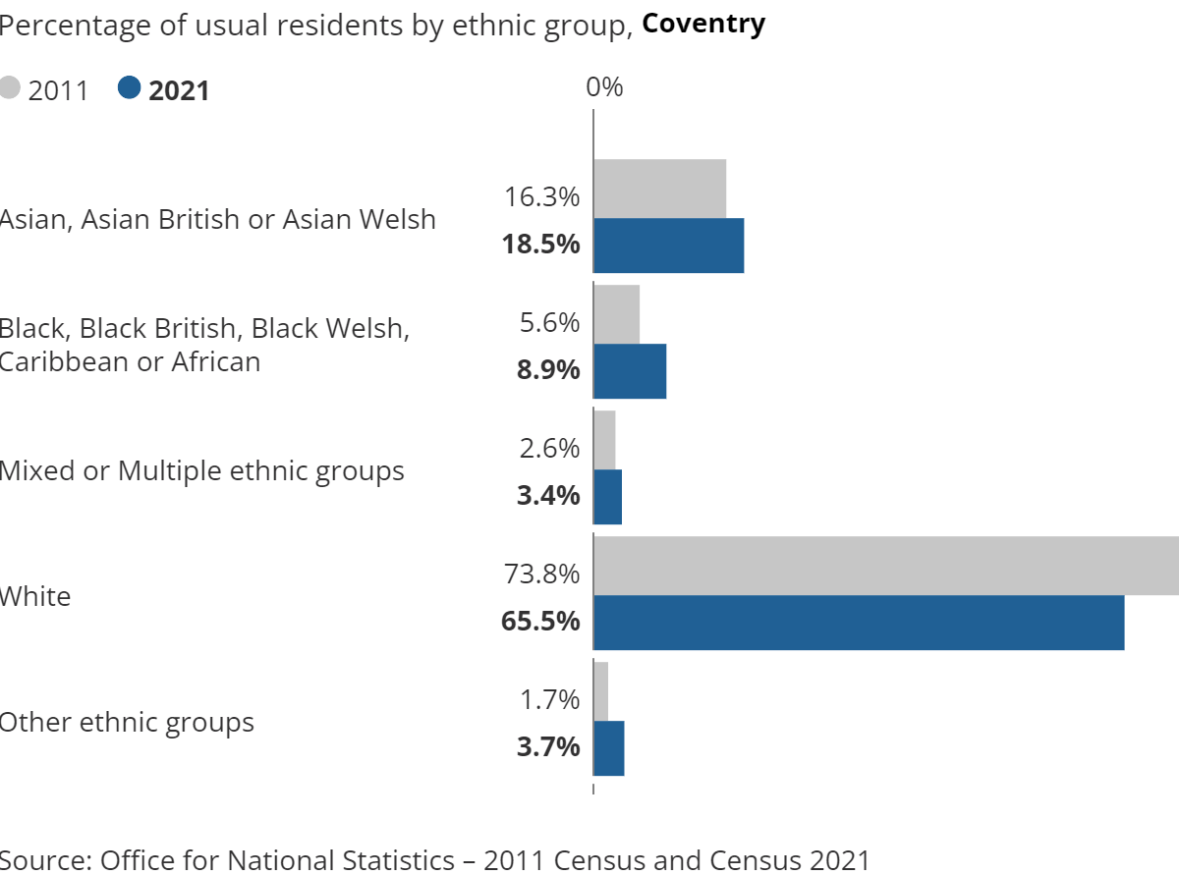

Figure 4

COUNTRY OF BIRTH
In the latest census, around 242,100 Coventry residents said they were born in England. This represented 70.1% of Coventry’s population. The figure has risen from just over 240,100 in 2011, which at the time represented 75.8% of Coventry's population.
India was the next most represented, with just over 15,600 Coventry residents reporting this country of birth (4.5%). This figure was up from just over 13,400 in 2011, which at the time represented 4.2% of the population of Coventry.
The number of Coventry residents born in Poland rose from around 6,400 in 2011 (2.0% of the local population) to just under 8,900 in 2021 (2.6%). See Figure 5 below.

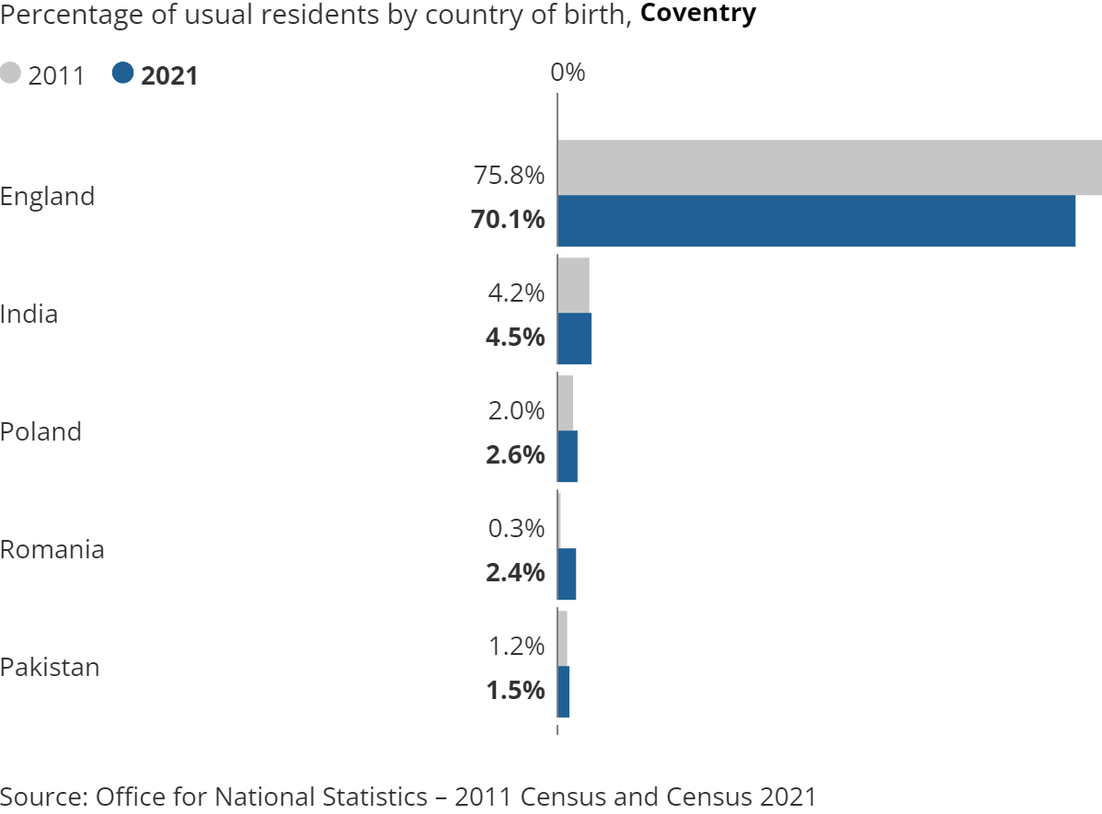

Figure 5

RELIGION
In 2021, 29.6% of Coventry residents reported having "No religion", up from 23.0% in 2011. The rise of 6.6 percentage points was the largest increase of all broad religious groups in Coventry.
43.9% of people in Coventry described themselves as Christian (down from 53.7%), while 10.4% described themselves as Muslim (up from 7.5% the decade before).
There are many factors that can cause changes to the religious profile of an area, such as a changing age structure or residents relocating for work or education. Changes may also be caused by differences in the way individuals chose to self-identify between censuses. Religious affiliation is the religion with which a person connects or identifies, rather than their beliefs or religious practice. See figure 6 below.

Figure 6

CIVIL AND MARRIAGE PARTNERSHIP
Of the Coventry residents aged 16 years and over, 40.2% said they were married or in a registered civil partnership in 2021, down from 41.9% in 2011.
In 2021, just over 4 in 10 (44.0%) said they had never been married or in a civil partnership, compared with 40.1% in 2011. The percentage of adults in Coventry that had divorced or dissolved a civil partnership decreased from 8.5% to 8.1%.
These figures include same-sex marriages and opposite-sex civil partnerships in 2021, neither of which were legally recognised in England and Wales in 2011. Same-sex marriages have been legally recognised in England and Wales since 2014 and opposite-sex civil partnerships have been recognised since 2019. See figure 7 below.

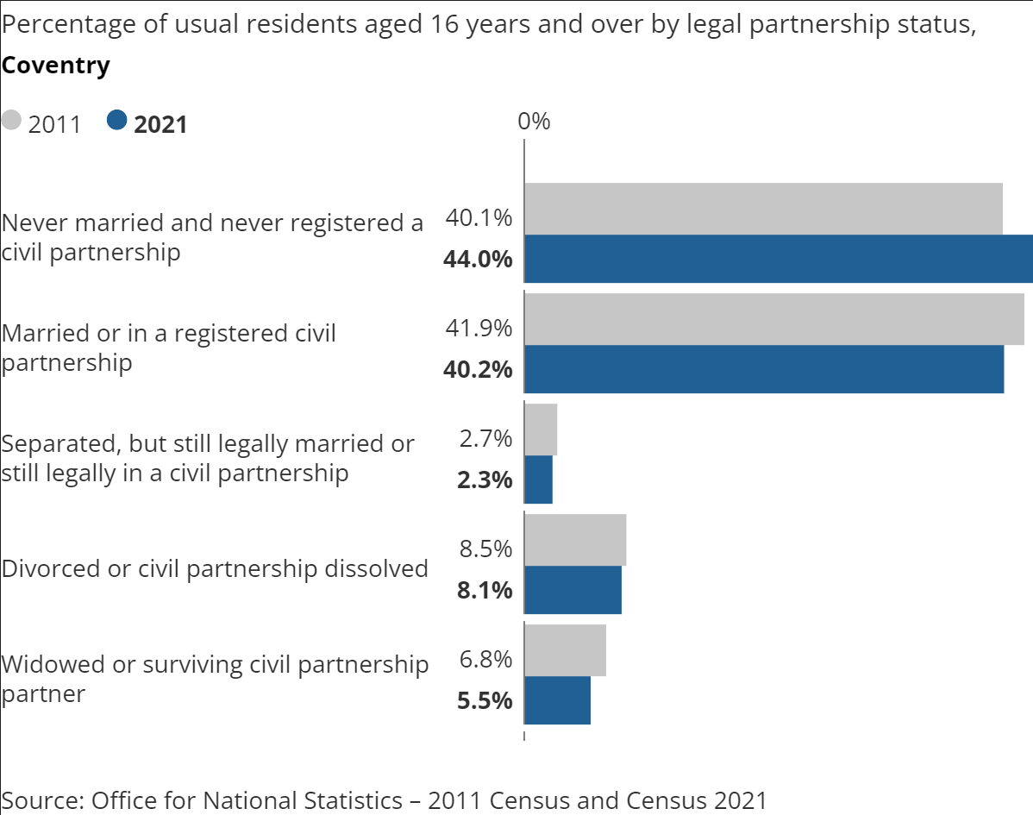 Figure 7

EMPLOYMENT

51.0% said they were employed (excluding full-time students) in 2021, a similar percentage as in 2011 (50.9%).

In 2021, just over 1 in 30 (3.4%) said they were unemployed, compared with 4.9% in 2011. The percentage of retired Coventry residents decreased from 19.1% to 17.3%.
Census 2021 took place during the coronavirus (COVID-19) pandemic, a period of rapid and unparalleled change; the national lockdown, associated guidance and furlough measures will have affected the labour market and the ONS’s ability to measure it. See figure 8 below.

Figure 8

NATIONAL IDENTITY

Coventry saw the West Midlands' joint third-largest percentage-point rise (alongside Rugby) in the share of people who did not identify with any national identity associated with the UK (from 14.1% in 2011 to 18.2% in 2021).
Every local authority area across the West Midlands saw a rise in the percentage of people who did not identify with any national identity associated with the UK, as the regional percentage grew from 6.2% to 8.7%.
In Census 2021, “British” was moved to the top response option and this may have influenced how people described their national identity. See figure 9 below.
Figure 9

SEXUAL ORIENTATION

For the first time, the 2021 census asked residents aged 16 and over about their sexual orientation with one voluntary question.

This question identified in Coventry, 88% of eligible residents (276,873) identified as straight or heterosexual, 3.2% as LGB+ and 8.8% did not answer the question. Fewer residents in Coventry identified as straight or heterosexual in Coventry compared to the West Midland’s 89.9% and England 89.4%.
Of those who identified as LGB+, 38% identified as gay or lesbian, 47% as bisexual, and 15% as all other sexual orientations. See figure 10. The percentage of residents who
identified as LGB+ in Coventry equalled England’s 3.2% and was higher than the West
Midland’s 2.6%.

Figure 10

There are 6 MSOAs where 92% of the residents identify as straight or heterosexual with
between 2-3% non-response rate. These MSOA’s are Finham Park, Binley, Sherbourne,
Walsgrave and Woodway Park, Coundon and Allesely Green and Lower Eastern Green.

Lower Stoke & Gosford Park, Chapelfields and Cannon Park & University had the highest percentage of residents identify as LGB+ with 6.6%, 7.6%, and 6.7

GENDER IDENTITY

For the first time, the 2021 census asked residents aged 16 and over about their Gender Identity with one voluntary question.

In Coventry, 91.6% of eligible residents (276,873) indicated that their gender identity was the same as their sex registered at birth, 7.6% did not answer the question and 0.8% that it was different, this is higher than the 0.5% in the West Midlands and England. See

Figure 11

Of those who indicated their gender identity was different, 51% gave no specific identity, 17% indicated trans woman, 17% indicated trans man, and 14% indicated another gender identity. See figure 12 to view comparison to England and West Midlands.

Figure 12

DISABILITY

In 2021, 8.4% of Coventry residents were identified as being disabled and limited a lot. This figure decreased from 10.5% in 2011. See figure 13. The decrease is similar to the decrease across the West Midlands (from 9.9% to 8.0%). Across England, the proportion fell by 1.6%, from 9.1% to 7.5%.

In 2021, around 1 in 10 people in Coventry (10.0%) were identified as being disabled and limited a little, compared with 10.7% in 2011.

The proportion of Coventry residents who were not disabled increased from 78.8% to 81.6%.

Figure 13

UNPAID CARERS
In 2021, 4.3% of Coventry residents (aged five years and over) reported providing up to 19 hours of unpaid care each week. This figure decreased from 7.2% in 2011. See Figure 14
The decrease of 2.9% in the proportion of people (aged five years and over) providing up to 19 hours of weekly unpaid care in Coventry was similar to the decrease across the West Midlands (2.9% percentage points, from 7.4% to 4.5%). Across England, the proportion fell by 2.8%, from 7.2% to 4.4%.
Caution should be taken when making comparisons between 2011 and 2021 because of changes in question wording and response options.

