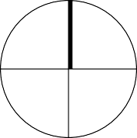N

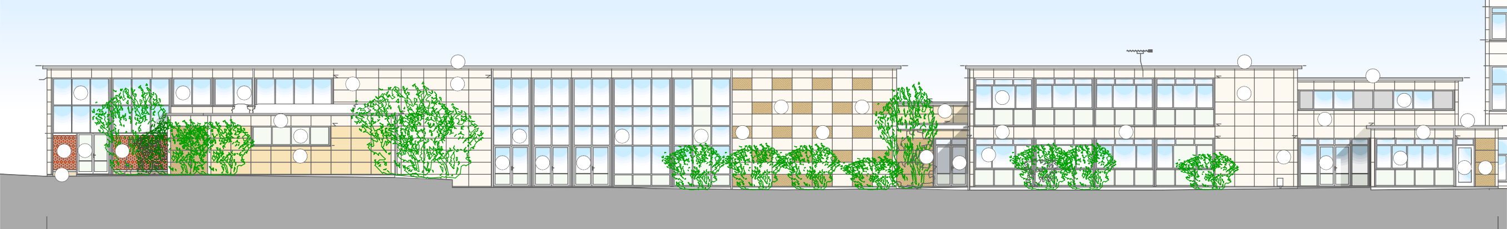

134.09

132.40

Antenna

131.09

19

131.09

131.09

19

131.09

131.09

Cladding

12a

12a

12a

Skylight

130.47

1

130.47

Cladding

130.47

130.47

130.47

1

19

130.48

Cladding

129.25

12a

1

Skylight

Skylight

128.67

1

1

128.02

1

128.16

12a

Cladding

128.81

1

128.02

1

128.05

19

127.41 127.42

128.05

127.65

Cladding

Cladding

12a

3

12a

12a

12a

3

3

128.02

1

1

Cladding

127.41

127.41

127.41

1

5 14a

5

127.04 Cladding

Vegetation

Cladding

14a

14a

14a

3

12a

1

12a

Cladding

14a

14a

7

Box

14a 3

125.21

Scale 1:100 

0 5 10 15 20m

Datum 122.00m

Main Block Elevation 1 South

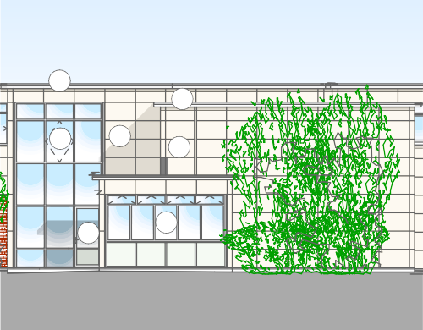

19

131.09 131.09

19

Cladding

12a

1

1

128.05

127.41

Unable to survey Bushes obscuring view

14a

12a

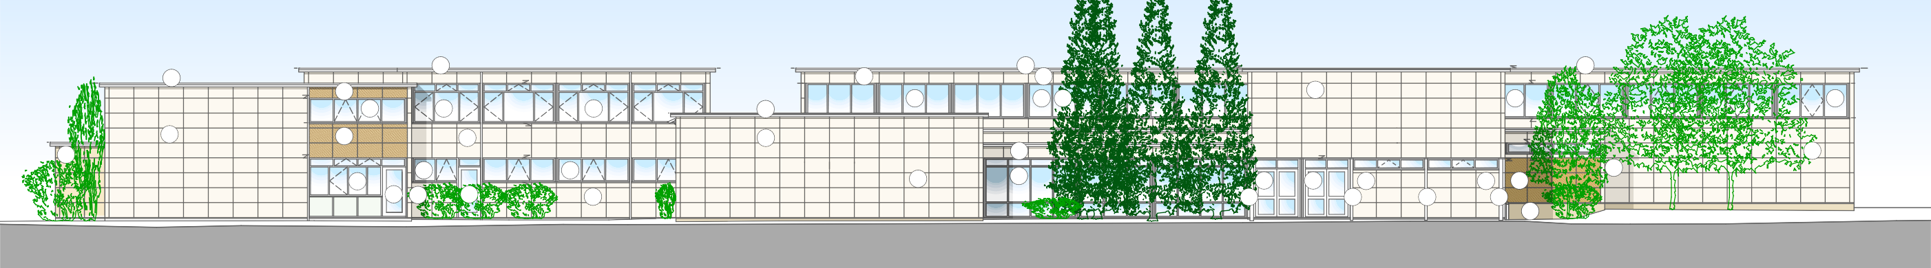

131.09

19

131.09

131.09

19

131.09

131.09

19

131.09

130.48

19

Cladding

130.47

130.47

1

1

130.47

130.47

Cladding

Cladding

130.47

2

12a

12a

12a

12a

12a12a

1

Cladding

129.86

12a

129.25

19

12a

129.05

128.85

129.05

129.05

128.85

CCTV

128.63

128.63

1

128.05

2

1

1

128.03

128.02

1

127.41

127.41

1

127.37

127.37

1

127.37 127.60

12a

12a

14a 1

12a

126.43

1

12a

1

14a

14a

4

4

2

14a

1

8

8

8

8

Pipe 7

Datum 122.00m Main Block Elevation 2 East

Datum 122.00m

Main Block Elevation 3 North

# 3

128.67

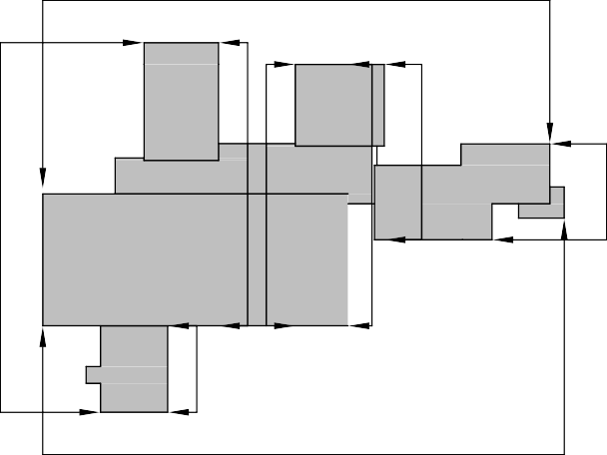

9

6

8

5

7

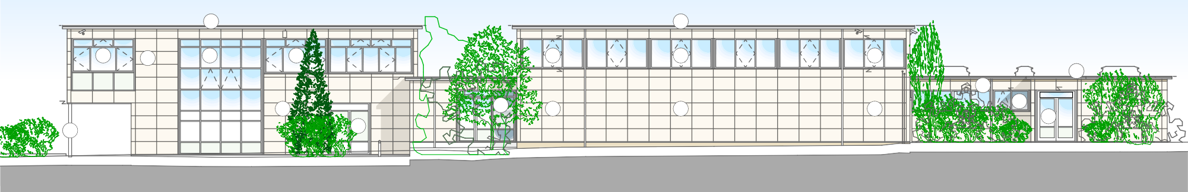

131.09

19

131.09

131.09

19

131.09

CCTV

Alarm

130.47

CCTV

130.47

CCTV

12a

1

12a

12a

12a

129.05

12a

12a

129.05

Skylight

Skylight

19

128.02

Skylight

128.67

128.63

128.05

1

128.02

127.37

1

vent

14a

1

1

1

12a

127.04

Door Door

Door Door

14a

8 Opening

14a

Unable to Survey Tree/bushes Obscuring view

vent

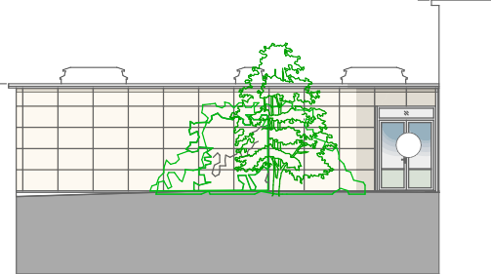

131.09

Skylight

Skylight

Skylight

Cladding

Cladding

Adjoining building

Unable to survey Trees/bushes

Cladding

14a

Cladding

Cladding

# 2

4

Datum 122.00m Main Block Elevation 4 West

Datum 122.00m Main Block Elevation 5

131.09

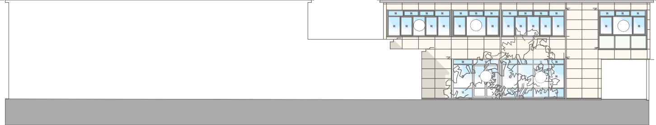

131.09

131.09

131.0

Cladding Cladding Cladding

130.47 130.47

12a

12a

Cladding

12a

128.63

Cladding

128.82

128.03

128.02

Cladding

Cladding

127.41

127.41

127.37

Adjoining building

Adjoining building

Cladding

14a

12a

Opening

Cladding

9

131.09

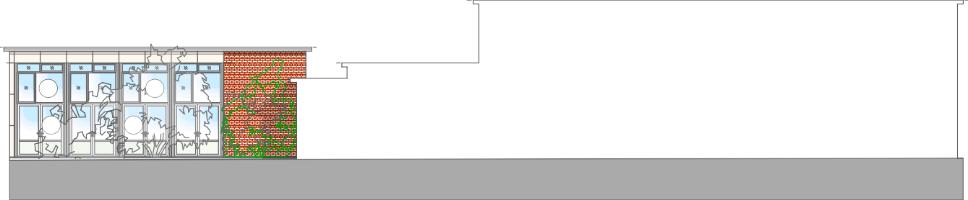

131.09

9.25

129.25

Cladding Cladding Brick

128.63 128.63 128.63

128.03

12a 12a

Brick

Adjoining building

Adjoining building

14a

14a

Bush

1

Main Block Elevation Key

12

Existing Concrete Cladding Panels Grey/Buff Existing Concrete Cladding Panels Red Existing Concrete Cladding Panels Green



1

2

3

4

5

6

7

8

9

10

11

12

12a 13

14

14a 15

16

17

18

19

Existing Concrete Cladding Panels Painted white/Cream

Existing Brickwork red facing

Datum 122.00m Main Block Elevation 6

Datum 122.00m Main Block Elevation 7

Existing Brickwork Buff facing

Existing Concrete shuttered wall Existing Steel Columns

Existing Corrugated/Flat metal Cladding Panels

Existing Timber Cladding

Existing Single Glazed Metal Framed Windows and infill Panels Existing Double Glazed Metal Framed Windows and infill Panels

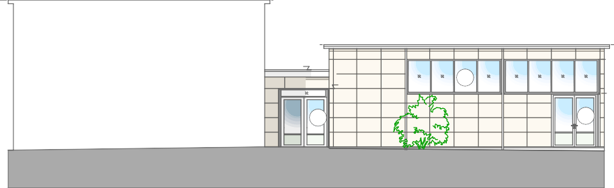

131.09

129.22

12

Cladding Cladding

128.60

128.16

Cladding

Adjoining building

127.37

12a

127.17

Cladding

Cladding

Cladding

14a

14a

Cladding Cladding

1

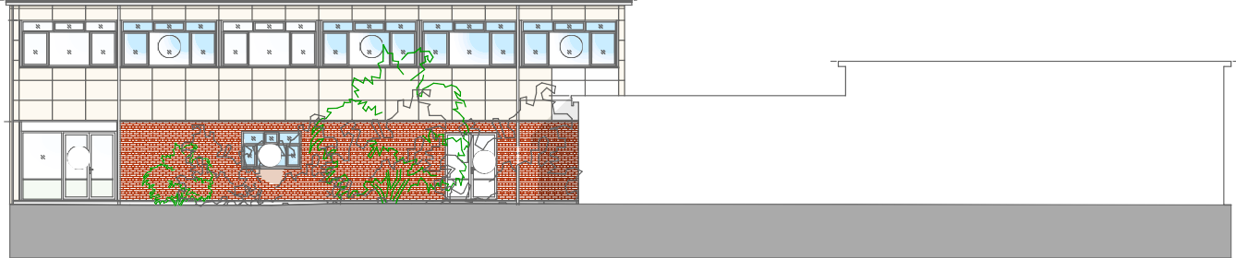

31.09

131.09

Cladding Cladding Cladding

130.47

12a

12a

12a

129.22

Cladding

Cladding

Cladding

128.16

127.37

Timber

Brick

14a

12a

Brick

Adjoining building

Adjoining building

Door 14a

129.22

131.09

9.22

Proposed Double Glazed Metal Framed Windows and infill Panels Existing Double Glazed UPVC Windows and infill Panels

Existing Glazed Metal Framed Doors

Proposed Double Glazed Metal Framed / Solid Doors Existing Timber Doors

Existing Louvres

New corten steel laser cut screens 3 meters high New red Brickwork infill to match existing

Existing Felt Flat Roofs

Datum 122.00m Main Block Elevation 8

Datum 122.00m Main Block Elevation 9





## NOTES REVISIONS PROJECTS CLIENT DRAWING TITLE DRAWING NO. REV

REV: DATE - DRAWN - CHECKED: NOTES

This drawing is the copyright of Quattro Design Architects Ltd and should not be reproduced in whole or in part without written permission. Only figured dimensions to be used for construction. Check all dimensions on site. Any discrepancies are to be reported to the Architect as soon as possible.



-: 10.02.22 - WJ - WJ: Drawing Created

Woodlands Academy - Masterplan Coventry City Council

 

Main Block Proposed Elevations

**6703-P-701 -**

**PLANNING ISSUE**

Matthews Warehouse, High Orchard Street

[www.quattrodesign.co.uk](http://www.quattrodesign.co.uk/)

## SCALE

1:100@A0

**DATE** February 2022

Gloucester Quays, GL2 5QY T: (01452) 424234