Coventry Independent Climate Change Board
Minutes:
Time and Date: Thursday 23rd November 2023. 12:30 – 14:30
Location: NAIC Boardroom, Lord Bhattacharyya Building, University of Warwick

Board members present |  |  | MS Teams
Margot James (MJ) – Chair, WMG  Cllr Jim O’Boyle (JO’B) -Vice Chair, Coventry City Council (CCC)  Julie Nugent (JN) – CEO CCC  Chris Lovatt (CL) - Chief Operating Officer, E.ON  Samantha Taylor (ST) - Ecologist, Canal & Rivers Trust  Clare Wightman (CW) - CEO, Grapevine  Emma Flynn (EF) - Provost, University of Warwick  Paul Smith (PS) - Area Director, Lloyds Bank  Helen Wheatley (HW) - Director of Film and Television Studies, University of Warwick  Rachel Jones (RJ) – ACT ON Energy (NEW BOARD MEMBER)  Ngoni Mupandawa (NM) - Environmental Manager, Galliford Try (NEW BOARD MEMBER)  Ed Green (EG) - Chief Executive, Warwickshire Wildlife Trust |  |  | Clive Robinson (CR) - Sustainable Development Manager, UHCW  Kevin Rodgers – Citizen Housing
Non-Board members present |  |  | Non-Board members on MS Teams
Manjit Bath (MB) - Business Development Manager, CCC  Andy Williams (AW) - Dir. Business, Investment & Culture, CCC  Bret Willers (BW) - Head of Climate Change & Sustainability, CCC  Keely Hancox (KH) – Coventry Chamber of Commerce  Laura Waller (LW) - Coventry City Council  Tamara Duignan (TD _ Coventry City Council  Selina Fletcher (SF) – Coventry University  Richard Hodge – Minutes, CCC |  |  | Zain Javed (ZJ) - WM Police  Darren O’Shaughnessy (DS) - Comms Manager, CCC
Apologies
Lisa Hofen – Director of Estates & Facilities, Coventry University  Sophie Mason - Energy & Sustainability Lead, Coventry Building Society  Russ Hall - Senior Research Fellow, WMG  Suzanne Ward- Area Environment Manager, Environment Agency  Colin Knight - Dir Transportation & Highways, CCC  Nicola Edgar – Avon Catchment Co-Ordinator, WM Environment Programme Team  Sarah Windrum - Future Mobility Cluster Lead, HORIBA MIRA  Philip Wallace – Head of City Transformation, E. ON  Charlotte Heeney - Finance Business Partner: Net Zero/Sustainability Severn Trent Water  Corin Crane – Coventry Chamber of Commerce  Matthew Rhodes – Camirus  Anna Smith – Coventry Building Society  Rhian Palmer (RP) - Strategic Lead for Green Futures, CCC |  |  | Non-Responders:  Audrey O’Connor - Canal River Trust  Mariama Ceesay – Coventry University  Marcelle Baston-Warner – Warwick University  Liz Hopkins – WM Fire Service  Duncan Healey – Galliford Try  Hopi Sen – Warwick University  Luke Winch – Galliford Try  Jemma Hodgson – WM Police

- Apologies, Welcome & Introductions:
MJ - Welcome to Rachel Jones-CEO Act on Energy, Tamara Duignan (Business Analyst, CCC), Laura Waller- (Digital Services & Inclusion Lead, CCC), Selina Fletcher- (Coventry University), Keely Hancox (Chamber of Commerce)

- Report of progress from the Pathway Chairs Workshops:
(Pathway Group Chairs: 12:35- 1:50)
Equitable Person - Clare Wightman (CEO - Grapevine) & Helen Wheatley (Director of Film & TV Studies) Warwick University)

CW – The Pathway Group is now known as Fairer Green Futures (FGF). “Larger Us” update to increase political prominence of Climate Change. Grapevine Coventry is part of the FG national pilot project. Coventry is using a place-based approach. Which prototype will yield the most aims, using stories to share Climate Change Messaging.
Research update regarding the study into best practice in the UK for delivering a just transition to ensure no members of our community experience disadvantage because of activities and to understand what it should look like in practice and to suggest measures used to define success. Julia Slay (Just Transition- Commissioned Researcher funded by the University of Warwick ) is looking for examples of best practice across the UK.
HW – Inspired by the work going on in Scotland around Transition which is well resourced. They are not engaging with huge numbers of people but going into depth on issues relating to Just / Fairer Transition.
CW – In Scotland former transitions have been poorly managed so they want this transition managed more fairly in the future. Where do the opportunities lie? Exacerbating inequality and thinking about how costs / benefits are being distributed.
MJ – Would be interested in receiving more detail about the work in Scotland in a future meeting
CW – The Scottish authorities have a significant resource to call upon with funding from the Scottish Government. BW arranged a meeting for the Pathway Group Chairs with the City of Glasgow who provided some interesting and useful information. Glasgow looked at Just Transition across certain sectors but with the wreckage of the 1980s transition at the forefront of their minds.
JO’B – Where are the recommendations going to come from? What are the next stages going to be as there are next steps the City can do bearing in mind CCC is not the Government.
BW – Useful to understand the difference in legislation between Scotland and England where Just Transition is a statutory requirement in the Scottish legislation. Lots of different models being adopted across Scotland and some local authorities in the UK are looking at the issue.
PS – What does good look like? What does great look like? What can Lloyds Bank and others do to help out?
CW – There will always be chances for people around the table to assist
MJ – Once we get to the recommendations from the Pathway Groups they should all be scrutinised by the Fairer Greener Pathway Group being led by CW & HW
RJ – Reported that the WMCA Research have finished Year 1 and looking at air quality and retro-fit which can be forwarded on.

ACTION: RJ to provide a copy of the WMCA Research into air quality & retrofit for the region
HW – the Pathway Group is also organising the Community Food Growing Summit which has been put back to later than scheduled, there is growing interest (excuse the pun) from an increasing number of community groups around the City.
BW- Citizen Housing have also identified several sites across the City some of which could be used for food growing
SF – Reported that there are a couple of sites identified by Coventry University. Waiting on the legals now to see if they will work.
ST – the Canal & River Trust are also working on sites around Coventry which could be of use for food growing.
Nature Based – Ed Green Chief Executive, Warwickshire Wildlife Trust
EG – Two areas of active collaboration – a) River Sherbourne with lots of positive feedback (see photos attached in appendix 1- North Brook Restoration carried out by the Sherbourne Team) & b) Brandon Wood Rewilding Project where they are working with Coventry City Council. Close to a decision and looking forward to seeing as many people as possible on Dec 8th for the Site Visit Tour 1:00pm-3pm. Numbers to be confirmed.
ACTION: anyone interested in attending the Brandon Wood Rewilding Tour at the former Brandon Wood Golf Course on Dec 8th 1-3pm to book by email: climatechangeboard@coventry.gov.uk
3rd area of collaboration is looking at The Climate Change Draft Strategy. Feedback from the City Council in January 2024.
So far there is no progress on the development of the River Sowe proposal.
EG referred to two new areas to be included in the list of the Pathway Group’s projects: –

c) one is an investment programme from Severn Trent to replace hard engineering drainage schemes with sustainable drainage systems Severn Trent Water are seeking approval from the regulator OFWAT to proceed and a decision is expected in Spring 2024. People asked what a sustainable urban drainage system is and what they would look like.
EG said SuDS are replacing hard concrete drainage systems with green substitutes so there could be options for links with the Adaptation and Resilience Group and Nature Based Pathway Group. It will add to green spaces.
BW – Sheffield have created sustainable drainage systems SuDS; they are areas of natural vegetation such as grasses and reeds etc to allow surface water to soak away with the vegetation providing a natural filtration system that slows the rate of flow and helps to filter the water removing nutrients etc. He reported that Severn Trent Water have trialled a system in Mansfield which is being scaled up in Coventry.
EG – said he thought there is unlikely to be much tree planting in the sustainable drainage systems that are being proposed.

d) The second is a project that has secured £500k to create “tiny forests” in the city and looking at potential sites currently.
JO’B – gets asked about planting trees in densely urban landscapes from residents. Deprived areas are where the green spaces are lacking.
EG – ST Water have chosen Coventry (their home city) to roll this out
PS – We have thousands of volunteers who would gladly get involved in tree planting and similar schemes.

ACTION: MB arrange for ED and PS to meet re: Lloyds Bank Volunteering programme and to attend the next Nature based Pathway group meeting
MJ – Great source of contribution with big firms who are looking to add Social Value
BW – outlined that tiny forests were first developed in Japan planting trees at a much higher density within a small area (the size of a tennis court) it contrasts from conventional tree planting methods and is believed to create a mature woodland with a varied canopy in a shorter space in time. He added that there are three sites in Coven try where “Tiny Forests” have recently been planted with Severn Trent & Earthwatch in schools as part of the Commonwealth Games legacy.
HW – Access to greenspace is an area of work from the Nature Based Pathway Group which is also contributing to a just transition
Resilience & Adaptation – Suzanne Ward (Area Environment Manager - Environment Agency) (Bret Willers substituting for SW)
BW –outlined that the consultancy brief for the production of the Resilience & Adaptation Plan is nearing completion
The Pathway Group are in the process of identifying the data and potential data sources required to inform the Plan and CK is in the process of securing the funding for consultancy support.
MJ – Any recommendations coming through?
BW – There will be a raft of recommendations across a wide range of activities, yes contained in the recommendations from the Adaptation & Resilience Plan including a major SUDs project with Severn Trent pending approval from OFFWAT.
MJ – input from Sustainability West Midlands
BW – Have been in conversation with them and the consultancy brief references the regional study carried out by Sustainability West Midlands and that the Coventry Plan will need to link to that.
HW – Will the ‘Just Transition’ be incorporated into the Resilience & Adaptation Plan?
BW – Just Transition is an important strand in the consultancy brief
MJ – suggested that Helen or Clare are invited to attend this Pathway Group.

ACTION: MB to Invite HW & CW to the next Adaptation & Resilience meeting to debate links to a Fair Transition.

Low Emissions – Bret Willers (head of Climate Change & Sustainability, CCC) &
Chris Lovatt (Chief Operating Officer - E.ON)
CL – How best to take this forward in conjunction with the Strategic Energy Partnership (SEP) and outlined that now the SEP is established it would not be appropriate for the SEP to Chair the Low Emissions Pathway (LEP) Group and that there will be a specific partnership team within the SEP delivering areas of this work.
MJ – Would the work with Sarginsons come under this?
CL – yes it would, he outlined the areas of activities identified for the Low Emissions Pathway (LEP) which would now sit with the SEP and stated that the SEP would continue to participate with the LEP which would cover those activities not covered by the SEP
BW – referred to the table illustrating the activities to be covered by the LEP and the SEP which was shown on the screen.
Members of the Board agreed with the split and felt there was still a need for the LEP with a particular emphasis on transport and behaviour change to encourage modal shift and to address the behavioural aspects of promoting domestic retrofit.
MJ – Transport question: it is responsible for 25-35% of emissions which the Board hasn’t really touched upon. Does it sit under LEP or not? BW confirmed that many of the transport actions come under the Low Emissions section of the Strategy MJ so therefore this is an area to look at with help / assistance from WMG.
AW – Colin Knight not present. Definitely working with WMCA amongst other bodies but what could be done now and what are the gaps and the challenges? Pick up with Colin and his team
BW – How we get the modal shift is also about encouraging behavioural change and the Fairer Green Pathway has a role to play with this.
PS – What can we do with SMEs and influencing better behaviour there in terms of buildings, etc. Gladly get involved in that working group. What stipulations does the Council put in their contracts in terms of greener credentials? BW the Coventry Alliance agreed a Corporate Social Responsibility and Sustainability performance framework and has a clear social value policy (https://www.coventry.gov.uk/strategies-plans-policies/social-value-1/2) regarding future development but needs to work on the detail for specific policies across a whole spectrum of sustainability issues and would love to work with partners in this important area.
KH – From the Chamber point of view – they ran a Net Zero conference only 6 weeks ago where SMEs and their actions were discussed. Chamber would welcome being involved in anything going forward. Happy to use the forum coming up in 3 months’ time
CW – Are there any risks in splitting out the SEP from the LEP and how do they manage that? Is there going to be a sixth group so that the SEP links with the Climate Change Board?
CL – E.ON / SEP should engage with the LEP but not lead on it. Scope has changed and the Terms of Reference are being looked at. Someone else needs to be the Chair in place of CL.
MJ – Great suggestion.
JO’B – Answer to SMEs. Where the Local Authority contracts services, they look to retain the effect within Coventry as well as getting best value. In terms of transport, CCC works closely with the WMCA . Looking at recommendations in relation to VLR and CCC will be getting a full electric bus fleet by 2025. There could be added value provided by the LEP in some of the other things listed in the table presented.

ACTION: Bret Willers (BW) & Rhian Palmer (RP) to arrange the appointment of a new Chair and the relationship of the SEP with the LEP and the Board, including ensuring that the Terms Of Reference for the group are updated in line with the areas of focus for this Pathway Group. Where there are links with the Strategic Energy Partnership’s activities, both BW and RP will seek to avoid duplication.

BW – mentioned a related activity which did not get presented to the Board last year where cross faculty teams at Warwick University looked at lots of different technical, marketing and behavioural change approaches to facilitating an increase in bus usage in a post-COVID era the range of measures were using existing available technologies in different ways and simple do-able improvements to design that are more user friendly and will encourage increased usage of buses? Should bring this to a future LEP meeting.

PS-Real challenge is around procurement and what to specify? Looking to compare notes. There is an opportunity there.
With regards to SMEs, we want to ensure that small businesses can compete with others to win those contracts talked about earlier. Construction firms are having to deal with things now that they never used to.
MJ – Are there firms looking to lower emissions?
NM – Galliford Try are being pushed by their clients to lower their emissions as sustainability criteria are being weighted more heavily in selection processes for construction contracts.

ACTION: all to consider for a future meeting how Board Members can share experiences and practice in relation to including sustainability criteria in their procurement processes.

Circular Economy – Russ Hall (Senior Research Fellow WMG)
(Presented by Laura Waller & Tamara Duignan)

(Slides presented on screen which will be shared after the meeting)

LW talked about Cov Connects and the environmental and social impact of digital inclusion.
Introduced #CovConnects Device Bank that was launched in June 2023 and case studies arising from this.
BW – What is the alternative for not recycling?
KH – Apprenticeships route in relation to digital transformation. Route to SMEs as well because they may not have the funding to wipe their devices. Chamber is very willing to help in this regard. Having the resource to wipe the hardware is the blocker.
LW – There is an aspect of community learning
TD – There will be a social impact within the city by following this programme.
MJ – Are all IT hardware included like printers?
LW – Essentially, they are looking to layer in various types of hardware.
TD – Current storage is limited so looking to scale up in this area as well.
RJ – ACT ON customers were unable to access their devices due to 3G dead spots. What is the impact?
BW – Looking at the business model is critical. If NHS data on the hard drives can be wiped clean to a high standard on their former devices, then we should be able to do that for other-used then that gives the green light due to the sensitive nature of what is on their hardware.
CW – What can the Board do to help?
LW – Funding is the big blocker so any options to get this would be gratefully received. At present NHS pay £50 / laptop to get them crushed and re-use could provide benefits to residents and promote health and ell.
CW – Are there big businesses can use their Social Value outcome to look at funding this?
CL – Looked at this a few times and the issue is that E.ON’s kit is outsourced.
PS – Lloyds rent / lease their laptops and phones.
BW – suggested that Board Members fed back to CW on the total number of laptops renewed each year, whether they were their own or leased from another company and in the case of the latter what does the company do with their returned laptops. What do the organisations do with their old laptops?
AW – Value proposition. How do we shape that going forward?
LW – Other elements apart from funding can be offered.
PS – SMEs don’t know where to start in a lot of cases. There must be an incentive to do this.
KH – Manpower in SMEs is an issue.
LW – Various businesses in and around Coventry who are involved of various sizes.

- Update on Climate Change Strategy Development - Rhian Palmer (CCC Strategic Lead Green Futures) & Bret Willers (CCC Head of Climate Change & Sustainability)
Next steps presented on the slides shown on the screen.
Circulate the submissions that have come from various Pathway Groups, so everyone is aware.
MB – Eleven detailed reports have been submitted.
MJ – Proper submissions from anyone represented on the Board.

- Coventry’s Strategic Energy Partnership (SEP) - Chris Lovatt (Chief Operating Officer- Energy Infrastructure Services, E.ON)

CL – Clear deliverables and themes as well as KPIs to form an Annual Business Plan. 3 Board Meetings have occurred, so the team is working well.
Specific projects covered in the slides presented.
KR – Home Tenure Grant question
CL – ECO Scheme is open to private homeowners. Scheme covers both in essence.
AW – 15-year partnership so this is the mindset we need to be in, i.e., long term.
CL – Solar Farm is a longer burn project.
MJ – Home Upgrade Grant question. Is there an issue with people being excluded for earning too much and then there are homes excluded due to not being able to be upgraded. Are there enough homes to make this viable?
CL – Great British Insulation Scheme aims to bring more people into scope. The supply chain needs to endure and know there is enough work in the future to remain viable.
RJ – Huge opportunity and ECO is not fit for purpose from a legislative point of view. Home Upgrade Grant is OFGAS properties only which excludes a lot of Coventry properties. Complexities that need feeding back up the supply chain. Reputational risk is significant for companies.
MJ – Green Deal is an example of this.
RJ – Green Deal is a great example of how firms have been “burned” in the past.
CL – E.ON are lobbying this greatly and there is pressure on E.ON to make this work.
HW – Not just the widening of the criteria but people are fearful of this, especially in the elderly community who are unable to ascertain who is cold calling and who isn’t.
RJ – Quite a lot of hand holding is required to get this over the line.
CL – People are very suspicious when energy firms ring up telling them they can save them money.
MJ – Low uptake is well recognised.
BW – Contractors around the country who are knocking on doors in Coventry which is adding to the problem. Local Authority Delivery Scheme (LADS)
KH – Hassle is a key issue to stop people upgrading their heating system. Is there a way to share data?
CL – Data doesn’t exist to enable this to target customers effectively.
BW – Data flow across the city. No LA can access that information. Meta Data exists but it’s getting the access to it that is key. Local Area Energy Planning project.
KR – Social Housing / Decarbonisation Grants. Wave 1 in Lower Coundon where the owner occupier residents were aggrieved that they weren’t included.
Four routes and Seven proxies show the level of complexity involved for customers to gain eligibility.
CL – Is there a way to help people learn about eligibility?
LW – Assumption that the homes involved do have digital literacy and are able to find out using devices, if they have any?

- AOB

2024 quarterly meetings
MJ – Looking to the Board Members to offer a similar location and catering. ST Water have offered their services. Can interested parties please let Manjit know.
BW – Is anyone interested in Green Skills then please get in touch with Bret directly.

APPENDICES
The pictures attached are from Ed Green which show details of the North Brook restoration carried out by the Sherbourne team, for the minutes

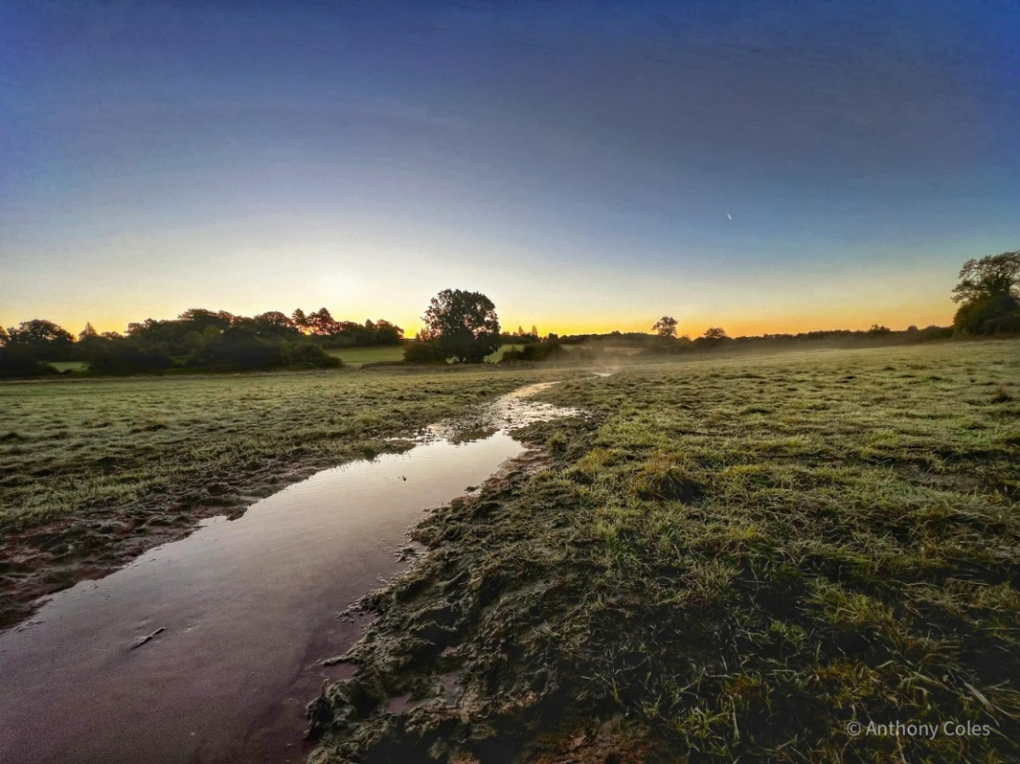
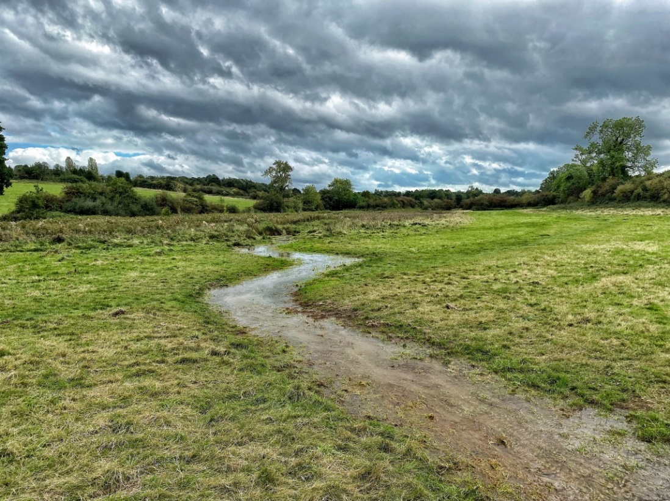
Date Of Next Meeting: Dates/times/Venues of 2024 quarterly meetings TBC

