RIGHT TRAX/24/007 Reference No: TRAX24/9955

RIGHT TRAX with Honour & Integrity.
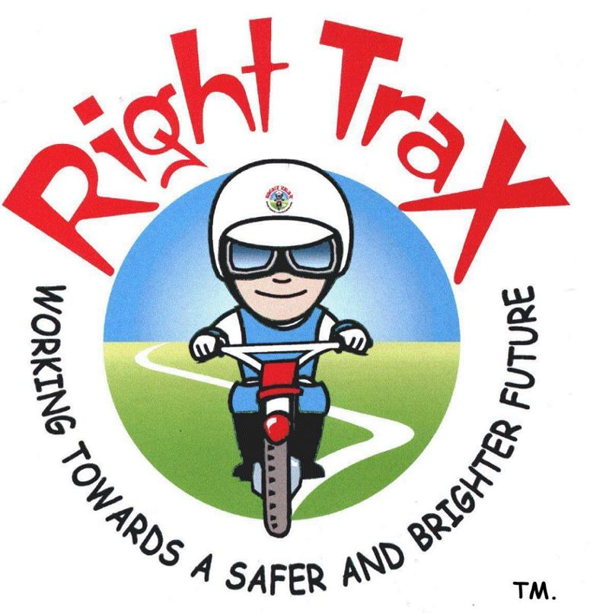
A Motorcycle & Bicycle Road Show for Young People.
Parental Consent Form (Age limit twelve upwards).

Venue: Coventry Alternative Provision (CAP),
at the Folly Lane Members Club, 401 London Road, Coventry CV3 4DA
Dates: 9th of September 2024 to the 21st of July 2025.
Activity: To instruct and assist young people in maintenance, safety & motorcycling skills.

Details.
I hereby give permission for my son/daughter (name in full) whose date of birth is to participate in the activity referred to above. This will involve riding small capacity geared motorcycles in a supervised and structured environment and carrying out basic maintenance, servicing & repairs. He/she, who signs for the event, takes the risk. Consent is also given for Facebook, filming & photographs to be taken for educational & publicity purposes and have data shared amongst providers which relates to curriculum needs, ( YES / NO ) please delete.

Metal Detector.
A metal detector used at the RIGHT TRAX venues to safeguard all students. If any dangerous objects are found or any students refuse to be scanned this will be reported to the Police/School/Parents or Guardian.

Mobile Telephones & VAPES.
All students will hand in their mobile telephones & VAPES to RIGHT TRAX staff, prior to riding the motorcycles. Failure to do so will result in the student not being allowed to ride.

Medical information.
To the best of my knowledge my son/daughter is 100% medically fit and able to participate in this event. My child is not receiving any medical treatment or taking medication that would affect him/her in taking part in this activity (e.g. some medication makes people drowsy). I undertake to notify the sponsoring organisation (Coventry Alternative Provision (CAP)) if any significant changes in my child’s fitness, that may occur prior to the activity.

Special needs.
Does your son/daughter have any special needs that we should be aware of, if so please notify in box.

Signed: . Parent/Guardian.

Home Address:

.

Postcode: .

Home telephone no: . Alternate contact no: .

Date: .

Follow us on... facebook
HONOUR | INTEGRITY | DEDICATED TO THE WELFARE & EDUCATION OF YOUNG PEOPLE | TEACHING RESPECT | A LEARNING EXPERIENCE |
RIGHT TRAX IS A RESPONSIBLE COMPANY WHO IS COMMITTED TO THE ENVIRONMENT.
RIGHT TRAX A Motorcycle & Bicycle Road Show for Young People. Gary C Elliston BEM 15 November 2004.
Registered in England & Wales. Registration number: 5253660. VAT Registration number: 870889765. Copyright.

