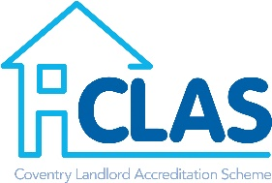

- Please complete the address information and advise in what capacity you are involved with the property.
- Please be advised that the information provided will need to correspond with any HMO Licences/Applications that we hold.
- You are only required to provide addresses within the Coventry area.

Address  Street name, number and post code |  | HMO or Single Occupancy | Are you the Landlord, Manager or Letting Agent (state all that apply) | Licence/Application number (HMO Only)

