**Add your setting name / logo**

[Cite your source here.]

**All About Me**

Parents and families are children’s first and most important educators.

We aim to build trusting and respectful relationships needed to achieve the best outcomes for your child, both at home and in our setting. We value your rich knowledge of your child’s unique personality; their interests, preferences, and skills. ‘All About Me’ helps us to listen, value and understand about how your child learns and develops at home. We will use this information to develop warm, reliable, nurturing and secure relationships with your child, so they feel confident to explore their environment and build friendships. The information you share, your child’s views and interests, and our observations will help plan a variety of exciting opportunities, which supports your child’s holistic development, such as their independence, curiosity, creativity and communication skills.

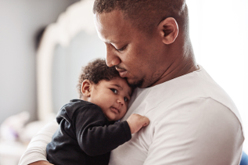We value and welcome everything you would like to share about your child during their settling in time and thereafter. So please feel free to share information about your child’s needs or any significant events within the family, at any time, with your child’s key person/s.

**Child’s personal details**

|  |  |
| --- | --- |
| Child’s full name |  |
| Name your child likes to be known as |  |
| Child’s birthday |  |
| Male or Female |  |
| Ethnicity |  |
| Religion |  |
| Language/s spoken by your child |  |

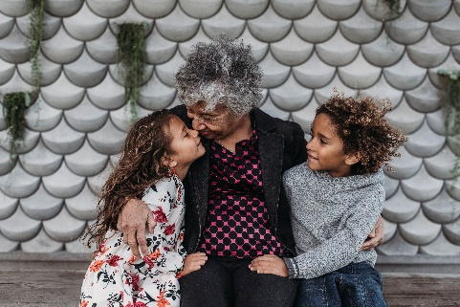 **Family, home life and culture**

|  |  |
| --- | --- |
| Who does your child live with? (including siblings, extended family, pets) |  |
| Any other special people in your child’s life? |  |
| Does your child have any special friends? |  |
| Does anyone else care for your child? (grandparent, relative, childminder, nursery) |  |
| Languages spoken / used at home? |  |
| Are there any key words we can use to support your child’s needs when settling in, such as, hungry, food, drink, sleep, toilet? |  |
| Are there any important or special events celebrated in the family? |  |
| Any other information about your child’s culture that you would like to share? |  |

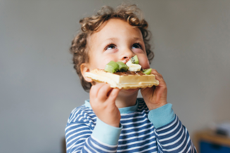**Nutrition, meals and drinks**

|  |  |
| --- | --- |
| Does your child have any specific dietary requirements? (allergies, medical, religious needs) |  |
| Does your child require any bottle feeding? (including breast milk, formula milk, cow's milk, etc)  If so, please discuss their routine, individual needs, preparation and storage of  bottles / milk. |  |
| Any food your child likes, dislikes or prefers?  If weaning, what consistency does their food need to be? Are they able to eat finger foods? |  |
| Does your child need support when eating? e.g. use a specific cup, need help with feeding. |  |
| How is your child during mealtimes at home? Do they use a highchair, sit independently, feed themselves? |  |
| Is there anything else you would like to share about your child’s needs / food arrangements? |  |

**Sleep routine / needs**

|  |  |
| --- | --- |
| Tell us about your child’s sleep needs?  i.e. their routine, how long they usually sleep for, do they have a comforter or dummy, how and where do they like to go to sleep, do they like a cuddle when waking up? |  |
| How do you know when your child is getting sleepy or tired? |  |

**Toileting / personal care needs**

|  |  |
| --- | --- |
| At the moment, my child uses…. (nappies, potty, toilet)  What support do they need?  Is there anything else we need to know about their personal care routines?  Any medical or health issues we need to be aware of? (including any oral health / toothbrushing concerns)  Does your child independently brush their own teeth at home?  Are there any creams or lotions to be used, while your child is here? |  |

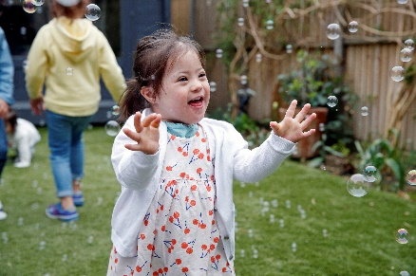

**Meeting your child’s individual**

**learning and development needs**

|  |  |
| --- | --- |
| What makes your child feel happy and content? |  |
| What may make your child feel upset or  anxious?  What helps to calm and reassure your child? |  |
| What interests does your child have?    i.e. things they like to play with, or things you do together at home. |  |
| Does your child like to play and interact with other children / adults? |  |
| Are there particular places, or people your child likes to visit?  (family, stay and play group, shops, swimming, holidays) |  |
| Do they enjoy playing outdoors / garden?  Is there anything in particular your child likes to do? i.e. climbing, playing with a ball, running, digging. |  |
| Does your child enjoy any particular books, songs and rhymes? |  |
| Is there anything you would like to share about your child’s language and communication development?  i.e. any words / phrases / gestures that your child uses to indicate their needs? |  |

|  |  |
| --- | --- |
| Is your child receiving support from any other professionals?  i.e. speech and language, physiotherapy, social care, dietitian. |  |
| Does your child have any special educational needs or disability (SEND)?  Any particular equipment, resources or adjustments required to meet their needs? |  |
| Has your child received their 2-year-old check up with a Health Visitor?  Were there any issues / concerns raised about your child’s development? |  |
| Any further information that would be helpful for us to know?  i.e. recent events at home, such as a house move, bereavement, new baby. |  |