Coventry Vaccine Superhero Programme
Information pack for schools

A public health initiative developed by Coventry City Council Public Health team in collaboration with Coventry School Aged Immunisation Service (SAIS).

Version 1.3: October 2024

Introduction

This information pack is designed to support schools participating in the Coventry Vaccine Superhero initiative to become champions for children and young people’s health by promoting the importance of vaccinations. The initiative is brought to you by a collaborative effort between the Coventry City Council Public Health Team and the NHS School Aged Immunisation Service (SAIS) team.

Why is this initiative important?
Childhood vaccination rates in Coventry are currently below the 95% population coverage recommended by the World Health Organisation. Coventry saw a decline in uptake of childhood vaccination rates in 2016/2017 with steady increases over the years peaking in 2021/2022 at 85.7%. Recent cases of vaccine-preventable diseases in the West Midlands emphasise the importance of ensuring children and young people receive their complete vaccinations based on the UK's routine childhood immunisation schedule. High levels of vaccine preventable infections can significantly increase the levels of absences of school staff and pupils.

Schools in Coventry have been instrumental in offering catch-up opportunities for missed vaccinations. This has been demonstrated time after time during the Covid pandemic and the recent cases of measles. The Coventry Vaccine Superhero Programme hopes to build on the schools’ role by providing fun and engaging activities to raise awareness about the importance of vaccinations.
The Coventry Vaccine Superhero Programme aims to enable and inspire school communities to become champions for childhood vaccination through fun and engaging activities. The objective is to educate children, share learning with parents, carers, and family and increase understanding about the importance of getting vaccinated no matter what age. In turn, we hope to increase the proportion of children and young people in Coventry that have been immunised against vaccine preventable diseases.

Calling All Primary and Special Schools in Coventry
The Vaccine Superhero Programme is designed to support our shared goal of helping children and young people think, learn and thrive.
The registration window for primary and special schools to join is open from Monday 8th July 2024, to Friday 31st January 2025. All program activities must be completed by the scheme's end in June 2025 to earn the badges and rewards for the academic year 2024/25.

Three level recognition model
The Vaccine Superhero Programme offers an opportunity for Coventry schools to become leaders in promoting children and young people’s health and vaccination awareness. By participating in this program, your school can earn digital badges at three levels—bronze, silver, and gold—each signifying a deeper commitment to educating children about the importance of vaccinations and their role in preventing diseases. These badges can be added onto your school website or letters.

To achieve each level, the school must demonstrate the following:
Digital badge | Description
Bronze | Requirement  - Complete a registration form for the program and submit this to Coventry City Council’s Health Protection Team at HPTeam@coventry.gov.uk. The registration form can be found in appendix 1.  - Designating a member of staff (ideally a member of the senior leadership team) as the lead contact to carry out the responsibilities outlined in all three levels.  - Lead contact being available for the School Aged Immunisation Service (SAIS) team to contact if additional assistance is needed to support them in preparing for upcoming vaccination clinics (e.g. language needs). In exceptional circumstances, this may involve a pre-meet to understand issues they need to prepare for.  - Designating a staff member with responsibility for looking after the Giant microbes (received as part of Bronze level) and share the resource out to different year groups.  - Sign a working agreement between CWPT and schools. This will clarify the schools role in supporting the Immunisation programs.  You will receive:  Once we have received your registration form, your school will receive a Welcome pack which includes:  - A Giant Microbe starter pack –This pack is based on actual microbes. It includes microbe plush toys from a selection of the following: Measles, E. Coli, Norovirus, the common cold, COVID-19, the flu, and chickenpox. The pack will also include a vaccine bottle plush for flu and a antibody plush toy (Each school will receive two packs).  - Giant Microbes information sheet  - Printed copy of this informational pack.  Once we've processed your registration form, the designated staff member will receive a digital bronze Vaccine Superheroes badge award via email to show your school's involvement in the Vaccine Superhero program.  This starter kit helps to transform classroom into fun and interactive way of learning about microbes and vaccines with the help of microbe toys. You can use these cuddly models to explain the different microbe features and their functions. Teachers can access and integrate sessions from the e-bug modules which can be accessed here for Early years, KS1 or KS2 .
Silver | Requirement  To claim a silver badge, the school must have already achieved the bronze level. The objective is to integrate a fun and engaging activity into their curriculum to teach children about microbes and how they relate to vaccinations.  Remember, keep it fun, keep it simple, and keep it relevant to microbes and vaccinations! Activities can be (but are not limited to) the following:  - Choose a relevant e-Bug module lesson plan: Focus on lessons about general microbes, not specific ones like oral hygiene (Early Years package). You can find the lesson plans on the UK Health Security Agency coordinated e-Bug website (https://www.e-bug.eu/teachers). Implement the chosen lesson with the children.  - Assemblies (for children or parents/carers or both)  - Involve the school council to deliver an activity for the school with or without the support of the SAIS team.  Please share examples of how the students learned about microbes and vaccinations by emailing examples to HPTeam@coventry.gov.uk. Student learning examples can include completed worksheets, photos of student artwork or models, pictures of participation in the activity or a summary of the lesson plan. Please ensure you also mention in the email the specific e-Bug lesson plan which you have used (e.g., Early Years: Respiratory Hygiene) and briefly outline how the activity helped the children learn about microbes and vaccinations.  The SAIS team are happy to participate in assemblies or workshops to support in discussions about vaccinations with students. Their visit can serve as an introduction, building a positive connection with the children (and/or parents and carers) before future vaccination appointments. They may also be able to join learning sessions for schools staff to boost knowledge and awareness of immunisation. To schedule a visit, please email the team at least two weeks in advance (contact details on page 6).  You will receive:  Once the team have reviewed your school’s submission and are satisfied with the learning example, the designated staff member at your school will receive a digital silver Vaccine Superheroes badge award to recognise the school’s continued commitment to the Vaccine Superhero program.
Gold | Requirement  To claim a gold badge, the school must have already achieved the silver level. The objective is to participate in the development of Coventry’s vaccination branding which will be incorporated in upcoming campaigns.  - School pupils to create an image of a vaccine superhero for the Coventry public health and SAIS team to include in our upcoming vaccination initiatives. The image should reflect the knowledge gained from the e-Bug lesson plans on microbes and their connection to vaccinations.  - The school to hold a competition and decide the winning vaccine superhero/s  - School to share the winning image/s to the public health team by emailing this to HPTeam@coventry.gov.uk.  These images symbolise the community's collective effort in fighting vaccine-preventable diseases and highlight the crucial role of our amazing children in protecting themselves and the people around them. The children's participation highlights their role as active contributors to public health, demonstrating that even the youngest members of our community can make a significant impact in the fight against infectious diseases.  You will receive:  Once we have received your Vaccine Superheroes artwork, your school will be awarded a digital gold Vaccine Superheroes badge, which can be displayed on your school website or letterhead. This badge signifies the school’s dedication to fighting vaccine-preventable diseases and promoting vaccinations as an essential part of every child's health and wellbeing.

What next?
Coventry City Council and the NHS encourage all primary and special schools in Coventry to take part in this initiative. Here’s a quick recap of how to get started and progress through the levels:

Register for the Programme: Complete the registration form and designate a lead staff member to oversee the initiative. Submit the form to the Coventry City Council’s Health Protection Team.
Claim the Bronze Badge: Use the resources in your Welcome Pack to introduce students to the world of microbes and vaccinations through fun and interactive activities.
Earn the Silver Badge: Implement engaging e-Bug lesson plans and activities to further educate students about microbes and vaccinations. Share examples of student learning with us.
Achieve the Gold Badge: Create vaccine superhero images that reflect students' learning and submit them to be included in upcoming public health campaigns.
By participating, your school helps promote a healthier community and receives recognition for your efforts. The digital badges can be proudly displayed on your school website and letterhead, showcasing your school’s dedication to public health.

Thank you for considering participation in the Vaccine Superhero Programme. Together, we can enable and inspire our children and young people to become informed advocates for vaccination, helping to protect themselves and the wider community from preventable diseases.

We look forward to your school joining us in this vital public health initiative and working together to improve outcomes for children and young people

Contact us
If you have any queries relating to this initiative, please contact the team using the contact information below:
Council:
Health Protection Team, Public Health, Coventry City Council
Email: HPTeam@coventry.gov.uk

NHS:
School Aged Immunisation Service, Coventry and Warwickshire NHS Trust
Tel: 024 76 961422
Email: Bewise.Immunise@covwarkpt.nhs.uk
Appendix 1:

Vaccine Superhero initiative
School Registration Form

School Name:
School Address:
Main school phone number:

Name of designated staff member representing the school for this initiative:
Job role in the school:
Contact email address and office contact number:

By signing this registration form, I confirm that I am authorised to sign up the school listed above to participate in the Vaccine Superhero initiative and agree that I will be the responsible lead contact to carry out the responsibilities outlined in all three levels.

Signature:
Name (Print):
Date:

Appendix 2
Vaccine Superheroes Programme 2024
Giant Microbes starter kit

Dear School,
Meet our Giant Microbes!
This kit will help to bring fun educational facts about microbes and the power of vaccines to life in the classroom.
This pack includes microbe plush toys from a selection of the following: Measles, E. Coli, Norovirus, the common cold, COVID-19, the flu, and chickenpox. The pack will also include a vaccine bottle plush for flu and an antibody plush toy to help demonstrate how the human body reacts and protects itself from harmful substances.
Chicken pox
Vaccine bottle
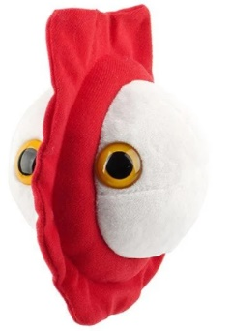
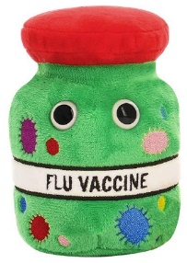
Here they are:

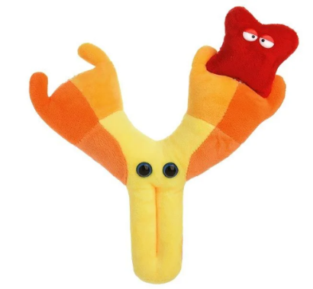
Antibody

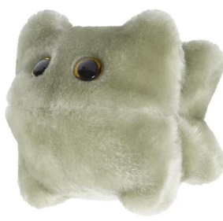
Norovirus

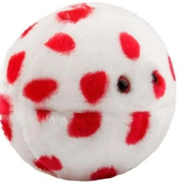
Measles
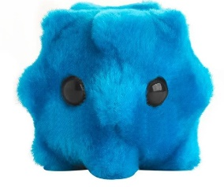
Common cold
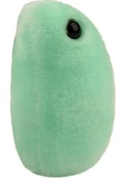
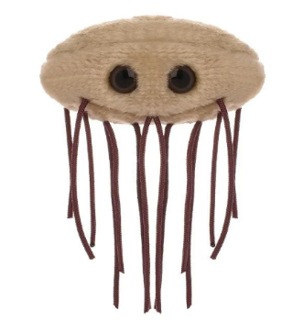
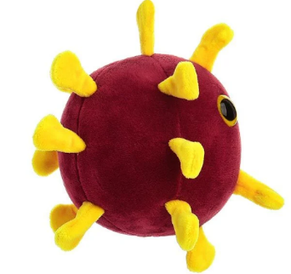
E. coli
Flu
COVID-19

Appendix 3 – SAIS Working Together Agreement form to be completed by the school.

Population vaccination coverage: MMR for two doses (5 years) 2023, Fingertips, Accessed on: https://fingertips.phe.org.uk/search/vaccination#page/4/gid/1/pat/15/par/E92000001/ati/502/are/E08000026/iid/30311/age/34/sex/4/cat/-1/ctp/-1/yrr/1/cid/4/tbm/1/page-options/car-do-0

